Effects of transparent brand communication on perceived brand authenticity and consumer responses

*Jing Yang*

School of Communication, Loyola University Chicago, Chicago, Illinois, USA, and

*Ava Francesca Battocchio*

Department of Advertising and Public Relations, Michigan State University, East Lansing, Michigan, USA

Abstract

Purpose – This study aims to understand the effects of brands’ transparent communication (i.e. production transparency and cost transparency) on consumers’ perceptions of a brand’s perceived transparency and authenticity, as well as how such perceptions impact consumers’ attitude, trust and behavioral intentions.

Design/methodology/approach – Two between-participants factorial design experiments (*n* = 176 for Study 1 and *n* = 169 for Study 2) were conducted to examine consumers’ responses to a brand’s cost transparency and production transparency.

Findings – The results revealed that transparency in the focal brand’s communication of production and cost would increase consumers’ perceptions of the brand’s transparency and authenticity because of its perceived information sensitivity. Such positive effects were found to similarly impact consumers’ attitude, trust and behavioral intention toward the brand.

Practical implications – The results point to the importance of brand transparency in marketing communication, speciﬁcally as it pertains to the inﬂuence that the inclusion of transparent cost and production information can have on consumers’ perceptions of authenticity, trust and attitude, as well as how these perceptions translate into behavioral intention.

Originality/value – To the best of the authors’ knowledge, this study is among the ﬁrst to explore the differences between production transparency and cost transparency in inﬂuencing consumer responses and the underlying mechanisms. The ﬁndings also expand to the literature on brand transparency and brand authenticity.

Keywords Brand trust, Brand authenticity, Cost transparency, Brand relationships, Brand transparency, Production transparency, Consumer attitude

Paper type Research paper

# Introduction

The idea of openness – generally cited in terms of “transparency,” a buzzword frequently used for pitching digital campaigns (Wilms, 2011) – has increased in usage since the late 20th century (Schnackenberg and Tomlinson, 2016). Transparency has been deﬁned as “the extent to which an entity reveals information about its decision process, procedures, functioning and performance” (Grimmelikhuijsen and Meijer, 2014, p. 139). As a strategy, such signiﬁers have been shown to increase stakeholder trust (Parris *et al.*, 2016), enhance consumer understanding and indicate a brand’s responsibility for its practices (Yoo and Jeong, 2014). The impact of social acceptance and perceived corporate social responsibility (CSR) arising from perceived brand transparency translates into commercial environments with credible and transparent principles that can drive purchase intention and

The current issue and full text archive of this journal is available on Emerald Insight at: https://[www.emerald.com/insight/1061-0421.htm](http://www.emerald.com/insight/1061-0421.htm)

increase customer bases (Connelly *et al.*, 2011; Lee *et al.*, 2005).

By the same token, “authenticity,” as a core component of brand image (Ballantyne *et al.*, 2006), is “one of the cornerstones of contemporary marketing” (Brown *et al.*, 2003) that often relates to the success of a brand’s identity (Beverland, 2005; Kapferer, 2004). Indeed, global issues, such as ﬁnancial, political and environmental instability, have led to increased demand for authentic engagement in daily life, including engagements between consumers and products (Brown *et al.*, 2003, p. 21). As a response to this demand, brand transparency can be evaluated based on the type of information and the level of detail revealed (Cambier and Poncin, 2020; Grimmelikhuijsen and Meijer, 2014). However, brand authenticity is more of a “master concept” that integrates various desirable qualities that can be applied to brands, e.g. *continuity*, *originality*, *reliability* and *naturalness* (Bruhn *et al.*, 2012); *credibility*, *integrity* and

Journal of Product & Brand Management 30/8 (2021) 1176–1193

© Emerald Publishing Limited [ISSN 1061-0421] [DOI [10.1108/JPBM-03-2020-2803](http://dx.doi.org/10.1108/JPBM-03-2020-2803)]

Received 21 March 2020

Revised 11 August 2020

30 September 2020

22 October 2020

Accepted 24 October 2020

*symbolism* (Morhart *et al.*, 2015); and *originality* and

*genuineness* (Akbar and Wymer, 2017).

Despite its rising importance, existing literature in brand communication has yet to explore the relationship between brand transparency and brand authenticity. To address this gap, this study draws on signaling theory (Spence, 1974) to investigate this relationship and analyzes information type (i.e. production vs cost) to determine consumers’ perceptions of a brand’s transparency and authenticity. Ultimately, this study aims to examine if increases in perception of transparency and authenticity help achieve positive consumer attitudes, trust and behavioral intentions toward a brand.

The purpose of this study is twofold. First, it intends to investigate which type of transparent information disclosure (i.e. production and cost) results in higher perceived brand transparency to analyze the underlying mechanism. Second, it intends to examine how perceived transparency further contributes to consumers’ perceptions of a brand’s perceived authenticity and their attitudinal and behavioral responses toward the brand. The ﬁndings of the current study advance existing literature on brand transparency and brand authenticity and provide actionable insights for companies to use in building an effective brand image.

# Literature review

Communicating brand transparency

The concept of transparency is a trending buzzword in today’s media and business realms because of today’s societal and economic environment. In the context of branding, scholars have taken various approaches to conceptualize and operationalize brand transparency. For instance, Yoo and Jeong (2014) deﬁned transparency as:

[.. .] consumers’ perceived levels of a brand’s strategic communication effort to make information available – whether positive or negative in nature – to enhance their understanding and make a brand accountable for marketing practices.

Meanwhile, Brandão *et al.* (2018) explained transparency as a brand’s effort to provide consumers with clear and relevant information regarding their business practices and products. Schnackenberg and Tomlinson (2016, p. 12) deﬁned it as “an evaluation of the quality of the information provided by the organization,” emphasizing information disclosure, clarity and accuracy. Fundamentally, what these scholars share regarding their conceptualizations of brand transparency is the core value of brand openness and accountability (Parris *et al.*, 2016; Yoo and Jeong, 2014).

Prior studies have revealed that when consumers perceive a brand as transparent, this perception tends to result in consumers’ trust-building as well as positive consumer attitudes and behavioral intentions toward the brand (Kang and Hustvedt, 2014a, 2014b; Kim and Kim, 2016; Reynolds and Yuthas, 2008). Lin *et al.* (2017) argued that when brands communicate transparently to consumers, consumers’ awareness of the brand’s initiatives and value increases, such as those regarding the ethical use of labor, sustainable manufacturing processes and social responsibility initiatives. Moreover, in recognizing and understanding a brand’s efforts in these regards, consumers are likely to appreciate the brand

more than before, thus leading to growth in trust, positive attitudes and behavioral intentions (Parris *et al.*, 2016).

In building perceived transparency, it is essential for brands to create appropriate strategies for communicating their transparency value to consumers (Kang and Hustvedt, 2014a; Parris *et al.*, 2016). Extant studies investigating brand transparency have primarily contextualized this within CSR, emphasizing a brand’s ethical conduct in production processes. These include practices such as the ethical use of labor and materials and sustainable production efforts for environment protection (Kang and Hustvedt, 2014a, 2014b; Kim and Kim, 2016; Reynolds and Yuthas, 2008). As such, prior studies have mainly focused on production transparency, which is deﬁned in this study as *the disclosure of a product*’*s manufacturing process, which includes the source of raw materials and related operation information.* However, beyond production transparency, other types of information can also be disclosed to help decrease information asymmetry and inequalities in the consumer marketplace (VanSandt and Sud, 2012). For example, McKay (2008) and Tapscott and Ticoll (2003) have suggested transparency is more than merely the full disclosure of information. It is about disclosing crucial information that consumers want to know and receive from brands. Thus, this study aims to understand how the communicated transparency of a product’s cost can impact consumers’ perceptions of a brand’s perceived transparency.

The term “cost transparency,” initially investigated in the context of supplier–company communication (Lamming *et al.*, 2001), is a relatively new concept and practice in consumer– company communications. Mohan *et al.* (2020, p. 1) have deﬁned it as “the practice of revealing the unit costs of production to consumers.” In a series of pioneering ﬁeld and lab studies, they found that including product cost information resulted in more brand trust and purchase intention. Cost transparency in this regard differs from how it has been traditionally known because price transparency usually refers to a clear overall understanding of the expected quoted charges of a product/service from a company/brand, such as designated markup and discounted price. At the same time, cost transparency exposes unit costs information such as costs for raw materials, labor and transportation (Ferguson, 2014; Matzler *et al.*, 2006). The current study thus posits that cost transparency is a relatively higher level of information disclosure. Such a level of information disclosure breaks conventional business practices by revealing product and brand information that is usually hidden, which can result in higher perceived brand transparency because of its information criticalness and sensitivity (McKay, 2008; Tapscott and Ticoll, 2003).

Following the literature on disclosure sensitivity, information sensitivity has been deﬁned as the potential loss associated with the disclosure of information that is risky for the discloser to reveal (Moon, 2000; Mothersbaugh *et al.*, 2012). Mohan *et al.*(2020) compared the perceived sensitivity of information across different types of transparency (e.g. operation transparency, cost transparency and price transparency) and found that cost information was perceived to be the most sensitive of all the transparencies. However, their studies did not directly examine the mediating role of perceived sensitivity of information between the type of information revealed and

consumer evaluations. Therefore, the current study builds on their ﬁndings by examining whether a difference exists between cost transparency and production transparency in informing consumers’ perceptions of brand transparency and whether information sensitivity will be a signiﬁcant mediator of such a difference. Such an exploration is valuable to the existing literature on brand transparency given its pioneering approach in making these particular comparisons. Based on the above discussion, it is proposed that:

*H1.* The disclosure of cost transparency (vs production transparency and none) will be perceived as more transparent because of higher perceived information sensitivity.

Brand authenticity

*Authenticity* originated from the Greek word *athentikos*, which emphasized the sense of truthfulness (Cappannelli and Cappannelli, 2004). Modern literature has claimed the concept of “authenticity” to be “one of the cornerstones of contemporary marketing” (Brown *et al.*, 2003, p. 21) because it contributes principal positive value to a brand’s image (Ballantyne *et al.*, 2006; Keller, 1998) and identity (Beverland, 2005; Kapferer, 2004). Authentic brands often distinguish themselves from others through their sincerity, stability, endurance, consistency, credibility, originality, truthfulness, genuineness, realness and dissociation from commercial motives (Ballantyne *et al.*, 2006; Beverland, 2006; Bruhn *et al.*, 2012; Grayson and Martinec, 2004; Holt, 2002).

Recent studies have primarily perceived brand authenticity to be more of a subjective evaluation by consumers based on their interpretation, knowledge, interest and personal tastes (Grazian, 2003; Leigh *et al.*, 2006; Napoli *et al.*, 2014). As a result, some scholars have developed several deﬁnitions and operationalized that regarding essential components of brand authenticity. For example, Bruhn *et al.* (2012, p. 572) deﬁned brand authenticity as a construct that centers on four dimensions: *continuity*, *originality*, *reliability* and *naturalness.* While Morhart *et al.* (2015) agree on the importance of *continuity*, they differ in that they see brand authenticity as the degree to which brands can practice *credibility*, *integrity* and *symbolism* (p. 203). Akbar and Wymer (2017) further reﬁned the scale proposed by earlier scholars by suggesting a two- dimensional conceptualization featuring only *originality* and *genuineness*. The current study adopts Bruhn *et al.*’s (2012) approach to reﬂect the construct of brand authenticity as determined by its higher comprehensiveness, inclusivity and relevance to other proposed operationalizations.

Drawing on signaling theory (Spence, 1974), other studies have suggested that a brand’s marketing communications have a substantial impact on consumers’ perceptions of the brand’s authenticity. For instance, consumers can communicate evaluations of the brand through diagnostic information and cues provided by the brand’s marketing communication (Grazian, 2003). Speciﬁcally, when a brand is transparent about its production and corporation activities, such transparency signals an invitation to consumers to participate in the brand’s decision-making processes and can help consumers feel they are witnesses of the company’s claims and actions. In

this regard, Cambier and Poncin (2020) revealed that a brand’s transparency, i.e. the level of information a brand reveals about its internal processes and performances (Grimmelikhuijsen and Meijer, 2014), can offer consumers credible and persuasive signals for making judgments about a brand’s integrity. As a brand’s integrity is an essential construct of its perceived authenticity, we hypothesize that, through a brand’s transparent presentation of its production and its product costs, consumers perceive the brand to be more authentic.

*H2.* Brand transparency will positively contribute to consumers’ perceptions of the brand’s authenticity.

Consumer responses

*Brand trust*

Trust is a critical component in any relationship, especially so in the relationship between brand and consumer (Kang and Hustvedt, 2014a; Moorman *et al.*, 1993; Morgan and Hunt, 1994; Sirdeshmukh *et al.*, 2002). Brand trust refers to customers’ willingness to rely on a brand in conditions of uncertainty or risk based on their beliefs and evaluation of the brand (Becerra and Korgaonkar, 2011). For trust to occur, there must be conﬁdence in “the exchange partner’s reliability and integrity” (Morgan and Hunt, 1994, p. 23) and “safety and honesty” (Chaudhuri and Holbrook, 2001, p. 82). The development of such trust in brand–consumer relationships can result from corporate and ﬁnancial transparency, which in turn can inﬂuence consumers’ ability to perceive the brand as authentic (Anderberg and Morris, 2006) or as performing a virtuous act (Zak *et al.*, 2005).

A brand’s ability to remain faithful to and open about its established identity, coupled with the truthfulness of a brand’s leader, are all factors that can foster a trusting environment. For instance, as previously mentioned, Anderberg and Morris (2006) found that brands can foster trust by being transparent about their corporate and ﬁnancial dealings. When brands are consistently transparent, it demonstrates to consumers that there is an alignment between a brand’s claim and actions. This alignment reinforces consumers’ perceptions of the brand’s ability to be authentic (Anderberg and Morris, 2006; Djelassi and Decoopman, 2013; Gebauer *et al.*, 2013). Furthermore, transparency can reinforce consumers’ perceptions of brand competence, empowerment, resource control and process (Christens *et al.*, 2011; Füller *et al.*, 2009; Zimmerman, 2000).

In general, transparency supports the establishment of brand trust by providing information that alleviates concerns associated with perceived risk, which can arise from uncertainty surrounding the appropriateness of product cost. Transparent pricing can thus help consumers rationalize their decisions about whether or not the cost is in line with what they want to pay and relax their self-interest (Carter and Curry, 2010; Maxwell, 1995). It can also help consumers ascertain adherence to social norms (Heyman and Mellers, 2008) while supporting the construction of trust between company and consumer in the process (Bertini and Gourville, 2012). Opaque pricing typically provides little information about cost distribution and a variety of other production factors. When brands provide information regarding price determination by outlining the costs associated with labor, materials and other

extraneous costs (Carter and Curry, 2010) or accurate outcome price (Bertini and Gourville, 2012), consumers’ perceptions of procedural justice and price fairness have been shown to improve (Carter and Curry, 2010).

*Attitude and behavioral intentions*

Consumers’ attitudes toward a brand and their subsequent behavioral intentions are often the result of a brand’s communication efforts. Both attitude and behavioral intention reﬂect consumers’ decision-making processes, especially those regarding the tendency toward ethical consumption (Chan, 2001; Marcketti and Shelley, 2009; Pino *et al.*, 2012). A consumer’s attitude toward a brand often refers to one’s judgment regarding the quality of the brand’s work (Thomson *et al.*, 2005); while consumers’ behavioral intentions toward brands are often operationalized as purchase intention (Lu *et al.*, 2015) and brand recommendation (Morhart *et al.*, 2015). As previously mentioned, prior studies in brand transparency and brand authenticity have long suggested positive impacts on consumers’ brand attitudes and behavioral intentions. For example, the use of transparent messaging surrounding CSR efforts, especially when associated with apparel marketing, has been shown to positively impact purchase intention (Hyllegard *et al.*, 2012; Yan *et al.*, 2010). Similarly, the use of a transparent revenue breakdown of a product can lead to higher purchase intentions in consumers who tend to purchase high-priced products (Carter and Curry, 2010). Given this, it is proposed that:

*H3*. Brand transparency will positively relate to consumers’

(a) trust, (b) attitude and (c) behavioral intentions toward the brand.

*H4*. Brand authenticity will positively relate to consumers’

(a) trust, (b) attitude and (c) behavioral intentions toward the brand.

Moreover, previous literature has also pointed out the impact of brand authenticity on consumer trust and attitude (Ewing *et al.*, 2012; Fritz *et al.*, 2017; Spiggle *et al.*, 2012), as well as on purchase intentions and recommendation behaviors (Lu *et al.*, 2015; Morhart *et al.*, 2015; Napoli *et al.*, 2014; Spiggle *et al.*, 2012). Components that contribute to brand authenticity and the subsequent ability to generate positive consumer responses include a brand’s ability to engage with sincerity, trustworthiness and credibility (Napoli *et al.*, 2014). As the consumers’ evaluation of a brand’s authenticity is likely to be inﬂuenced by the signals sent through transparent brand communication (Spence, 1974), we thus propose that:

*H5.* Brand authenticity will mediate the positive relationship between brand transparency and consumers’ (a) trust,

(b) attitude and (c) behavioral intentions toward the brand (Figure 1).

# Method

Research design

To build the conditions needed to examine the proposed hypotheses, two online between-participant experiments using both a ﬁctitious brand and a real brand were conducted. The inclusion of both ﬁctitious and real brands can help improve the

internal validity and external validity of the study, as the adoption of a ﬁctitious brand can heighten the experimental control and the inclusion of real brand can extend the effects to a real-world situation. Through the manipulation of the presence/absence of production information and cost information, four transparency conditions were created, namely, the control condition (absence of both cost and production information), the production transparency condition (presence of production information and absence of cost information), the cost transparency condition (presence of cost information and absence of production information) and the combined condition (presence of both cost and production information).

Stimuli development

A pre-test was conducted to determine the name of the ﬁctitious brand and the real brand’s selection in two studies. Artiﬁcial names (e.g. “A_Tee,” “BASIC” and “FAD”) for the ﬁctitious brand were generated with the help of the digital tool *Namelix*. And the real brands were selected from the apparel industry because of its growing reliance on e-commerce sales (eMarketer, 2020). We selected *H&M*, *ZARA*, *Uniqlo, Muttonhead* and *Wild Fang* because of their similarity in targeted audiences and inclusion of gender-neutral products. Participants (*n* = 35; 66% male; age range: 18–64 years) were recruited from Amazon Mturk, an online research pool for people to participate in studies in exchange for monetary beneﬁts.

The pre-test results of repeated-measure ANOVA indicated no signiﬁcant difference of their attitude toward the ﬁctitious names [*F* (4, 40) = 0.53, *p* = 0.72] and their familiarity with the ﬁctitious names [*F* (4, 40) = 1.65, *p* = 0.18]. Given that participants’ attitude toward “A_Tee” [M = 4.13, standard error (SE) = 0.23] was the closest to the mean value (M = 4.12, SE = 0.17) and their familiarity with the brand name is also the lowest across all names. Thus, we selected the brand name “A_Tee” to create the e-commerce website mock-up examples for Study 1. Moreover, in selecting the real brands to be adopted in developing the stimuli for Study 2, results of repeated-measure ANOVA showed no signiﬁcant difference of participants’ attitude toward the brand [*F* (4, 40) = 2.05, *p* = 0.11] and signiﬁcant differences in terms of participants familiarity with the brand [*F* (4, 40) = 5.63, *p* < 0.01]. Given that participants’ attitude toward the brand “Uniqlo” (M = 3.79, SE = 0.27) was the closest to the mean value (M = 3.80, SE = 0.15), and their familiarity of the brand “Uniqlo” (M = 4.38, SE = 0.34) was also the closet toward the mean value (M = 4.19, SE = 0.18), indicating neutral likability and familiarity. Therefore, the brand “Uniqlo” was selected in Study 2 for stimuli development.

To ensure the manipulation success of the different types of transparency (i.e. production transparency and cost transparency), another between-participant experiment pre- test of the mock-up examples was conducted with participants from Amazon MTurk (*n* = 50; 70% male; age range: 22–56 years). For the control condition, information on the e-commerce mock-up page only included a unisex *t*-shirt product display, price, material and size options, following a normal e-commerce website layout. For the condition of cost transparency, the costs of the materials, the hardware, the

Figure 1 Proposed research framework

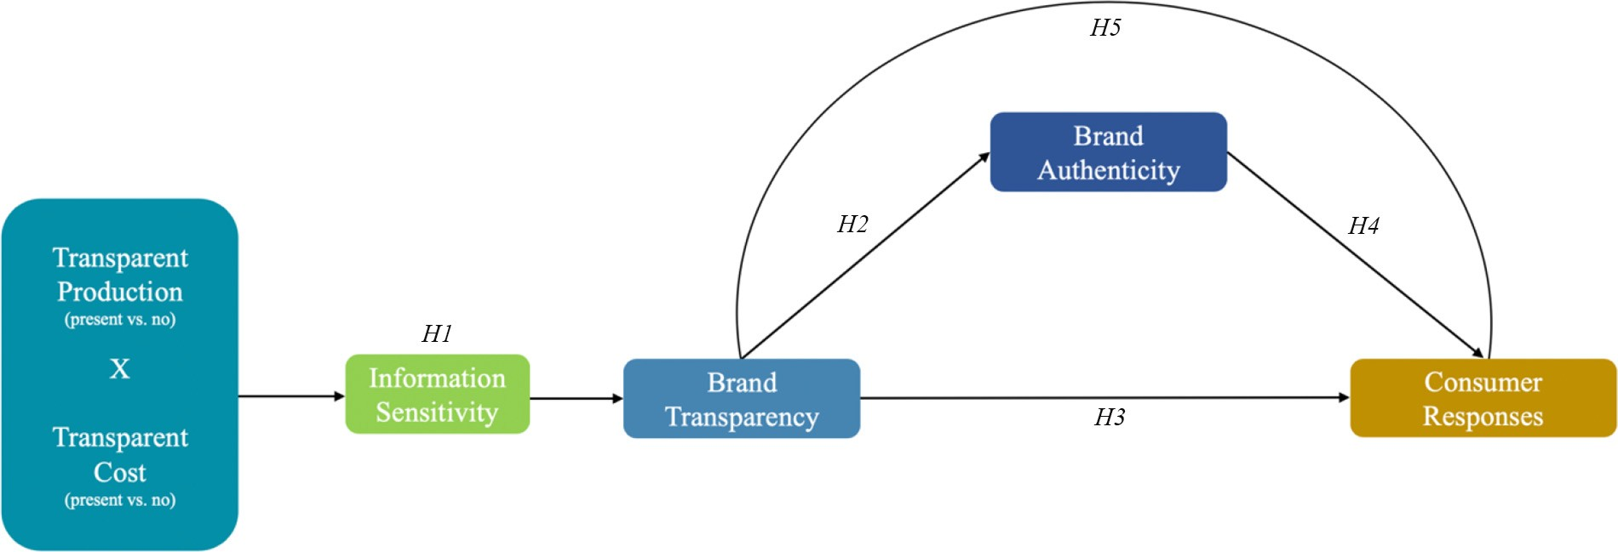

labor, the duties and the transportation fees were provided. For the condition of production transparency, partnered factories and material sourcing information were included. Lastly, for the combined condition, both the cost information and the production information were included. Two-way ANOVA analysis results indicated successful manipulation of production transparency [*F*(1, 46) = 11.42, *p* < 0.01] and cost transparency [*F*(1, 46) = 7.37, *p* < 0.01], such that the presence (vs absence) of production information resulted in greater production transparency (M*difference* = 1.99, SE = 0.59, *p* < 0.01) and the presence (vs absence) of cost information resulted in greater cost transparency (M*difference* = 1.78, SE = 0.66, *p* < 0.01). Therefore, we proceeded with the stimuli design. See Appendix for the stimuli.

# Study 1

Measures

*Brand transparency*

Brand transparency (Cronbach’s *a* = 0.92) is a scale developed speciﬁcally for this study to ﬁt the holistic perception of a brand being transparent about its products. The scale included ﬁve seven-point Likert scale items which are developed based on previous literature (Alcaide Gonz'alez *et al.*, 2020; Hustvedt and Kang, 2013; Lin *et al.*, 2017), anchored with “strongly disagree

= 1” to “strongly agree = 7”: “The brand A_Tee is transparent in its product information disclosure” (item 1); “The brand A_Tee is candid in delivering information about its product” (item 2); “The brand A_Tee provides clear information about its product” (item 3); “The brand A_Tee is open in communicating its product information” (item 4); and “Overall, the brand A_Tee provides relevant information to ensure transparency of its product” (item 5).

Reliability and validity tests of the scale were performed using SPSS Amos version 27. As indicated in Table 2, results of the conﬁrmatory factor analysis revealed great factor loadings for all of the ﬁve items (ranging from 0.754 to 0.921) with a good model ﬁt (chi-square/df = 1.017, comparative ﬁt index (CFI) = 0.999, goodness of ﬁt index (GFI) = 0.991, adjusted goodness of ﬁt index (AGFI) = 0.965, root mean square error of approximation index (RMSEA) = 0.010 and p of close ﬁt (PCLOSE) = 0.601), which satisﬁed the acceptable thresholds suggested in previous literature (Hu and Bentler, 1999; MacCallum *et al.*, 2001). In

addition, the composite reliability (CR) of the scale was at 0.915, which is above the threshold of 0.7 (Hair *et al.*, 2011). Thus, we concluded that the scale achieved good reliability. In addition, to examine the convergent validity and discriminant validity of the scale, we calculated the average variance extracted (AVE) and the maximum shared variance (MSV). Results showed that the AVE was at 0.729, which is above the threshold of 0.5 (Malhotra and Dash, 2011). The MSV was at 0.506, which is smaller than the AVE. Thus, we concluded that the scale also reached good convergent validity and discriminant validity (Fornell and Larcker, 1981). Discriminant validity test comparing the scale of brand transparency and brand authenticity also showed acceptable value of heterotrait–monotrait ratio of correlations (HTMT) at 0.81, which is below the threshold of 0.90 (Henseler *et al.*, 2015). We thus concluded the scale was appropriate for the subsequent hypotheses testing.

*Brand authenticity*

Brand authenticity (Cronbach’s *a* = 0.88) was adapted from Bruhn *et al.*’s (2012) scale that included perceived continuity (four items, Cronbach’s *a* = 0.87), originality (four items, Cronbach’s *a* = 0.94), reliability (four items, Cronbach’s *a* = 0.89) and naturalness (three items, Cronbach’s *a* = 0.79). Similarly, this study used a seven-point Likert scale anchored with “strongly disagree =1” to “strongly agree =7.” Items measuring perceived continuity addressed statements such as “I think the brand A_Tee stays true to itself” and items measuring perceived originality used items such as “The brand A_Tee stands out from other brands.” While items measuring perceived reliability used statements such as “The brand A_Tee’s promises are credible.” Lastly, the items measuring perceived naturalness addressed items such as “The brand A_Tee makes a genuine impression.”

*Brand trust*

Brand trust (Cronbach’s *a* = 0.87) was measured using ﬁve seven-point Likert scale items, anchored with “strongly disagree = 1” to “strongly agree = 7,” which were adapted from Erdem and Swait’s (2004) scale: “A_Tee does not pretend to be something it isn’t”; “A_Tee’s product claims are believable”; “Over time, my experiences with A_Tee have led me to expect it to keep its promises, no more and no less”;

“A_Tee has a name you can trust”; and “A_Tee delivers what it promises.”

|  |  |  |  |  |
| --- | --- | --- | --- | --- |
| Table 1 Demographic information |  | | | |
|  | Study 1 |  | Study 2 |  |
|  | (*n* = 176) | (%) | (*n* = 169) | (%) |
| *Gender* |  |  |  |  |
| Male | 120 | 68.2 | 106 | 62.7 |
| Female | 56 | 31.8 | 63 | 37.3 |
| *Age* |  |  |  |  |
| 18*–*24 | 86 | 48.9 | 108 | 63.9 |
| 25*–*34 | 62 | 35.1 | 42 | 24.9 |
| 35*–*44 | 16 | 9.2 | 11 | 6.4 |
| 45*–*54 | 11 | 6.2 | 4 | 2.4 |
| >55 | 1 | 0.6 | 4 | 2.4 |
| *Education* |  |  |  |  |
| Less than high school | 6 | 3.4 | 7 | 4.1 |
| High school graduate | 45 | 25.6 | 47 | 27.8 |
| Some college | 40 | 22.7 | 43 | 25.4 |
| 2-year associate degree | 7 | 4.0 | 10 | 5.9 |
| 4-year bachelor*’*s degree | 41 | 23.3 | 36 | 21.3 |
| Professional/master*’*s degree | 37 | 21 | 23 | 13.6 |
| Doctoral degree | 0 | 0 | 3 | 1.8 |
| *Ethnicity/race* |  |  |  |  |
| White | 144 | 81.8 | 146 | 86.4 |
| Black or African American | 5 | 2.8 | 3 | 1.8 |
| Asian | 5 | 2.8 | 9 | 5.3 |
| Two or more race/ethnicity | 9 | 5.1 | 8 | 4.7 |
| Hispanic | 13 | 7.4 | 3 | 1.8 |
| *Annual household income* |  |  |  |  |
| Less than $20,000 | 80 | 45.5 | 59 | 34.9 |
| $20,000*–*$34,999 | 43 | 24.4 | 47 | 27.8 |
| $35,000*–*$49,999 | 26 | 14.8 | 31 | 18.3 |
| $50,000*–*$74,999 | 17 | 9.7 | 20 | 11.8 |
| $75,000*–*$99,999 | 4 | 2.3 | 5 | 3.0 |
| over $100,000 | 6 | 3.4 | 7 | 4.1 |
| *Employment* |  |  |  |  |
| Fulltime | 56 | 31.8 | 44 | 26 |
| Part-time | 18 | 10.2 | 19 | 11.2 |
| Unemployed | 22 | 12.5 | 19 | 11.2 |
| Student | 63 | 35.8 | 75 | 44.4 |
| Retired | 0 | 0 | 2 | 1.2 |
| Self-employed | 17 | 9.7 | 10 | 5.9 |

*Attitude toward the brand*

Attitude toward the brand (Cronbach’s *a* = 0.91) was measured using three seven-point Likert scale items, anchored with “strongly disagree = 1” to “strongly agree = 7,” as adapted from Sengupta and Johar’s (2002) scale: “I think A_Tee is a very good brand”; “I think A_Tee is a very useful brand”; and “My opinion of A_Tee is very favorable.”

*Behavioral intention*

Behavioral intention (Cronbach’s *a* = 0.914) was measured using three seven-point Likert items adapted from Oh *et al.*’s (2019) scale that asked participants’ likelihood regarding: “visiting a store/website in the future”; “buying a product”; and “recommending the brand to other people.”

*Perceived sensitivity*

Perceived sensitivity was measured using a single-item seven- point Likert scale that asked participants to evaluate the brand’s communication with the question: “How sensitive is the information disclosed by the brand on this website?” (1 = not at all sensitive; 7 = extremely sensitive).

*Control variable*

Product involvement (Cronbach’s *a* = 0.923) was measured using three seven-point Likert scale items adapted from Strazzieri (1994), anchored with “strongly disagree = 1” to “strongly agree = 7”; “I am interested in this product category”; “This product category counts to me”; and “I give special importance to products in this category.”

Participants and procedure

A total of 176 valid participants were recruited from *Proliﬁc*, an online consumer panel platform with reliable consumer research (Peer *et al.*, 2017). More than half of the participants were male (68.2%) and non-Hispanic White (81.8%). Their age ranged from 18 to 57 years (M = 26.9, standard deviation = 8), with the majority being Millennials (84.1% from ages 18 to 34). About one-third of the participants worked full time (31.8%), and more than 80% had an annual household income under $50,000. Column 1 of Table 1 presents the details of this sample.

After consenting to participate in the study, participants were randomly assigned to one of the four experimental conditions. Once they ﬁnished reviewing the mock-up page of the brand’s e-commerce, they were asked to answer two manipulation check questions (i.e. perceived production transparency and perceived cost transparency). This was followed by the measurement items of perceived sensitivity of the information, brand transparency, brand authenticity, brand attitude, brand trust and behavioral intentions. Demographic information was collected toward the end. Two attention check questions were inserted in the survey. Those who failed the attention check question were directed to the end of the survey and thus not included in the ﬁnal data analysis.

Data analysis

*Manipulation check*

Prior to data analysis, a manipulation check was performed using two-way ANOVA analyses. Results indicated successful manipulation of the production transparency [*F* (1, 171) = 51.98, *p* < 0.001], such that the presence (vs absence) of production information resulted in greater production transparency (M*difference* = 1.97, SE = 0.27, *p* < 0.001). In addition, the results also showed successful manipulation of cost transparency [*F* (1, 171) = 80.43, *p* < 0.001], such that the presence (vs absence) of cost information resulted in greater cost transparency (M*difference* = 2.60, SE = 0.29, *p* < 0.001). Moreover, pairwise comparisons across the four conditions also revealed that the production transparency condition resulted in greater perceived production transparency than cost

Table 2 Results of reliability and validity tests for brand transparency

|  |  |  |  |  |  |  |  |  |  |  |  |
| --- | --- | --- | --- | --- | --- | --- | --- | --- | --- | --- | --- |
| Model fit indices | | | | | | | | | | | |
|  | Factor loadings | CR | AVE | MSV | HTMT | Chi-square/ | CFI | GFI | AGFI | RMSEA | PCLOSE |
| Study 1 | (>0.70) | (>0.70) | (>0.50) | (<AVE) | (<0.90) | df (<3) | (>0.90) | (>0.95) | (>0.80) | (<0.05) | (>0.05) |
| Item 1 | 0.862 | 0.915 | 0.729 | 0.506 | 0.81 | 1.017 | 0.999 | 0.991 | 0.965 | 0.010 | 0.601 |
| Item 2 | 0.921 |  |  |  |  |  |  |  |  |  |  |
| Item 3 | 0.847 |  |  |  |  |  |  |  |  |  |  |
| Item 4 | 0.753 |  |  |  |  |  |  |  |  |  |  |
| Item 5 | 0.804 |  |  |  |  |  |  |  |  |  |  |
| Study 2 Factor loadings CR AVE MSV HTMT Model ﬁt indices | | | | | | | | | | | |
|  | (>0.70) | (>0.70) | (>0.50) | (<AVE) | (<0.90) | Chi-square/ | CFI | GFI | AGFI | RMSEA | PCLOSE |
|  |  |  |  |  |  | df (<3) | (>0.90) | (>0.95) | (>0.80) | (<0.05) | (>0.05) |
| Item 1 | 0.846 | 0.904 | 0.703 | 0.563 | 0.77 | 1.27 | 0.999 | 0.991 | 0.945 | 0.040 | 0.452 |
| Item 2 | 0.850 |  |  |  |  |  |  |  |  |  |  |
| Item 3 | 0.797 |  |  |  |  |  |  |  |  |  |  |
| Item 4 | 0.850 |  |  |  |  |  |  |  |  |  |  |
| Item 5 | 0.846 |  |  |  |  |  |  |  |  |  |  |

transparency condition (M*difference* = 1.89, SE = 0.38, *p* < 0.001). And the cost transparency condition was perceived with greater cost transparency than the production transparency condition (M*difference* = 2.35, SE = 0.41, *p* < 0.001). Therefore, the manipulation was successful.

*Hypotheses testing*

*H1* suggested that cost transparency (vs production transparency and no disclosure of information) would be perceived as having higher brand transparency because of its information sensitivity. Therefore, we performed a multi- categorical mediation analysis using Model 4 in Hayes (2017) PROCESS macro with 5,000 bootstrap samples. The transparency condition was entered as the independent variable. As there were four transparency conditions, three dummy variables were created using the cost transparency as the reference level. (*D*1 indicated the difference between cost transparency, control group. *D*2 indicated the difference between cost transparency and production transparency. *D*3 indicated the difference between cost transparency and the combined transparency.) In the data, the cost transparency was coded as -1, the control group was coded as 0, the production transparency was coded as 1 and the combined transparency was coded as 2. Brand transparency was entered as the outcome variable, with the perceived information sensitivity as the mediator, and individuals’ product involvement as the control variable.

Results showed that individuals’ product involvement was not a signiﬁcant covariate (*b* = 0.13, SE = 0.07, *p* = 0.06). When only considering the difference between cost transparency and the control group (i.e. *D*1), the perceived information sensitivity did not mediate the effect of transparency condition on consumers’ perception of the brand’s transparency: *effect* = -0.09, *BootSE* = 0.09 and *Bootstrap CILL-UL* = -0.29–0.08. Furthermore, when only considering the difference between cost transparency and production transparency (i.e. *D*2), the perceived information sensitivity also did not mediate the effect of transparency condition on consumers’ perception of the brand’s transparency: *effect* = -0.04, *BootSE* = 0.05 and *Bootstrap CILL- UL* = -0.16–0.04. Lastly, when considering the difference

between cost transparency and the combined transparency (i.e. *D*3), the perceived information sensitivity also did not mediate the effect of transparency condition on consumers’ perception of the brand’s transparency: *effect* = -0.01, *BootSE* = 0.03 and *Bootstrap CILL-UL* = -0.07–0.05. Therefore, *H1* was not supported.

Post-hoc two-way analysis of covariance (ANCOVA) revealed that only the presence of cost transparency showed signiﬁcant impact on participants’ perception of information sensitivity [*F* (1, 171) = 18.20, *p* < 0.001] and brand

transparency [*F* (1, 171) = 17.27, *p* < 0.001], but not the presence of production transparency in differentiating the perceived information sensitivity [*F* (1, 171) = 2.03, *p* = 0.16] and brand transparency [*F* (1, 171) = 3.07, *p* = .08]. Moreover, least signiﬁcant differences (LSD) pairwise comparisons of the four conditions showed that the cost transparency condition was signiﬁcantly different from production transparency condition in the perceived information sensitivity (M*difference*

= 0.74, SE = 0.37, *p* < 0.05), but not perceived brand transparency (M*difference* = 0.44, SE = 0.26, *p* = 0.90).

*H2* and *H3* addressed the direct effects of consumers’ perceived brand transparency on perceived brand authenticity as well as on consumers’ trust, attitude and behavioral intentions toward the brand. Multiple regression analyses controlling individuals’ product involvement were conducted in examining the proposed hypotheses. The results indicated that perceived brand transparency was signiﬁcantly associated with perceived brand authenticity (*b* = 0.71, SE = 0.04, *t* = 13.91, *p* < 0.001), consumers’ brand trust (*b* = 0.63, SE = 0.05, *t* = 11.14, *p* < 0.001), consumers’ attitude toward the brand (*b* = 0.63, SE = 0.05, *t* = 12.29, *p* < 0.001) and

consumers’ behavioral intention toward the brand (*b* = 0.451, SE = 0.08, *t* = 6.67, *p* < 0.001). Therefore, *H2* and *H3* were both supported.

*H4* asked about the direct effects of brand authenticity on consumers’ trust, attitude and behavioral intentions toward the brand. Following the same procedure, the results of multiple regression analyses showed that consumers’ perceived brand authenticity also had a signiﬁcantly positive inﬂuence on consumers’ brand trust (*b* = 0.74, SE = 0.05, *t* = 14.65, *p* <

0.001), attitude (*ß* = 0.82, SE = 0.05, *t* = 18.65, *p* < 0.001) and

behavioral intentions (*ß* = 0.38, SE = 0.08, *t* = 5.92, *p* <

0.001). Therefore, *H4* was also supported.

In testing the mediation effect of brand authenticity between brand transparency and consumers’ responses toward the brand, the authors conducted a mediation analysis using Model 4 in Hayes’ (2017) PROCESS macro with 5,000 bootstrap samples. Brand transparency was entered as the predictor. Brand trust, attitude toward the brand and behavior intention were entered as the outcome variables independently. Brand authenticity was entered as the mediator and individuals’ product involvement was entered as a covariate. Results showed a signiﬁcant mediation effect of brand authenticity between brand transparency and consumers’ trust toward the brand (*effect* = 0.34, *BootSE* = 0.06, *Bootstrap CILL-UL* = 0.22– 0.47), attitude toward the brand (*effect* = 0.44, *BootSE* = 0.06, *Bootstrap CILL-UL* = 0.33–0.56) and behavioral intention toward the brand (*effect* = 0.49, *BootSE* = 0.09, *Bootstrap CILL- UL* = 0.33–0.68). Individuals’ product involvement was found to be a signiﬁcant covariate when the output variables were brand attitude (*b* = 0.13, SE = 0.05, *p* < 0.01) and behavioral intention (*b* = 0.19, SE = 0.08, *p* < 0.05), but not for brand trust (*b* = 0.06, SE = 0.05, *p* = 0.19). In sum, *H5* was supported. See Figures 2, 3 and 4 for details.

Discussion

The above results revealed the impact of transparent brand communication on consumers’ perception of a brand’s transparency and authenticity. Although the mediation effect of information sensitivity was not signiﬁcant between the

transparency conditions and the perceived brand transparency, the post-hoc analyses revealed cost transparency as the main driver in inﬂuencing the perceived information sensitivity and brand transparency. Moreover, when only comparing the difference between cost transparency and production transparency conditions, results indicated signiﬁcant difference in information sensitivity but not brand transparency. In other words, consumers’ perceptions of brand transparency, under the condition of unknown brands, are based on the presence (vs absence) of cost transparency information, as well as the amount of information revealed. Moreover, this effect of brand transparency could also be carried onto consumers’ attitudinal response, trust and behavioral intentions toward the brand via the mediation of perceived brand authenticity.

# Study 2

To increase the current study’s external validity and its application to a real-world situation, Study 1 was replicated with a real brand from the apparel industry.

Measures

In addition to the measures used in Study 1, namely, brand transparency (Cronbach’s *a* = 0.922), brand authenticity (Cronbach’s *a* = 0.924), brand trust (Cronbach’s *a* = 0.870), attitude toward the brand (Cronbach’s *a* = 0.885), behavioral intention (Cronbach’s *a* = 0.907), product involvement (Cronbach’s *a* = 0.932) and perceived information sensitivity, the current study also involved additional control variables to avoid external effects from confounding variables

Figure 2 Mediation analysis with brand attitude as consequent variable (ﬁctions brand)

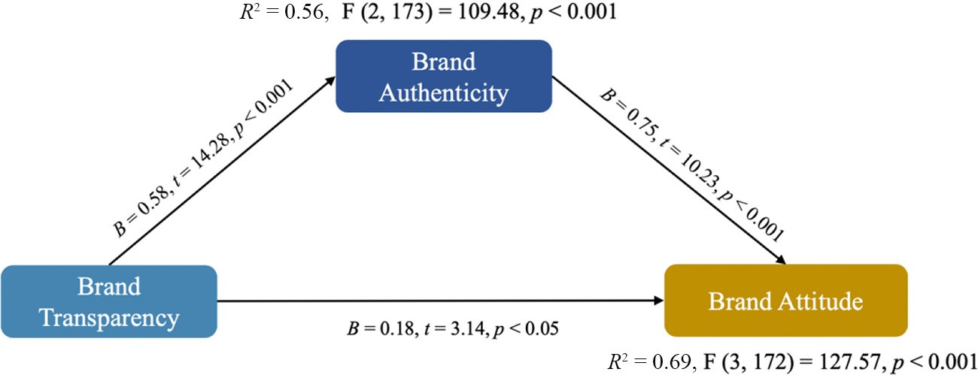

Figure 3 Mediation analysis with brand trust as consequent variable (ﬁctions brand)

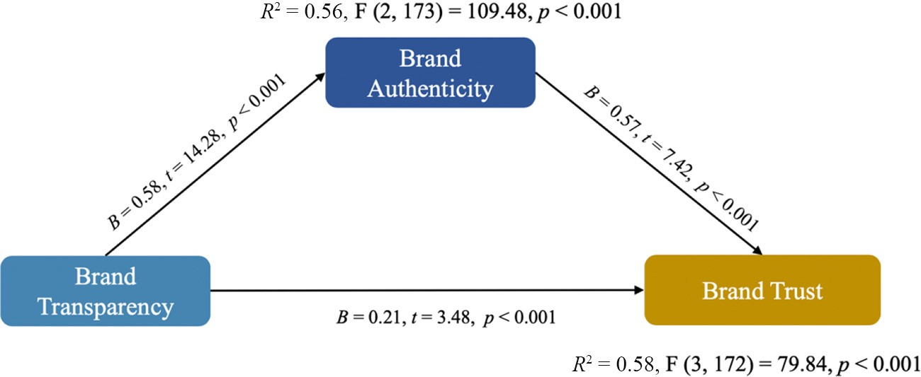

Figure 4 Mediation analysis with behavioral intention as consequent variable (ﬁctions brand)

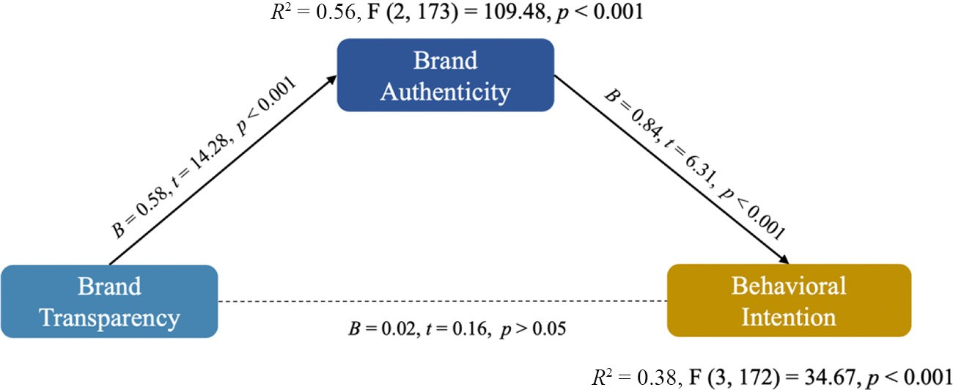

(i.e. pre-existing brand attitude and brand familiarity). Pre- existing brand attitude (Cronbach’s *a* = 0.907), as adapted from Lutz *et al.* (1983), was measured using a seven-point bipolar scale with items including “negative = 1” to “positive = 7”; “bad = 1” to “good = 7”; and “unfavorable = 1” to “favorable = 7.” Brand familiarity (Cronbach’s *a* = 0.964) was measured using scale items from Becker-Olsen *et al.* (2006), anchored with “unfamiliar = 1” to “familiar = 7”; “did not recognize = 1” to “recognized = 7”; and “had not heard of = 1” to “had heard of = 7.”

The validity and reliability of the newly developed brand transparency scale were again tested using SPSS Amos version

27. The detailed results are presented in Table 2. In a brief summary, the scale once again showed good factor loadings (ranged from 0.797 to 0.850) and a good model ﬁt (chi-square/ df = 1.270, CFI = 0.999, GFI = 0.991, AGFI = 0.945,

RMSEA = 0.040 and PCLOSE = 0.452), which satisﬁed the thresholds suggested in previous literature (Hu and Bentler, 1999; MacCallum *et al.*, 2001). Results also showed good reliability, convergent validity and discriminant validity of the scale, such that CR was at 0.904, which is above 0.70, AVE was at 0.703 which is above 0.50 and MSV was at 0.563, which is smaller than AVE (Malhotra and Dash, 2011; Fornell and Larcker, 1981). The value of HTMT (comparing brand transparency with brand authenticity) was at 0.77, which is smaller than the threshold of 0.90 (Henseler *et al.*, 2015). Thus, the measure of brand transparency was appropriate for hypotheses testing in Study 2.

Participants and procedure Participants (*n* = 200) were, again, recruited from *Proliﬁc*. After excluding participants who failed the attention check questions, there were a total of 169 valid responses. More than half of the participants were male (62.7%), non-Hispanic White (86.4%), ages 18–63 years, with the majority being Millennials (88.8%). About half of the participants were students (44.4%), and the majority (81.1%) had an annual household income under

$50,000. Column 2 of Table 1 presents the details of the sample.

After consenting to participate in the study, participants were ﬁrst asked to evaluate their product involvement with clothing products, followed by their pre-existing attitude and familiarity with Uniqlo. Then, they were randomly assigned to one of the four experimental conditions. After reviewing the e-commerce website mock-up page, they were presented with two

manipulation check questions (i.e. perceived production transparency and perceived cost transparency). These questions were followed by the measurement items of perceived sensitivity of the information, brand transparency, brand authenticity, brand attitude, brand trust and behavioral intentions. Demographic information was collected toward the end.

Data analysis

*Manipulation check*

Results of the two-way ANOVA analyses indicated successful manipulation of the production transparency [*F* (1, 161) = 45.24, *p* < 0.001] and cost transparency [*F* (1, 161) = 118.70, *p* < 0.001], such that the presence of production information would lead to greater perceived production transparency than the absence of production information (M*difference* = 1.73, SE = 0.26, *p* < 0.001) and the presence of cost information would lead to greater perceived cost transparency than the absence of such information (M*difference* = 2.97, SE = 0.27, *p* < 0.001). Therefore, the manipulation was successful in Study 2 as well.

*Hypothesis testing*

To test *H1*, which suggested cost (vs production) information transparency will result in higher brand transparency because of its information sensitivity, we ran a multi-categorical mediation analysis using Model 4 in Hayes’ (2017) PROCESS macro with 5,000 bootstrap samples. Repeating the process, as indicated in Study 1, the transparency group condition was entered as the independent variable. Three dummy variables were created using the cost transparency as the reference level (*D1* indicated the difference between cost transparency and control group; *D2* indicated the difference between cost transparency and production transparency; and *D3* indicated the difference between cost transparency and the combined transparency). In the data, the cost transparency was coded as

-1, the control group was coded as 0, the production transparency was coded as 1 and the combined transparency was coded as 2.

The perceived brand transparency was entered as the outcome variable, and the perceived information sensitivity was entered as the mediator. In addition, individuals’ pre-existing brand attitude, brand familiarity and product involvement were entered as covariates.

Results showed that individuals’ pre-existing brand attitude (*B* = 0.55, SE = 0.10, *p* < 0.001), brand familiarity (*B* = -0.17,

SE = 0.04, *p* < 0.001) and product involvement (*B* = 0.15, SE = 0.06, *p* < 0.001) were all signiﬁcant covariates. The perceived information sensitivity was found to be a signiﬁcant mediator: *effect* = -0.11, *BootSE* = 0.07 and *Bootstrap CILL-UL*

= -0.25 to -0.02, when only considering the difference between cost transparency and the control group (i.e. *D1*); when only considering the difference between cost transparency and production transparency: *effect* = -0.07, *BootSE* = 0.05 and *Bootstrap CILL-UL* = -0.17 to -0.002. But it was not a signiﬁcant mediator when only considering the difference between cost transparency and the combined transparency condition: *effect* = 0.05, *BootSE* = 0.04 and *Bootstrap CILL-UL* = -0.12–0.13. Therefore, based on the above ﬁndings, *H1* was supported.

Similar to study 1, post-hoc two-way ANCOVA analyses revealed that the presence of cost transparency showed signiﬁcant impact on participants’ perception of information sensitivity [*F* (1, 161) = 22.60, *p* < 0.001] and brand

transparency [*F* (1, 161) = 30.08, *p* < .001]. The presence of production transparency also had signiﬁcant effect on information sensitivity [*F* (1, 161) = 3.88, *p* < 0.05] and brand transparency [*F* (1, 161) = 7.77, *p* < 0.01]. Moreover, LSD pairwise comparisons of the four conditions showed that the cost transparency condition was signiﬁcantly different from production transparency in the perceived information sensitivity (M*difference* = 0.73, SE = 0.36, *p* < 0.05) and perceived brand transparency (M*difference* = 0.51, SE = 0.21, *p* < 0.05).

*H2* and *H3* predicted the direct effects of consumers’ perceived brand transparency on perceived brand authenticity and consumer responses, such as brand trust, brand attitude and behavioral intentions. Multiple regression analyses controlling individuals’ product involvement, pre-existing attitude and brand familiarity were conducted to examine the proposed hypotheses. Results indicated that perceived brand transparency signiﬁcantly inﬂuenced perceived brand authenticity (*B* = 0.64, SE = 0.04, *t* = 12.20, *p* < 0.001), consumers’ brand trust (*B* = 0.61, SE = 0.05, *t* = 10.71, *p* < 0.001), consumers’ attitude toward the brand (*B* = 0.53, SE = 0.06, *t* = 8.97, *p* < 0.001) and consumers’ behavioral intention toward the brand (*B* = 0.47, SE = 0.08, *t* = 7.24, *p* < 0.001). Therefore, *H2* and *H3* were both supported.

*H4* addressed the direct effects of brand authenticity on consumers’ trust, attitude and behavioral intentions toward the brand. The results of multiple regression analyses controlling individuals’ product involvement, pre-existing attitudes and brand familiarity showed that consumers’ perceived brand authenticity signiﬁcantly inﬂuenced brand trust (*B* = 0.80, SE = 0.05, *t* = 16.28, *p* < 0.001), attitude (*B* = 0.73, SE = 0.06,

*t* = 13.81, *p* < 0.001) and behavioral intentions (*B* = 0.61, SE = 0.10, *t* = 9.73, *p* < 0.001). Therefore, *H4* was also supported.

To examine the mediation effect of brand authenticity between brand transparency and consumers’ responses toward the brand, this study used the mediation Model 4 analysis in Hayes’ (2017) PROCESS macro with 5,000 bootstrap samples. Brand transparency was entered as the predictor. Brand trust, attitude toward the brand and behavior intention were entered independently as the consequent variables. Brand authenticity was entered as the mediator. Individuals’ product involvement, pre-existing brand attitude and brand familiarity

were entered as covariates. Results showed a signiﬁcant mediation effect of brand authenticity between brand transparency and consumers’ trust toward the brand: *effect* = 0.36, *BootSE* = 0.05 and *Bootstrap CILL-UL* = 0.26–0.47; attitude toward the brand: *effect* = 0.40, *BootSE* = 0.06 and *Bootstrap CILL-UL* = 0.28–0.53; and behavioral intention toward the brand: *effect* = 0.42, *BootSE* = 0.10 and *Bootstrap CILL-UL* = 0.24–0.64. Individuals’ pre-existing brand attitude was found to be a signiﬁcant covariate only when the output variable was brand attitude (*B* = 0.34, SE = 0.09, *p* < 0.001). Individuals’ product involvement (*B* = 0.15, SE = 0.06, *p* < 0.05) and brand familiarity (*B* = 0.34, SE = 0.09, *p* < 0.001) were found to be signiﬁcant covariates only when the output variable was behavioral intention. In sum, *H5* was also supported. See Figures 5, 6 and 7 for details.

Discussion

The results of Study 2 further conﬁrmed the impact of transparent brand communication on consumers’ perception of a brand’s transparency and authenticity and its effects on consumers’ attitudes, trust and behavioral intentions toward the brand. However, unlike Study 1, ﬁndings from Study 2 revealed that both the presence of cost transparency and production transparency would lead to greater perception of brand transparency. The ﬁndings of pairwise comparisons indicated that cost transparency condition, compared to production transparency condition, resulted in higher perceived brand transparency. Moreover, the current study also revealed the reason for such difference between cost transparency condition and production transparency condition, which is the perceived sensitivity of the disclosed information from the brand. Combined with the ﬁndings from Study 1, the following section provides a general discussion of the research ﬁndings and their theoretical and managerial value.

# General discussion

Theoretical contributions

Transparency and authentic communication continue to become more salient in modern marketing communication (Brown *et al.*, 2003; Yoo and Jeong, 2014). In response to this uprising trend, the current research aimed to investigate the effects of different types of transparent brand communication (i.e. production vs cost transparency) on consumers’ perceptions of brand transparency and authenticity, as well as their corresponding impact on consumers’ trust, attitude and behavior intention toward the brand. Two distinct studies were conducted to examine the proposed effects using both a ﬁctitious brand and a real brand to ensure its internal and external validity. The results of these two studies indicated several exciting ﬁndings that contribute to existing literature on brand transparency and brand authenticity.

First, in terms of building brand transparency, the current study took a pioneering approach by comparing different types of transparent information disclosure, i.e. production transparency and cost transparency. As suggested by Mohan *et al.* (2020), cost transparency is a relatively new type of brand communication in response to the current and ongoing societal changes. It is also a form of sensitive disclosure compared to

Figure 5 Mediation analysis with brand attitude as consequent variable (real brand)

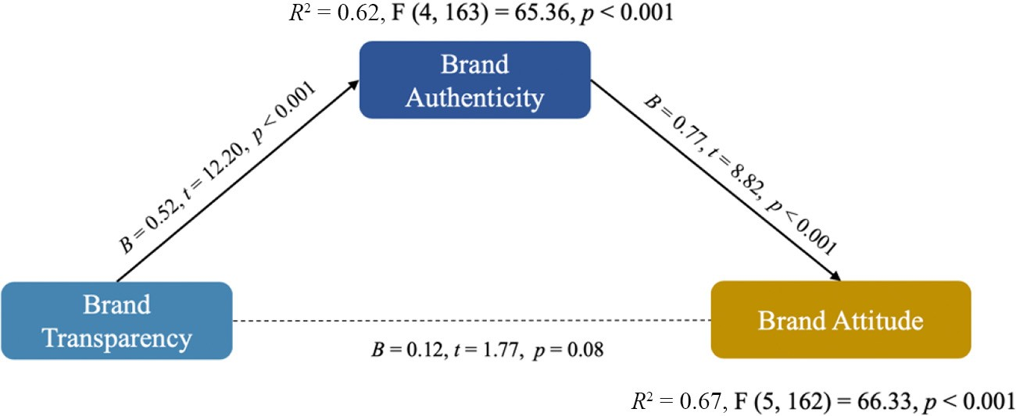

Figure 6 Mediation analysis with brand trust as consequent variable (real brand)

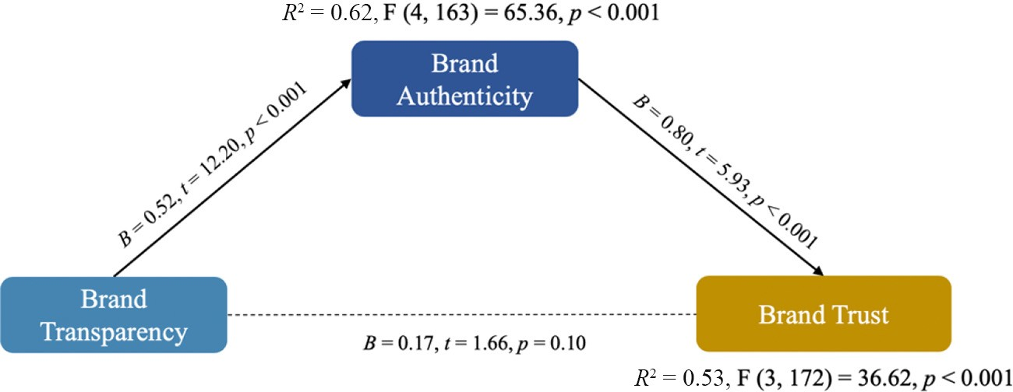

Figure 7 Mediation analysis with behavioral intention as consequent variable (real brand)

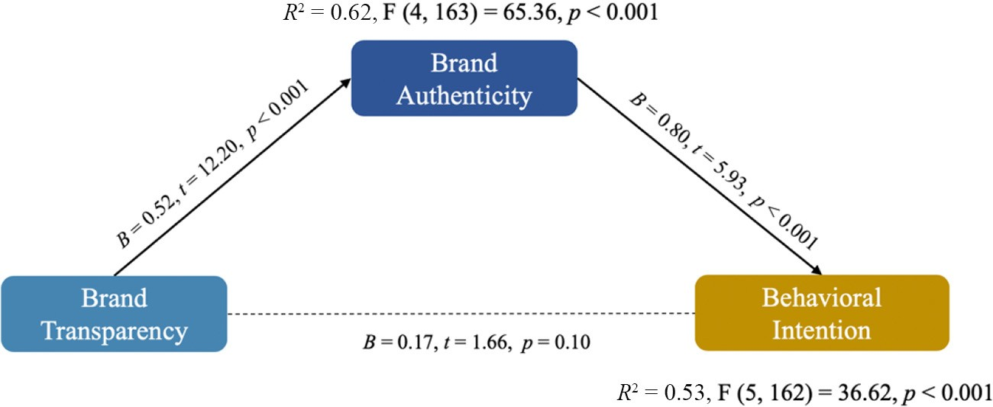

other information disclosures. McKay (2008) and Tapscott and Ticoll (2003) have pointed out that consumers’ subjective evaluation of a brand’s transparency does not merely depend on the full disclosure of information from brands, but also on how crucial and relevant the information is to consumers. Therefore, the ﬁndings from both Studies 1 and 2 provided empirical support for the signiﬁcant role of disclosing cost information in driving the perceived brand transparency. Speciﬁcally, in comparing the effects in between cost transparency and production transparency,

Study 2 provided empirical evidence that cost transparency was perceived as more transparent than production transparency because of its higher level of information sensitivity. However, interestingly, when we used an

unknown/ﬁctitious brand in Study 1, such a difference in perceived brand transparency was not found to be signiﬁcant between cost and production transparency. This may be because of the perceived effort a brand makes by disclosing its sensitive information. One core component of disclosure sensitivity is the potential loss/risks associated with the disclosure. For brands that are already well-established and well-known by consumers, giving up sensitive information comes with more risks/possible loss than a brand that is young and new. Therefore, in reality, more young interruption brands have been observed in different product categories as presenting themselves to be more transparent and authentic. This move, however, is more difﬁcult for established brands to pull off.

The ﬁndings also demonstrated that, by disclosing more information, brands are perceived as having higher brand authenticity, which further results in positive consumer attitudes, trust and purchase intentions. These ﬁndings echo previous studies that have suggested transparent brand communication and brand authenticity to have a positive impact on consumer responses (Ewing *et al.*, 2012; Fritz *et al.*, 2017; Hyllegard *et al.*, 2012; Lu *et al.*, 2015; Napoli *et al.*, 2014; Spiggle *et al.*, 2012; Yan *et al.*, 2010). When brands provide transparent information, they can minimize skepticism toward ad content (Darke and Ritchie, 2007; Poetzsch, 2014), evoke more brand trust and foster consumer connection with the brand (Anderberg and Morris, 2006; Grayson and Martinec, 2004). Furthermore, a brand’s disclosure of information regarding its business practices and procedures can narrow the social distance gap between a brand and its consumers. As suggested by Mohan *et al.* (2020), when a brand discloses secrets that are typically tightly guarded, consumers are likely to be more attracted to the brand. This ﬁnding also resonates with self-disclosure reciprocity effects (Sprecher *et al.*, 2013), which have been shown to indicate that higher self-information disclosure tends to result in afﬁliated affective responses, such as liking and trust. Thus, in a consumer–brand interaction domain, it is likely that a high level of brand self-disclosure will lead to consumers’ positive affective responses, trust and behavioral intentions.

Brand transparency and brand authenticity are two closely related constructs in branding literature that share common characteristics such as “genuineness,” truthfulness” and “realness.” The current study further develops this connection while also extending literature on brand transparency and brand authenticity through theoretical lens of signaling theory (Spence, 1974). Brand transparency provides signals that can develop new perceptions or support existing perceptions of brand authenticity. Furthermore, transparent brand communication offers cues that can be used to build perceived brand authenticity in consumers’ minds.

Lastly, the operationalization of brand transparency in previous studies is limited to contexts such as transparency regarding the ethical use of labor and manufacturing (Bhaduri and Ha-Brookshire, 2015; Hustvedt and Kang 2013; Kang and Hustvedt, 2014b) and environmentally friendly green production transparency (Lin *et al.*, 2017) as opposed to that of transparency regarding general brand perceptions. Scholars studying brand transparency have operationalized it by manipulating whether or not information is disclosed in experiment stimuli. As a result, the existing literature lacks a holistic approach to understanding consumers’ perceptions of brand transparency. The current study ﬁlls this gap by introducing its scale to brand transparency as a holistic consumer perception. Such a scale can serve future scholars who want to study the overall effects of brand transparency in different contexts.

# Managerial implications

From a managerial perspective, the current study provides insight into how brands can improve their perceived transparency and authenticity through marketing communication. Based on the ﬁndings of this study, companies

and brands can inﬂuence the perception of authenticity among consumers by being more transparent with their production process and costs of producing their products.

The results suggest that higher perceived transparency and authenticity of a brand beneﬁted the relationship between the brand and consumers (i.e. brand trust and attitude). For existing brands speciﬁcally, transparent communication regarding cost was perceived with a higher level of information sensitivity, thus resulting in higher perceived brand transparency and authenticity. This ultimately fostered the consumer–brand relationship (i.e. brand trust and brand attitude) and increased consumers’ behavioral intention toward the brand. For established brands trying to change consumers’ perceptions of their authenticity or attract target audiences that value brand character, brand managers should strategically consider adopting such a tactic and disclosing more crucial/ sensitive information to consumers.

For brands that are new or unknown, the practice of disclosing cost and production information can similarly help build consumers’ perception of the brand’s perceived transparency and authenticity. As such a practice of cost and production transparency has not yet been widely adopted in today’s marketplace, brand managers who want to distinguish their brands from the commercial brands should also consider adopting this approach, as it would ultimately assist the brand in building long-term relationships with consumers and drive consumers’ behavioral intentions, such as making purchases and positive word of mouth.

Moreover, given the current dramatic switch from ofﬂine retail to online consumption because of the global COVID-19 pandemic outbreak, we believe such a tactic can be more commonly instituted by brands on their e-commerce sites and digital marketing communication channels. Such changes can help consumers feel like participating in the brand’s production process by knowing more about the product they are consuming, reducing uncertainties in making purchases. Moreover, it also provides consumers the opportunity to monitor the brand’s actions, thereby leading to even more long- term consumer–brand relationships (i.e. brand trust) and a healthy/ethical market environment.

# Limitations and future studies

Although the current study was carefully designed, it is not without limitations, which leave opportunities for future studies. First, the present study was performed within one industry sector (i.e. apparel). To increase generalizability, future studies should test the proposed hypotheses under different industry sectors, such as travel and fast consumption goods.

Although cost transparency was found to be an effective approach in generating positive consumer responses in this study, future studies should examine its application to luxury products and services, as this type of product and service rely heavily on sensational experiences that are hard to be calculated based on material costs. Future studies can examine the impact and potential harm of revealing cost information to a brand’s overall image and consumer–brand relationships. In line with this, a future study might also investigate perceived price appropriateness in cases where cost information is disclosed to consumers, as it could potentially inﬂuence consumers’

perceptions and subsequent evaluations of the brand and product.

In addition to production and cost information, future studies should consider expanding the types of data disclosed to consumers. Additional information might include internal company spending for its employees, external marketing efforts, inﬂuencer collaborations and costs and other related sponsorship events. Such scenarios would provide valuable insights into consumer receptiveness of a variety of information transparency and its cruciality and relevance.

Lastly, boundary conditions based on individuals’ differences in pre-existing attitude, product involvement and brand self-identiﬁcation should also be explored to see if variations would inﬂuence the effects observed in this study. Speciﬁcally, individuals’ ad skepticism would be an exciting aspect to explore, particularly in terms of whether it could mitigate the positive impact of transparent brand communication. Following the persuasion knowledge model (Friestad and Wright, 1994), when consumers identify marketers’ persuasion tactics, they activate their persuasion knowledge in resisting the marketing message. Future studies that center on the mitigation of positive effects brought on by transparent information disclosure from brands in regards to the activation of persuasion knowledge have the potential to greatly impact current literature.

# References

Akbar, M.M. and Wymer, W. (2017), “Reﬁning the conceptualization of brand authenticity”, *Journal of Brand Management*, Vol. 24 No. 1, pp. 14-32.

Alcaide Gonz'alez, M.Á., De La Poza Plaza, E. and Guadalajara

Olmeda, N. (2020), “The impact of corporate social responsibility transparency on the ﬁnancial performance, brand value, and sustainability level of IT companies”, *Corporate Social Responsibility and Environmental Management*, Vol. 27 No. 2, pp. 642-654.

Anderberg, J. and Morris, J. (2006), “Authenticity and transparency in the advertising industry: an interview with John Morris”, *The Journal of Management Development*, Vol. 25 No. 10, pp. 1021-1023.

Ballantyne, R., Warren, A. and Nobbs, K. (2006), “The evolution of brand choice”, *Journal of Brand Management*, Vol. 13 Nos 4/5, pp. 339-352.

Becerra, E.P. and Korgaonkar, P.K. (2011), “Effects of trust beliefs on consumers’ online intentions”, *European Journal of* *Marketing*, Vol. 45 No. 6, pp. 936-962.

Becker-Olsen, K.L., Cudmore, B.A. and Hill, R.P. (2006), “The impact of perceived corporate social responsibility on consumer behavior”, *Journal of Business Research*, Vol. 59 No. 1, pp. 46-53.

Bertini, M. and Gourville, J.T. (2012), “Pricing to create shared value”, *Harvard Business Review*, Vol. 90 No. 6,

pp. 96-104.

Beverland, M.B. (2005), “Crafting Brand authenticity: the case of luxury wines”, *Journal of Management Studies*, Vol. 42 No. 5, pp. 1003-1029.

Beverland, M.B. (2006), “The ‘real thing’: branding authenticity in the luxury wine trade”, *Journal of Business Research*, Vol. 59 No. 2, pp. 251-258.

Bhaduri, G. and Ha-Brookshire, J. (2015), “Gender differences in information processing and transparency: cases of apparel brands’ social responsibility claims”, *Journal* *of Product & Brand Management*, Vol. 24 No. 5, pp. 504-517. Brandão, A., Gadekar, M. and Cardoso, F. (2018), “The impact of a ﬁrm’s transparent manufacturing practices on women fashion shoppers”, *Journal of Global Fashion*

*Marketing*, Vol. 9 No. 4, pp. 322-342.

Brown, S., Kozinets, R.V. and Sherry, J.F. (2003), “Teaching old brands new tricks: retro branding and the revival of brand meaning”, *Journal of Marketing*, Vol. 67 No. 3, pp. 19-33.

Bruhn, M., Schoenmüller, V., Schäfer, D. and Heinrich, D. (2012), “Brand authenticity: towards a deeper understanding of its conceptualization and measurement”, *NA - Advances in Consumer Research*, Vol. 40, pp. 567-576.

Cambier, F. and Poncin, I. (2020), “Inferring brand integrity from marketing communications: the effects of brand transparency signals in a consumer empowerment context”, *Journal of Business Research*, Vol. 109 No. 2, pp. 260-270.

Cappannelli, G. and Cappannelli, S. (2004), *Authenticity: simple Strategies for Greater Meaning and Purpose at Work and* *at Home*, Emmis Books, Cincinnati, OH.

Carter, R.E. and Curry, D.J. (2010), “Transparent pricing: theory, tests, and implications for marketing practice”, *Journal of the Academy of Marketing Science*, Vol. 38 No. 6,

pp. 759-774.

Chan, R.Y.K. (2001), “Determinants of Chinese consumers’ green purchase behavior”, *Psychology and Marketing*, Vol. 18 No. 4, pp. 389-413.

Chaudhuri, A. and Holbrook, M.B. (2001), “The chain of effects from brand trust and brand affect to brand performance: the role of brand loyalty”, *Journal of Marketing*, Vol. 65 No. 2, pp. 81-93.

Christens, B.D., Peterson, N.A. and Speer, P.W. (2011), “Community participation and psychological empowerment: testing reciprocal causality using a cross- lagged panel design and latent constructs”, *Health Education & Behavior*, Vol. 38 No. 4, pp. 339-347.

Connelly, B.L., Certo, S.T., Ireland, R.D. and Reutzel, C.R. (2011), “Signaling theory: a review and assessment”, *Journal of Management*, Vol. 37 No. 1, pp. 39-67.

Darke, P.R. and Ritchie, R.J.B. (2007), “The defensive consumer: advertising deception, defensive processing, and distrust”, *Journal of Marketing Research*, Vol. 44 No. 1,

pp. 114-127.

Djelassi, S. and Decoopman, I. (2013), “Customers’ participation in product development through crowdsourcing: uses and implications”, *Industrial Marketing Management*, Vol. 42 No. 5, pp. 683-692.

eMarketer (2020), “Apparel sales take a hit as consumers pull back spending on clothes”, available at: [www.emarketer.](http://www.emarketer.com/content/apparel-sales-take-a-hit-as-consumers-pull-back-spending-on-clothes-9) [com/content/apparel-sales-take-a-hit-as-consumers-pull-back-](http://www.emarketer.com/content/apparel-sales-take-a-hit-as-consumers-pull-back-spending-on-clothes-9) [spending-on-clothes-9](http://www.emarketer.com/content/apparel-sales-take-a-hit-as-consumers-pull-back-spending-on-clothes-9) (accessed 7 August 2020).

Erdem, T. and Swait, J. (2004), “Brand credibility brand consideration and choice”, *Journal of Consumer Research*, Vol. 31 No. 1, pp. 191-198.

Ewing, D.R., Allen, C.T. and Ewing, R.L. (2012), “Authenticity as meaning validation: an empirical investigation of iconic and indexical cues in a context of

‘green’ products”, *Journal of Consumer Behaviour*, Vol. 11 No. 5, pp. 381-390.

Ferguson, J.L. (2014), “Implementing price increases in turbulent economies: pricing approaches for reducing perceptions of price unfairness”, *Journal of Business Research*, Vol. 67 No. 1, pp. 2732-2737.

Fornell, C. and Larcker, D.F. (1981), “Structural equation models with unobservable variables and measurement error: algebra and statistics”, *Journal of Marketing Research*, Vol. 18 No. 3, pp. 382-388.

Friestad, M. and Wright, P. (1994), “The persuasion knowledge model: how people cope with persuasion attempts”, *Journal of Consumer Research*, Vol. 21 No. 1,

pp. 1-31.

Fritz, K., Schoenmueller, V. and Bruhn, M. (2017), “Authenticity in branding – exploring antecedents and consequences of brand authenticity”, *European Journal of* *Marketing*, Vol. 51 No. 2, pp. 324-348.

Füller, J., Mühlbacher, H., Matzler, K. and Jawecki, G. (2009), “Consumer empowerment through internet-based co- creation”, *Journal of Management Information Systems*, Vol. 26 No. 3, pp. 71-102.

Gebauer, J., Füller, J. and Pezzei, R. (2013), “The dark and the bright side of co-creation: triggers of member behavior in online innovation communities”, *Journal of Business Research*, Vol. 66 No. 9, pp. 1516-1527.

Grayson, K. and Martinec, R. (2004), “Consumer perceptions of iconicity and indexicality and their inﬂuence on assessments of authentic market offerings”, *Journal of Consumer Research*, Vol. 31 No. 2, pp. 296-312.

Grazian, D. (2003), *Blue Chicago: The Search for Authenticity in Urban Blues Clubs, Chicago*, University of Chicago Press, Chicago, IL.

Grimmelikhuijsen, S.G. and Meijer, A.J. (2014), “Effects of transparency on the perceived trustworthiness of a government organization: evidence from an online experiment”, *Journal of Public Administration Research and Theory*, Vol. 24 No. 1, pp. 137-157.

Hair, J.F., Ringle, C.M. and Sarstedt, M. (2011), “PLS-SEM: indeed a silver bullet”, *Journal of Marketing Theory and Practice*, Vol. 19 No. 2, pp. 139-152.

Hayes, A.F. (2017), *Introduction to Mediation, Moderation, and Conditional Process Analysis: A Regression-Based Approach*, Guilford publications, New York, NY.

Henseler, J., Ringle, C.M. and Sarstedt, M. (2015), “A new criterion for assessing discriminant validity in variance-based structural equation modeling”, *Journal of the Academy of Marketing Science*, Vol. 43 No. 1, pp. 115-135.

Heyman, J.E. and Mellers, M.A. (2008), “Perceptions of fair pricing”, Haugtvedt, C.P., Herr, P.M. and Kardes, F.R. (Eds), *Handbook of Consumer Psychology*, Taylor and Francis, New York, NY.

Holt, D.B. (2002), “Why do brands cause trouble? A dialectical theory of consumer culture and branding”, *Journal of Consumer Research*, Vol. 29 No. 1, pp. 70-90.

Hu, L.T. and Bentler, P.M. (1999), “Cutoff criteria for ﬁt indexes in covariance structure analysis: conventional criteria versus new alternatives”, *Structural Equation Modeling: A Multidisciplinary Journal*, Vol. 6 No. 1, pp. 1-55.

Hyllegard, K.H., Yan, R.N., Ogle, J.P. and Lee, K.H. (2012), “Socially responsible labeling: the impact of hang tags on consumers attitudes and patronage intentions toward an apparel brand”, *Clothing and Textiles Research Journal*, Vol. 30 No. 1, pp. 51-66.

Kang, J. and Hustvedt, G. (2014a), “Building trust between consumers and corporations: the role of consumer perceptions of transparency and social responsibility”, *Journal of Business Ethics*, Vol. 125 No. 2, pp. 253-265.

Kang, J. and Hustvedt, G. (2014b), “The contribution of perceived labor transparency and perceived corporate giving to brand equity in the footwear industry”, *Clothing and* *Textiles Research Journal*, Vol. 32 No. 4, pp. 296-311.

Kapferer, J.N. (2004), *Strategic Brand Management: Creating and Sustaining Brand Equity Long Term*, Kogan Page, London.

Keller, K.L. (1998), “Strategic brand management: Building”, *Measuring, and Managing Brand Equity*, Prentice Hall, Upper Saddle River, NJ.

Kim, S.B. and Kim, D.Y. (2016), “The impacts of corporate social responsibility, service quality, and transparency on relationship quality and customer loyalty in the hotel industry”, *Asian Journal of Sustainability and Social* *Responsibility*, Vol. 1 No. 1, pp. 39-55.

Lamming, R.C., Caldwell, N.D., Harrison, D.A. and Phillips,

W. (2001), “Transparency in supply relationships: concept and practice”, *Journal of Supply Chain Management*, Vol. 37 No. 3, pp. 4-10.

Lee, B.C., Ang, L. and Dubelaar, C. (2005), “Lemons on the web: a signalling approach to the problem of trust in internet commerce”, *Journal of Economic Psychology*, Vol. 26 No. 5,

pp. 607-623.

Leigh, T.W., Peters, C. and Shelton, J. (2006), “The consumer quest for authenticity: the multiplicity of meanings within the MG subculture of consumption”, *Journal of the Academy of Marketing Science*, Vol. 34 No. 4, pp. 481-493.

Lin, J., Lobo, A. and Leckie, C. (2017), “The role of beneﬁts and transparency in shaping consumers’ green perceived value, self-brand connection and brand loyalty”, *Journal of Retailing and Consumer Services*, Vol. 35 No. 2, pp. 133-141.

Lu, A.C.C., Gursoy, D. and Lu, C.Y. (2015), “Authenticity perceptions, brand equity and brand choice intention: the case of ethnic restaurants”, *International Journal of Hospitality* *Management*, Vol. 50, pp. 36-45.

Lutz, R.J., MacKenzie, S.B. and Belch, G.E. (1983), “Attitude toward the ad as a mediator of advertising effectiveness: determinants and consequences”, *ACR North American Advances*, Vol. 10, pp. 532-539.

McKay, L. (2008), “Transparency”, *Customer Relationship Management*, Vol. 12, pp. 24-29.

MacCallum, R.C., Widaman, K.F., Preacher, K.J. and Hong,

S. (2001), “Sample size in factor analysis: the role of model error”, *Multivariate Behavioral Research*, Vol. 36 No. 4,

pp. 611-637.

Malhotra, N.K. and Dash, S. (2011), *Marketing Research an* *Applied Orientation*, Pearson Publishing, London.

Marcketti, S.B. and Shelley, M.C. (2009), “Consumer concern, knowledge and attitude toward counterfeit apparel products”, *International Journal of Consumer Studies*, Vol. 33 No. 3, pp. 327-337.

Matzler, K., Wurtele, A. and Renzl, B. (2006), “Dimensions of price satisfaction: a study in the retail banking industry”, *International Journal of Bank Marketing*, Vol. 24 No. 4,

pp. 216-231.

Maxwell, S. (1995), “What makes a price increase seem ‘fair’”,

*Pricing Strategy and Price*, Vol. 3 No. 4, pp. 21-27.

Mohan, B., Buell, R.W. and John, L.K. (2020), “Lifting the veil: the beneﬁts of cost transparency”, *Marketing Science*, Vol. 39 No. 6, pp. 1-17.

Moon, Y. (2000), “Intimate exchanges: using computers to elicit self-disclosure from consumers”, *Journal of Consumer* *Research*, Vol. 26 No. 4, pp. 323-339.

Moorman, C., Deshpande, R. and Zaltman, G. (1993), “Factors affecting trust in market relationships”, *Journal of* *Marketing*, Vol. 57 No. 1, pp. 10-81.

Morgan, R. and Hunt, S. (1994), “The commitment-trust theory of marketing relationships”, *Journal of Marketing*, Vol. 58 No. 3, pp. 20-38.

Morhart, F., Malär, L., Guèvremont, A., Girardin, F. and Grohmann, B. (2015), “Brand authenticity: an integrative framework and measurement scale”, *Journal of Consumer* *Psychology*, Vol. 25 No. 2, pp. 200-218.

Mothersbaugh, D.L., Foxx, W.K., Beatty, S.E. and Wang, S. (2012), “Disclosure antecedents in an online service context: the role of sensitivity of information”, *Journal of Service* *Research*, Vol. 15 No. 1, pp. 76-98.

Napoli, J., Dickinson, S.J., Beverland, M.B. and Farrelly, F. (2014), “Measuring consumer-based brand authenticity”, *Journal of Business Research*, Vol. 67 No. 6, pp. 1090-1098.

Oh, H., Prado, P.H.M., Korelo, J.C. and Frizzo, F. (2019), “The effect of brand authenticity on consumer–brand relationships”, *Journal of Product & Brand Management*, Vol. 28 No. 2, pp. 231-241.

Parris, D., Dapko, J., Arnold, R. and Arnold, D. (2016), “Exploring transparency: a new framework for responsible business management”, *Management Decision*, Vol. 54 No. 1,

pp. 222-247.

Peer, E., Brandimarte, L., Samat, S. and Acquisti, A. (2017), “Beyond the Turk: alternative platforms for crowdsourcing behavioral research”, *Journal of Experimental Social Psychology*, Vol. 70 No. 3, pp. 153-163.

Pino, G., Peluso, A.M. and Gianluigi, G. (2012), “Determinants of regular and occasional consumers’ intentions to buy organic food”, *Journal of Consumer Affairs*, Vol. 46 No. 1, pp. 157-161.

Poetzsch, B. (2014), “Echt authentisch”, *Handelsblatt*, available at: [www.handelsblatt.com/unternehmen/dienstleister/werber-](http://www.handelsblatt.com/unternehmen/dienstleister/werber-rat/der-werber-rat-echt-authentisch/10361450.html) [rat/der-werber-rat-echt-authentisch/10361450.html](http://www.handelsblatt.com/unternehmen/dienstleister/werber-rat/der-werber-rat-echt-authentisch/10361450.html) (accessed 7 August 2020).

Reynolds, M. and Yuthas, K. (2008), “Moral discourse and corporate social responsibility reporting”, *Journal of Business Ethics*, Vol. 78 Nos 1/2, pp. 47-64.

Schnackenberg, A.K. and Tomlinson, E.C. (2016), “Organizational transparency: a new perspective on managing trust in organization-stakeholder relationships”, *Journal of Management*, Vol. 42 No. 7, pp. 1784-1810.

Sengupta, J. and Johar, G.V. (2002), “Effects of inconsistent attribute information on the predictive value of product attitudes: toward a resolution of opposing

perspectives”, *Journal of Consumer Research*, Vol. 29 No. 1, pp. 39-56.

Sirdeshmukh, D., Singh, J. and Sabol, B. (2002), “Consumer trust, value, and loyalty in relational exchanges”, *Journal of* *Marketing*, Vol. 66 No. 1, pp. 15-37.

Spence, A.M. (1974), *Market Signaling: Information Transfer in Hiring and Related Processes*, Harvard University Press, Cambridge, MA.

Spiggle, S., Nguyen, H.T. and Caravella, M. (2012), “More than ﬁt: brand extension authenticity”, *Journal of Marketing Research*, Vol. 49 No. 6, pp. 967-983.

Sprecher, S., Treger, S., Wondra, J.D., Hilaire, N. and Wallpe,

K. (2013), “Taking turns: reciprocal self-disclosure promotes liking in initial interactions”, *Journal of Experimental Social Psychology*, Vol. 49 No. 5, pp. 860-866.

Strazzieri, A. (1994), “Mesurer l’implication durable vis-à-vis d’un produit indépendamment du risque perçu”, *Recherche et Applications en Marketing (French Edition))*, Vol. 9 No. 1,

pp. 73-91.

Tapscott, D. and Ticoll, D. (2003), *The Naked Corporation: How the Age of Transparency Will Revolutionize Business*, Simon and Schuster, New York, NY.

Thomson, M., MacInnis, D.J. and Park, C.W. (2005), “The ties that bind: measuring the strength of consumers’ emotional attachments to brands”, *Journal of Consumer* *Psychology*, Vol. 15 No. 1, pp. 77-91.

VanSandt, C.V. and Sud, M. (2012), “Poverty alleviation through partnerships: a road less travelled for business, governments, and entrepreneurs”, *Journal of Business Ethics*, Vol. 110 No. 3, pp. 321-332.

Wilms, T. (2011), “Social media means transparency into corporate social responsibility”, Forbes”, available at: [www.](http://www.forbes.com/sites/sap/2011/10/31/social-media-means-transparency-into-corporate-social-responsibility/) [forbes.com/sites/sap/2011/10/31/social-media-means-transpa](http://www.forbes.com/sites/sap/2011/10/31/social-media-means-transparency-into-corporate-social-responsibility/) [rency-into-corporate-social-responsibility/](http://www.forbes.com/sites/sap/2011/10/31/social-media-means-transparency-into-corporate-social-responsibility/) (accessed 7 August 2020).

Yan, R.N., Ogle, J. and Hyllegard, K. (2010), “The impact of message appeal and message source on Gen Y consumers’ attitudes and purchase intentions toward American apparel”, *Journal of Marketing Communications*, Vol. 16 No. 4,

pp. 203-224.

Yoo, C.Y. and Jeong, H.J. (2014), “Brand transparency in social media: effects of message sidedness and persuasion knowledge”, *The Korean Journal of Advertising*, Vol. 3 No. 2,

pp. 5-44.

Zak, P., Kurzban, R. and Matzner, W.T. (2005), “Oxytocin is associated with human trustworthiness”, *Hormones and* *Behavior*, Vol. 48 No. 5, pp. 522-527.

Zimmerman, M.A. (2000), “Empowerment theory”, Rappaport, J. and Seidman, E. (Eds), *Handbook of Consumer Psychology*, Springer, Boston, MA.

# Further reading

Phillips, D. and Young, P. (2009), *Online Public Relations: A Practical Guide to Developing an Online Strategy in the World of Social Media*, 2nd ed., Kogan Page, London.

Schallehn, M., Burmann, C. and Riley, R. (2014), “Brand authenticity: model development and empirical testing”, *Journal of Product & Brand Management*, Vol. 23 No. 3,

pp. 192-199.

# Appendix

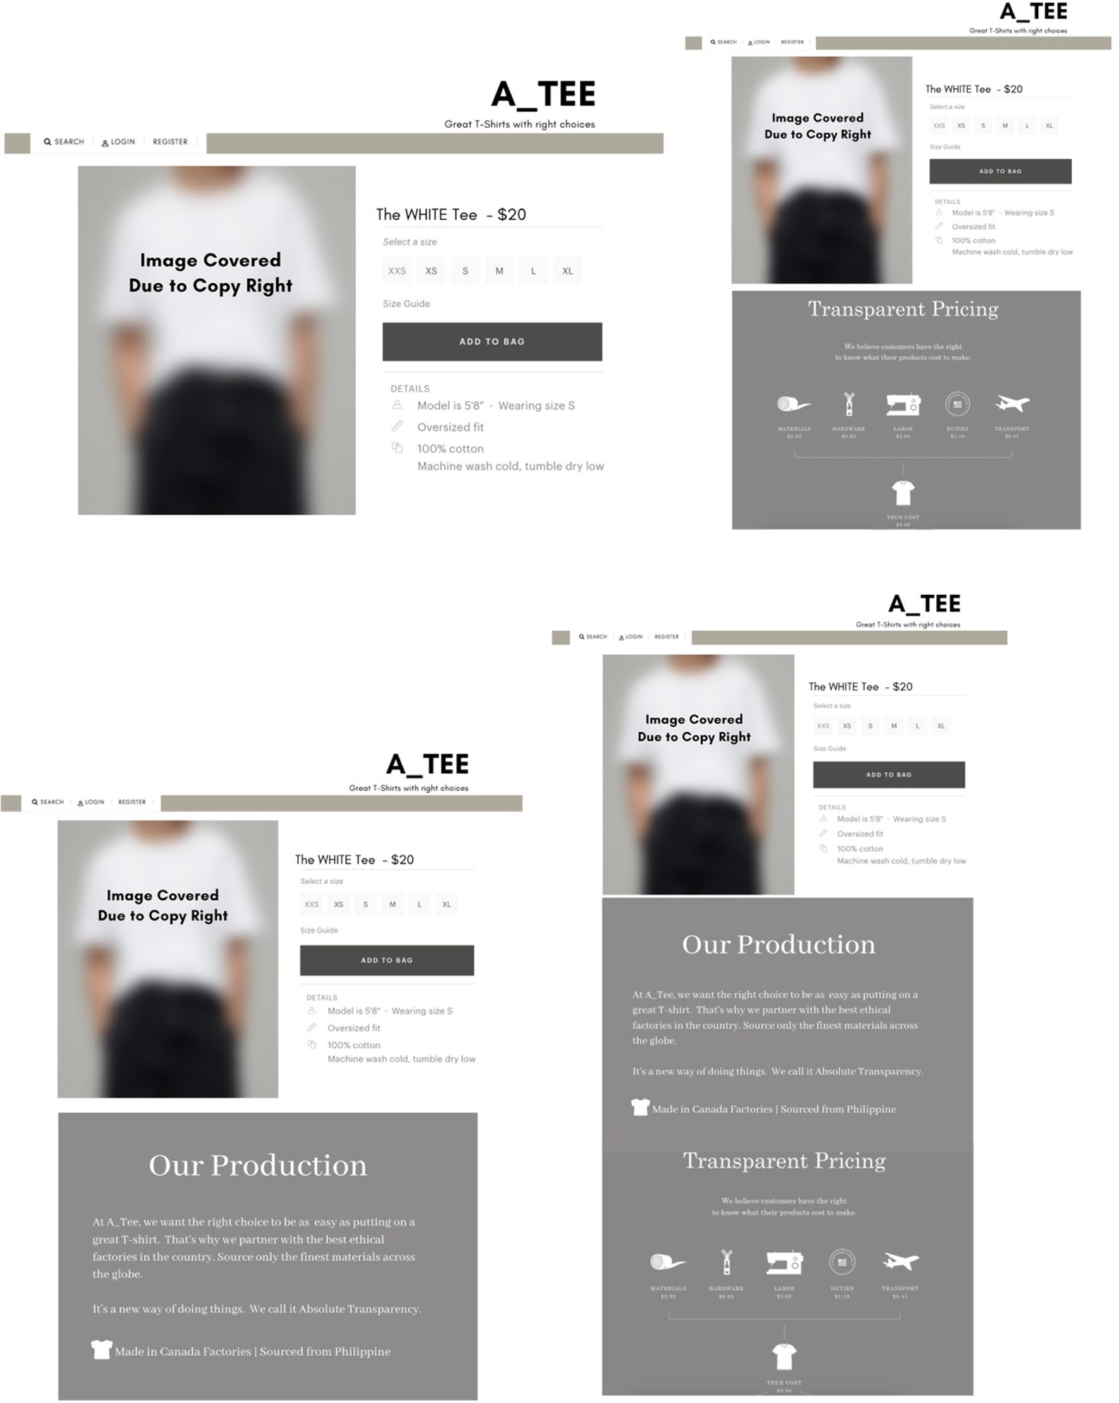

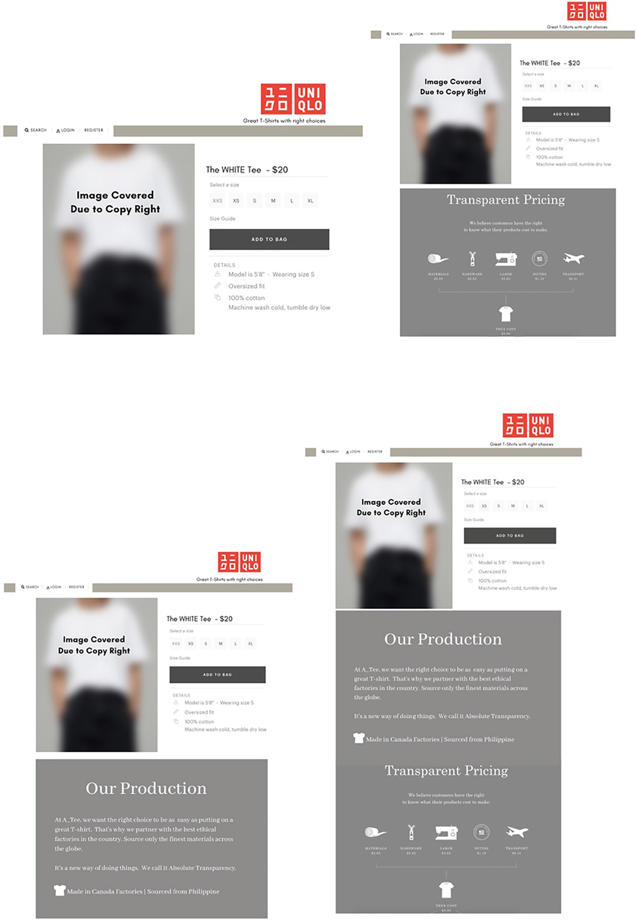

About the authors

Jing Yang, PhD, Michigan State University, USA is an Assistant Professor in the School of Communication at Loyola University Chicago. Her research interests include message effects in digital advertising and e-commerce space and computational/artiﬁcial intelligence advertising. Jing Yang is the corresponding author and can be contacted at: [jyang13@luc.edu](mailto:jyang13@luc.edu)

Ava Francesca Battocchio, MS, Loyola University Chicago, USA is a Doctoral Student in the Department of Advertising and Public Relations at Michigan State University, USA. Ava Francesca’s research interests include rural and remote communities, civic infrastructure, information accessibility, media ecology and affective polarization.

For instructions on how to order reprints of this article, please visit our website:

[www.emeraldgrouppublishing.com/licensing/reprints.htm](http://www.emeraldgrouppublishing.com/licensing/reprints.htm)

Or contact us for further details: [permissions@emeraldinsight.com](mailto:permissions@emeraldinsight.com)