manuscript

Andres Beltran - Yohanna Cabrera - Andres Cabrera

December 7, 2021

# 1 Abstract

# 2 Introduction

# 3 Methods

## 3.1 Statistical analysis

# 4 Results and discussion

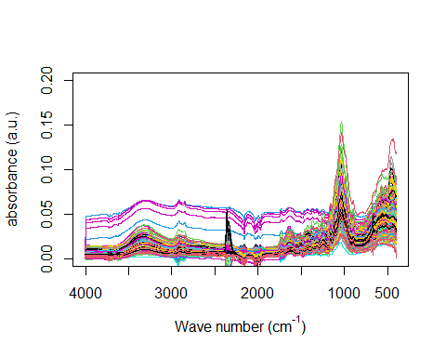

Figure 4.1: raw spectra of triplicated samples

the spectra recorded from 4000 to 400 cm-1 is reported in figure 4.1. Due to a background correction procedure performed using the software of the spectrometer, there is noise information around 2400 cm -1, so we can reduce the spectra to a region of interest

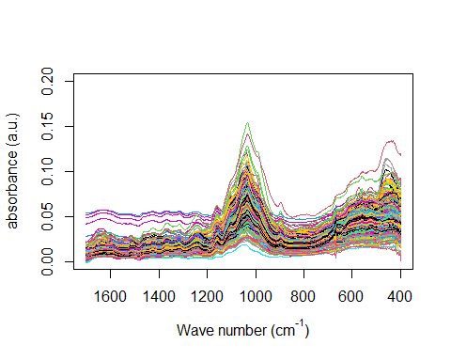

Figure 4.2: ROI spectra of triplicated samples

# 5 Conclussion

# 6 References