manuscript

Andres Beltran - Yohanna Cabrera - Andres Cabrera

December 7, 2021

x <- rnorm(100)  
y <- rnorm(100)  
plot(x,y)

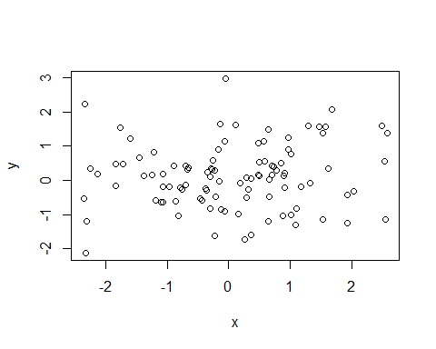

Figure 1: Life expectancy from 1952 - 2007 for Australia. Life expentancy increases steadily except from 1962 to 1969. We can safely say that our life expectancy is higher than it has ever been!

Australia’s life expectancy has increased a great deal over the past 50 years

(See Figure 1)