**Using the Table component causes the unit test run to fail**

1. **Step to reproduce:**

1. yarn install

1. yarn run test
2. **Table run failed with error:**  
    *Error: Uncaught [TypeError: Cannot read properties of undefined (reading 'addListener')]*

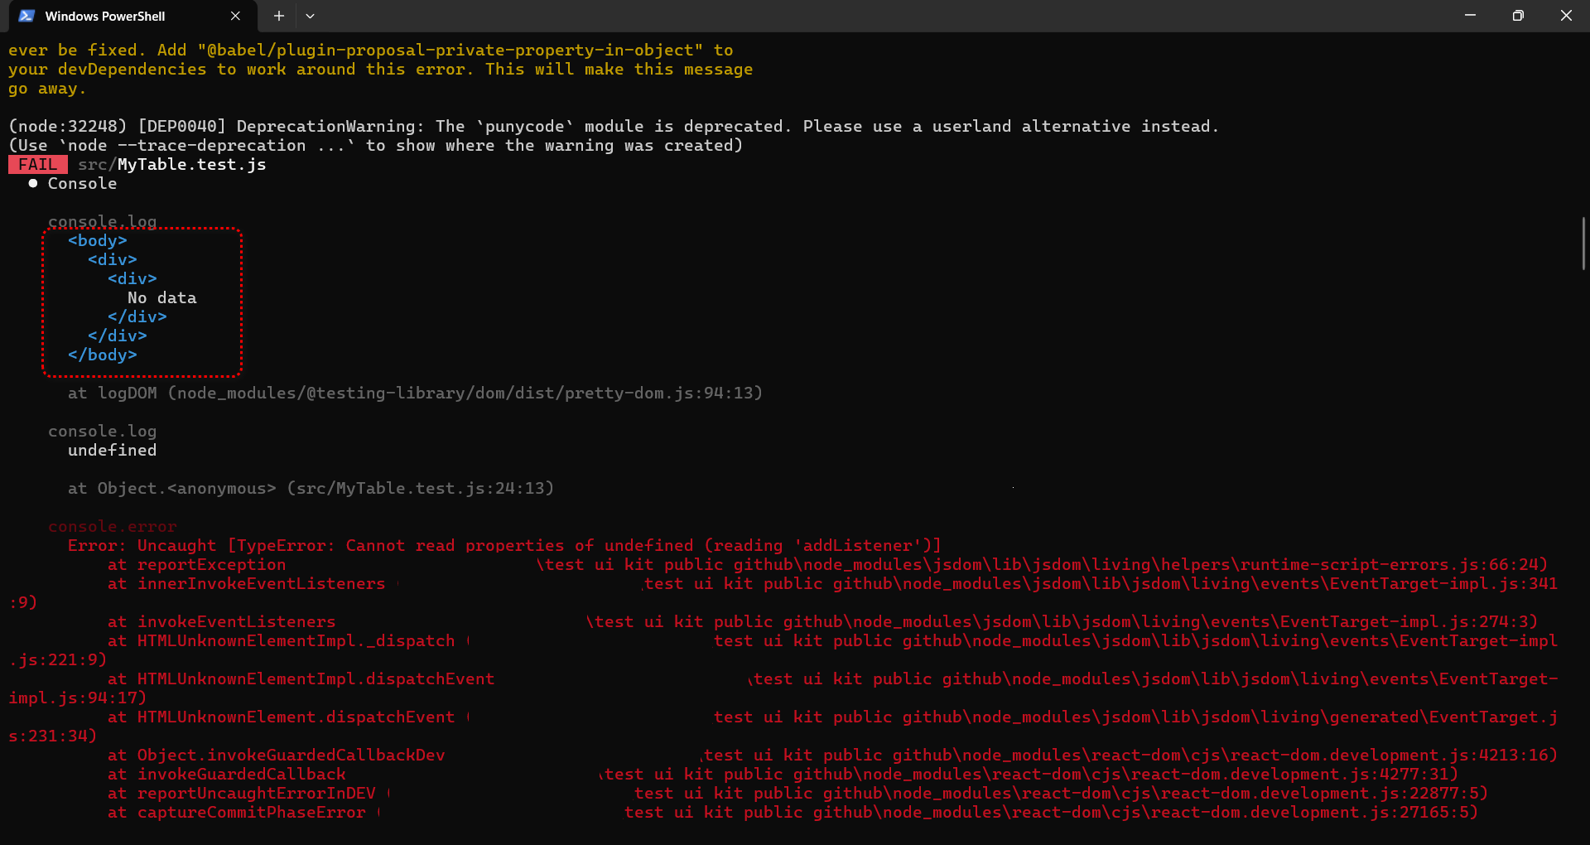

1. Input run pass: I use Input, it work ok.

