**Database Homework 3**

**By: Ryan Riopelle**

**Sales Cube**

**Noted: Answers are bolded for each number**

**## 1)**

## Cost with No ID's=

"GroupAggregate (cost=277118.03..330611.22 rows=100000 width=21)"

## Created Customer_ID Index=

"GroupAggregate (cost=277118.03..330611.22 rows=100000 width=21)"

## Created Sales.Index=

"GroupAggregate (cost=277118.03..330611.22 rows=100000 width=21)"

**## Cost was not improved by indexes for this step**

**## 2)**

## Cost with no indexes involved

"HashAggregate (cost=91950.93..91953.43 rows=200 width=128)"

**## Cost was not improved by indexes for this step**

**## 3)**

# Cost with no indexes

"Sort (cost=37739.03..37739.04 rows=1 width=14)"

#Cost reduced with index placed on the customer ID column of sales

"Sort (cost=8.47..8.47 rows=1 width=14)"

CREATE INDEX index1 ON sales.sale(customer_id);

#I also tried to use other columns for indexes such as sale_id, and product_id

##but neither of these effected the speed

**## Cost was not improved by indexes for this step**

**## 4)**

**# This query was not effected by indexes**

**## 5)**

##Cost with no indexes

"GroupAggregate (cost=485614.11..518114.11 rows=1000000 width=128)"

# Cost with indexes on sales table product ID

"GroupAggregate (cost=485614.11..518114.11 rows=1000000 width=128)"

#Cost with indexes on the product table

"GroupAggregate (cost=485614.11..518114.11 rows=1000000 width=128)"

**# There is no decrease in cost on any of the available indexes here.**

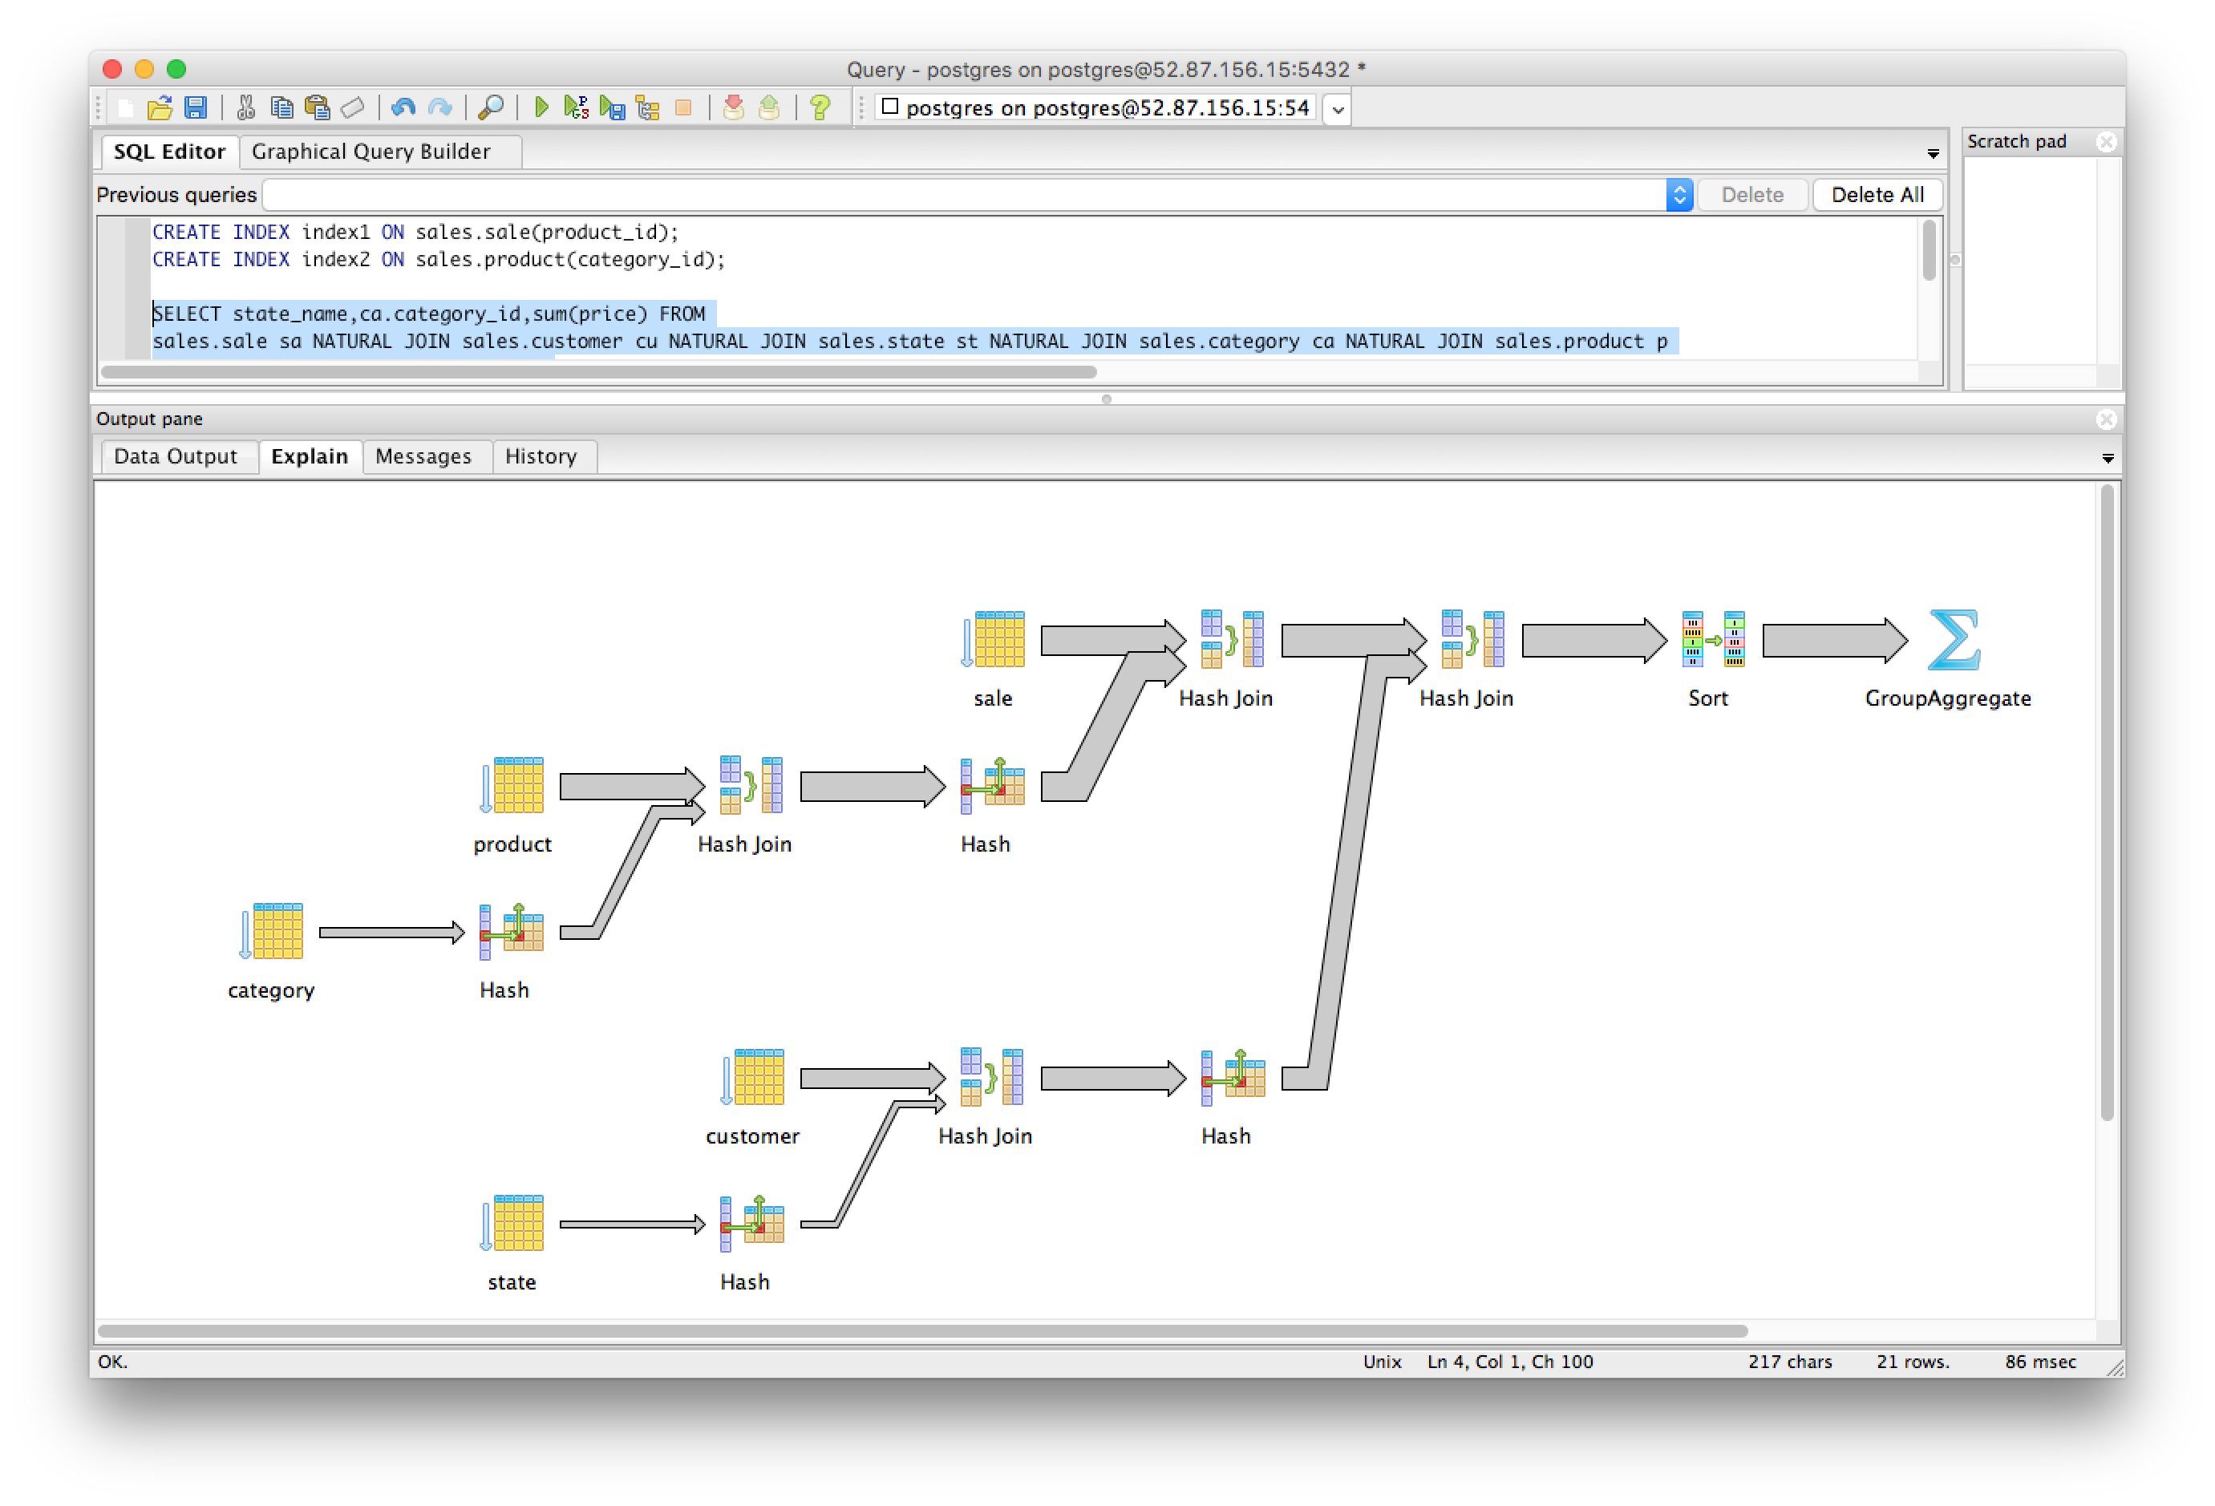

**## 6)**

##With no indexes involved, cost is the highest

"Sort (cost=206072.90..206073.10 rows=80 width=18)"

##Putting an index on catogory ID did not improve the cost because the number of

## values is larger in the product table

##With index on product_id in sale table, reduces cost

CREATE INDEX index1 ON sales.sale(product_id);

"Sort (cost=175603.68..175603.88 rows=80 width=18)"

**##With index on category_id in product table and product_id in the sale table, cost is reduced further**

CREATE INDEX index2 ON sales.product(category_id);

"Sort (cost=168252.13..168252.33 rows=80 width=18)"

