Ryan Riopelle

Due: March 19, 2016

**MAS 201 – Homework 4 – Sales**

**Step 1) Original Query**

*SELECT cate.category_id,cust.customer_id,sum(quantity),sum(price) FROM*

*(SELECT category_id,sum(price) AS dollar_value FROM*

*sales.category NATURAL JOIN sales.product NATURAL JOIN sales.sale*

*GROUP BY category_id ORDER BY dollar_value DESC limit 10) AS cate,*

*(SELECT customer_id,sum(price) AS dollar_value FROM sales.sale*

*GROUP BY customer_id ORDER BY dollar_value DESC limit 10) AS cust, sales.sale s,sales.product p*

*WHERE p.category_id = cate.category_id and s.customer_id = cust.customer_id and s.product_id = p.product_id*

*GROUP BY cate.category_id,cust.customer_id ORDER BY cate.category_id*

**Size**

"Sort (cost=206072.90..206073.10 rows=80 width=18)"

**Visual Representation**

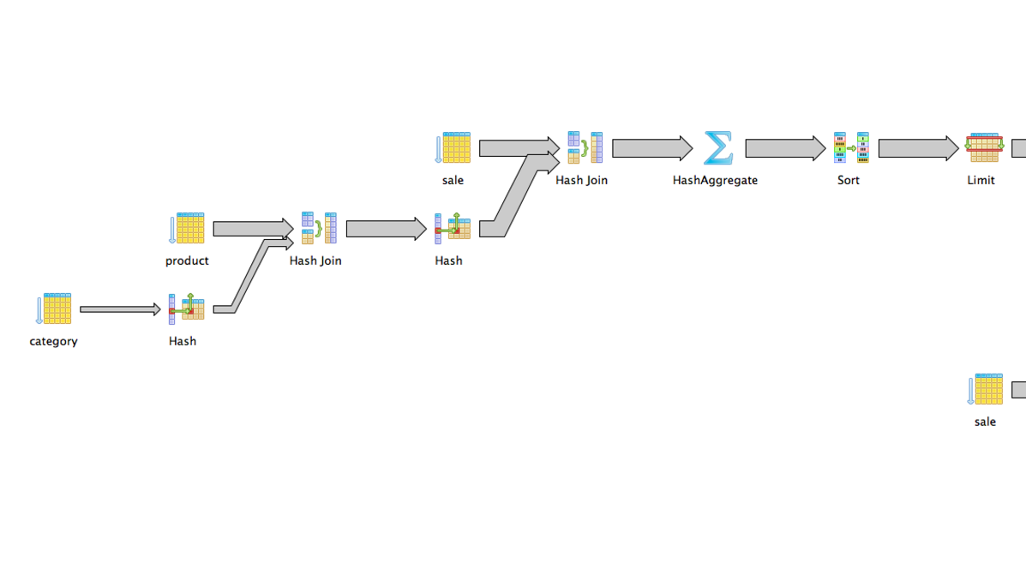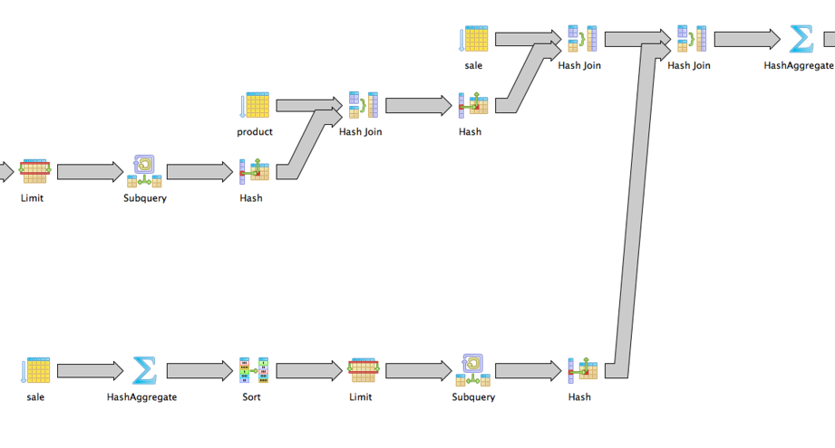

**Step 2) Create Pre-computed Tables**

*DROP TABLE IF EXISTS sales.PRE_Category_Sale ;*

*create table sales.PRE_Category_Sale as*

*SELECT category_id,sum(price) AS dollar_value*

*FROM sales.category NATURAL*

*INNER JOIN sales.product NATURAL*

*INNER JOIN sales.sale*

*GROUP BY category_id;*

*DROP TABLE IF EXISTS sales.PRE_Customer_Sale;*

*create table sales.PRE_Customer_Sale as*

*SELECT customer_id,sum(price) AS dollar_value*

*FROM sales.sale*

*GROUP BY customer_id;*

**Step 3) Create ID’s**

*CREATE INDEX pre_category_sale_id_key*

*ON sales.pre_category_sale*

*USING btree*

*(dollar_value DESC, category_id);*

*CREATE INDEX category_id_product_id_key*

*ON sales.product*

*USING btree*

*(category_id, product_id);*

*CREATE INDEX product_id_category_id_key*

*ON sales.product*

*USING btree*

*(product_id, category_id);*

*CREATE INDEX product_id_quantity_price_id*

*ON sales.sale*

*USING btree*

*(product_id, quantity, price);*

**Step 4) Create Triggers Using Trigger for product_id=** **87943**

**--Trigger Table For Category Sales**

*CREATE or replace FUNCTION sales.FN_PRE_Category_Sale() RETURNS trigger AS $FN_PRE_Category_Sale$*

*BEGIN*

*UPDATE sales.PRE_Category_Sale as pre*

*SET dollar_value = pre.dollar_value + NEW.price*

*FROM sales.product as p*

*WHERE pre.category_id = p.category_Id*

*AND p.product_id = NEW.product_id;*

*IF NOT FOUND THEN*

*--no category_id updated*

*INSERT INTO sales.PRE_Category_Sale (category_id, dollar_value)*

*SELECT p.category_id, NEW.price*

*FROM sales.product p*

*WHERE p.product_id = NEW.product_id;*

*END IF;*

*RETURN NEW;*

*END;*

*$FN_PRE_Category_Sale$ LANGUAGE plpgsql;*

*DROP TRIGGER IF EXISTS trigger_Sale_Category ON sales.sale ;*

*CREATE TRIGGER trigger_Sale_Category*

*BEFORE INSERT ON sales.sale*

*FOR EACH ROW EXECUTE PROCEDURE sales.FN_PRE_Category_Sale();*

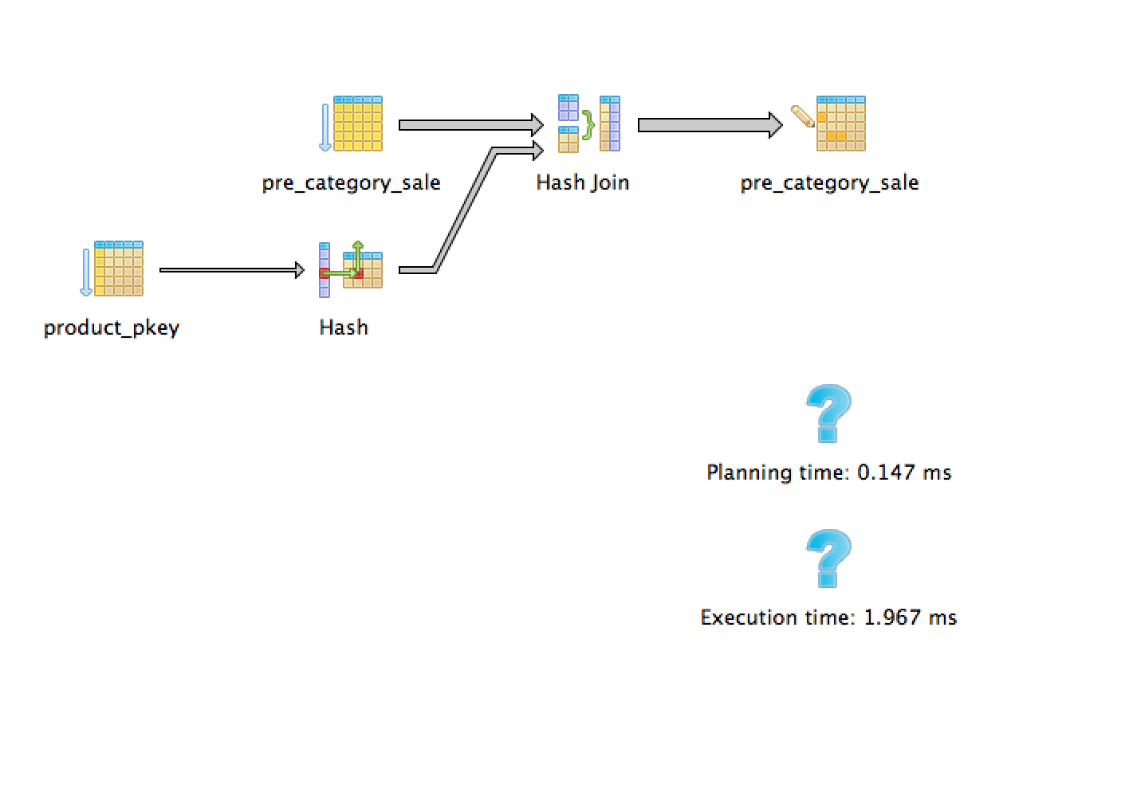

"Update on pre_category_sale pre (cost=8.45..105.21 rows=1 width=24) (actual time=1.918..1.918 rows=0 loops=1)"

**-- Trigger Table For Customer Sale**

*CREATE or replace FUNCTION sales.FN_PRE_Customer_Sale() RETURNS trigger AS $FN_PRE_Customer_Sale$*

*BEGIN*

*UPDATE sales.PRE_Customer_Sale*

*SET dollar_value = dollar_value + NEW.price*

*WHERE customer_id = NEW.customer_id;*

*IF NOT FOUND THEN*

*--no category_id updated*

*INSERT INTO sales.PRE_Customer_Sale (customer_id, dollar_value)*

*SELECT NEW.customer_id, NEW.price;*

*END IF;*

*RETURN NEW;*

*END;*

*$FN_PRE_Customer_Sale$ LANGUAGE plpgsql;*

*DROP TRIGGER IF EXISTS trigger_Sale_Customer ON sales.sale ;*

*CREATE TRIGGER trigger_Sale_Customer*

*BEFORE INSERT ON sales.sale*

*FOR EACH ROW EXECUTE PROCEDURE sales.FN_PRE_Customer_Sale();*

"Update on pre_customer_sale (cost=0.00..25.39 rows=6 width=42) (actual time=0.010..0.010 rows=0 loops=1)"

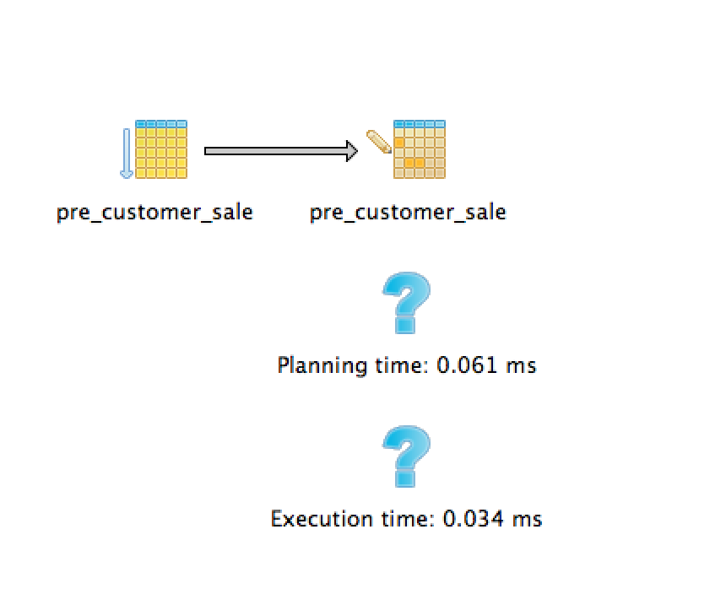

**Step 4) Run Query that uses pre-computed tables**

"Sort (cost=15658.99..15659.24 rows=100 width=18) (actual time=43.675..43.683 rows=80 loops=1)"

*WITH cate AS (SELECT category_id FROM sales.PRE_Category_Sale ORDER BY dollar_value DESC limit 10),cust as (SELECT customer_id*

*FROM sales.PRE_Customer_Sale ORDER BY dollar_value DESC limit 10)*

*SELECT cate.category_id,cust.customer_id,sum(quantity),sum(price)*

*FROM cate,cust,sales.sale s,sales.product p*

*WHERE p.category_id = cate.category_id AND s.customer_id = cust.customer_id AND s.product_id = p.product_id*

*GROUP BY cate.category_id,cust.customer_id*

*ORDER BY cate.category_id*

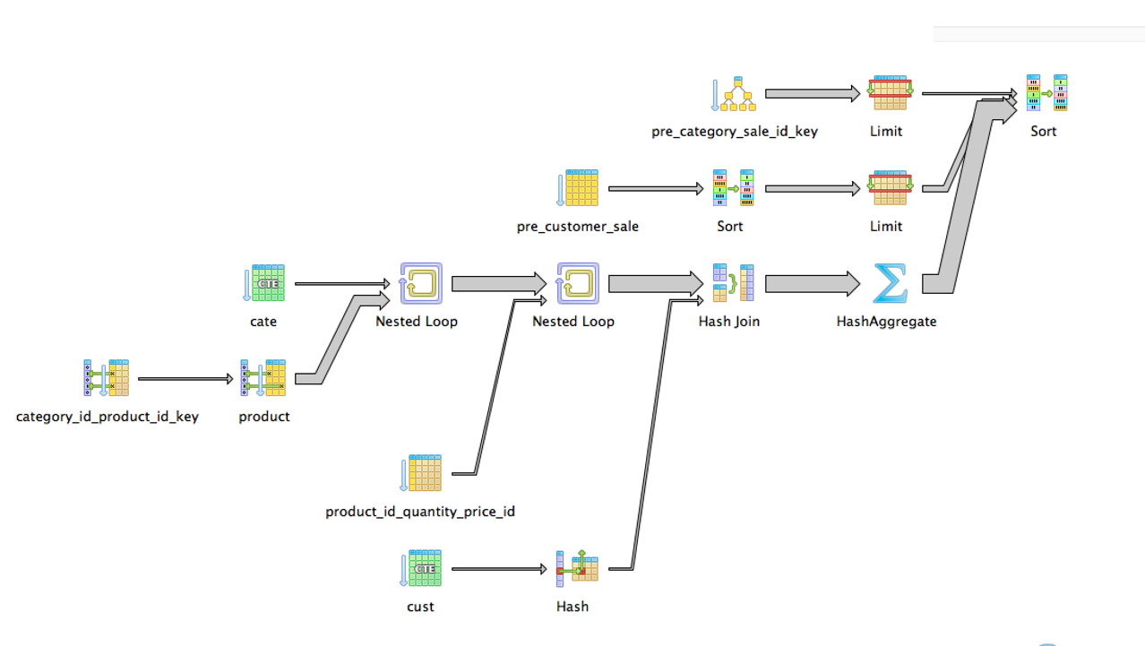

**Conclusion:**

|  |  |
| --- | --- |
| **Trigger Maintenance Query Cost** | |
| **Category Sale** | **Customer Sale** |
| 105 | 25.39 |

The total cost is 105+25=130. Compared to the original query of 206072 there is a large difference which means the trigger can perform frequently and still have a lower overall cost than running the original query. This value is (206072-130)/130=1584.