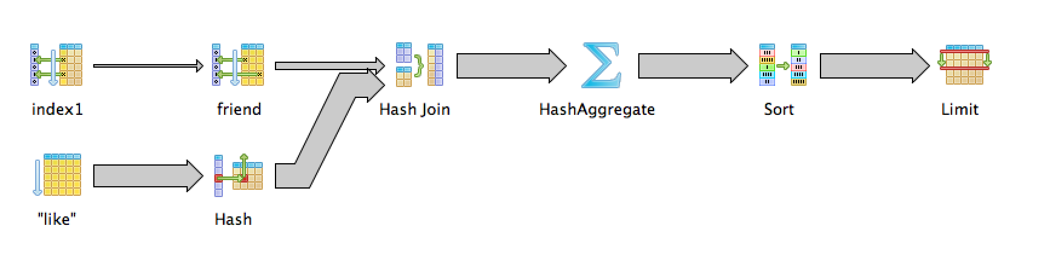
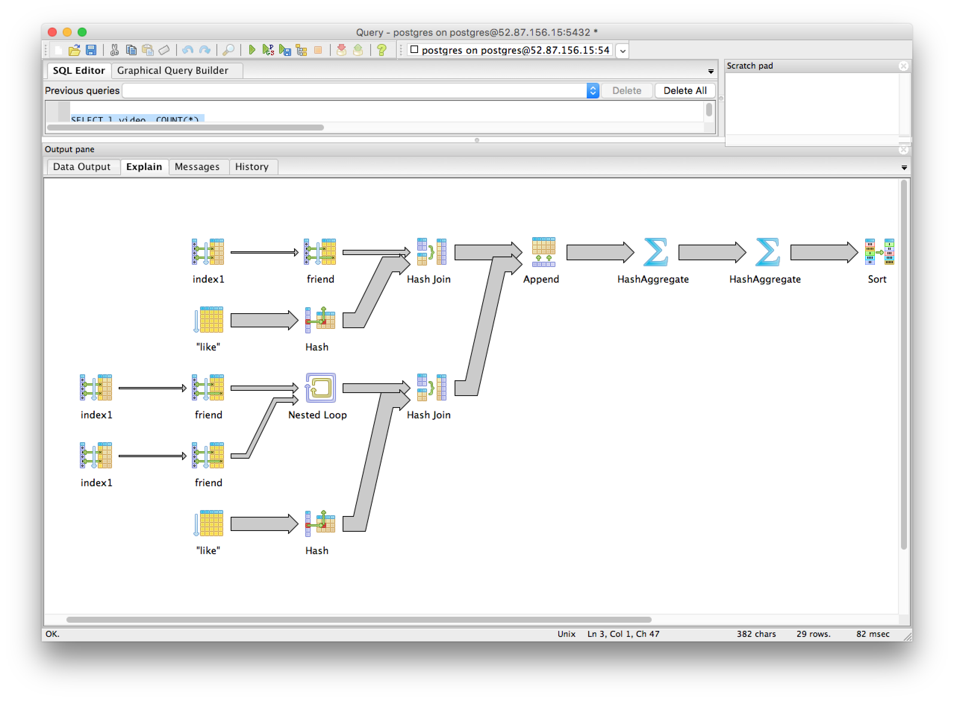
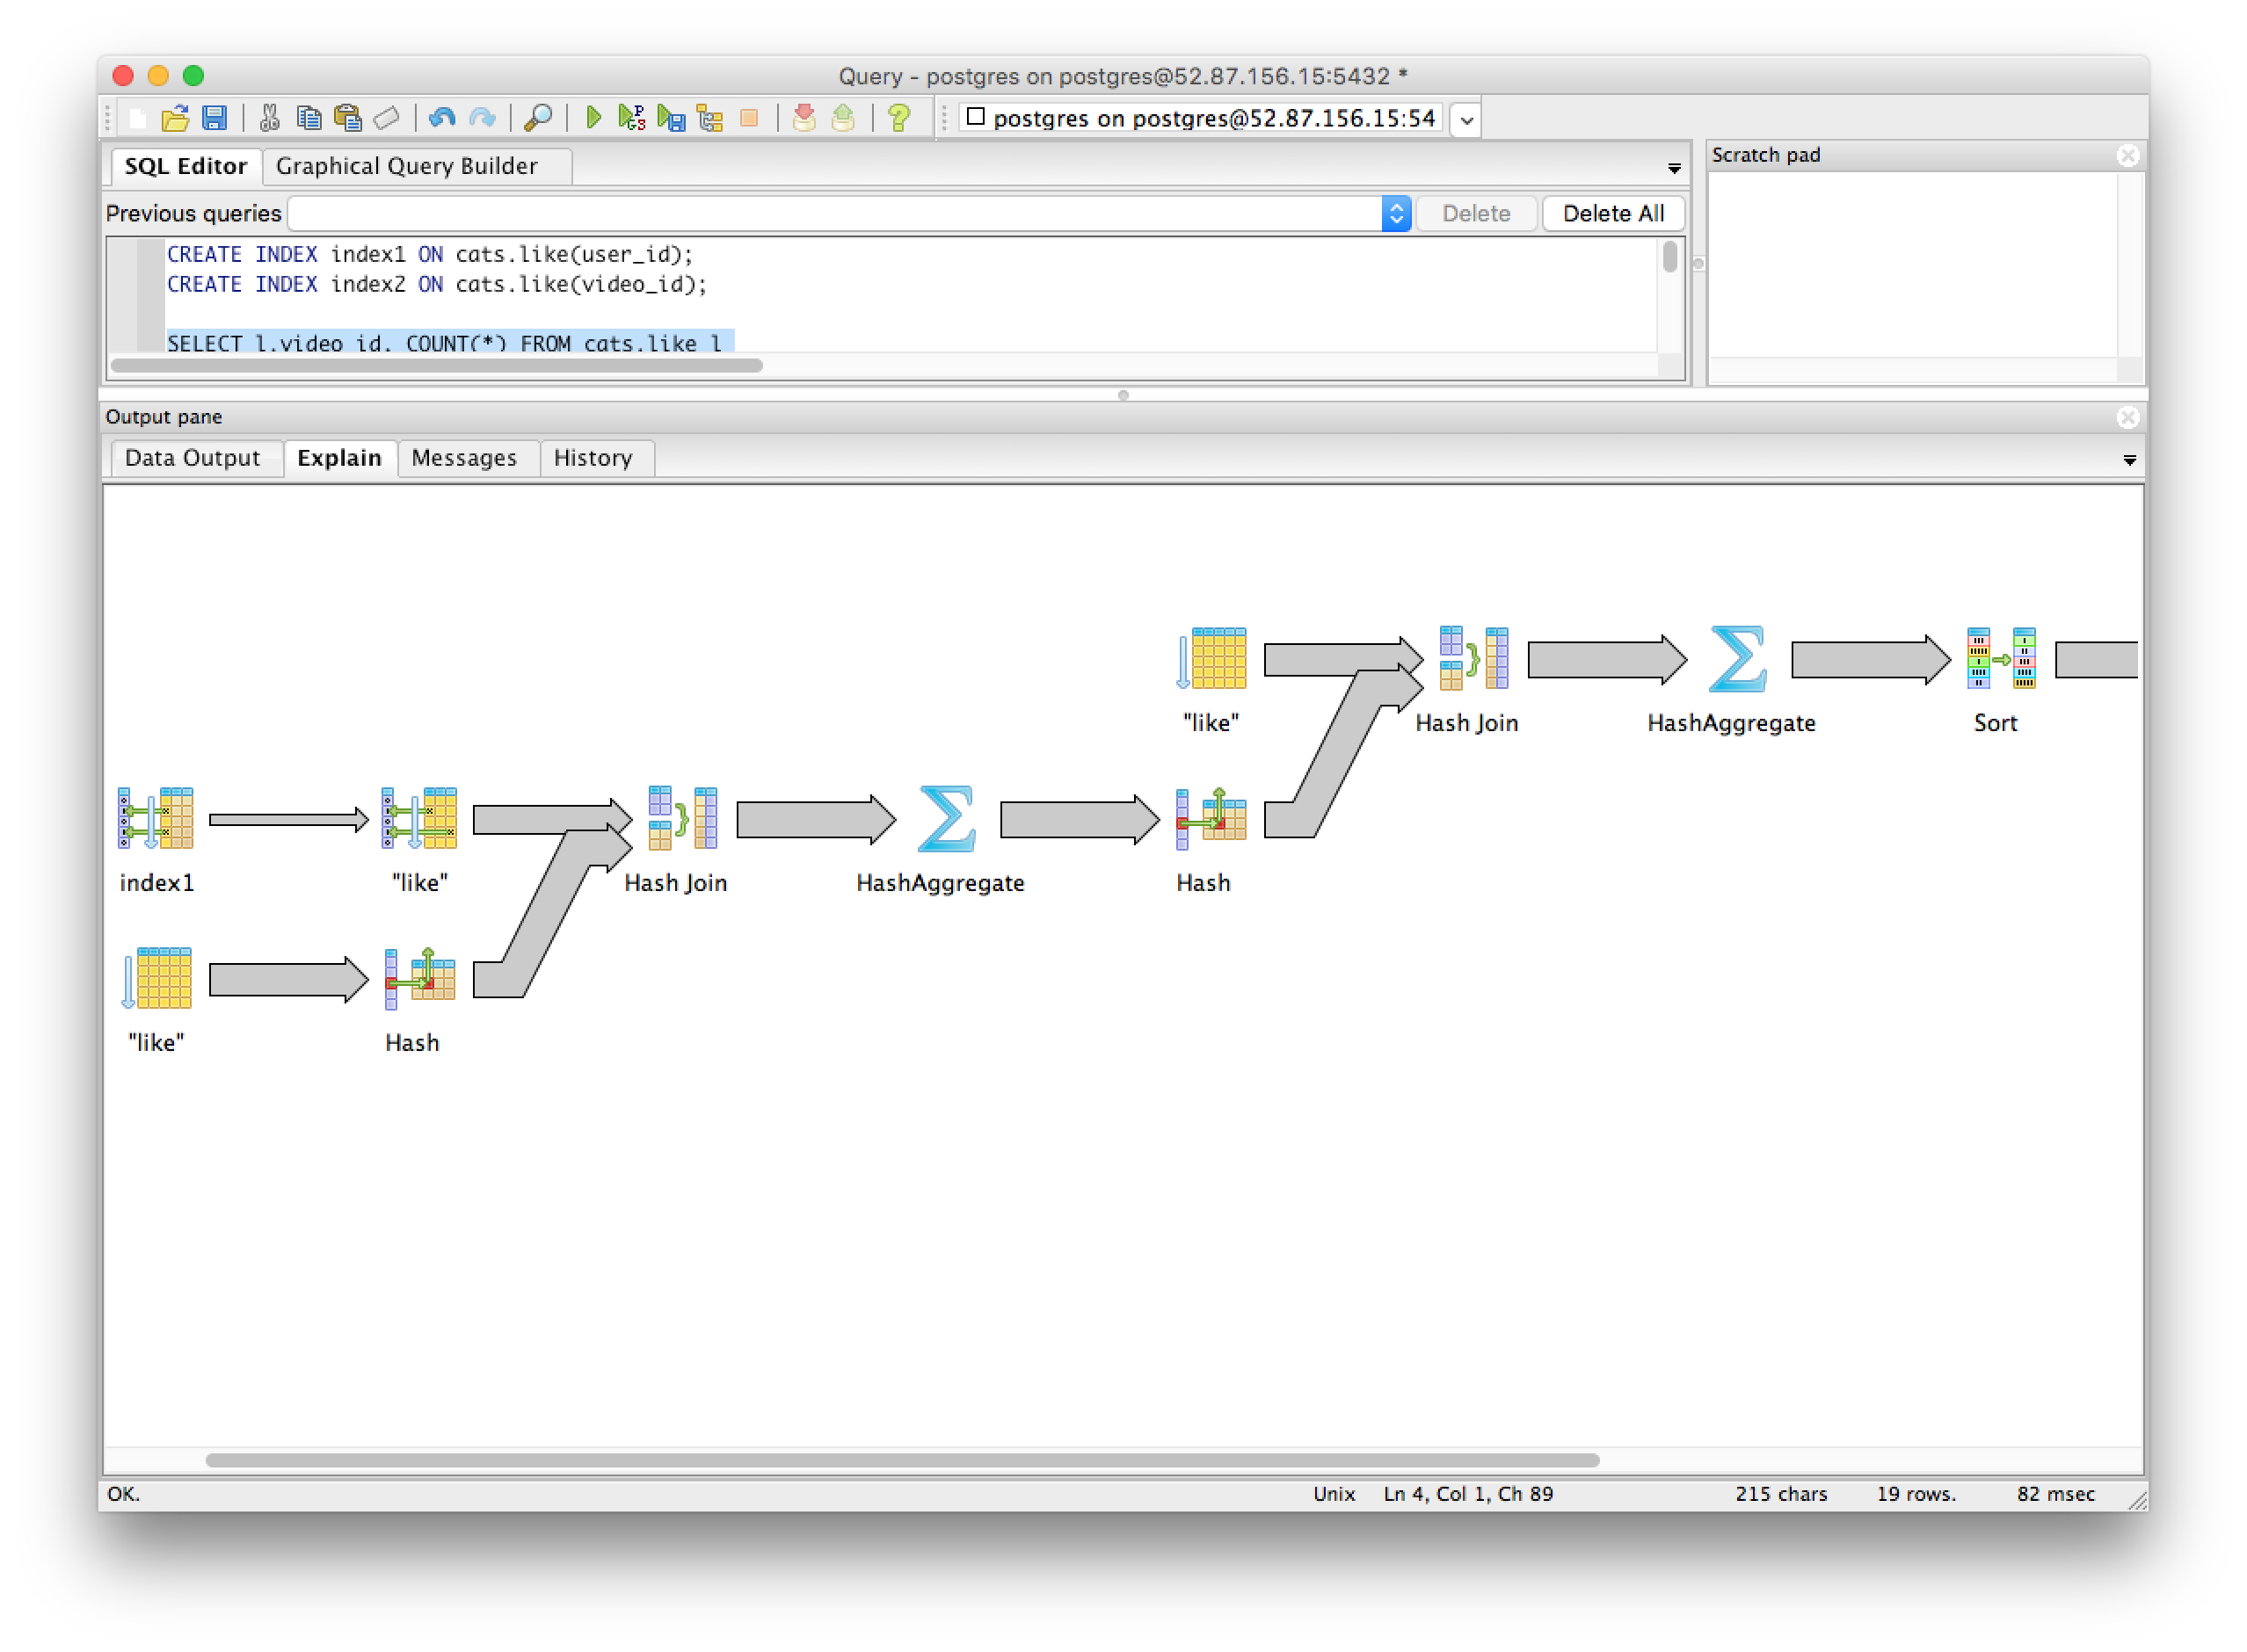
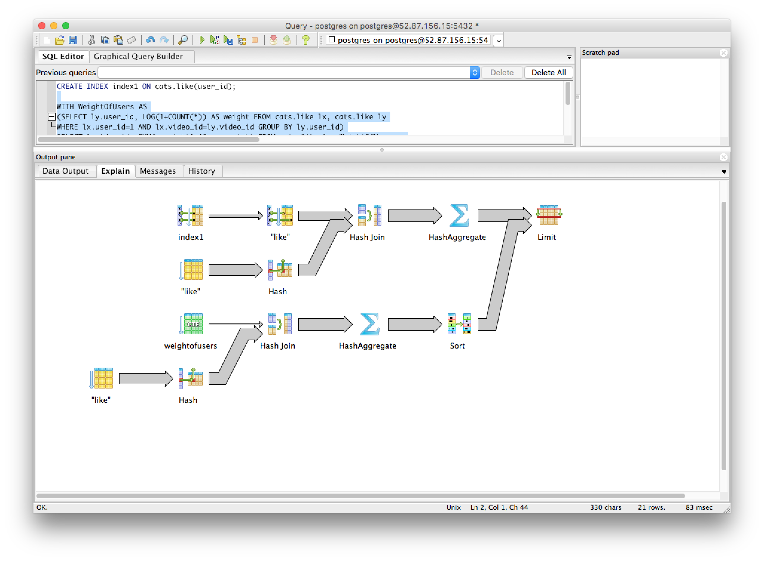
Database Homework 3
By: Ryan Riopelle

Cats

Noted: Answers are bolded for each number

1) ## No place to put the index here because there is no where or join clause
2)
##Cost with no indexes created
"Limit (cost=107391.36..107391.39 rows=10 width=4)"
# Reduced cost with Index on user_id in the friends table
CREATE INDEX index1 ON cats.friend(user_id);
"Limit (cost=73619.53..73619.56 rows=10 width=4)"

## 3)
##Cost with no indexes created
"Limit (cost=284830.76..284830.79 rows=10 width=4)"
## Reduced Cost With Indexes Created on user_id in the friends table
"Limit (cost=152067.65..152067.68 rows=10 width=4)"
## 4)
##Cost with no indexes
"Limit (cost=214655.54..214655.57 rows=10 width=4)"
## Cost was reduced with indexes on the like table for user ID
CREATE INDEX index1 ON cats.like(user_id);
"Limit (cost=186603.76..186603.79 rows=10 width=4)"
##Cost with indexes created on video_id of the like table, this didn't show any improvements over the user_id
CREATE INDEX index2 ON cats.like(video_id);
## cost with both
CREATE INDEX index1 ON cats.like(user_id);
CREATE INDEX index2 ON cats.like(video_id);
"Limit (cost=186603.76..186603.79 rows=10 width=4)"
## 5)
## Cost of queries with no indexes
"Limit (cost=256169.77..256169.80 rows=10 width=12)"
## reduced cost of queries with indexes on the like_user
CREATE INDEX index1 ON cats.like(user_id);
"Limit (cost=228117.99..228118.02 rows=10 width=12)"

