|  |
| --- |
| Urban Science Intensive – Spring 2016 |
| A Seasonal Flu Social Vulnerability Index for NYC |
| March 14, 2016 |

|  |
| --- |
| Maria Filippelli, Priya Khokher, Nikhil Kishore, Ramda Yanurzha |

**INTRODUCTION**

Seasonal influenza (flu) is one of the most common disease outbreaks in New York City (NYC)[1]. Each year approximately 2,000 residents perish from flu and pneumonia, which can develop as a flu complication[2]. For 2014, this was more than homicides (328)[3] and HIV/AIDS related deaths (1,473)[4] combined. Nationally, the Centers for Disease Control (CDC) estimates that 5-20% of people contract seasonal flu annually, this is upwards of as many as 1.7 million NYC residents. There are 209 different types of human influenza A virus and the number is constantly increasing[5]. The flu virus has the ability to evolve with humans has made it difficult to develop a permanent solution to influenza.

In addition, the density, complex infrastructure, and international stature of the city increases the risk of spreading illness. Because of this, prevention measures such as educational outreach and vaccines are of utmost importance. Given that any agency needs to optimize their budgets, a targeted prevention outreach strategy would be helpful in decreasing the number of seasonal flu deaths. To assist in that effort this project creates a NYC Seasonal Flu Social Vulnerability Index (Flu SVI), using demographic and social variables to identify areas where the flu is likely to affect large portions of the population.

**BACKGROUND**

Currently efforts to track and quantify flu cases occur on the federal, state, and local levels. Nationally, the CDC track viral strains, pediatric mortality rates, influenza-associated hospitalizations, and other statistics on the flu. The New York State Department of Health tracks similar statistics and produces a weekly report on the county level. At the city level, the Department of Health and Mental Hygiene (DOHMH) monitors emergency department (ED) discharges to track trends over time.

While the seasonal flu outbreaks are tracked, there is no evidence of planning for their occurrence. There is, however, planning efforts for the pandemic (global epidemic) flu as it is estimated that it could have a fatality rate up to 40,000 residents in a single wave (or cycle)[6]. Both the CDC and DOHMH have developed ways to measure risk.

In 2011, the CDC published *A Social Vulnerability Index for Disaster Management [7]*(Index) which uses 15 census variables, put into four categories:

* socioeconomic status,
* household composition and disability,
* minority status and language, and
* housing and transportation,

to better assist disaster management planning. The Index was a shift from traditional disaster management planning, which tended to focus on infrastructure only, and it incorporated social factors such as mobility and primary language. Every census tract in the United States with a non-zero population (65,081) was given an index number based on the percentile rank of the individual and grouped variables.

The DOHMH released *Vulnerable Populations: A Function-Based Vulnerability Measure for the New York City Region[8]* in 2013 which took into account individual level data to create a score for each American Community Survey (ACS) Public Use Microdata Sample (PUMS), a demographic designation that has individual level data while still providing confidentiality. While both models are significant undertakings, the focus is on collecting information after people are diagnosed or on large-scale, global (pandemic) outbreaks.

With respect to outreach, the DOHMH offers information about flu vaccination locations and preventative measures for schools and employers on their website[9]. There is no evidence to suggest a more proactive outreach approach. Efforts have also been made to require mandatory flu shots for children to varying effectiveness. As such, flu vaccinations remain a voluntary activity.

This project borrows and builds upon both models, most specifically using census tract level data and percentile ranks like the CDC Index, to create the NYC Seasonal Flu Social Vulnerability Index (Flu SVI). The Flu SVI differs from previous models because it takes into account NYC specific variables like the high percentage of residents that commute to work via public transportation and high residential density.

**DATA**

The majority of variables used in the Flu SVI were collected from the 2010-2014 5 years estimate American Community Survey (ACS) and Longitudinal Employment-Household Dynamics Origin-Destination Employment Statistics (LODES). Variables used for each census tract are:

|  |  |  |  |
| --- | --- | --- | --- |
| **Variable Name** | **Explanation** | **Normalization Variable** | **Source** |
| Vulnerable Age | Percentage of resident aged below 18 and above 65 | Total Population | ACS 2010-2014 |
| Insurance coverage | Percentage of resident without health insurance | Total Population | ACS 2010-2014 |
| Population Density | Number of resident per square mile | - | ACS 2010-2014 |
| Commute | Percentage of resident to work using public transportation (MTA & Taxi, resident only) | Total Population | ACS 2010-2014 |
| Poverty Rate | Percentage of resident earning less than $19,999 (as approximation of official NYC poverty rate of $20,160 for three-person household) | Household | ACS 2010-2014 |
| Household Income | Median household income | Household | ACS 2010-2014 |
| Employment Density | Total jobs | Area | LODES Workplace Area Characteristic |

Once the variables were normalized, they were each given a percentile rank. Percentile ranking allows for even distribution among the census tracts. It can, however, overestimate skewed distributions.

Census tract level cartographic boundary shapefiles for spatial analysis and visualization are obtained from The United States Census Bureau.

**METHODOLOGY**

In total, there are 2,064 census tracts in NYC. Census tracts with non-zero populations were removed from the index because they are largely parks and cemeteries and do not have population or employment density (or statistically significant values) available.

For each variable in the data, a percentile ranking was generated on a scale of 0 and 100. The index is then constructed by summing across the variables using the formula:

Vulnerability Index =

In addition to that, a “flag” variable with the value of 1 is generated for each of the individual percentile rank that exceeds 90th (PCT_90) and 75th percentile (PCT_75). Both the index and flags are then mapped into corresponding census tract in the boundary map and then plotted.

**RESULTS**

**VULNERABILITY INDEX**

Figure XX illustrates the spatial distribution of census tract SVI values, with each colors denoting the category of severity, with the breakdown of each borough described in Table XX. The area with darker red color indicates high SVI value, which are mostly distributed in Bronx, Queens, and Brooklyn. Bronx is especially highly vulnerable with more than 67% of its population living in census tracts with SVI 400 and above, implying an average of 60th percentile in every category.

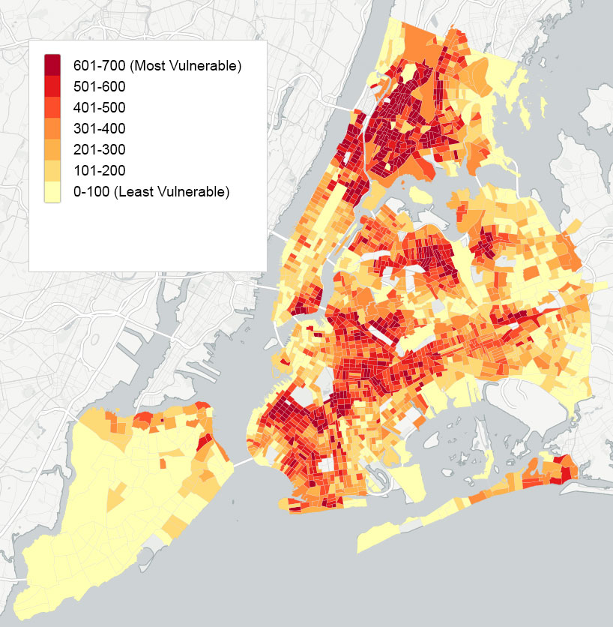

|  |  |  |  |  |  |
| --- | --- | --- | --- | --- | --- |
| **SVI score range** | **Bronx** | **Brooklyn** | **Manhattan** | **Queens** | **Staten Island** |
| 0-100 |  | 0.22% | 0.38% | 0.46% | 5.46% |
| 101-200 | 6.62% | 4.00% | 5.39% | 10.60% | 58.01% |
| 201-300 | 8.58% | 19.53% | 39.34% | 23.38% | 22.19% |
| 301-400 | 16.69% | 22.61% | 19.81% | 35.03% | 10.95% |
| 401-500 | 18.50% | 37.43% | 18.59% | 20.64% | 3.02% |
| 501-600 | 44.18% | 15.91% | 16.49% | 9.88% | 0.37% |
| 601-700 | 5.42% | 0.30% |  |  |  |

**FLAG MAP**

While SVI map provides us with general overview of SVI value across the city, the “flag” map enables us to pinpoint which of the census tract having individual percentile rank scoring above certain value. The assignment of the flag value for both 75th and 90th percentile threshold is illustrated in Figure XX with the number of census tracts by flag value by borough is described in Table XX.

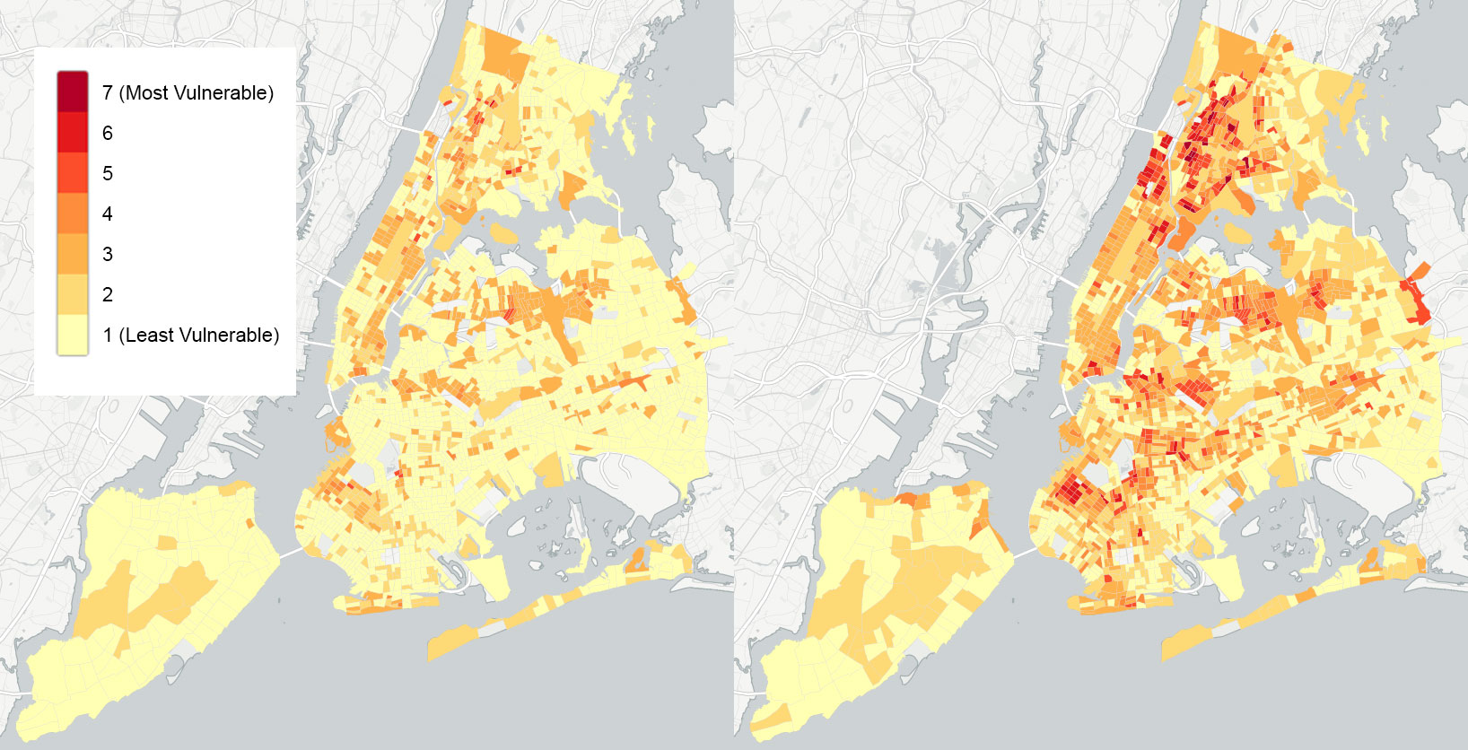

|  |  |  |  |  |  |  |  |  |  |  |
| --- | --- | --- | --- | --- | --- | --- | --- | --- | --- | --- |
| **Borough** | **Bronx** | | **Brooklyn** | | **Manhattan** | | **Queens** | | **Staten Island** | |
| Flags | 75 | 90 | 75 | 90 | 75 | 90 | 75 | 90 | 75 | 90 |
| 0 | 172 | 67 | 510 | 221 | 104 | 40 | 451 | 278 | 98 | 66 |
| 1 | 81 | 77 | 116 | 207 | 61 | 32 | 43 | 82 | 9 | 34 |
| 2 | 51 | 61 | 82 | 150 | 90 | 130 | 119 | 175 | 1 | 6 |
| 3 | 25 | 46 | 14 | 78 | 11 | 34 | 10 | 53 | - | 2 |
| 4 | 6 | 50 | 3 | 51 | 3 | 15 | 2 | 34 | - | - |
| 5 | 2 | 24 | - | 18 | - | 18 | - | 3 | - | - |
| 6 | - | 12 | - |  | - | - | - | - | - | - |

The difference of threshold value choice will affect the extent of focus area which, if used to determine census tract level outreach targeting, change the implementation scope and resource requirement. The interpretation of flag map should ideally be combined with individual SVI map to see which variables does the census tract are prominent on.

**CORRELATION TESTING**

Producing a correlation matrix allowed for an investigation into the dependence between multiple variables at the same time. Values near 1 and -1 show variables that are highly correlated. Table 1 shows the variables in the Flu SVI are mostly uncorrelated, with the exception of household size and employment density which appear to have perfect correlation. Additional investigation would have to occur to determine why these variables appear so closely linked.

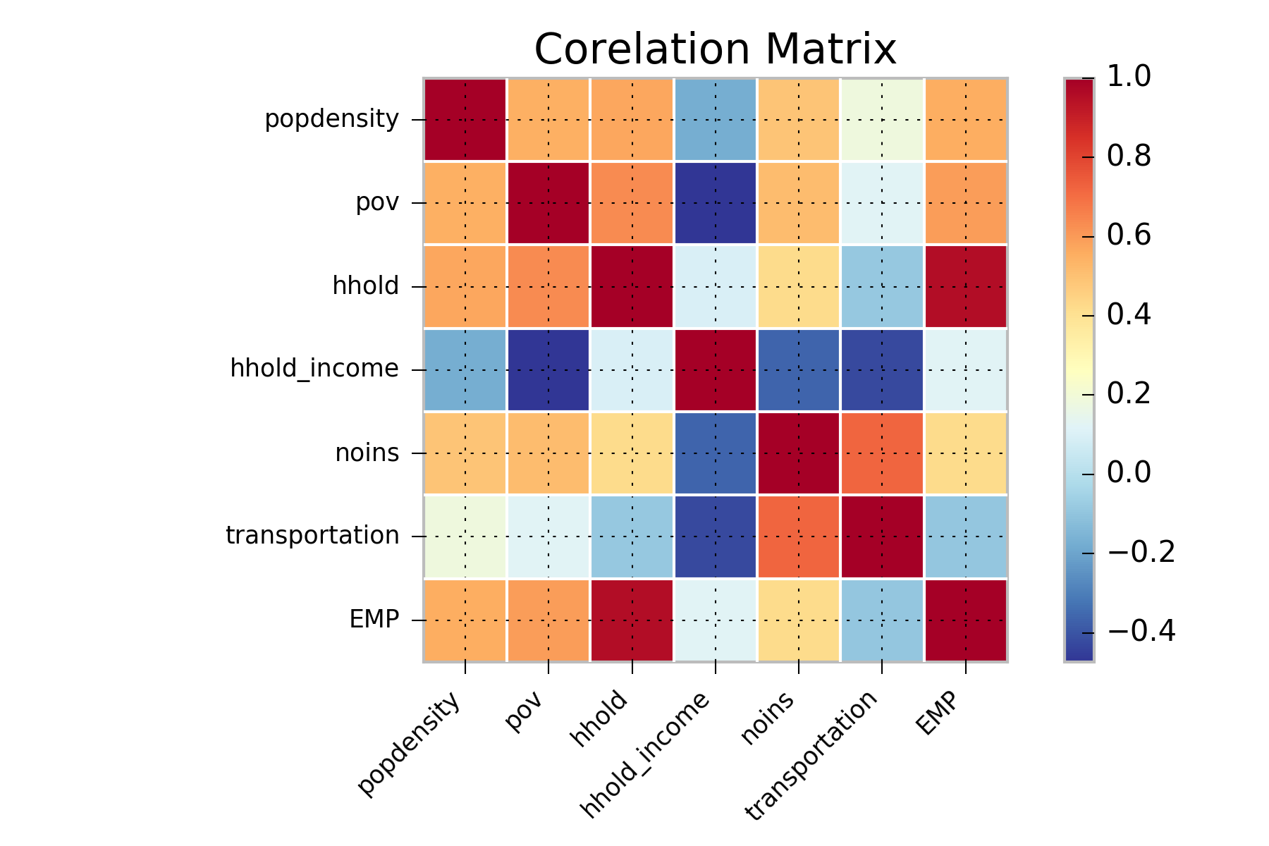

*Table 1: Correlation Matrix for all 7 Variables*

**SPATIAL AUTOCORRELATION**

The percentile ranking use for the Flu SVI helps in detecting the outliers in the sense it helps to gauge the census tracts which are at a greater risk. Obtaining additional information about the surrounding census tracts (the ones perceived as most vulnerable), will help in knowing if there is a match in attributes in the surrounding areas.

We have performed a spatial correlation using coefficient from Moran I (Moran 1950) and “queen” criterion of neighborhood which took census tracts sharing common boundary for correlation, resulting in closely placed census tracts with similar SVI will be grouped together and not the ones located beyond a specified distance. If a census tract stands out from the rest of its surrounding or a group of census tracts together are at a greater combined risk, helping to generalize better over a larger area the relative risk-prone areas when used in conjunction with index and flag map. The resulting boundaries can also be used to determine new boundaries for operationalization of the outreach which may span multiple community district.

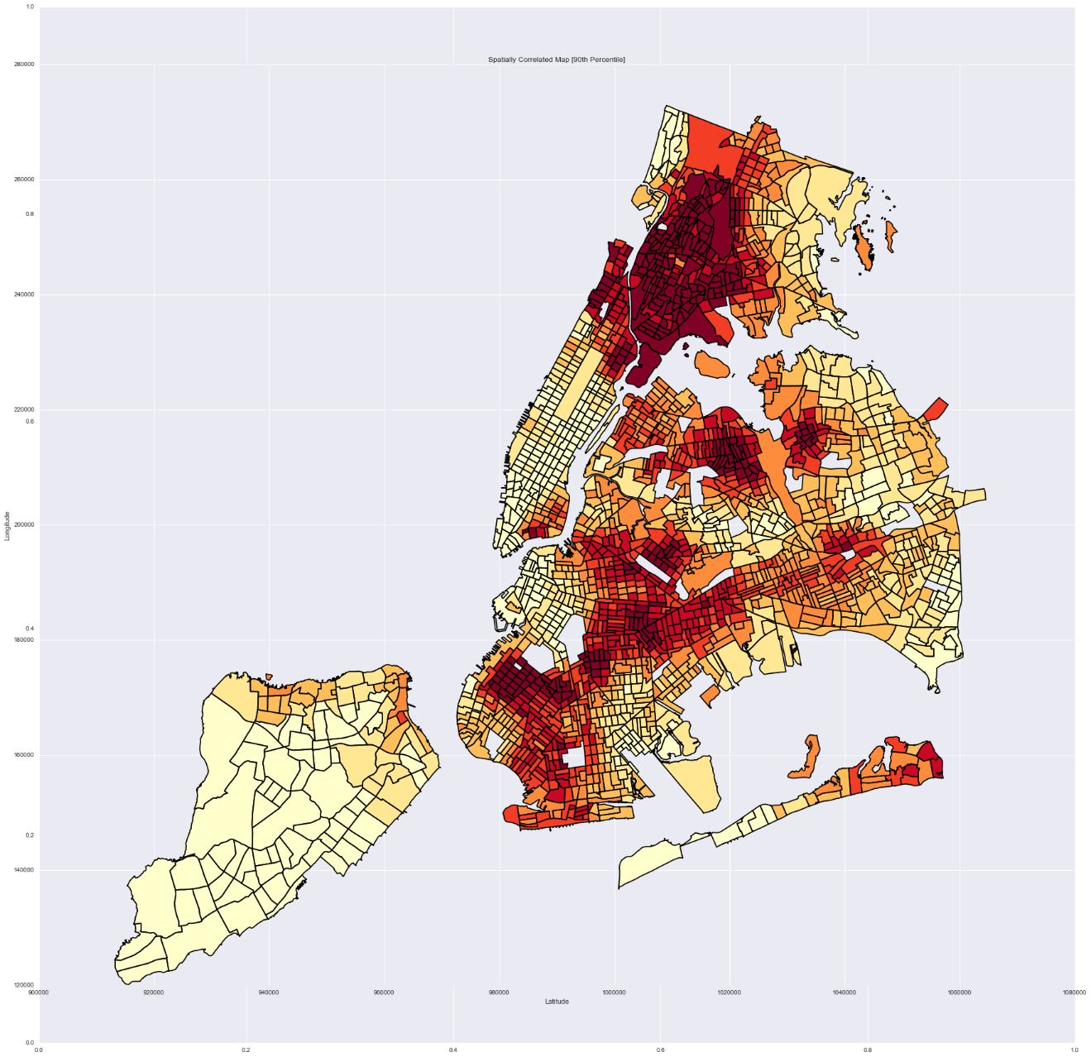

*Figure XX: Spatially Correlated Map [Vulnerability Index]*

**ACCESS GAP**

One of the main ways to prevent the spread of flu is through ensuring equal and easy access to vaccinations. NYC DOHMH maintains the location where flu shots can be purchased, which price range from $0 with insurance to $40 without. Lack of access to these facilities may exacerbates the vulnerability of the resident in the given census tract. Under the assumption that distance is an additional variable that must be considered, the vaccination locations for NYC were overlaid on the Flu SVI with a quarter-mile buffer (Figure XX) to illustrate the access gap. Using appropriation method based on percentage of area covered, the computed access gap for each borough is presented in Table X.

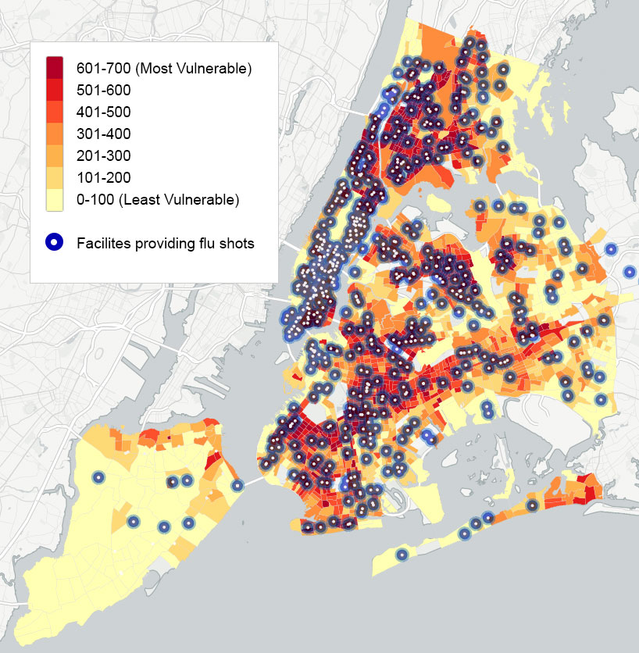

|  |  |  |  |  |  |
| --- | --- | --- | --- | --- | --- |
| **Borough** | **Bronx** | **Brooklyn** | **Manhattan** | **Queens** | **Staten Island** |
| Number of vulnerable-age resident with limited access to vaccination location | 273,332 (53.94%) | 518,916 (60.36%) | 90,302 (21.68%) | 478,792 (66.74%) | 165,052 (98.16%) |
| Number of vulnerable-poor households with limited access to vaccination location | 41,967 (50.87%) | 69,333 (58.97%) | 15,977 (23.38%) | 44,132 (60.54%) | 12,585 (98.37% |

**CASE STUDY**

There are many places in NYC which needs targeted attention and based on this map it would be easy to identify them. For example, area between sunset park and borough park is highly vulnerable to flu (based on SVI index) (Figure XX). This area does not have any pharmacy providing flu shots nearby. Such areas could be considered by the

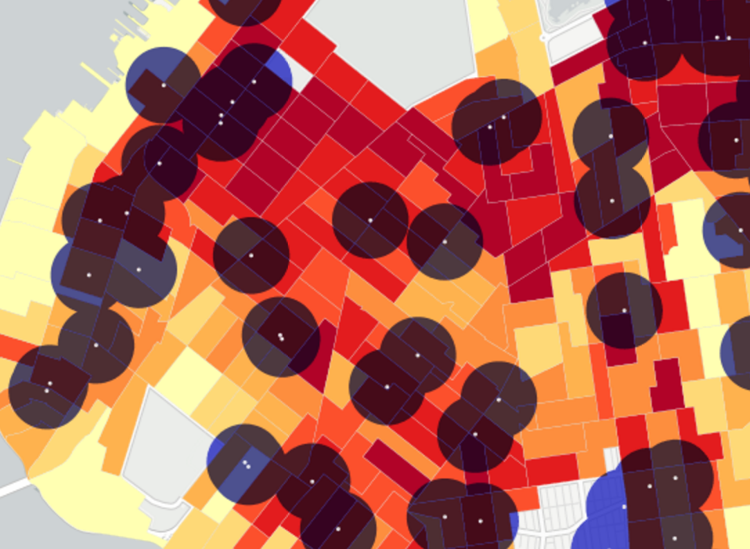

government while designing the any flu mitigation plan.

**LIMITATION**

The main limitation of the resulting index is the inability to validate the model using hospital discharge and mortality data due to the lack of publicly available sources providing data on the same level granularity. The use of census tract level of these data has been proposed to see the link between them and vulnerability-related characteristic of the area (Hadler, 2016). Percentage of residents who are immunized against flu has also been considered as one of the index variable, but the CDC Behaviourial Risk Factor Surveillance System (BRFSS) survey as the only source of the large scale public data only statistically valid up to county (borough) level. Furthermore, prior research indicated that other factors such as preexistent beliefs on vaccination, racial discrimination, immigration status, and language barrier to outreach materials are contributing in vaccination rate of a community. Further research to

**OUTREACH PLAN**

Based upon the Flu SVI, targeted outreach should be conducted in the following communities…with specific strategies to include…

Vaccination location could be better distributed throughout the city by locating sites…

**CONCLUSIONS**

The Flu SVI, in its current form, highlights areas of high vulnerability for seasonal flu outbreaks. [some additional recap here]

Next steps could include utilizing infection rates at a low level of granularity, such as census tract, to further refine outreach and healthcare needs. This SVI can also be used for other easily communicable airborne diseases. Outreach at a Community District level may be the best approach as it will cover the census tracts of high vulnerability and their surrounding area.

1. https://www1.nyc.gov/html/doh/downloads/pdf/ip/ip-death-all-rank.pdf
2. http://www.nyc.gov/html/doh/flu/html/public/general.shtml
3. http://www.nyc.gov/html/doh/downloads/pdf/dires/2014-hiv-surveillance-annual-report.pdf
4. http://www.nytimes.com/2015/01/01/nyregion/new-york-city-murders-fall-but-the-police-arent-celebrating.html?_r=0
5. http://www.fludb.org/brc/home.spg?decorator=influenza
6. http://www1.nyc.gov/assets/em/downloads/pdf/hazard_mitigation/nycs_risk_landscape_chapter_4.9_pandemic_flu.pdf
7. http://gis.cdc.gov/grasp/svi/A%20Social%20Vulnerability%20Index%20for%20Disaster%20Management.pdf
8. http://www1.nyc.gov/assets/doh/downloads/pdf/em/regional_hazards_vulnerability_measures.pdf
9. http://www1.nyc.gov/site/doh/health/health-topics/flu-seasonal-brochures-and-posters.page