doctors.csv - Example Dataset for ITHS presentation

# CTS Physician Surveys and the HSC 2008 Health Tracking Physician Survey

<https://www.icpsr.umich.edu/icpsrweb/HMCA/studies/27202>

Data fields:

* id
* age  
  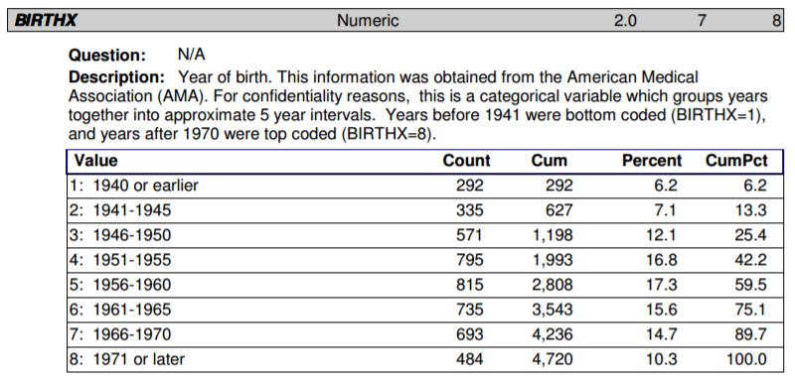
* sex  
  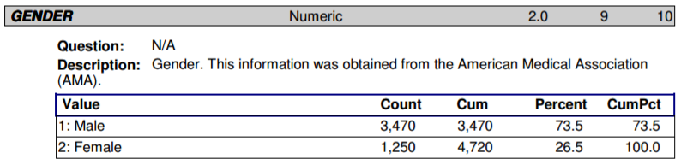
* race  
  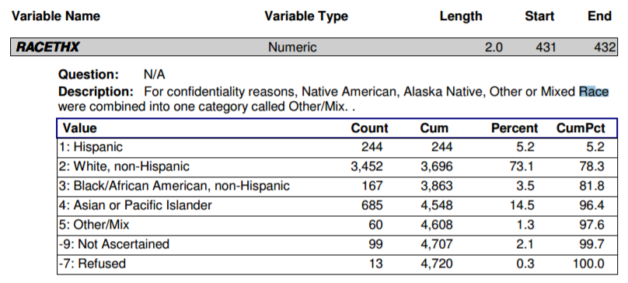
* specialty  
  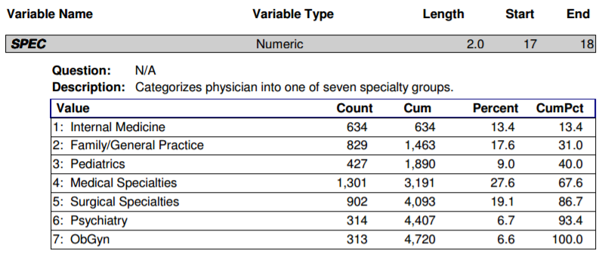
* hours_per_week  
  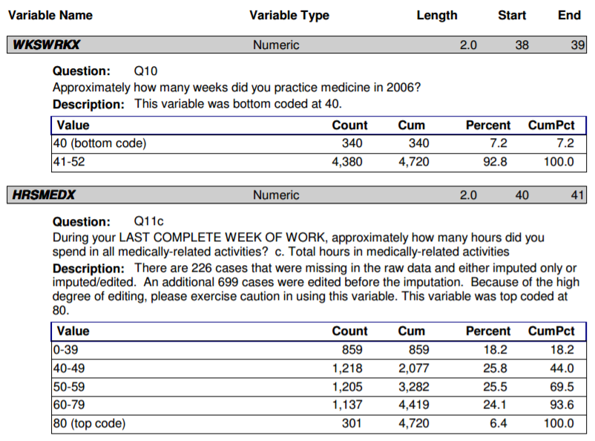
* it_use - technology use for treatment alternatives and recommended guidelines  
  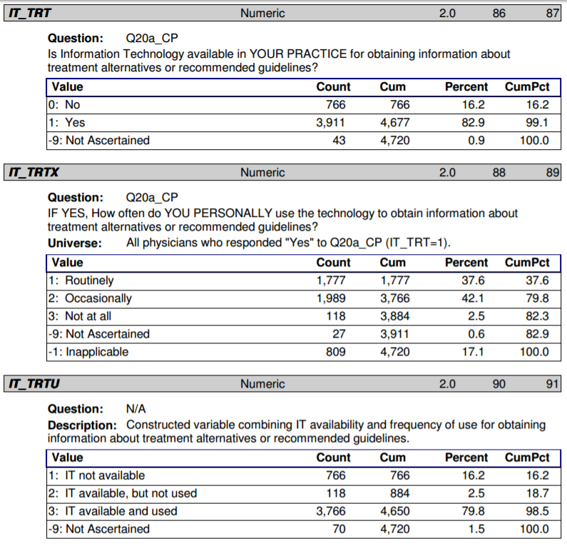
* minority_health_cme - education on minority health  
  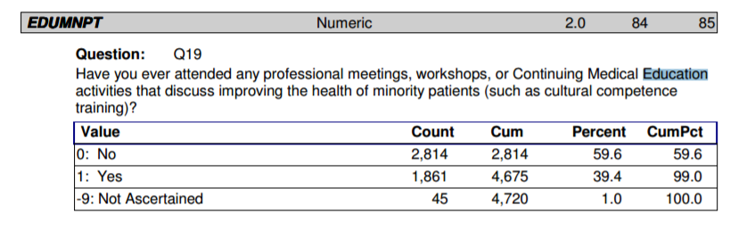
* survey_weight  
  