# NeXO USER MANUAL

# Navigation with Cytoscape

The NeXO\_x\_x.cys is a Cytoscape session file that can be loaded directly into Cytoscape (available from http://www.cytoscape.org/) to allow for visualization and interactive analysis of the entire ontology. The session provides three versions of NeXO: the tree, displaying the backbone of the ontology, the DAG where supplementary term-term relations are added, and also the DAG with additional gene-term assignments. The following steps illustrate an exemplary analysis using Cytoscape.

1. **Launch Cytoscape** and use the **File🡪Open menu** to locate and select the file NeXO.cys.
2. Select the **NeXO Tree** from the Network tab of the Control Panel at left (below screenshot).

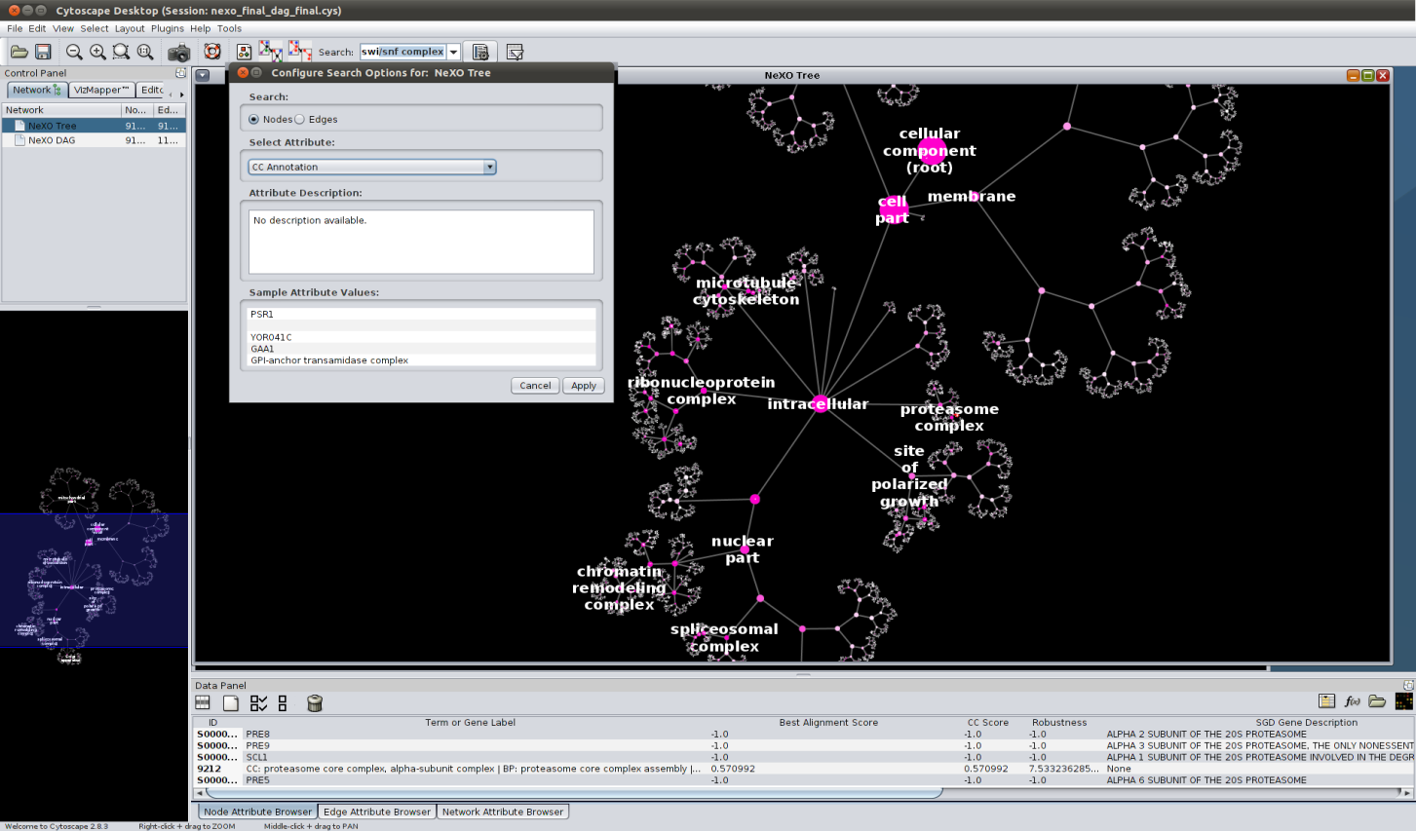

1. Select the menu item **View🡪Show Graphics Details** (if the menu reads **Hide Graphics Details**, this command is already active).NeXO is visualized with high-level terms labeled via alignment to the GO Cellular Component ontology. Node size scales with the number of genes assigned at or below that term. Node color intensity scales with the Best Alignment Score to GO. See above screenshot and Fig. 2 in the main text.
2. **Select parts of the tree using the mouse** (e.g. the proteasome subtree). Information on selected nodes (terms or genes) are shown in the table in the Data Panel. The main attributes (columns) are as follows. Further details about the derivation of each attribute are provided in Supplementary Methods.

**ID** The NeXO identifier (terms) or SGD identifier (genes) of the node.

**Term or Gene Label** For terms, names are transferred from GO alignment (scores > 0.1, CC = Cellular Component, BP = Biological Process, MF = Molecular Function). For genes, common names are shown or, if unavailable, the ORF is shown.

**CC Score** The alignment score vs. GO Cellular Component (defaults to -1.0 for genes).

**Best Alignment Score** Maximum alignment score against the CC, BP, and MF ontologies of GO.

**Robustness** The term robustness score (Supplementary Methods, defaults to -1.0 for genes).

**SGD Gene Description** Provides the free-form Gene Description field from SGD (genes only).

Additional attributes such as term definitions (CC, BF, MF), term size (number of assigned genes) and interaction density can also be loaded using the **Data Panel**.

1. Select the **VizMapper** tab of the Control Panel (below screenshot) and switch from the **NeXO Overview** to the **NeXO CC Analysis** visual style. This display will color the nodes according to their alignment score against the GO Cellular Component ontology. Green paths indicate consistent term-term relations between the two ontologies, i.e. ancestor-descendant pairs that are aligned to GO terms that are also in an ancestor-descendant relation. In contrast, a blue edge (parent to child) indicates a relation present in NeXO but absent from GO, such that the GO terms aligned to the child and the nearest aligned NeXO ancestor are not in a descendant-ancestor relation in GO. Only NeXO terms with high alignment score (CC score ≥ 0.2) are considered in this relation analysis – other terms are neutral for determining agreements and conflicts (e.g., a green path may pass through them).
2. Search NeXO for cellular components or genes of interest. Use the mouse to push the buttonto the right of the **Search field** (above screenshot) to configure search options.Select the **CC Annotation** attribute andpush **Apply**. Type “swi/snf” into the search field and press **Enter**. Gene names are also searchable using this attribute. The SWI/SNF complex will be shown.
3. Select the **NeXO DAG** or **NeXO DAG (filtered)** from the Network tab of the Control Panel and repeat steps 3-6. In the full DAG version of the ontology, edges are added which connect child terms to additional parents (see below example, in which a subunit of RSC is connected to the SWI/SNF complex). Similar analysis can also be performed using NeXO DAG with additional gene-term assignments.

# cyto_screen2.png