

Safety Plan Lane Assistance

**Document Version: [Version]**

**Template Version 1.0, Released on 2017-06-21**



# Document history

**[Instructions: Fill in the date, version and description fields. You can fill out the Editor field with your name if you want to do so. Keep track of your editing as if this were a real world project.**

**For example, if this were your first draft or first submission, you might say version 1.0. If this is a second submission attempt, then you'd add a second line with a new date and version 2.0]**

|  |  |  |  |
| --- | --- | --- | --- |
| Date | Version | Editor | Description |
| 23/08/2017 | 1.0 | Bide Hunag | Initial Draft |
|  |  |  |  |
|  |  |  |  |
|  |  |  |  |
|  |  |  |  |

# Table of Contents

**[Instructions: We have provided a table of contents. If the table of contents is not showing up correctly in your word processor of choice, please update it. The table of contents should show each section of the document and page numbers or links. Most word processors can do this for you. In** [**Google Docs**](https://support.google.com/docs/answer/116338?co=GENIE.Platform%3DDesktop&hl=en)**, you can use headings for each section and then go to Insert > Table of Contents.** [**Microsoft Word**](https://support.microsoft.com/en-us/help/285059/how-to-create-a-table-of-contents-by-marking-text-in-word) **has similar capabilities]**

Document history

Table of Contents

Introduction

Purpose of the Safety Plan

Scope of the Project

Deliverables of the Project

Item Definition

Goals and Measures

Goals

Measures

Safety Culture

Safety Lifecycle Tailoring

Roles

Development Interface Agreement

Confirmation Measures

# Introduction

## Purpose of the Safety Plan

**[Instructions: Answer what is the purpose of a safety plan?]**

The purpose is to define the role and responsibilities in lane assistance system functional safety. It provides development interface agreement between each party of the product to ensure all parties are developing product in compliance with ISO 26262.

## Scope of the Project

**[Instructions: Nothing to do here. This is for your information.]**

For the lane assistance project, the following safety lifecycle phases are in scope:

Concept phase

Product Development at the System Level

Product Development at the Software Level

The following phases are out of scope:

Product Development at the Hardware Level

Production and Operation

## Deliverables of the Project

**[Instructions: Nothing to do here. This is for your information.]**

The deliverables of the project are:

Safety Plan

Hazard Analysis and Risk Assessment

Functional Safety Concept

Technical Safety Concept

Software Safety Requirements and Architecture

# Item Definition

**[Instructions:**

**REQUIRED**

**Discuss these key points about the system:**

**What is the item in question, and what does the item do?**

The lane assistance is part of ADAS that provides two main functions including lane departure warning and lane keeping assistance.

**What are its two main functions? How do they work?**

Lane Departure Warning uses a video camera to detect lane markings ahead of the vehicle and to monitor the vehicle's position in its lane. When it detects that the vehicle is about to unintentionally move out of the lane, it warns the driver by visual indicator or steering wheel vibration.

Lane keeping assistance provides gentle steeering torque when detecting vehicle is drifting away from the center of the lane to keep vehicle in its lane.

**Which subsystems are responsible for each function?**

Camera sub-system is responsible for sending signals to the Electronic Power Steering System.

When the camera senses that the vehicle is leaving the lane, the camera sends a signal to the

electronic power steering system. Car Display sub-system also receives signal from Camera and is resonsible for giving visual warning to the driver and indicating any malfunction of the system.

Power Steering sub-system is responsible for receiving torque request from camera sensor ECU and steering wheel. Also Power Steering sub-system is responsible for sending torque request of the lane departure warning function and the lane keeping assistance function to the Steering wheel.

**What are the boundaries of the item? What subsystems are inside the item? What elements or subsystems are outside of the item?**

As shown in the figure below. The green box outline the boundary of the lane assistance system.

It consists of Camera sensor ECU, Display Unit, and Electronic power steering ECU. Steering wheel is outside of the item as it is not an electronic unit which is not part of our concern in functional safety analysis.

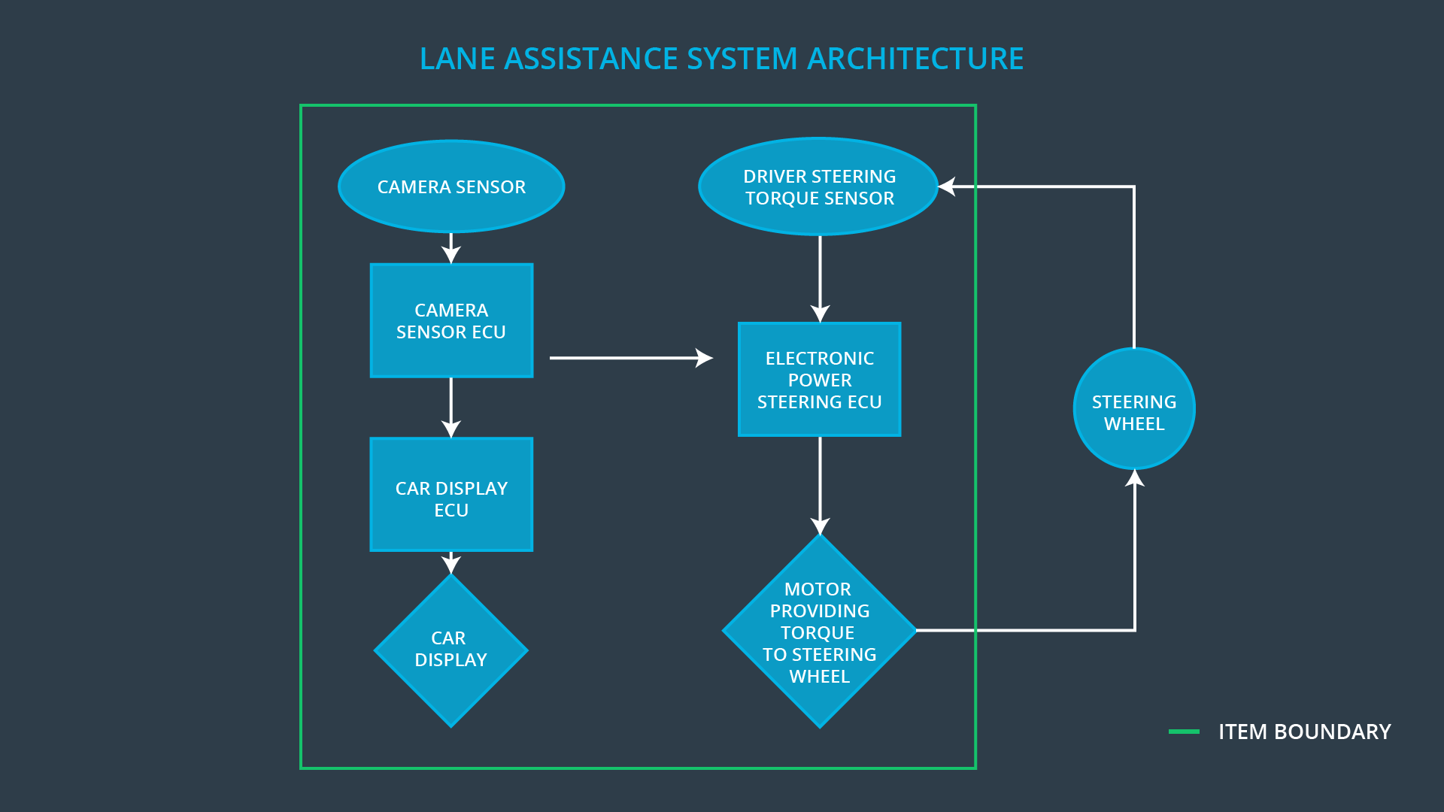

**OPTIONAL**

**Optionally, include information about these points as well. These were not included in the lectures, but you might be able to find this information online:**

* **Operational and Environmental Constraints. This could especially be limited to camera performance; lane lines are difficult to detect in snow, fog, etc**
* **Legal requirements in your country for lane assistance technology**
* **National and International Standards Related to the Item**
* **Records of previously known safety-related incidents or behavioral shortfalls**

**]**

# Goals and Measures

## Goals

**[Instructions:**

**Describe the major goal of this project; what are we trying to accomplish by analyzing the lane assistance functions with ISO 26262?]**

The goal is to identify risk and potential hazardous situation in lane assistance system malfunction that may cause injury to the driver or other people on the road. A system engineering approach is used to lower and minimize the risk level and prevent accidence from happenning.

## Measures

**[Instructions:**

**Fill in who will be responsible for each measure or activity. Hint: The lesson on Safety Management Roles and Responsibilities.**

**The options are:**

**All Team Members**

**Safety Manager**

**Project Manager**

**Safety Auditor**

**Safety Assessor**

**]**

|  |  |  |
| --- | --- | --- |
| Measures and Activities | Responsibility | Timeline |
| Follow safety processes | All Team  Members | Constantly |
| Create and sustain a safety culture | Safety  Manager | Constantly |
| Coordinate and document the planned safety activities | Safety  Manager | Constantly |
| Allocate resources with adequate functional safety competency | Project  Manager | Within 2 weeks of start of project |
| Tailor the safety lifecycle | Safety  Manager | Within 4 weeks of start of project |
| Plan the safety activities of the safety lifecycle | Safety  Manager | Within 4 weeks of start of project |
| Perform regular functional safety audits | Safety Auditor | Once every 2 months |
| Perform functional safety pre-assessment prior to audit by external functional safety assessor | Safety  Manager | 3 months prior to main assessment |
| Perform functional safety assessment | Safety  Assessor | Conclusion of functional safety activities |

# Safety Culture

**High priority**: safety has the highest priority among competing constraints like cost and

productivity.

**Accountability**: processes ensure accountability such that design decision are traceable back to the people and teams who made the decisions.

**Rewards**: the organization motivates and supports the achievement of functional safety.

**Penalties**: the organization penalizes shortcuts that jeopardize safety or quality

**Independence**: teams who design and develop a product should be independence from the

teams who audit the work

**Resources**: projects have necessary resources including people with appropriate skills

**Diversity**: intellectual diversity is sought after, valued and integrated into processes.

**Communication**: communication channels encourage disclosure of problems

# Safety Lifecycle Tailoring

**[Instructions:**

**Describe which phases of the safety lifecycle are in scope and which are out of scope for this particular project. Hint: See the** **Intro section** **of this document**

**]**

For the lane assistance project functional safety plan, the ISO26262 standard has been tailored

to include following safety lifecycle phases in scope.

* Concept phase
* Product development at the system level
* Product development at the software level

The following phases are out of scope.

* Product development at the hardware level
* Production and operation

# Roles

**[Instructions:**

**This section is here for your reference. You do not need to do anything here. It is provided to help with filling out the development interface agreement section.**

**]**

|  |  |
| --- | --- |
| Role | Org |
| Functional Safety Manager- Item Level | OEM |
| Functional Safety Engineer- Item Level | OEM |
| Project Manager - Item Level | OEM |
| Functional Safety Manager- Component Level | Tier-1 |
| Functional Safety Engineer- Component Level | Tier-1 |
| Functional Safety Auditor | OEM or external |
| Functional Safety Assessor | OEM or external |

# Development Interface Agreement

**[Instructions:**

**Assume in this project that you work for the tier-1 organization as described in the above roles table. You are taking on the role of both the functional safety manager and functional safety engineer.**

**Please answer the following questions:**

1. **What is the purpose of a development interface agreement?**

Development Interface Agreement defines the roles and responsibilities between

companies involved in developing a product. All involved parties need to agree on the contents

of the DIA before the project begins. The purposes are the following.

* Avoid disputes
* Liability
* Makes clear who should fix issues

1. **What will be the responsibilities of your company versus the responsibilities of the OEM? Hint: In this project, the OEM is supplying a functioning lane assistance system. Your company needs to analyze and modify the various sub-systems from a functional safety viewpoint.**

**]**

**OEM Project Manager**: Allocates resources needed for the functional safety activities in

Item Level. Also he/she appoints safety manager or might act as a safety manager.

**Tier1 Project Manager**: Allocates resources needed for functional safety activiteis in

component level. Also he/she appoints safety manager or might act as a safety manager.

**OEM** **Functional Safety Manager/Engineer**:Coordinate and document the item level planned

safety activities at the following functional safety phases:concept phase and product

development at the system level. Also performs pre-audits before the safety auditor(3 months

prior to main assessment)

**Tier1 Functional Safety Manager/Engineer**:Coordinate and document the component level

planned safety activities at the following functional safety phases:concept phase and product

development at the sub-system level and software level which is in compliance with the item

level planned and safety activities developed by OEM Functional Safety Manager/Engineer.

**Safety Auditor**:Perform regular functional safety audits once every 2 months.

**Safety Assessor**:Perform functional safety assessment at conclusion of functional safety

activities.

# Confirmation Measures

**[Instructions:**

**Please answer the following questions:**

1. **What is the main purpose of confirmation measures?**
2. **What is a confirmation review?**
3. **What is a functional safety audit?**
4. **What is a functional safety assessment?**

**]**

1. Confirmation measures serve three purposes:

* Make sure a functional safety project conforms to ISO 26262
* The project really does make the vehicle safer.
* Project execution is following the safety plan.

2. Confirmation review

Ensures that the project complies with ISO 26262. As the product is designed and developed, an independent person would review the work to make sure ISO 26262 is being followed.

3. Functional safety audit is to make sure that the actual implementation of the project conforms to the safety plan is called a functional safety audit.

4. Functional safety assessment is to Confirm that plans, designs and developed products actually achieve functional safety is called a functional safety assessment.

A safety plan could have other sections that we are not including here. For example, a safety plan would probably contain a complete project schedule.

There might also be a "Supporting Process Management" section that would cover "Part 8: Supporting Processes" of the ISO 26262 functional safety standard. This would include descriptions of how the company handles requirements management, change management, configuration management, documentation management, and software tool usage and confidence.

Similarly, a confirmation measures section would go into more detail about how each confirmation will be carried out.