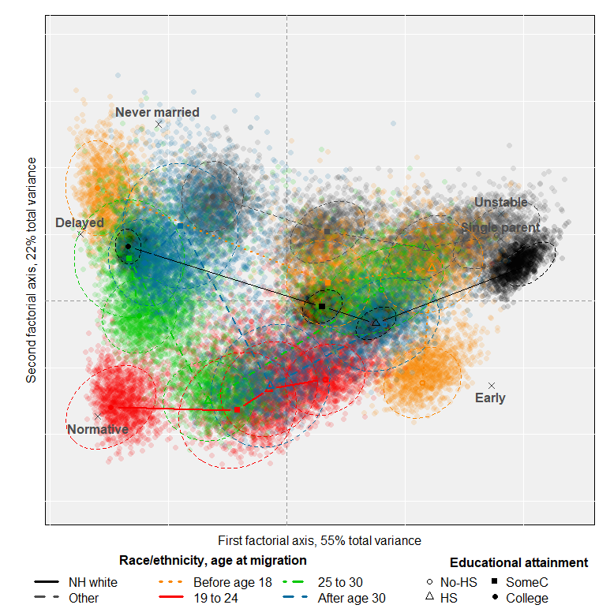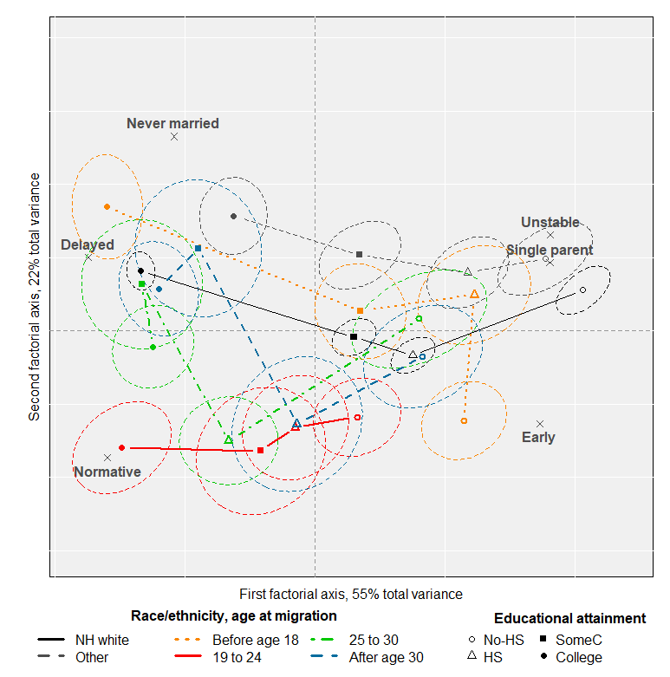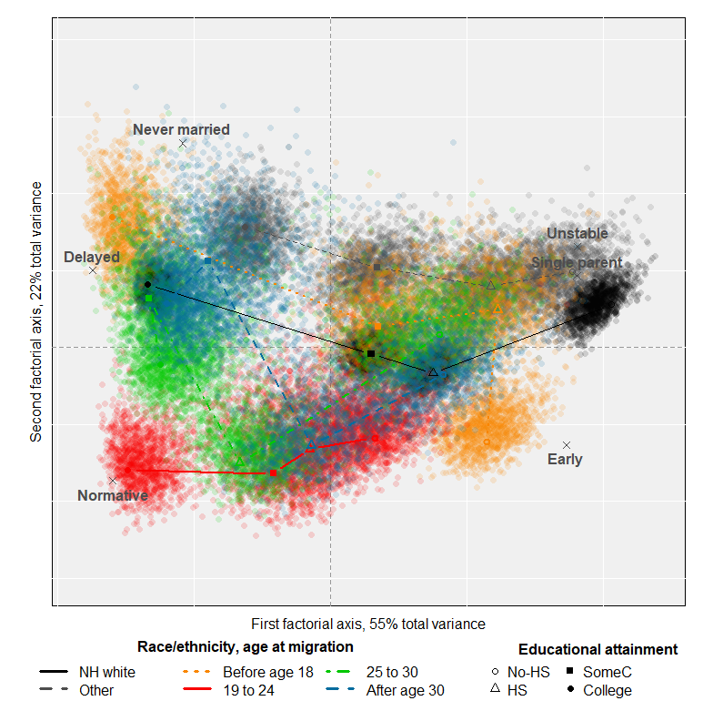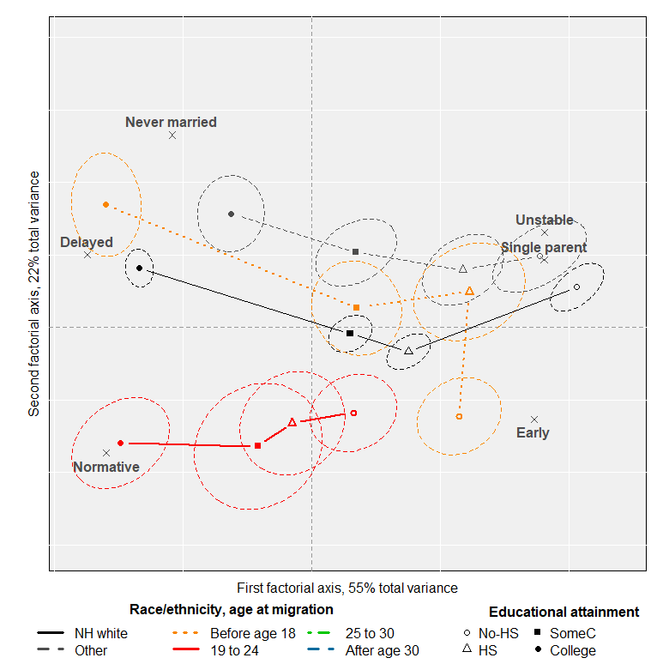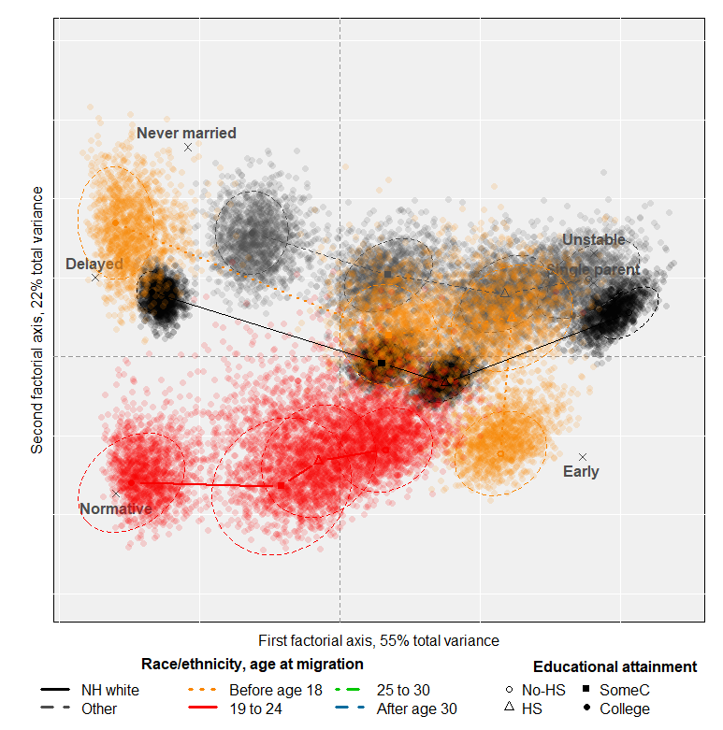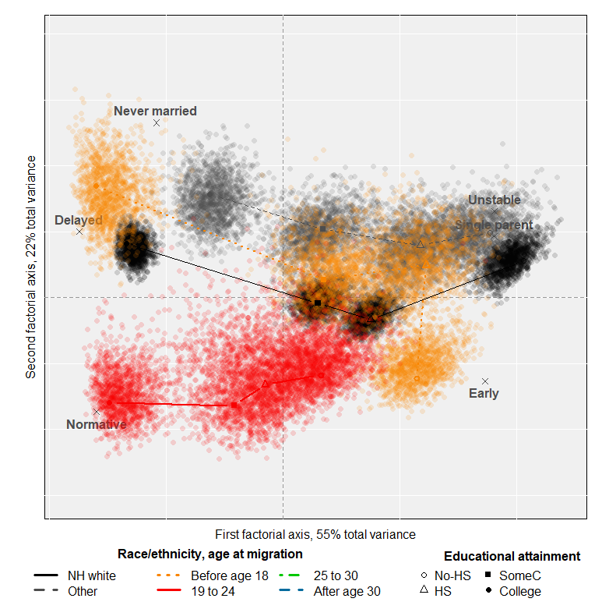

**The final**

**Women Men**

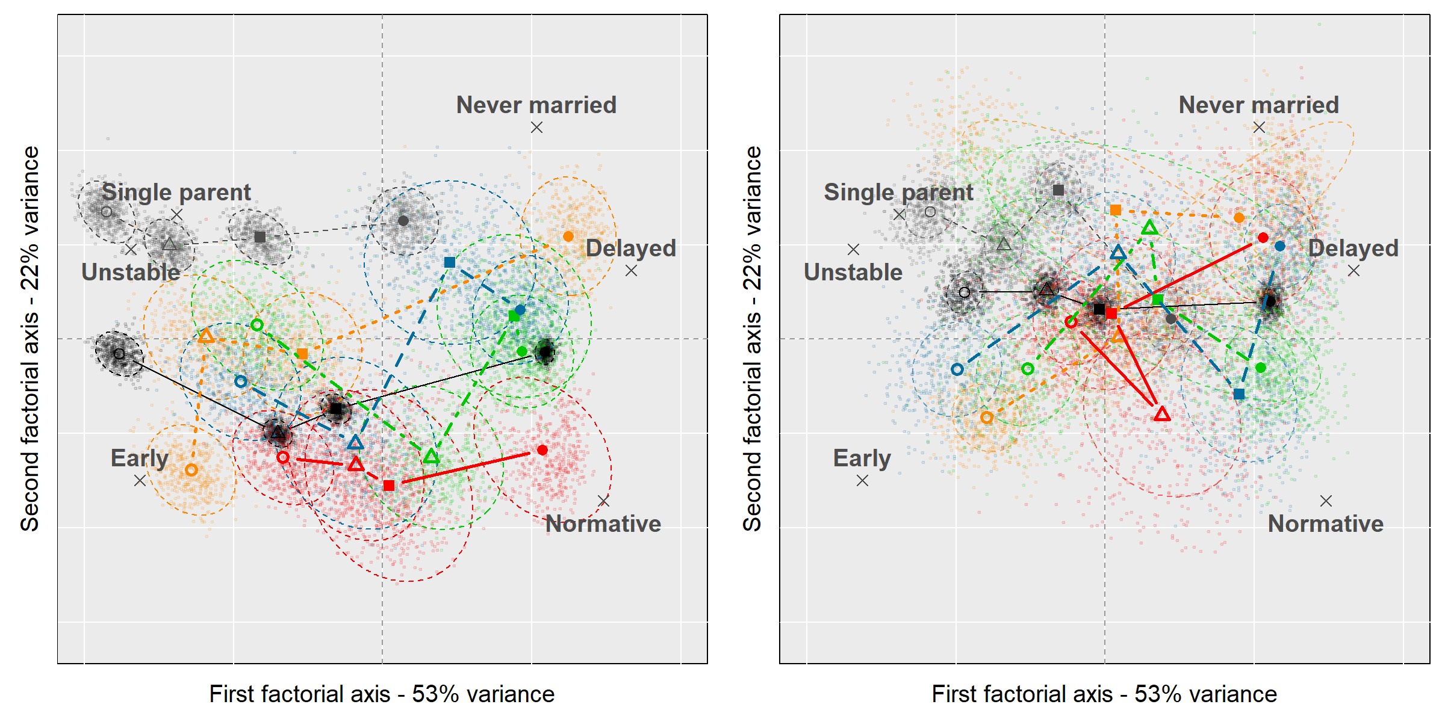



*Notes:* the mean profiles are (Women-Men): *Never married* (9.1-14.0), *Delayed* (17.5-22.9), *Normative* (28.6-29.6), *Unstable* (9.2-9.9), *Single parent* (8.1-5.8), *Early* (27.6-17.8). Background white lines are separated by one standard deviation. The % of variance of each axis refers to the total variance in Tables A4 and A5, and not to the variance of individual family trajectories. Dispersion clouds are obtained by replicating the probability table 500 times. Replications account for the estimated standard errors. Confidence ellipses include 85% of the points for women and 50% of the points for men.