2015 ADF&G St. Matthew survey: *Chionoecetes opilio* bitter crab research

NOAA Fisheries, Alaska Fisheries Science Center, Seattle

We would like *Chionoecetes opilio* blood samples collected and preserved in plates of ethanol: **A) 2 plates for visually + bitter crabs (also held for live collection)** and **B) 2 plates for BCS prevalence (crabs randomly selected)**. We have provided 4 blood collection plates pre-filled with 100% ethanol, syringes, and a sharps collection box (for syringe needles). Collection plates have assigned numbers (#40 – 43) -- use 2 plates each for A & B. We will use the preserved blood to assay for Bitter Crab Syndrome (BCS) using molecular techniques & ship live BCS+ crabs to Kodiak for further research.

If you see a **King Crab** that could be BCS+, see instructions below.

**BCS+ Live Collection plates (A):**

1. Remove visually BCS + crabs from the catch & place in deck tank. After double tagging crab, taking a blood sample (see below) & filling out datasheet, place live BCS+ crabs in white baskets or, if too large for a basket, into onion bags; tags for baskets and onion bags are provided. Place crabs in hold. Please treat BCS+ crabs gently as we need them alive.
2. Check on crabs periodically – frequency will be determined by survey lead. If a crab is dead, record tag numbers & date on provided tally sheet, remove tags and discard crab.

**BCS prevalence plates (B):**

1. Randomly choose crabs at stations determined by survey lead. Crab samples must be **random**; please do not cherry pick crabs based on their visual status.
2. Take blood samples (see below), record data & discard crabs.

**Blood Collection Protocol**

Crabs can be kept in the deck tank until you are ready to draw blood. And if it is difficult to draw blood, allowing the crabs a short recovery time in seawater, rather than leaving them dry, will make the process easier.

1. Enter collected crab data onto provided data sheets. Data should include the vessel, your name or initials, station/pot number, plate number, species, sex, size (carapace width in mm), shell condition, chela height (males), and **note if crab looks visually BCS+ or BCS-**.

For *BOTH* **BCS+ Live Collection plates (A)** and **Prevalence plates (B) –** measure the carapace width and chela height as follows:

MALES: **≥ 70 mm** = measure both carapace width and chela height to nearest 0.1 mm

MALES: **> 70mm** = measure carapace width to nearest mm; chela height is optional

FEMALES: **All sizes** = measure carapace width to nearest mm; DO NOT measure chela height

1. Obtain a clean syringe with attached needle. Choose a region of the crab where the arthrodial membrane is exposed and insert the needle (a good spot is where the legs meet the carapace). Pull back on the plunger to extract hemolymph; you may need to move the needle around to locate a sinus. **Do not collect more than 0.2 mL hemolymph!** Blood may be light orange in color, but is usually clear to white and may turn blue as it is exposed to air (crabs have hemocyanin, not hemoglobin). If the hemolymph is brownish-yellow, green or black (from hitting an organ), the sample must be discarded. Obtain a new syringe and try again.
2. If there is excess air in the syringe, hold the syringe up so the needle points towards the sky. Finger flick the syringe to move the air towards the needle. Depress the syringe slowly to expel air from the syringe and until blood moves into the needle. If cap pops off well (not a good thing), see “**What if…**”section below.
3. Insert the needle into the colored well plug (cap) and eject **0.2 mL** hemolymph into the well prefilled with ethanol. Pull out the needle (the well plug will reseal itself). Do **not** use wells A12, B10, D3, F8 and G5 (**grey**-colored caps).
4. Remove needle from the syringe using the needle remover on the sharps container, trap the plastic part of the needle in the V and twist off the syringe. Used syringes and wrappers may be placed in trash or returned to Seattle.
5. Start all plates with the well **A1** (**pink** cap) then proceed down **column 1** to B1, C1 etc. When **column 1** is full, move to well **A2** and continue filling **column 2** etc. Use this pattern for all plates. When a column is complete move the rubber band over the well plugs to the next column to help you keep track of where you are on the plate. If you have any problems, comments, or mistakes, note the well number and any information on the back of the datasheet.
6. **Periodically invert the plate to mix the hemolymph and ethanol**.
7. When a plate is full, replace in Ziploc bag and seal. Stack and store in the white 5-gal bucket.
8. At the end of the survey, please ship the blue cooler, white 5-gallon bucket, and autoclave baskets to Seattle using Coastal Transportation. *Bill of Lading info*: Christie Lang, 7600 Sand Point Way NE, Seattle WA, 206-526-6715. Send shipment COD. Please see “NOAA Fisheries Collection Plate Packing and Shipping Instructions” for collection plate packing and shipping instructions.

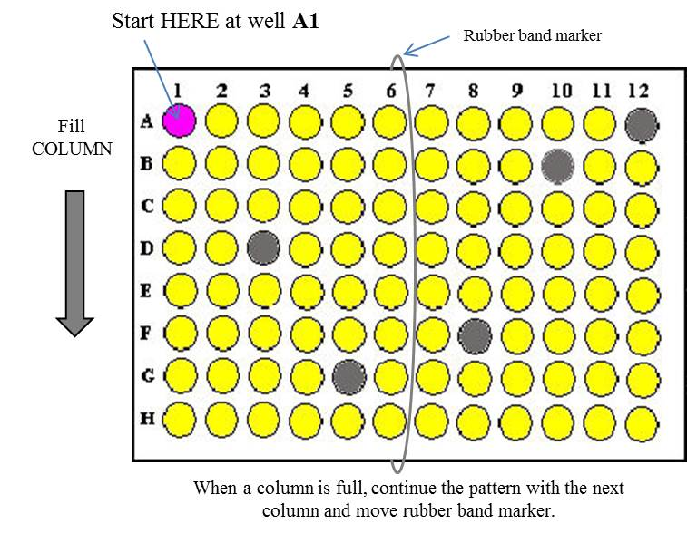

**King Crab Samples -- Blood in ethanol & Smear Technique:**

1. Place a blood sample in ethanol (use an *opilio* well in BCS+ Live Collection plates (A) & clearly indicate the species on the sample sheet). Since we have not detected *Hematodinium* in king crab from the Bering Sea, we will need molecular confirmation as well as histological evidence by way of blood smears.
2. Please take **3 blood smears** per infected-looking king crab. Keep unused slides dry! Once wet, they clump together. If there is an on-deck camera available, please take photos of crab, concentrating on features that look indicative of BCS, and email to [christie.lang@noaa.gov](mailto:christie.lang@noaa.gov) with reference number (collection plate & well number, i.e., 2015-43 C12)
3. Label Slide: In pencil, write the **BCS+ Live Collection plate (A) well number (e.g. 2015-43 C12)**on the white frosted end of a new microscope slide. Record crab data on data sheet (species, sex, carapace height, shell condition, etc.)
4. Withdraw hemolymph using a syringe and dispense 2 drops of hemolymph near the edge of the non-frosted end of the microscope slide.
5. Take a second slide, place it at a 30o-45o angle, place it so it touches the inner edge of the drop of blood and then drag the “smearing” slide toward the frosted end of the slide with a smooth and steady motion. Drag blood, don’t push it (see figure below). Used “smearing” slides can be disposed of in the container labeled “Used Smearing Slides”. At the end of the survey, cover the opening and tape the lid to the container for

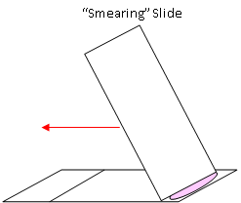

shipping back to Seattle.

1. Set smears aside and allow to dry, try to avoid all water splash while making smears.
2. After the slides are completely dry, place in slide box. Add a folded paper towel on

top of slides for cushioning, tape box closed, put in baggie & seal.

🡨 Drag smearing slide from non-frosted to frosted end 🡨

***What if…….?***

1. The cap pops off the well?
   1. Replace the cap (if you can find it); note well # on back of datasheet.
   2. Gently rinse the plate with fresh water to prevent contamination of caps (Yes, you can push contaminating blood on a cap through into the ethanol with a needle & our assay is sensitive enough to be affected). Blot plate to dry, or shake off water.
   3. You are most likely injecting air into the well with the blood. Finger flick (step 3) & eject blood slowly.
   4. OR, you put blood into a well that already contains a sample. Check your datasheet.
   5. Take a fresh sample of blood & put in a new well (note on back of datasheet).
2. I can’t get 0.2 mL of blood out of the crab using the syringe?
   1. Inject whatever blood is available in the syringe into the well and note on the datasheet that less than 0.2 ml blood was preserved.
3. The blood clogs the needle?
   1. This usually happens because the blood coagulates with prolonged exposure to air in the syringe (it may also turn blue).
   2. To prevent this, minimize the time the blood is in the syringe.
   3. If a clogged needle does occur before acquiring the desired volume, inject what you have in the well if possible and collect more blood using a fresh needle and syringe. You’ll need to keep track of the blood volumes until you reach 0.2 ml total.
4. I find other crab species that look BCS+ ? In Alaska*, Chionoecetes bairdi, C. opilio, C.tanneri, C. angulatus, Hyas coartatus* & *H. lyratus* are known be infected with *Hematodinium* (the dinoflagellate parasite that causes BCS).
   1. If it is a **king crab**, see above. Take lots of pictures of the crab.
   2. For any other new host species, if you have time, similarly take samples (smears & ethanol-preserved blood) and photos.

**THANK YOU C:\Users\pam.jensen\AppData\Local\Microsoft\Windows\Temporary Internet Files\Content.IE5\J9BTC5LE\Crab[1].jpg**

**Send questions, smears & photos to:**

Pam Jensen OR Christie Lang

NOAA/NMFS NOAA/NMFS

7600 Sand Point Way NE 7600 Sand Point Way NE

Seattle, WA 98115 Seattle, WA 98115

Pam.Jensen@noaa.gov Christie.Lang@noaa.gov

206-526-4122 206-526-6715