FRP database Readme

The FRP database holds sample collection data for all samples (fish, invertebrates, mammals, plankton, environmental) collected by the Pathobiology group from 1978 through 2014, only excluding sample sets from the BCSIndexSite project and the BCS_JuneauMortality project. Collection data include collection location information, host details, sample type, preservation and current status. These data are separated into 3 tables with one-to-many relationships linking them and lookup tables (tlkp_XXX) available for most non-numeric fields but only tlkp_Species is linked with a relationship.

tbl_Haul_Data – sample collection location information specifics, some from RACEBASE and some from other surveys, SCUBA collection, shore collection etc. C_V_H is the primary key for this table and in general is the concatenation of the Cruise Vessel and Haul for the collection location, for some records that do not have a cruise vessel haul a combination of 0_0_SPNO is used instead to ensure a unique value is used for location data

tbl_Sample_Collection – host information, collection comments, reference numbers if applicable. SPNO is the primary key for this table and each host has a unique SPNO, the format is 8 numerals with the first 4 representing the year the sample was collected

tbl_Samples – details about the actual sample(s) collected from the host, tissue type, sample type, preservative, current status of sample. SPNO_Alpha is the primary key for this table and each sample from a host has a unique SPNO_Alpha, with the SPNO of the host and an underscore with alpha characters that are unique to each sample.

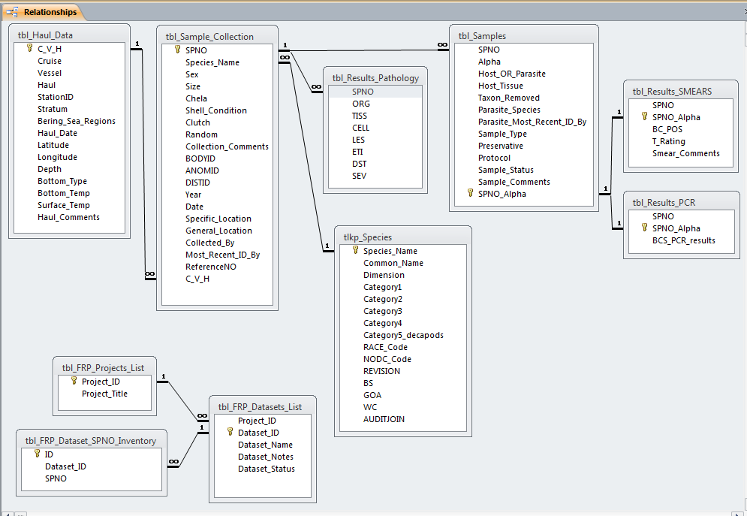

There are also some results for certain broad scope projects within the FRP database.

tbl_Results_Pathology – pathology results for primarily fish and crab necropsies from the Pacific west coast of the United States and Alaska, although results for other hosts and regions are also included in this table. Results include organ/tissue/cell examined, lesion present if applicable, etiology, distribution and severity. Pathology results are linked to the host specimen number and multiple records exist for each host, there is no primary key for this table. Lookup tables describing the codes used are available for these fields, note that tlkp_All_Organ_Tiss_Cell is the lookup table for 3 separate fields ORG, TISS, and CELL due to overlapping use of codes throughout these fields.

tbl_Results_PCR – Hematodinium PCR assay results for SPNO_Alpha that have been run with the PCR assay. Numeric results of 0 = BCS negative, 1 = BCS positive, 3 = inconclusive (ie. disagreement at loci, extraband).

tbl_Results_SMEARS – Results from visual inspection of hemolymph smear preparations for SPNO_Alpha that have been stained with Geimsa and read with a compound microscope. BC_POS is the field name for numeric results of 0 = BCS negative, 1 = BCS positive, blank = slide read but no conclusive result, more details described in Smear_Comments. T_Rating field has more detail about the cells on the slide for BCS positive samples including Hematodinium stage (T = trophont, P = prespore, D = dinospore) and relative amount of that cell type ranging from 1 – 5 (*1 = up to 10% of cells viewed and 5 = over 90% of cells viewed*). T_Rating is not available for samples collected prior to 1999.