HandsMen Threads: Elevating the Art of Sophistication in Men's Fashion
Abstract
The primary objective of this project is to design and implement a customized Salesforce CRM solution for HandsMen Threads to optimize core business operations, strengthen data integrity, and elevate customer engagement across the brand. By establishing a centralized platform to manage customers, orders, products, inventory, and automated workflows, the project aims to automate essential business processes including order confirmations, loyalty tier updates, inventory alerts, and scheduled bulk processing. The solution maintains accurate and reliable data through structured data modeling, validation rules, and controlled UI input while providing real-time visibility into customer activity and stock levels to support informed decision-making. Additionally, it enhances internal collaboration through role-based access, streamlined workflows, and unified data access, ultimately delivering personalized customer experiences supported by automated communication, loyalty programs, and targeted notifications.
Objective
The primary objective of this project is to design and implement a customized Salesforce CRM solution for HandsMen Threads to optimize core business operations, strengthen data integrity, and elevate customer engagement across the brand.
By establishing a centralized platform to manage customers, orders, products, inventory, and automated workflows, the project aims to:
- Automate essential business processes including order confirmations, loyalty tier updates, inventory alerts, and scheduled bulk processing.
- Maintain accurate and reliable data through structured data modeling, validation rules, and controlled UI input.
- Provide real-time visibility into customer activity, order history, and stock levels to support informed decision-making.
- Enhance internal collaboration through role-based access, streamlined workflows, and unified data access.
- Deliver personalized customer experiences supported by automated communication, loyalty programs, and targeted notifications.
Technology Description
1. Salesforce
Salesforce is the world's leading Customer Relationship Management (CRM) platform that enables businesses to build and strengthen customer relationships. It helps organizations manage customer data, automate workflows, and enhance service delivery, marketing campaigns, and sales operations through intuitive point-and-click configuration tools for building customized business solutions.
2. Custom Object
Custom Objects in Salesforce function as database tables that store specific business data.
Examples:
- HandsMen_Customer__c – Maintains customer information
- HandsMen_Product__c – Contains men's fashion product details
- HandsMen_Order__c – Records order and transaction data
- HandsMen_Inventory__c – Tracks inventory data and stock movements
3. Tabs
Tabs display object data within the Salesforce user interface, providing users with easy access to view and manage records.
Examples:
- A tab for HandsMen_Product__c enables users to view and manage product catalog information
- A tab for HandsMen_Order__c allows users to monitor customer orders
- A tab for HandsMen_Inventory__c provides visibility into stock levels and inventory updates
4. Custom App
A Custom App organizes related tabs for streamlined access to business functions.
Tabs shown in the HandsMen Threads application:
- HandsMen Customers – Used to view and manage customer records.
- HandsMen Orders – Provides access to order and transaction data.
- HandsMen Products – Allows users to view, create, and update product listings.
- Inventorys – Displays the inventory object where stock levels and stock movements are recorded.
- Marketing Campaigns – Standard Salesforce tab for managing marketing initiatives.
- Reports – Used to generate and view analytical reports.
- Dashboards – Displays visual dashboards derived from reports.
- Accounts – Standard Salesforce object for managing account-level data.
- Contacts – Standard Salesforce object for managing contact information.
5. Profiles
Profiles determine user permissions and control which users can create, read, update, or delete records on specific objects.
6. Roles
Roles control data visibility through Salesforce's role hierarchy. They define how records are shared within the organization's structure and support reporting relationships and record-level access control.
7. Permmision Set
Permission Sets grant additional access rights to users without modifying their base profile, enabling flexible and granular permission management.
8. Validation Rules
Validation Rules ensure data entered into Salesforce meets defined business requirements.
Example:
- Email must contain a valid domain (e.g., @gmail.com).
8. Email Templates
Pre-designed message formats used to send consistent communications to customers or internal users.
9. Email Alerts
Email Alerts are automated notifications triggered by Flows or Workflow Rules that send emails using predefined templates.
10. Flows
Flows automate business processes declaratively without requiring code. They can update or create records, send notifications, and execute complex business logic within Salesforce.
11. Apex
Apex is Salesforce's object-oriented programming language that enables developers to write custom business logic and extend platform functionality.
Detail Execution of Project Plan
Phase 1: Salesforce Cerdentials Setup
- Create a Salesforce Developer Org
- Visit <https://developer.salesforce.com/signup>
- Fill out the registration form with your details
- Check your email inbox for a verification email from Salesforce
- Click the verification link in the email to verify your account
- Set up your password
- You will be redirected to your Salesforce setup page
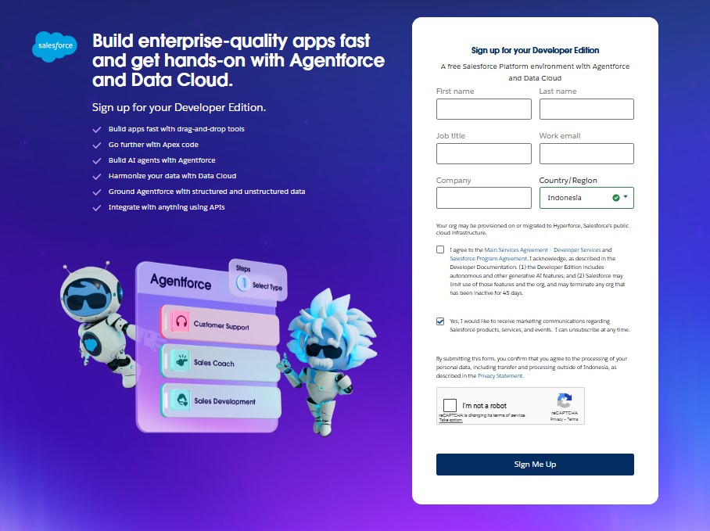
Gambar 1 Developer Account Creation Form
Phase 2: Data Management – Objects, Tabs, App Manager, Fields
Create Custom Objects
The following custom objects need to be created:
- HandsMen Customer
- HandsMen Order
- HandsMen Product
- Inventory
- Marketing Campaign
Steps to Create Custom Objects:
- Click Setup from the home page
- In the Quick Find box, search for Object Manager
- Click Object Manager from the results
- Click Create → Custom Object
- Fill in the following details:
- Enable the following options:
  - Allow Reports
  - Allow Search
- Click Save
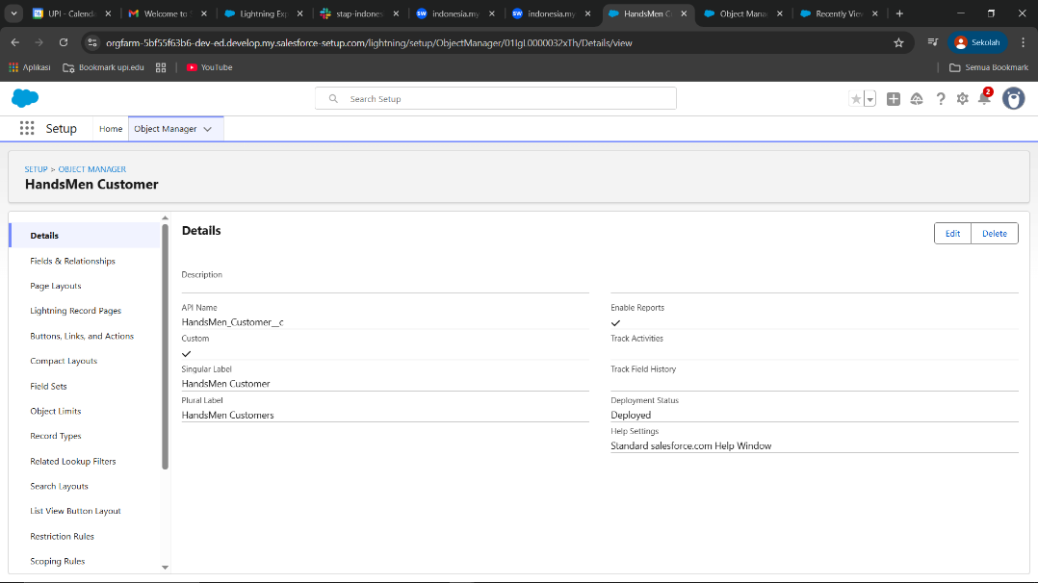 Gambar 2 Custom Object HandsMen Customer
Create a Lightning App
- Go to Setup page
- Search for App Manager in Quick Find
- Click App Manager
- Click New Lightning App
- Enter App Name: HandsMen Threads
- Click Next through the setup wizard
- Add Navigation Items (Tabs):
  - HandsMen Customer
  - HandsMen Order
  - HandsMen Product
  - Inventory
  - Marketing Campaign
  - Reports
  - Dashboards
  - Accounts
  - Contacts
- Add User Profiles: Select System Administrator
- Click Save & Finish
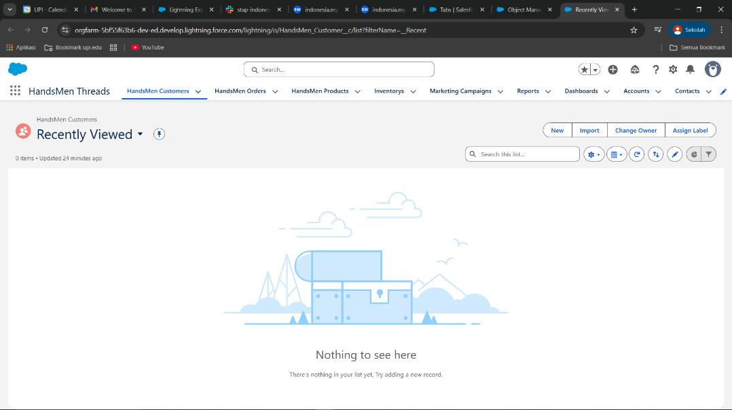 Gambar 3 App HandsMen Threads
Creating Fields in Custom Objects
- Steps to Create Fields:
- Go to Setup
- Click Object Manager
- Search for the object name (e.g., HandsMen Customer) in the Quick Find bar
- Click on the object name
- Click on Fields & Relationships
- Click New to create a new field
- Select the appropriate field type and follow the wizard
Make sure that each Custom object has the following fields
Object Name | Type | Description | Key Fields
HandsMen Customer__c | Custom Object | Stores customer details | - Name (Record Name)  - Email (Email)  - Phone (Phone)  - Loyalty_Status__c (Picklist: Bronze, Gold, Silver) [Loyalty status field is already created in previous activity do not create it again]  - Total_Purchases__c (Number)
HandsMen Product__c | CustomObject | Stores product catalog | - Name (Record Name)  - SKU (Text)  - Price (Currency)  - Stock_Quantity__c (Number)
HandsMen Order__c | CustomObject | Stores customer orders | - Order_Number (Record Name)  - Status (Picklist: Pending, Confirmed, Rejection)  - Quantity__c (Number)  - Total_Amount__c (Number)
Inventory__c | CustomObject | Tracks inventory levels | - Auto Number (Record Name)  - Warehouse (Text)  - Stock_Quantity__c (Number)
Marketing_Campaign__c | CustomObject | Manages promotions & campaigns | - Campaign_Name (Record Name)  - Start_Date (Date)  - End_Date (Date)
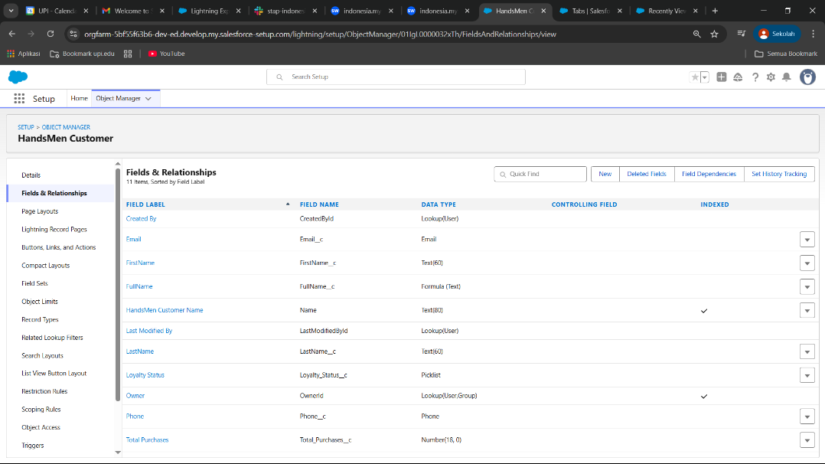 Gambar 4 Field HandsMen Customer
Phase 3: Data Configuration – Validation Rules
- To ensure accurate data entry and enforce business logic, we neet to apply validation rules
- Steps to Create Validation Rules:
- Go to Setup → Object Manager
- Select the object (e.g., HandsMen Order__c)
- Click Validation Rules
- Click New
- Enter:
  - Rule Name: Descriptive name
  - Error Condition Formula: The validation logic
  - Error Message: Message displayed when validation fails
- Click Save
Make sure that each object has the following validation rule
Object | Field | Validation Rule
HandsMen Order__c | Total_Amount__c | Total_Amount__c <= 0
Inventory__c | Stock_Quantity__c | Stock_Quantity__c < = 0
HandsMen Customer__c | Email | NOT CONTAINS(Email, "@gmail.com")
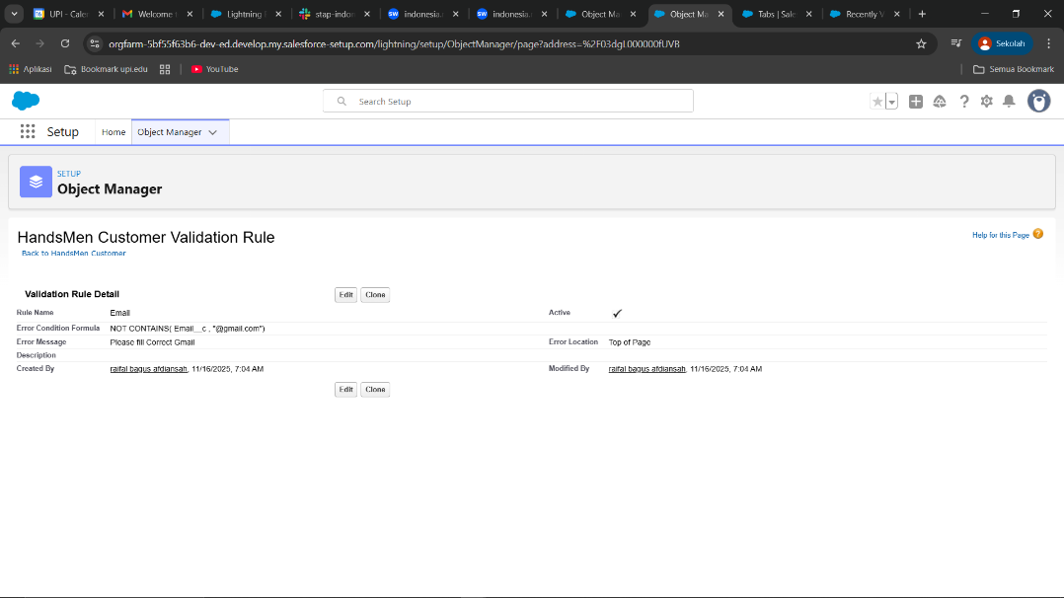 Gambar 5 Validation HandsMen Customer
Phase 4: Data security – Profiles,Roles, Users,Permmision Set
Cloned the Standard User profile to a new profile named Platform 1 and added access to necessary custom objects.
Created roles for different departments:
- Sales Manager, Inventory Manager, Marketing Team
Users were created in Salesforce and assigned appropriate roles and profiles to reflect their
responsibilities:
- Niklaus Mikaelson - Assigned the Sales role
- Kol Mikaelson - Assigned the Inventory role
- These role-based assignments help enforce proper data access and process control within the system.
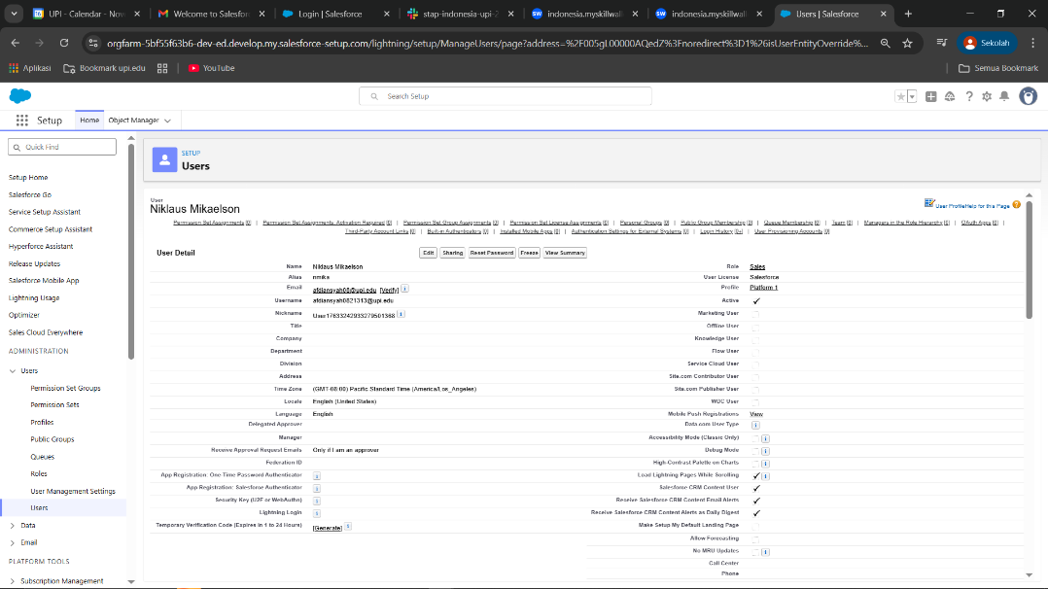 Gambar 6 Create Users
Phase 5: Email Template
Created three email templates:
- Order Confirmation - Sent on order status = Confirmed
- Low Stock Alert - Sent when Inventory < 5 units
- Loyalty Program Email - Sent when loyalty status changes
Corresponding Email Alerts were created using these templates and linked to automation flows.
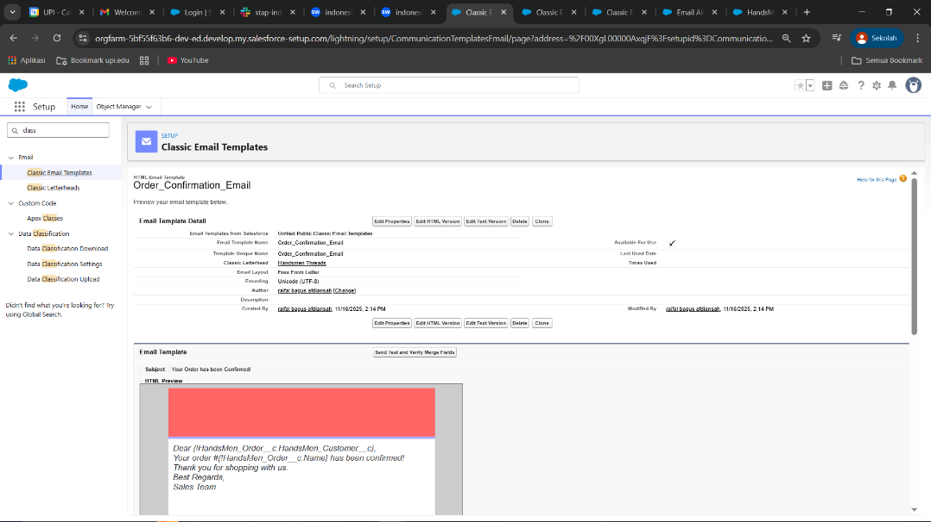
Gambar 6 Email Template
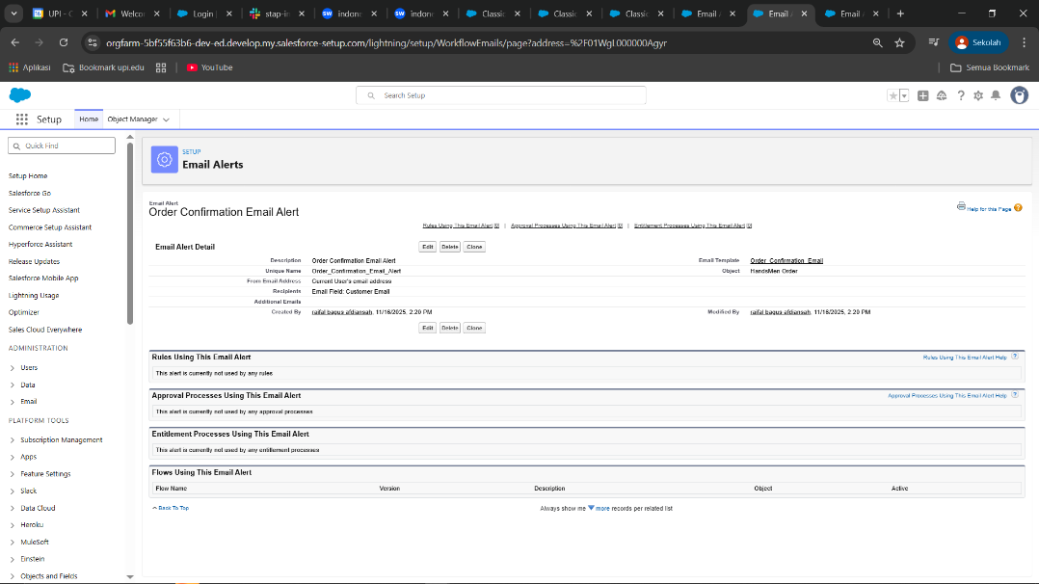 Gambar 7 Email Template Alert
Phase 6: Flows
a. Order Confirmation Flow
- Triggered when an order is updated to Confirmed.
- Sends an Order Confirmation email to the related customer.
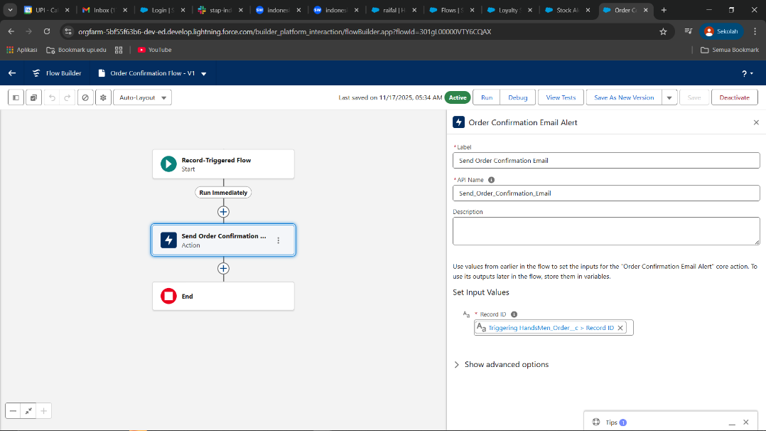
Gambar 8 Order Confirmation Flow
b. Stock Alert Flow
- Triggered when Inventory stock drops below 5.
- Sends Low Stock email to Inventory Manager.
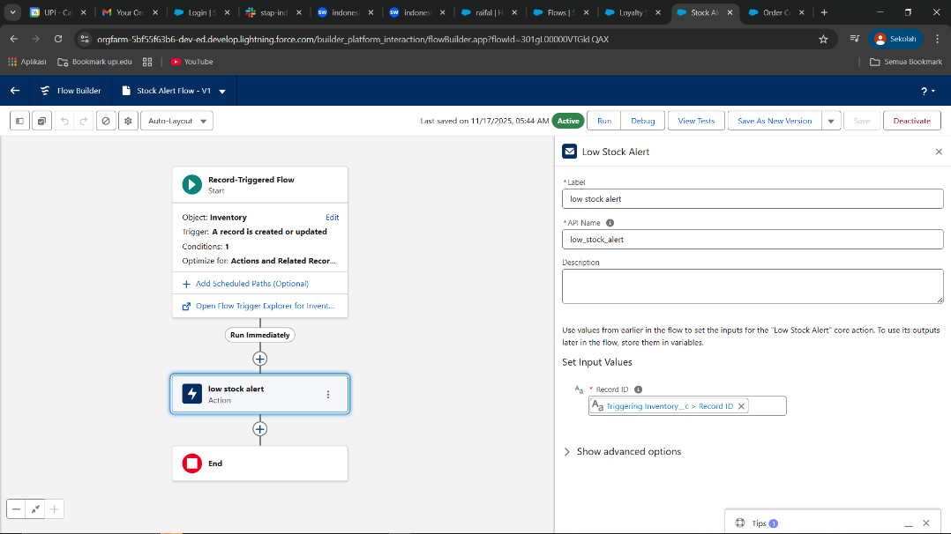 Gambar 9 Stock Alert Flow
c. Scheduled Flow: Loyalty Update
- Runs daily at midnight.
- Loops through customers and updates their Loyalty Status based on total purchases.
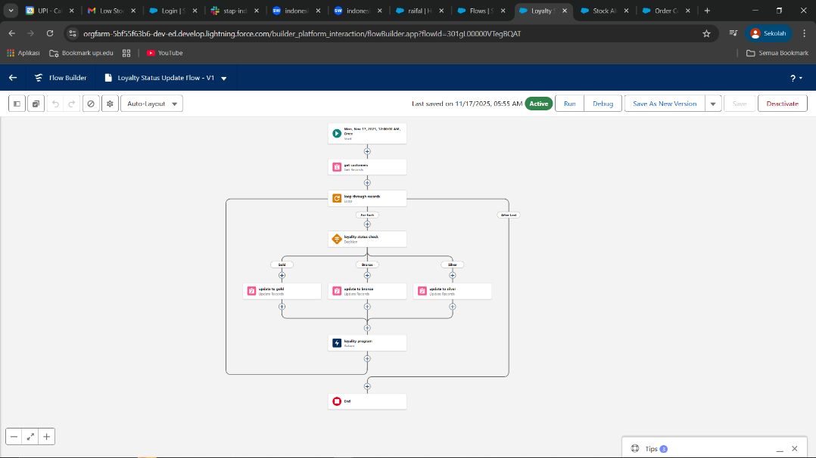
Gambar 10 Loyalty Update Flow
Phase 7: Automation using Apex
- Order Total Trigger: Auto-calculates Total Amount based on quantity and unit price.
- Stock Deduction Trigger: Reduces stock when an order is placed.
- Loyalty Status Trigger: Updates Loyalty Status based on total purchases.
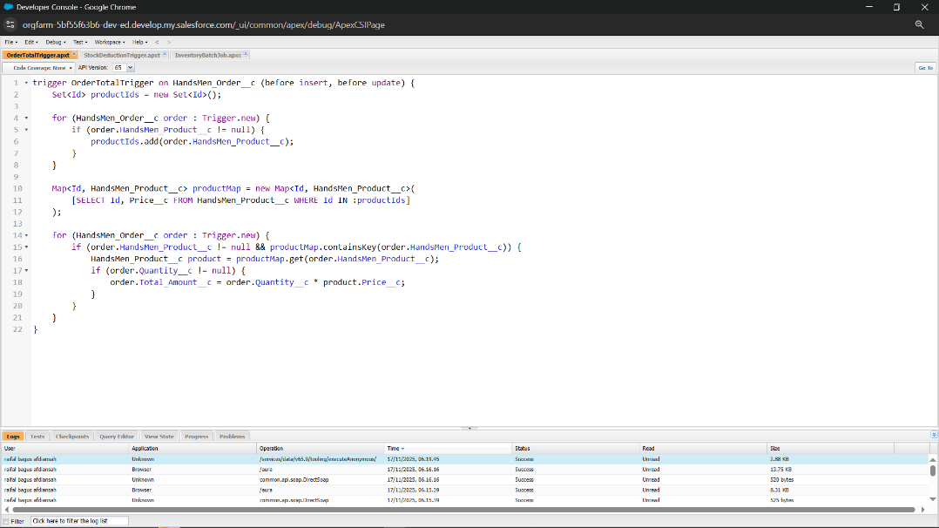
Gambar 11 Apex File OrderTotalTrigger
Conclusion
The Salesforce CRM implementation project for HandsMen Threads has been successfully completed through seven comprehensive phases, establishing a robust and scalable solution for the men's fashion brand. The implementation encompasses the creation of custom objects for managing customers, products, orders, inventory, and marketing campaigns, all integrated with sophisticated data validation rules to ensure data quality and business logic compliance. A comprehensive security architecture was established through custom profiles, roles, and permission sets to control data access across different organizational levels including Sales Managers, Inventory Managers, and Marketing Teams. The solution features automated communication workflows through custom email templates and alerts, intelligent process automation using Salesforce Flows for order confirmations, stock alerts, and scheduled loyalty updates, and advanced business logic implementation through Apex triggers for automatic order calculations, real-time stock deductions, and dynamic loyalty status management. This comprehensive CRM solution positions HandsMen Threads to deliver superior customer experiences, maintain operational efficiency, and scale their sophisticated men's fashion business with data-driven insights and automated processes that support both customer satisfaction and sustained business growth.
Future Scope
- Process Builder & Advanced Flows: Develop more complex approval processes for high-value orders, automated discount calculations, and cross-object workflow automation
- Salesforce Mobile App: Enable mobile access for sales teams and managers to manage orders, check inventory, and update customer records on-the-go
- Reports & Dashboards Enhancement: Create advanced dynamic dashboards with real-time metrics, sales performance tracking, inventory turnover analysis, and customer segmentation insights
- Custom Lightning Web Components: Develop interactive user interfaces for enhanced product catalogs, order management dashboards, and inventory visualization

