**Going digital: Digitalization and the American workplace**

Or: The digital tide: Where and how digitalization is sweeping across the American workplace

By Mark Muro, Sifan Liu, and Siddharth Kulkarni

October 2017

**Executive Summary**

Over the past half century, wave after wave of digital innovation has ensured that “digitalization”—the diffusion of digital technologies into nearly every business and workplace and pocket—has been continually remaking the U.S. economy and the world of work. From land-line telephones in the 1990s to the first iPhones a decade ago to today’s ubiquitous cloud-based computing, the pace of change has if anything accelerated.

So rapid are the developments, in fact, that while the “digitalization of everything” has become a hallmark of tech’s promise of individual and business empowerment so has it begun to prompt widespread anxiety, including among workers who worry about their future in a world of brilliant machines

And yet, for all of the evidence that big changes are underway, surprisingly little data exist to track the spread of digital adoption across industries and into local workplaces and labor markets. In the absence of such information, the digitalization trend, as prominent as it is, remains diffuse and hard to pin down.

Hence this report: Designed to help address the shortage of data on the topic, the present assessment provides a detailed analysis of changes in the digital content of 545 occupations covering 90 percent of the workforce in all industries since 2001. Along these lines the report finds that:

* Though digitalization is an ongoing trend, the U.S. economy has digitalized rapidly over the last decade.
* The degree and pace of digitalization vary widely across occupations and industries.
* Digitalization is associated with increased pay for many workers and reduced risk of automation, but it is also helping to “hollow out” job creation and wages by favoring occupations at the high and low ends of the pay scale while disfavoring those in the middle.
* The extent of digitalization also varies widely across places and is strongly associated with variations in regional economic performance.
* Digitalization is changing the skills needed to access economic opportunity while creating new race- and gender-based access challenges.

In keeping with these trends, the overall takeaway here is twofold, as befits a powerful but ambiguous trend. Digitalization, for one thing, is vastly expanding the potential of the American economy, and generating opportunities for many. However, the construction of an inclusive labor market as digitalization proceeds won’t happen by itself. Instead, it will require significant improvements of digital education and training, both to broaden the high-skill talent pipeline and ensure that underrepresented groups can connect to an increasingly digital economy. In addition, it is going to be important for workers to get better at being “what we are that computers aren’t.”

1. **Introduction**

Over the past half century, wave after wave of digital innovation has ensured that “digitalization”—the diffusion of digital technologies into nearly every business, workplace, and pocket—continues to remake the U.S. economy and the world of work.

Nurses work like scientists, using portable vein finders for blood tests, while auto mechanics employ laptops to troubleshoot the car and sales people rely on cloud-based, artificially intelligent software agents like Siri and Amy to schedule the meetings.

So rapid are the developments, in fact, that while the “digitalization of everything” has become a hallmark of tech’s promise of individual and business empowerment so has it begun to prompt anxiety, including among workers who worry about their future in a world of brilliant machines.[1]

And yet, for all of that, and despite much evidence that big changes are underway, surprisingly little data exist to track the spread of digital adoption across industries and into various workplaces and labor markets.[2] In the absence of such information, the digitalization trend, as prominent as it is, remains diffuse and hard to pin down.

Which is where this report comes in. To help address the shortage of data on the topic, the assessment here provides a detailed analysis of changes in the digital content of 545 occupations covering 90 percent of the workforce in all industries since 2001.

The latest in a series of analyses from the Metro Program aimed at helping leaders understand and manage the disruption associated with major economic trends, the report moves initially to define and state the importance of “digitalization” and then to describe a novel method for quantifying the trend. With the resulting data in hand, the analysis then reviews a series of trends reflecting the spreading reach of digitalization and the varied ways it is affecting workers, industries, and places. Detailed information for states and large and small metropolitan areas is provided in an accompanying web-based interactive tool. Finally, the report discusses implications of the findings and suggests ways communities can work with firms and workers to spread the benefits of digitalization while mitigating its potentially harmful effects.

In keeping with this discussion, the report concludes by stressing the importance of improving digital education and training, both to support growth by widening the high-skill talent pipeline and ensuring that underrepresented groups can connect to an increasingly digital economy. In addition, the discussion notes how important it is becoming for all workers to cultivate durable “soft” or human skills as a way to get better at being “what we are that computers aren’t.”

In the end, then, the main takeaway is twofold, as befits a powerful but ambiguous trend. Digitalization is vastly expanding the potential of the economy, and generating opportunities for many. However, the construction of an inclusive labor market as digitalization proceeds won’t happen by itself.

**II. Digitalization: What it is, why it matters**

What precisely is digitalization and why does it matter so much?

**What it is**

Digitalization, according to Gartner, Inc., is the process of employing digital technologies and information to transform business operations.[3]

As such, the digitalization of American life may be the fastest, most striking,

example yet of the adoption of what economists call a general purpose technology (GPT)—a technology like steam power or electricity so broadly useful that it reorients the entire economy and tenor of life.[4]

The speed of digital technology improvement is encapsulated in Moore’s Law, which is an expansion of the observation made in 1965 by Gordon Moore, a co-founder of Intel, that the transistor density of low-cost integrated circuits was doubling every 12 months and was likely to continue to do so.[5] Over time Moore’s Law has become shorthand for the idea that anything involving computing gets more capable over time.[6] That Moore’s Law has largely played out for 50 years underscores the momentum of digital technology improvement.

The rapid diffusion of such gains, meanwhile, can be measured by wide extent with which new digital products have been adopted by consumers and businesses.[7] After the introduction of the Apple II in 1977 and the IBM PC in 1981, personal computers spread rapidly, followed by regular waves of innovation including the internet, 2G and 3G smartphones, fixed and then mobile broadband, the cloud, the Internet of Things, social media, and artificial intelligence.

Figure 1 and just a few numbers illustrate the pace and reach of digital technology throughout the world:

* Global *annual* sales of personal computers have increased from 700,000 units in 1980 to 260 million today.[8]
* Smartphones in use have proliferated from 23,000 in 1980 to 7.2 billion in 2015, approximately one for every person on Earth.[9]
* Microsoft Office now has more than 1.2 billion users.[10]
* Amazon Web Services, one of the largest cloud computing providers, took seven years to store its first trillion digital objects in 2012 but now stores tens of trillions.[11]
* The use of mobile point of sale credit card readers like Square surged from 5.8 million installations in 2014 to 15.6 million last year with that number expected to double by 2020.[12]
* Likewise, 35.6 million Americans now use voice-activated “smart speakers” like the Amazon Echo or Google Home to conduct business or order dinner.[13]

Figure 1. Worldwide digital device penetration, 1980 - 2015

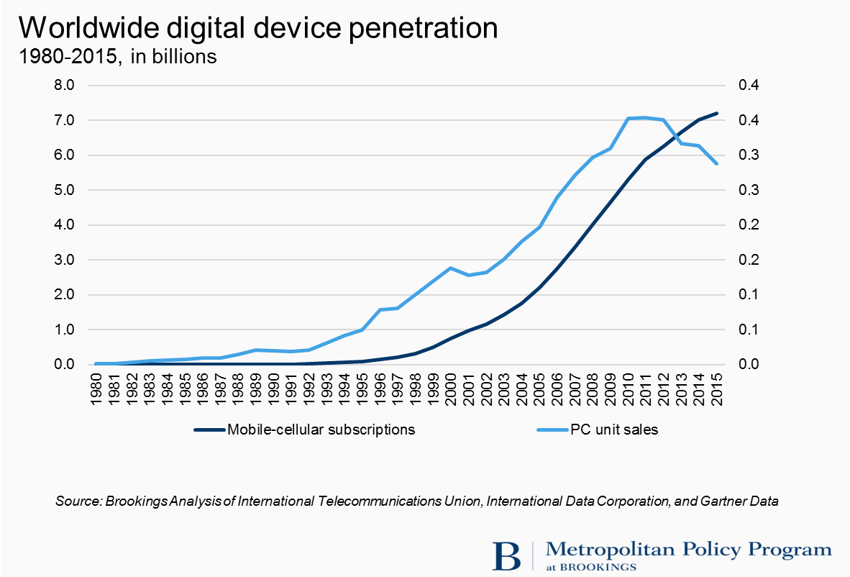

As to its concrete impacts, all of this installation has been reinventing business activity thanks to the power of computing and IT to manage information, speed calculations, accelerate sharing, reduce marginal costs, and improve the scalability of operations.[14]

In this connection, the arrival of technologies such as smartphone apps, mobile computing, file-sharing, cloud computing, software-as-a-service (SaaS), the Internet of Things, big data, digital marketplaces, and social media has enabled an explosion of digitally enabled business models and ways of working.

In terms of business models organizations of all kinds are experimenting with myriad new organizational formats ranging from decentralized and remote work, e-commerce, internet marketplaces, online talent platforms, online supply chain management, “sharing” models, dynamic pricing, crowd financing, and many more.[15]

In the workplace, meanwhile, the basic conduct of work has been remade by the continuing integration of digital tools ranging from digital storage, the Windows operating system, e-mail, productivity software like Word and Excel to enterprise management platforms like PeopleSoft and social and collaboration tools like Slack and Skype.[16] As a result, workers of every stripe—from corporate finance officers to sales people to machine operators to utility workers and Uber drivers—are spending sizable portions of their workdays running the Waze app to navigate traffic; connecting to the office by text message; managing processes through Salesforce; running diagnostic software at the building site or at bedside.

Nor does the process of digitalization appear to be slowing. While less-extensively digital industries such as retail and health care are expanding their adoption of digital technology, others are expanding their use of enterprise management software, digital payment systems, social media marketing, and data analytics.[17] Beyond that, powerful new tools are arriving in the workplace. As McKinsey notes, the rapid spread of the Internet of Things is opening the possibility of improving the utilization of machinery, boosting the output of oil fields, and making buildings and roads more efficient.[18] And in the world of professional services and business administration, even bigger changes are on the horizon with advances in artificial intelligence and machine learning.

**Why digitalization matters**

The progress of digitalization is crucial to follow, meanwhile, because major economic and labor-market impacts that flow from it are redefining work and transforming the opportunity structure of economic life for all.

Central to these impacts is the role technology has long played in the collection, storage, exchange, and use of information.[19] Digital technology particularly has a special power because it amplifies the ability of workers and firms to add value by improving the organizational, analytic, and managerial aspects of production while demoting the value of and need for other kinds of work.

In this regard, digital technology has emerged as arguably the most important driving force in the economy today given its power to both massively improve information management and rules-based processing in workplaces even as it disrupts established business practices with sizable impacts on workers.[20] Which is why academic research in recent decades has tended to show that the spread of digital technology is having significant impacts on workers, firms, industries, labor markets, and whole regions:

* **Individual workers** are seeing the nature and rewards of work change rapidly thanks to digitalization. Significant research examining labor markets in the 1970s, 1980s, 1990s, and 2000s shows that workers who use computers at work earn more.[21] Research also shows, however, that while digital technologies reward those who use them, they penalize those whose rote work the technologies can replace. Given that, most analysts attribute at least a portion of the nation’s increased inequality among workers to the spread of computers in the workplace.[22]

* **Firms**, for their part, have been shown to reap performance gains from digitalization. Firm-level analysis in recent decades on both the services and manufacturing sides has found cost savings, improved output, and productivity gains from the adoption of digital technology.[23] Numerous studies have concluded that service firms’ IT competence supports improved business performance and innovation.[24] And an even longer string of research findings documents IT’s favorable impact on manufacturing firms’ productivity.[25] For example, one recent study found that software-oriented manufacturing firms generate more patents per research-and-development dollar and achieve better valuations of their innovation investments in equity markets.[26] Much of this firm-level research stresses that the benefits of digitalization are best realized when digital investments are combined with organizational adjustments.[27] Such combinations of technology and workplace readjustment are likewise leading to effective new arrangements of work: more virtual and interdisciplinary teams; more use of networks, outsourcing, and online platforms; and more use of nonstandard work arrangements, crowd sourcing, and cloud-based services. Of course, the inverse is also true: firms that do not go digital or do not combine digitalization with organizational innovations are falling behind.[28]

* Digitalization has also helped improve the performance of whole **industries.** That was especially the case in the last major U.S. productivity boom in the 1990s and early 2000s. Between 1995 and 2000, high-tech IT-producing industries saw mean annual growth rates of 13 percent a year; industries using IT grew by 2.9 percent a year; and non-IT users expanded by only 1.7 percent a year.[29] Economy-wide, IT-producing and IT-using industries accounted for all of the nation’s productivity revival, while nonparticipating industries made a negative contribution. More recently, the McKinsey Global Institute has found that industry performance is correlated with industry digitalization.[30] Most notably, McKinsey concluded that industry digitalization levels were an important influence on 10-year productivity growth trends in the 2000s.
* Digitalization has meanwhile been transforming the aggregate **labor market**. On the positive side, the digital shift has created hundreds of new occupations that did not exist before, ranging from solution architect and cloud services specialist to app developer and social media manager. Likewise, the wider use of online talent-matching platforms like Monster.com and LinkedIn may be improving the overall functioning of the labor market.[31]

With that said, the digitalization revolution is widely believed to have contributed to the “hollowing out” of the occupational distribution. This it has done by introducing substantial tech-related skills biases into the wage distribution. Most notably, economist David Autor and his colleagues argue that as digital technologies infiltrate business processes and redefine roles, they alter what tasks workers are paid to do and so “polarize” employment and wages.[32] How does this happen? Autor and others argue that that computerization “substitutes” for workers who perform routine cognitive or manual tasks that follow explicit rules and “complements” workers who perform non-routine, more creative problem-solving and complex communication tasks. Given these differential impacts, significant literature concludes that computerization is associated with reduced demand for rote, rule-based labor and increased demand for higher-order, non-routine cognitive tasks. Data analyzed by the Federal Reserve Bank of St. Louis confirm that in the United States employment in non-routine cognitive and non-routine manual jobs has grown steadily since the 1980s, whereas employment in routine jobs of all kinds has been flat.

In terms of the trend’s effects on pay, digitalization has likely contributed to the divergence in recent decades between the earnings of the highest-skilled workers at the top and everyone else.[33]

* Finally, the digital boom is having major impacts on both the **national and regional economies**. At the national level, digitalization contributed heavily to the rapid output and productivity growth of the late 1990s and early 2000s as businesses both within and far beyond the information and communications technology (ICT) sector invested in ICT tools and business reengineering.[34] Ultimately this productivity surge drove growth in gross domestic product to nearly 4 percent a year in real terms. Since 2005, though, these gains have disappeared, and productivity growth has languished, although the continued diffusion of powerful new technologies has left many observers to hold out the possibility that productivity and output gains are either happening but poorly measured or are otherwise forthcoming.[35] With that said, a troubling aspect of the productivity-enhancing aspect of digitalization is that it may be contributing to jobless recoveries from recessions. Economists Nir Jaimovich and Henry Siu, for example, have suggested that the installation of labor-saving technology in downturns accentuates middle-skill job-losses that then depress recoveries.[36]

At the same time, the local metropolitan effects of the digital revolution are increasingly being shown to be dramatic—for good and ill. Beaudry, Doms, and Lewis have shown that the cities that adopted PCs earliest and fastest saw their relative wages increase the quickest.[37] More pointedly, Giannone has recently suggested that the “great divergence” of city wages since 1980 represents a physical expression of skill-biased technical change and related “agglomeration” effects.[38] In other words, just as technology is favoring workers with the right skills and not others, so it is favoring certain cities that contain the favored skills. No longer, therefore, are the incomes of college-educated tech and other workers converging across cities. They are diverging, as workers in digitally oriented metropolitan areas reap the benefits of working there while others do not. As to the local impacts of digital employment on poverty and social inclusion, Lee and Rodríguez-Pose also looked across metros and report that while digital employment does not reduce local poverty it does increase wages for lower-skilled workers in a region.[39] These findings suggest that local digital skills levels can have significant impacts economic performance and social inclusion

*

In sum, compelling research suggests that understanding the nature of digitalization is going to be essential to addressing such challenges as improving the prospects of workers, boosting the productivity of firms and industries, and enhancing the prosperity of regional economies.

The fact that digitalization amplifies both opportunity and inequality means that getting a clear view on its workings is an urgent priority for workers, business people, and policymakers who want to maximize the benefits of the trend and mitigate its harmful effects.

What is needed now, then, is more granular information on digitalization’s progress and impacts, occupation by occupation, industry by industry, and region by region.

**III. Defining and measuring digitalization**

Although digital tools and processes surround virtually every worker, their presence and influence remain surprisingly difficult to measure.

Most notably, broad measures of industry investment in computers or of regional concentrations of IT-trained workers, while useful for some purposes, fail to provide a granular feel for the use of digital technologies in specific tasks and workplaces. In other words, such measures do not provide insights about the workplace.

Which is why the first order of business in seeking to understand digitalization is to locate a fine-grained way to measure the trend’s presence in the workplace. This goal points in turn to the value of looking at detailed information on the characteristics of specific occupations, something that scholars like David Autor have investigated to measure related trends.

**Data**

To build this measure, we turned to the Occupation Information Network (O*NET) database, a project funded by Department of Labor’s Employment and Training Administration to provide comprehensive information about every occupation in the U.S. economy.[40]

O*NET is critical here because it surveys incumbent workers in every occupation to obtain detailed, job-specific information on workers’ education, training, experience, and skill-related work requirements. In that way, extremely detailed task-level information about the characteristics of hundreds of occupations allows for the assessment of the degree and pace of computerization across millions of workplaces.

At the same time, the study also uses historical Occupational Employment Statistics (OES) data from the Bureau of Labor Statistics for data on employment and wages, and the Current Population Survey for data on demographic variation.[41]

By collecting, linking, and analyzing these data we are able to assess the digital content of hundreds of occupations over time, analyze their association with particular industries, track their pay and growth rates, map their locations, and consider their distribution across educational and demographic groups.

### **Measuring digitalization**

To identify the digital content for each occupation, we used O*NET survey data to construct occupation-specific digital scores. O*NET surveys incumbents in every occupation to collect information about the knowledge, skills, tools and technology, education and training, work context, and work activities required for their jobs, and this inquiry drew on selected measures focused on digitalization.

Specifically, the research teams was interested in variables describing the digital content of occupations, and identified two of O*NET’s three technology variables as the most relevant measures of the overall digital tenor of occupations. One of these variables—“knowledge–computer and electronics”—measures the overall knowledge of computers and electronics required by a job, while the other—“work activity–interacting with computers—quantifies the centrality of computers to the overall work activity of the occupation. These measures seem to best capture the overall importance of digital knowledge and activity, job by job. As such, the two variables measure the level of digital skills required in each workplace.

In terms of converting these measures to mathematical data, O*NET reports a numerical score for each occupation on each variable. Requisite computer-electronics knowledge *levels* for each occupation are reported on a 0 to 7 scale, and the *importance* of computers to each job is reported on 1 to 5 scale. In the survey questions, O*NET gives examples (or anchors) of the specific tasks at level 2, 3, and 6.

Because the level and importance scales each have different ranges of possible scores, we have employed O*NET’s recommended method to equally weight the two scores by converting the original ratings to a standardized combined score ranging from 1 to 100. Along these lines we use the following equation to construct occupational digital scores as the weighted sum of the two variables:[42]

Digital score =

The maximum possible occupational digital score is thus = 100. By dint of these procedures, the least digital occupations rate low scores and the most intensely digital ones rate high scores.

### **Levels of digital skill**

With numerical digital scores assigned to every occupation, we deemed it useful to introduce two score cutoffs to allow for the classification of occupations as requiring low, medium, or high levels of digital skill. Rather than employing arbitrary mean or median digital scores as cutoffs, we have preferred to introduce level breaks based on a qualitative assessment of the occupational scores associated with O*NET’s seven- and five-point rating systems. Using those, we created three tiers of digitalization (Table 1). Occupations scored above 60 are high digital jobs, occupations scored between 33 and 60 are medium digital jobs, and occupations scored below 33 are low digital jobs.

Table 1. Derivation of O*NET digitalization cutoffs and tiers

**Derivation of O*NET digitalization cutoffs and tiers**

|  |  |  |  |  |
| --- | --- | --- | --- | --- |
| **Level measure (0-7)** | **Importance measure (1-5)** | **Standardized digital score** | **Digital level** | **Representative occupations** |
| Scored at least 5 for both knowledge and work activity | Scored at least 3 for both knowledge and work activity | 60 and above | High | Software developers (94)  Financial analysts (73) |
| Scored at least 3 for both knowledge and work activity | Scored at least 2 for both knowledge and work activity | 33 - 60 | Medium | Sales managers (60)  Registered nurses (55) |
| Everything else | Everything else | 33 and below | Low | Construction laborers (17)  Personal care aides (14) |

To bring this down to the level of familiar occupations it is worth considering the digital scores of some representative occupations. Examples from the most highly digital band of occupations include software developers and financial analysts (digital scores of 94 and 73, respectively). Sales managers (60) and registered nurses (55) are typical medium-digital occupations, while construction laborers (17) and personal care aides (14) exemplify the low band. Table 2 lists other representative occupations along with their associated education requirements and wage levels.

Table 2. Representative occupations and their digitalization levels

### 

**Industrial and regional analysis**

Scores were also developed for industries and states and metropolitan areas.

Using occupational digitization scores and OES industry-specific estimates, we created mean digital scores for each industry. Industrial digital scores are weighted by the occupational distribution within the industry.

### Similarly, mean digital scores were calculated for each state and metropolitan area using OES state and metropolitan estimates. Regional digital scores are the mean occupational digital scores, weighted by the occupational employment within the region.

### **Measuring change over time**

Digitalization is not static, meanwhile. Change is proceeding rapidly, driven by the wide adoption of digital devices and processes, with significant implications for workers, firms, and the labor market. Fortunately, O*NET permits us to measure the change of occupations’ digital content over time.

Since 2002, O*NET has employed a database structure consistent with the Office of Management and Budget-approved Data Collection Program. O*NET updates the database periodically, though not on a yearly basis. Therefore, to analyze the change of occupational digital scores over a considerable time span, we limited our time series to observations of occupations that were first surveyed before 2004 (2004 included) and have been updated at least once since 2009 (2009 included).

This limiting reduces the scope of analysis somewhat—from 774 (2010) Standard Occupational Classification (SOC) detailed occupations to 545. Nevertheless, analysis of those 545 occupations enables significant coverage of the labor market. Using estimates from the 2016 OES, these 545 occupations covered 90.8 percent of total U.S. employment in May 2016.[43]

For this analysis, we take the first score (surveyed between year 2002 and 2004) to represent the occupational digitization score of year 2002, and the latest score (surveyed between year 2009 and 2016) to represent the occupational digitization score of year 2016. Based on the assumption that occupational digital scores have been increasing over the years, using the outer boundary of this time span is probably a conservative measure of the score from 2002 to 2016.

### **Strengths and limitations**

The present assessment, in the final analysis, has strengths and weaknesses. As such the figures and trends should all be viewed as useful estimates.

The main strength here is that the methodology exploits a rich source of direct survey data to provide specific, comparable task-level information for 545 occupations as they are changing over time. This information allows for the production of a useful new data resource for policymakers and a novel analysis of the impacts of digitalization as they are making themselves felt in specific jobs, across industries, and across metropolitan areas. The result is a valuable, workplace-oriented look at how a global technology trend is touching down in particular jobs.

A key shortcoming, meanwhile, is that the O*NET occupational data are reported as aggregates and are not available as microdata that provide information at the level of individual respondents. Therefore, the digitalization scores we use for this analysis are not specific to particular industries or metropolitan areas. Rather, our analyses—including local ones—employ digital scores assigned nationally, without regard to the particular industry and location. That procedure introduces potential inaccuracy into the digital scores of particular industries as well as those of occupations and industries at the local level.

Likewise, the current requirements for a job may not be captured by the O*NET-reported occupational requirements, which often reflect information gathered in significantly earlier surveys of incumbent workers and may not reflect the latest skills being sought by employers in new hires. Given those factors, the current digital scores of some occupations may be higher than reported here.

Overall, though, this analysis provides a fresh look at the magnitude and dynamics of digitalization in the U.S. workplace over the past 15 years, and begins a discussion of how that trend has affected occupations, industries, and metropolitan areas in the United States.

**IV. Findings**

Analysis of the O*NET dataset yields a series of takeaways about the speed and extent of the digitalization trend:

1. **The U.S. economy is digitalizing at an extremely rapid pace.**

Between 2002 to 2016—the most recent period trackable with O*NET data—the shares of U.S. jobs and employment that require substantial digital knowledge rose rapidly, whether because of changes in the digital content of existing occupations (the largest effect, by far) or thanks to shifts in the distribution of occupations toward mid- and high-digital activities.[44]

The changes have been striking. By 2016, the share of employment in occupations with high digital content—defined as occupations with digital scores above 60 on a 100-point scale—more than tripled, from 4.8 to 23 percent of employment, while employment in occupations with medium digital content (scores of 33 to 60) increased from 39.5 to 47.5 percent (Figure 2). By contrast, employment in occupations with low digital scores (below 33) declined precipitously, from 55.7 to 29.5 percent.

In absolute terms, more than 32 million workers are employed in highly digital jobs, while nearly 66 million others hold moderately digital positions. Just 41 million jobs require only low digital skills.

Figure 2. Employment by intensity of job digitalization, 2002 and 2016

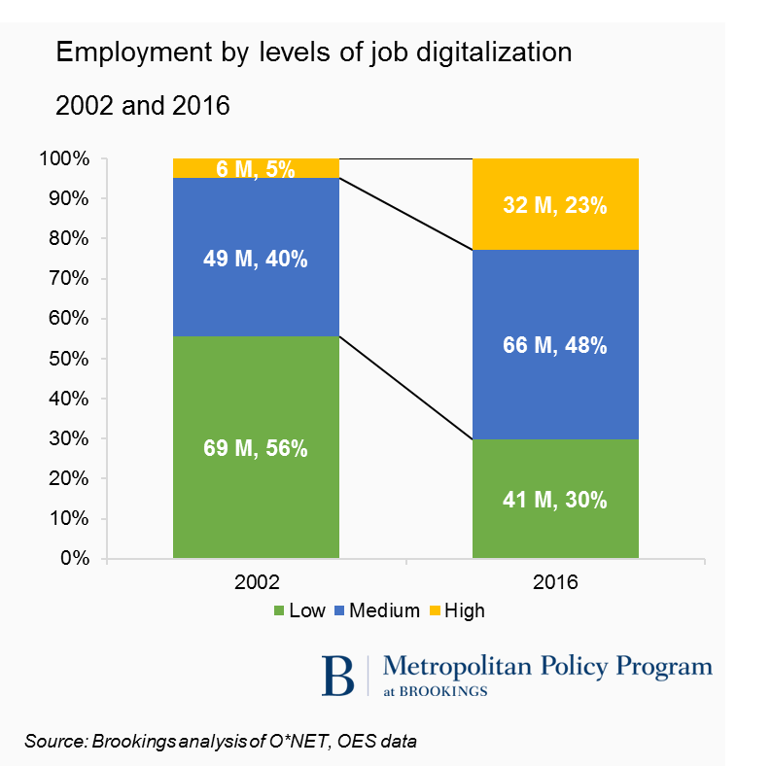

In keeping with these trends, job transformation and creation in the last few years has heavily favored digitally oriented occupations.

Specifically, nearly 4 million of the nation’s 13 million new jobs created since 2010—30 percent—have required high-level digital skills (Figure 3). Nearly two-thirds of new jobs required either high- or medium-level digital skills.

Figure 3. Digitalization intensity of new jobs, 2010 to 2016

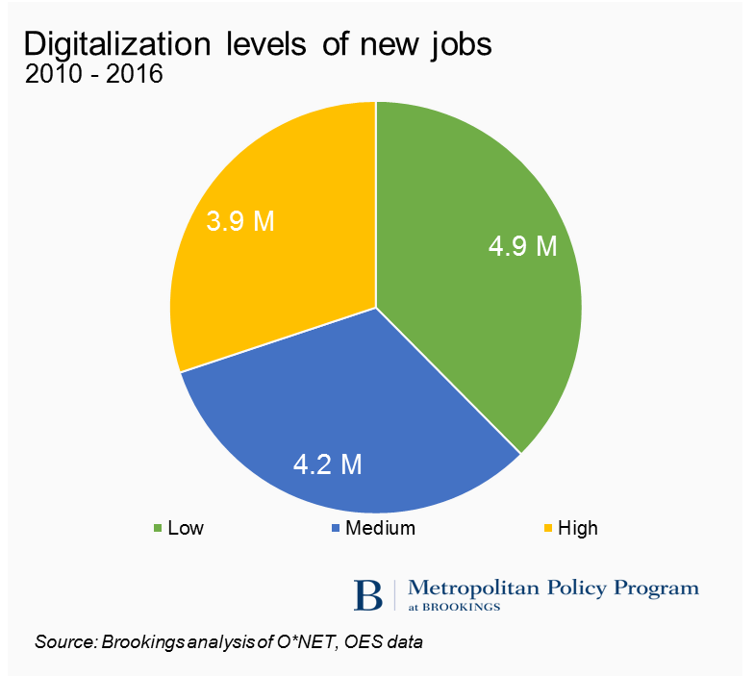

Overall, digitalization is transforming the nation’s job rolls both by expanding the digital content of hundreds of existing jobs and shifting the overall job mix toward more digitally intensive occupations.

1. **The degree and pace of change of digitalization vary widely across occupations and industries.**

Digitalization is proceeding rapidly and widely but not evenly across occupations and industries.

Looking broadly across the job rolls, digitalization scores rose in 517 of 545 analyzed occupations from 2002 to 2016. The average digitalization score across all occupations rose from 29 in 2002 to 46 in 2016, a 57 percent increase. Middle-range occupations including home health aides, teachers’ assistants, and customer service representatives have in many cases seen digitalization score increases of 19 to 36 points since 2002.

And yet, that is the middle of the distribution. Digitalization is in fact proceeding at varying rates and extents up and down the occupation list.

At the top of the scale, numerous highly digital occupations became even more digital, including computer network support specialists (a rise from 61 to 74), electronics engineers (69 to 90), aerospace engineers (65 to 77), and statistical assistants (66 to 73). At the same time, each of the three most intensely digitalized occupations in the analysis—software application developers, computer hardware engineers, and systems developers—saw modest declines in their starting scores of around 97. In general, however, occupations that were initially highly digital logged modest further digitalization, though overall the digitalization score of the aggregate highly digital group slipped by 2 points (Figure 4).

Figure 4. Mean digital scores of occupational tiers by 2002 scores, 2002 and 2016

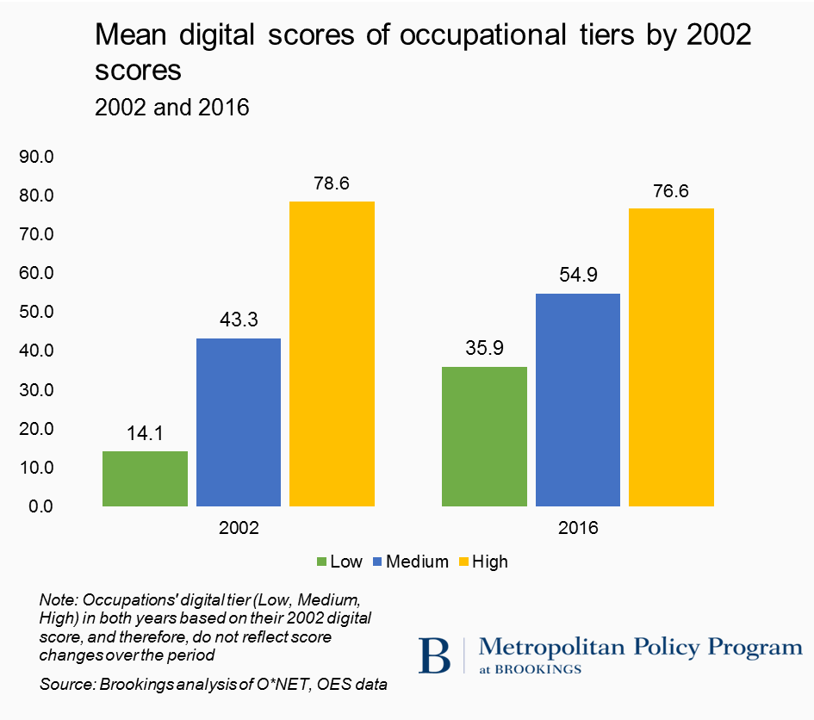

Turning to the middle of the scale the average 2002 digitalization score of 43 among medium-digital occupations rose by 12 points to reach 55 in 2016. In this part of the distribution, many less-digitalized occupations underwent radical increases in their digitalization scores.

At the middle of this middle band of occupations, digital scores for secretaries, elementary school teachers, and computer-controlled machine tool operators surged from 45 to 59, 45 to 58, and 40 to 56, respectively. In dozens of moderately digitalized occupations, such as automotive service technicians (39 to 55), registered nurses (38 to 55), and human resources specialists (37 to 60) digital content and scores rose 50 percent or more. Further dramatizing the extent of the changes is the transformation of many middle-range jobs into highly digital ones. Examples of such transitions include chemical engineering (with a sore rise from 47 to 69), actuaries (40 to 78), financial managers (41 to 61), and first-line supervisors of office and administrative support workers (39 to 64). In short, hundreds of thousands of middle-skill jobs in occupational areas such as business and financial operations, office and administrative support, and health care have been taking on substantially greater digital content (Table 3). As they have, these large and mostly mid-digital occupational groups have accounted for the greatest change in the nation’s overall digital job distribution, in part by scoring the largest digitalization increases, occupation by occupation.

Table 3. Selected occupations by digital score increase



Nor have the least digitalized occupations remained static. In fact, very dramatic task change is occurring among some of the most traditionally accessible occupations that have historically allowed new or less-skilled or -educated workers to find decent employment. Here across the lower end of the scale the average 2002 digitalization score of 14 among low-digital occupations rose by now less than 22 points, or 154 percent, over the time period to reach 36 in 2016. The scores of many lower-score occupations, including home health aides (score rise from 3 to 23), welders (3 to 23), and heavy truck drivers (7 to 30), saw their scores triple or more. By 2016 no fewer than 229 initially low-digital occupations, or 48 percent of them, employing 33 million workers in 2002 had exited the low-digital category and become medium-digital or even high-digital occupations, marking the steady upskilling of even lower-end jobs accessible to new or less-skilled workers. Among the occupations transitioning from low scores to medium or high include tool and die makers (score rise from 3 to 51), social and human service assistants (17 to 54), bus and truck mechanics (17 to 48), and audio equipment technicians (30 to 75).

Thus, while the digital content of virtually all jobs has been increasing, the extent of the increases varies widely, and appears most dramatic in the middle and toward the lower end of the skills distribution.

How do these changes tie into trends in industry, meanwhile? Add them up, and the ongoing digitalization of hundreds of occupations reflects the fact that the entire U.S. economy is digitizing rapidly but unevenly, with much variation in the extent and pace of digitalization across industries.

Virtually all industry groups saw their mean digital scores increase between 2002 and 2016 (Table 4), but the degree and speed of digital adoption vary significantly, suggesting wide variation in industries’ and firms’ ability to improve their operations, productivity, and results. Leading the digitalization race with many of the highest employment-weighted mean digitalization scores for 2016 is a group of broad service sectors, including professional, scientific, and technical services (mean 2016 digital score of 55); media (52); finance and insurance (55); and management of companies (51).[45] These sectors have also seen rapid digitalization over time. Overall, the 50 industries that compose the nation’s higher-tech advanced industry sector exhibit significantly higher mean digital scores (48) than the rest of the economy (40).[46]

Table 4. Industry mean digitalization scores and change, 2002 and 2016

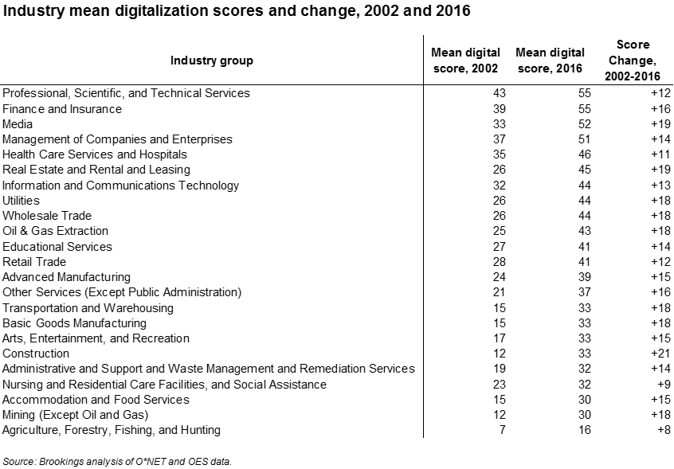

Following these pace-setters are a number of capital-intensive sectors like utilities, oil and gas extraction, and advanced manufacturing with middling digital scores but also brisk adoption. Some of these are the kinds of “physical” industries that some economists believe will be further energized by the infusion of information.[47]

Finally, a number of large labor-intensive, often locally traded industries have lower scores but are also beginning to substantially absorb digital technologies. These sizable and often lower-productivity sectors—which include education, transportation and warehousing, basic goods manufacturing, and construction—have scores mostly in the 30s and remain in the mid- to low-digital tiers of industries. However, many of their digital scores have tended to double since 2002, suggesting they may be able to achieve greater efficiency in the near future. With that said, the scores of some less-digital industries—such as nursing and residential care facilities or accommodation and food services—may reflect an orientation to direct human interaction that makes them less amenable than others to using technology to cut costs and increase productivity.

In any event, wide gaps exist between the most heavily and least-digitalized occupations and industries, with some of the least-digitalized sectors also exhibiting some of the slowest digital adoption. To the extent that current levels of digital skills may forecast varied levels of future success in navigating economic change, these uneven levels of digitalization warrant concern while holding out opportunities.

1. **Digitalization is associated with increased pay and job resiliency in the face of automation but also “U-shaped” job creation patterns.**

The unevenness of digitalization across occupations and industries is important because digitalization influences pay, job durability, and growth.

Digitalization is a key pathway to increased earnings. All across the skills continuum employees are rewarded for the depth and breadth of their digital skills through increased wages. Workers in occupations with medium or high digital skills in 2016 were paid significantly more than those in low-digital occupations.

Specifically, while the mean annual wage for workers in highly digital occupations reached $72,896 in 2016, workers earned about $48,274 in middle-level digital jobs and $30,393 in low-digital positions (Figure 5).

Figure 5. Mean annual wage by digitalization level, 2016

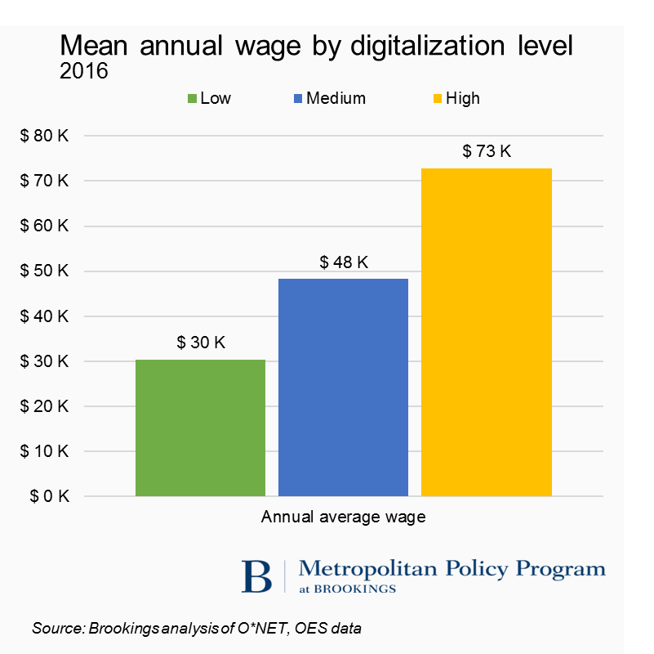

Nor do these pay differentials owe simply to educational differences (which themselves bring digital skills differences). In fact, even when controlling for education levels, the data here confirm the presence during the 2000s of a consistent, statistically significant wage premium for computer skills that has almost doubled since 2002 (see the box, “Untangling Digital Skills and Education”).

These pay differentials are important not just for their influence on worker compensation but also because they point to the durability of work in the era of automation. To explore this, we compared occupations’ digital scores to their automation potential, as quantified by the McKinsey Global Institute’s estimates of the share of an occupation's overall task content that could be automated by adapting currently demonstrated technology.[48] In this vein, a number of statistical tests reveal a modestly strong negative correlation between a job’s increased digital content and the share of its tasks vulnerable to automation (Figure 6). For example, nearly 60 percent of the task content of low-digital occupations appears susceptible to automation, compared to only around 30 percent of tasks in highly digital occupations. These numbers range from over 85 percent of the task load in production occupations to less than 30 percent for computer occupations.

Figure 6. Average automation potential of major occupational groups, by mean digital score

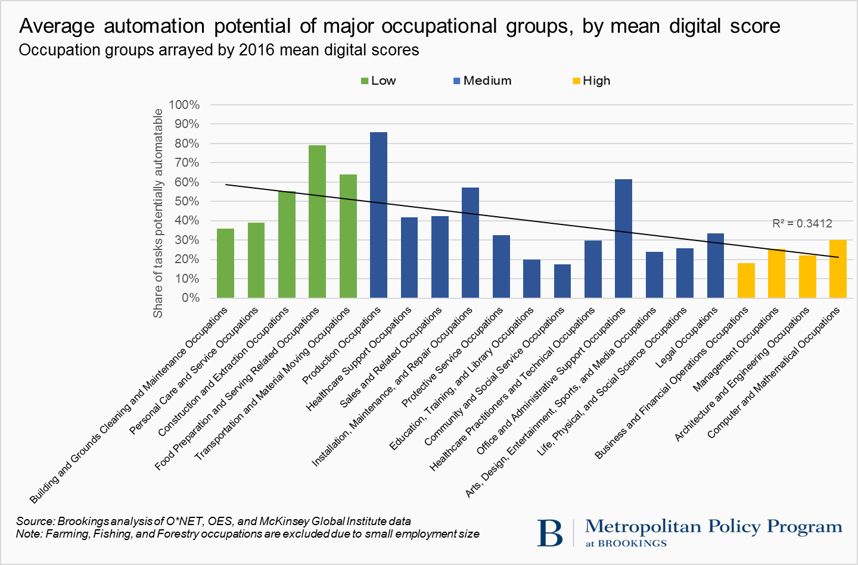

In sum, workers with superior digital skills tend to earn higher wages than similarly educated workers with lower digital skills, and they may be marginally less exposed to automation-driven displacement.

**Untangling digital skills and education**

To what extent do digital skills reflect a distinct component of human capital as opposed to a general expression of education levels? Statistical analysis suggests that while the two are related, they are not the same. While there is a positive correlation between digitalization level and education level, significant technical and pay variations exist among occupations that require the same level of education, pointing to the existence of a distinct wage premium for digital skills in the workplace.

**Figure 7. Distribution of average digital score by education requirements**

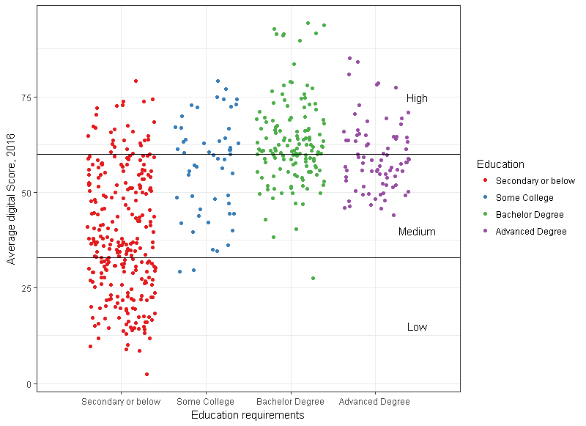

One way to see this is to note that while rising education levels tend to be associated with higher digital skills, the digital scores of particular occupations associated with particular educational levels vary widely (Figure 7). Notably, the O*NET data confirm that numerous good-paying, highly digital jobs—including numerous technician and clerical jobs—are obtainable by workers without a bachelor’s degree.

Another way to look at this, however, is to assess whether the job market pays a statistical wage premium for digital skills. To this end, we ran regression analyses to compare the average annual wage of the 545 occupations under study with their digitalization scores, while controlling for the education level required by each occupation. The result: digitalization scores have significant and positive effects on real annual wages even when controlling for education level. And the effect is growing. In 2002, a one-point increase in digitalization score predicted a $166.20 (in 2016 dollars) increase in real annual average wages for occupations with the same education requirements. By 2016 this wage premium had almost doubled to $292.80.

In sum, workers with superior digital skills are more and more earning higher wages (all other things being equal) than similarly educated workers with thinner digital skills.

Similar trends surface with regard to digitalization and wage growth. Again, digital skills command increased rewards, in this case because computer skills command not just initial modest wage premiums but also sizable wage gains over time associated with what the economist James Bessen shows are “skills learned through experience on the job.”[49]

At the top of the wage distribution, occupations with high-level 2016 digital scores on average registered more than 0.8 percent wage growth annually between 2010 to 2016 (Figure 8).

Figure 8. CAGR of real mean annual wage by occupation group, 2010 - 2016

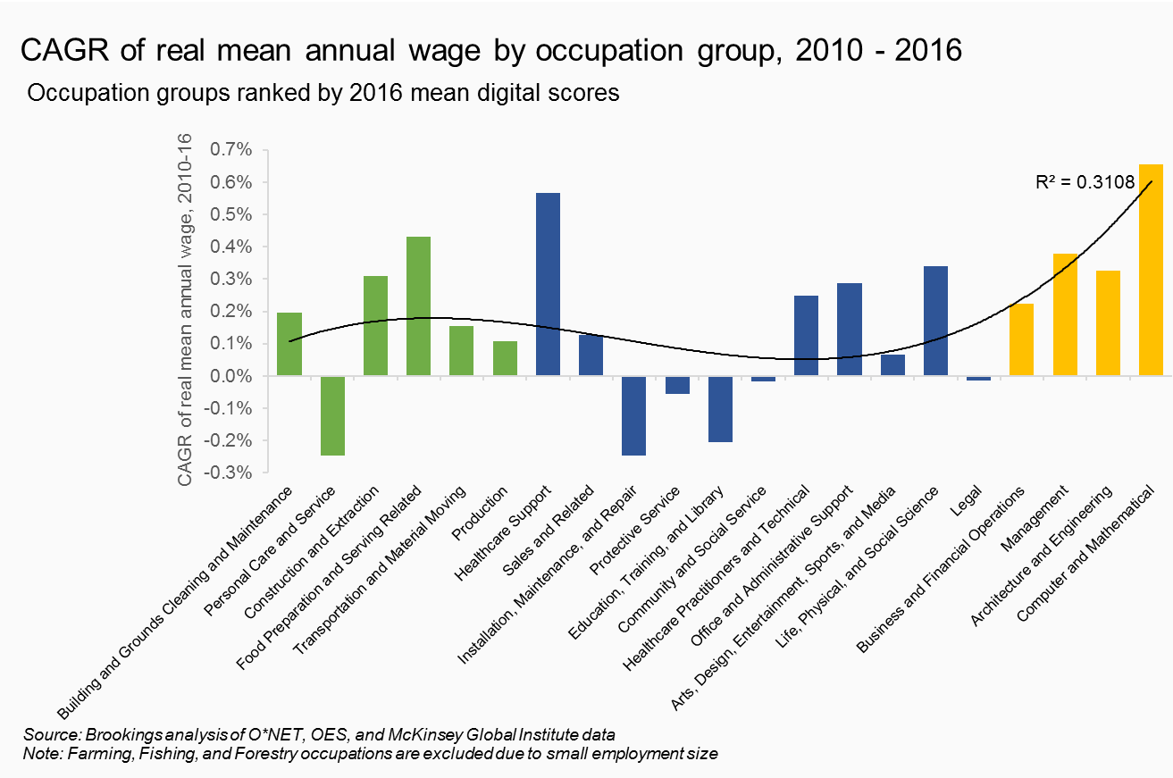

Leading the way were computer-mathematical occupations that scored wage gains of 0.7 percent a year in the post-Great Recession period. For their part, medium-digital occupations experienced middle-range wage growth of 0.3 percent over the period, while occupational groups that have low mean digital scores, such as personal care and maintenance, saw average wage declines of about 0.2 percent a year. (Note that while most low-digital occupational groups saw modest wage growth, those groups’ aggregate performance was trivial given the strongly negative wage trend of the huge personal care and service group).

Aggregating these data to look at sectors and industries, meanwhile, this analysis finds that industry digitalization levels are strongly associated with key indicators of industry performance such as output, productivity, and wage growth—though job creation has a different pattern.

Output growth during the 2000s, for example, has been heavily associated with industries’ mean digital scores. For example, highly digital service industries like professional, scientific, and technical services; ICT; and media turned in some of the economy’s fastest output growth in the 2010 to 2016 period (Table 5). Likewise, in an era of slowing productivity growth, these same most highly digitalized sectors led the economy on productivity increases. For example, the ICT and media sectors each increased its annual productivity growth by more than 2.5 percent. By contrast, productivity in medium-digital sectors like health care and advanced manufacturing grew by only a modest 0.7 and 0.3 percent a year, while the lagging hospitality and construction industries saw slightly negative productivity growth.

Table 5. Industry mean digitalization scores and economic performance, 2016



Focusing on patterns of job creation, finally, the digitalization of the U.S. economy appears to be contributing to the hollowing out and polarization of employment and wage distributions noted by Autor and colleagues.[50]

Along these lines, O*NET analysis suggests that job growth has been differentially rapid in occupations at the upper and lower ends of the skill distribution and sluggish in the middle. For example, job creation has been relatively robust since 2010 for both highly digital computer-mathematical and business-finance occupational groups and low-digital occupational fields such as personal care and food preparation (Figure 9). By contrast, mid-digital occupational groups like office-administrative and education occupations have seen much slower job and wage growth.

Figure 9. CAGR of employment by occupation group, 2010 - 2016

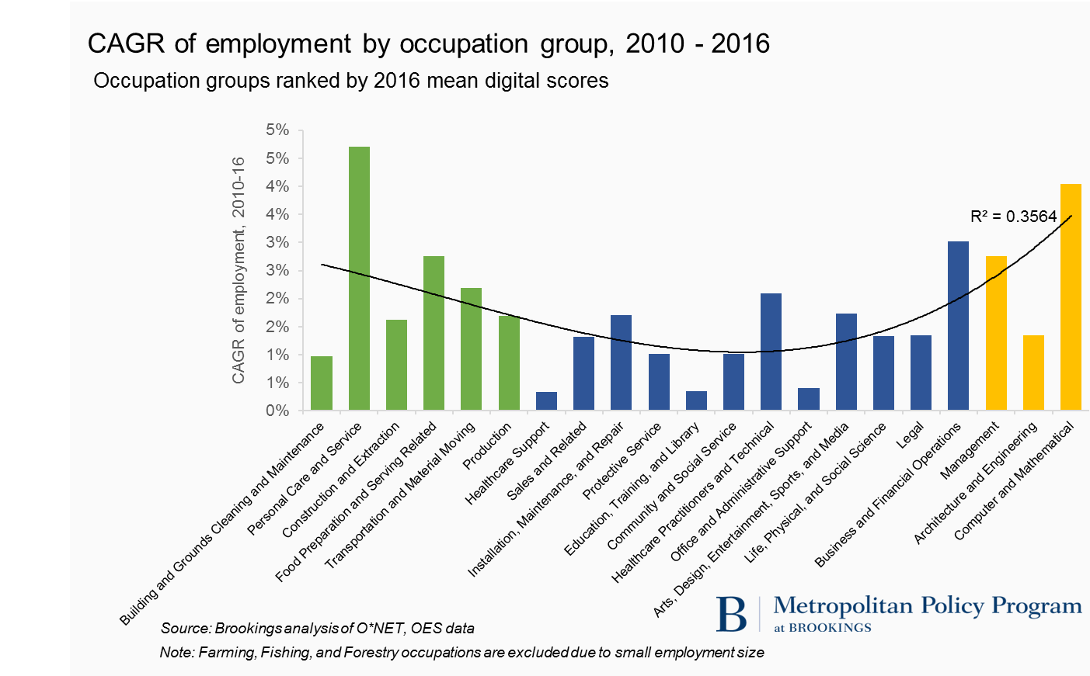

Why might this be? Autor and others suggest that such effects reflect the differential ways digital technology shapes the demand for workers. As discussed above, they hypothesize that computerization strongly complements the non-routine, creative problem-solving tasks of highly skilled workers while directly substituting—say through computerization or automation—for the routine, repetitive tasks found in many traditional middle-skill, middle-digital occupations. As to the low end of the skills distribution, Autor and others hold that rising employment and even wage expansion among some lower-digital occupations reflect a strong shift of work into face-to-face personal service occupations supported by increased demand generated by high-digital consumers. Another factor is likely the difficulty of automating personal service work (such as personal care, cleaning, or maintenance) that relies heavily on flexible interpersonal communication and direct physical proximity.[51] By the same token, many middle-skill, repetitive jobs in the middle of the occupational distribution may well be experiencing significant automation already and slower growth because of it.

In this regard, digitalization appears to be contributing to: job creation and pay gains in high-digital industries; slow job creation and modest pay gains in medium-digital occupational groups (except in personal-services like health care, where the growth has been faster); and faster job growth but low and slow-growing wages in low-digital personal service occupations.

Taken together, these output, productivity, wage, and growth variations and dynamics suggest that digitalization trends may be a key to the nation’s challenging economic cross-currents in recent decades. For workers, the acquisition of digital skills offers one route to improved pay in a challenging labor market. And for industries, further digital adoption—particularly by lagging industries—may be a way to score significant near-term output and productivity gains at a time of too-slow growth.

1. **The extent of digitalization varies widely across places and is strongly associated with variations in regional economic performance.**

In geographical terms, digitalization is happening everywhere, but its progress varies widely across the map. Just as the diffusion of digital technology and processes has been uneven across occupations and industries, it is proceeding unevenly across space.

States’ mean 2016 digitalization scores vary extensively (Figure 10), and range from 51 in the **District of Columbia** to 41 in **Nevada**. **Massachusetts**, **Maryland**, **Virginia**, and **Connecticut**—all with mean 2016 digitalization scores exceeding 47—top the list of states with the most digitally oriented occupational bases. It bears noting that all states’ mean digitalization scores rose by 18 to 22 points between 2002 and 2016, with **Utah**, **Arizona**, **Mississippi**, **Tennessee**, **Arkansas**, and **Rhode Island** all seeing their mean scores increase by more than 21 points.

Figure 10. Mean digital scores by state, 2016

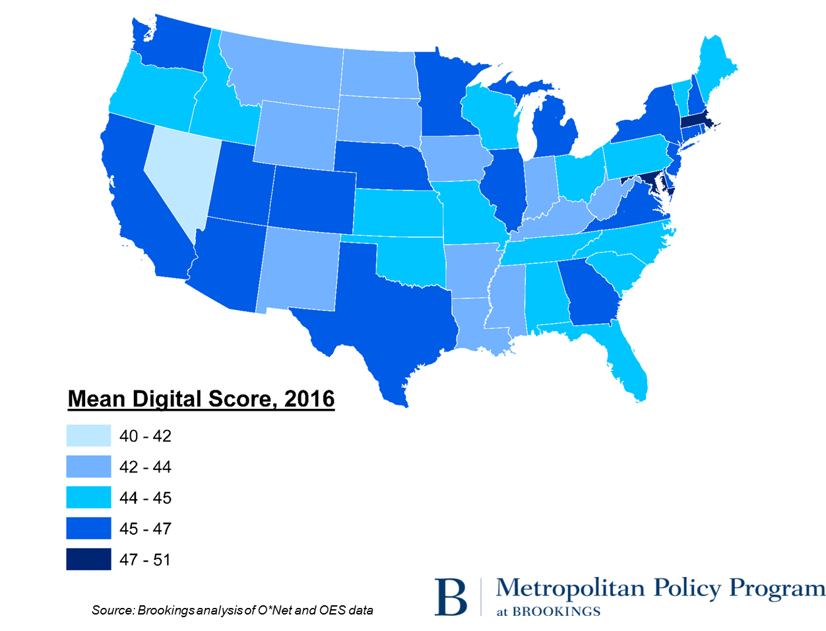

Not surprisingly, states’ median wages correlate with their mean digital scores (Figure 11). The **District of Columbia**, **Massachusetts**, **Maryland**, and **Connecticut** enjoy median wages of $55,000 or more. By contrast, the mean wage in **Nevada**—with a mean digital score of 41—remains around just $43,000.

Figure 11. Correlation between states’ mean annual wage and mean digital scores, 2016

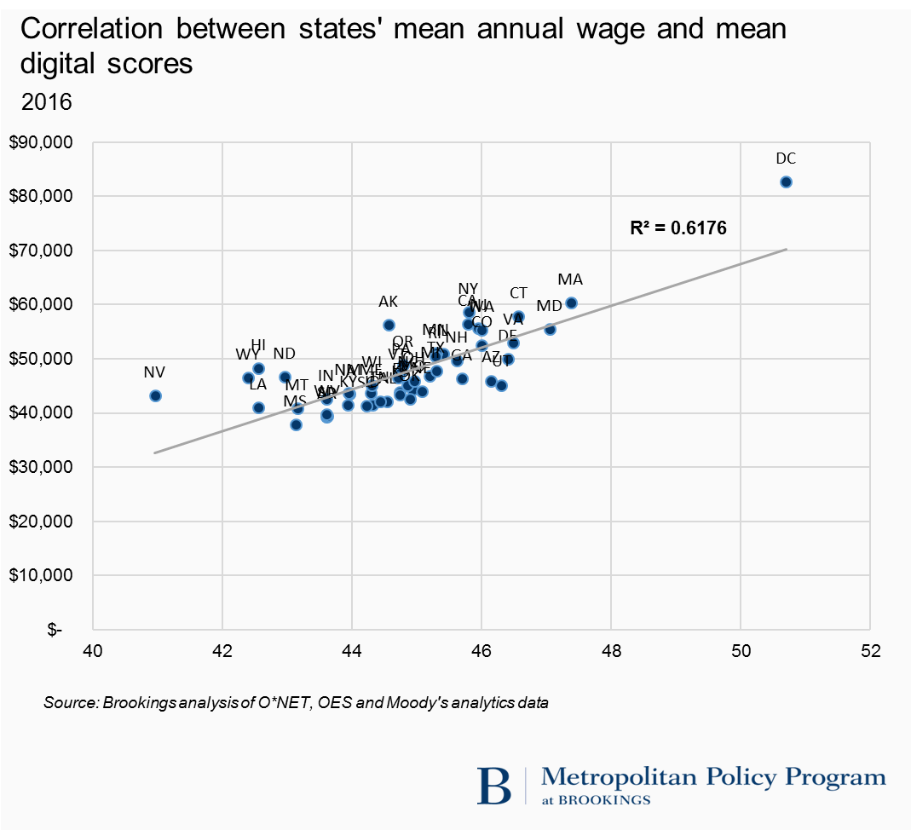

Such trends suggest that digitalization is sweeping through all state economies, with varied impacts and implications for competitive advantage. Lower-scoring, slower-digitalizing states have work to do to catch up.

Table 6: Top 15 and bottom 5 metropolitan areas by 2016 mean digital score

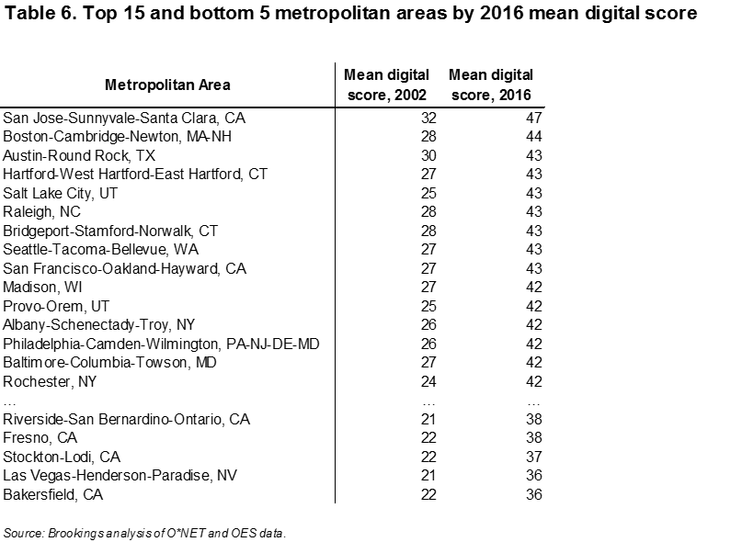

Turning to metropolitan areas the data reveal more variation (Table 6). Large-metro mean digitalization scores for 2016 range from 47 in **San Jose,** Calif. to 36 in **Las Vegas**. Following San Jose at the top of the digitalization rankings comes a “who’s who” of higher-tech advanced industry centers ranging from **Boston**; **Austin**, Texas; **Hartford**, Conn.; **Salt Lake City**; **Raleigh**, N.C.; **Seattle**; San Francisco; and **Madison**, Wis.—all with mean 2016 digitalization scores above 43 (Figure 12).

Figure 12. Mean digital score and share of high digital jobs by metropolitan area, 2016

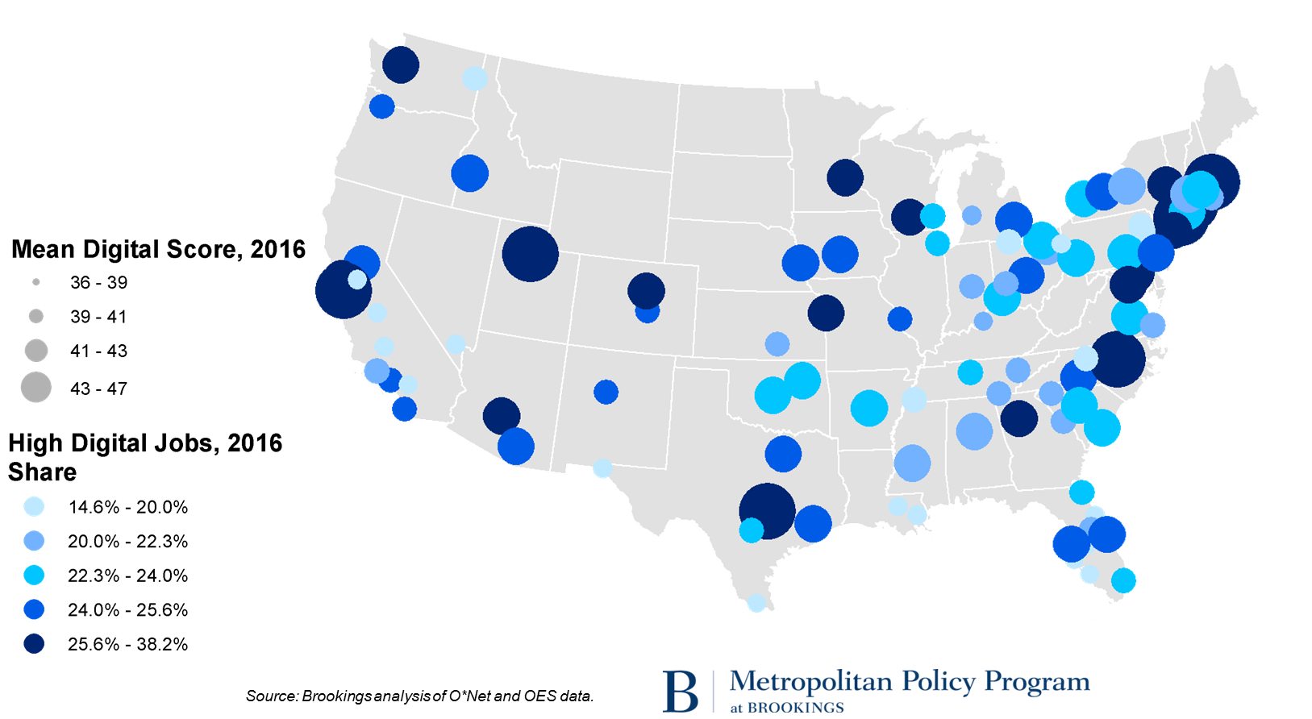

Digitalization scores in all of these more digital metros increased by 12 to 18 points. **Salt Lake City**; **Rochester**, N.Y.; Phoenix; **Little Rock**, Ark; **Charleston**, W. Va.; and **Akron**, Ohio have all elevated their mean digitalization scores by 18 points or more, though *all* metros saw significant score increases to the point that large cities’ mean digitalization scores have been converging. The left panel of Figure 13 shows that metros with lower mean digital scores have actually been increasing their digital ratings faster than metros with higher scores. On this measure mean digital skills levels is converging.

The story is different, however, when mapped for metros’ varying shares of employment in *high*-digital occupations (right panel of Figure 13). This more high tech-favoring measure exposes a much wider range of 2016 metro digitalization scores, ranging from nearly 38 percent of local employment in highly digital occupations in **San Jose** to just 14.6 percent in **Stockton-Lodi**, Calif. The list of the most digitalized metros reads like a gazetteer of the largest, best-established tech hubs in the nation—ranging from Metro **Washington**, **Seattle**, **San Francisco**, and **Boston** to fast-followers like **Austin** and **Denver** and to such university towns as **Madison** and **Raleigh**.

Figure 13. Convergence and divergence among large metros by mean digital score and high digital share, 2002-2016

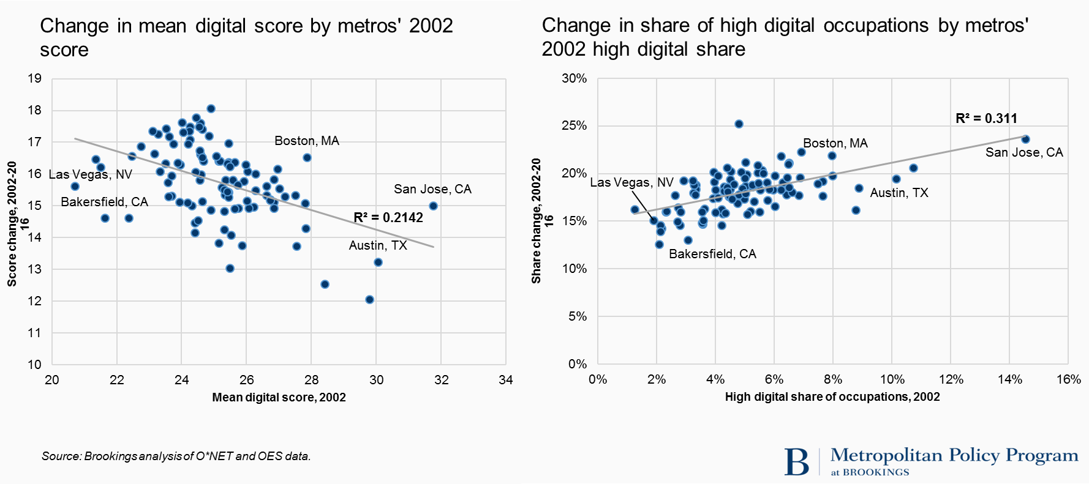

Not only do metros’ high-skill digitalization ratings vary sharply; they are also *diverging*. In this regard, the digital rich are getting richer, a trend that can be seen in the 100-metro scatterplot in Figure 13. The higher a metro area’s 2002 share of highly digital occupations the greater the growth of its share of jobs in such occupations in the years 2002 to 2016. For example, **San Jose**, **Washington**, and **Austin**—with highly digital employment shares in excess of 10 percent in 2002—have all increased their shares by more than 20 percentage points since then. By contrast, metros with low starting presence in highly digital occupations (such as **Stockton**; **Youngstown**, Ohio; and **McAllen**, Texas), all with high-digital job shares of less than 2 percent in 2002, have seen much slower employment growth in highly digital occupations—more along the lines of 10 percentage points. In short, a high initial digital score predicts faster future digitalization.

As to the implications of these variations for regional economies, they follow directly from the strong correlation of digitalization with worker compensation and industry performance. Both metropolitan areas’ current wage levels and recent wage growth appear to be highly correlated with mean digitalization scores, which are tightly linked (though not identical) to education levels.[52] For example, the metros with the highest 2016 mean digital scores were also the ones with the highest education levels and mean annual wages. **San Jose**, **San Francisco**, and **Washington** dominate this distribution, with their very high digital scores correlating with average wage levels of $64,000 a year or more. By contrast, metros like Las Vegas; Bakersfield, Calif.; and Riverside, Calif., with digital scores in the mid-thirties, support annual wage levels of $45,000 or below. These patterns comport with significant prior findings that have shown that differences in technology use across cities likely affect relative wages.

Figure 14. Correlation between metros’ mean annual wage and mean digital scores, 2016

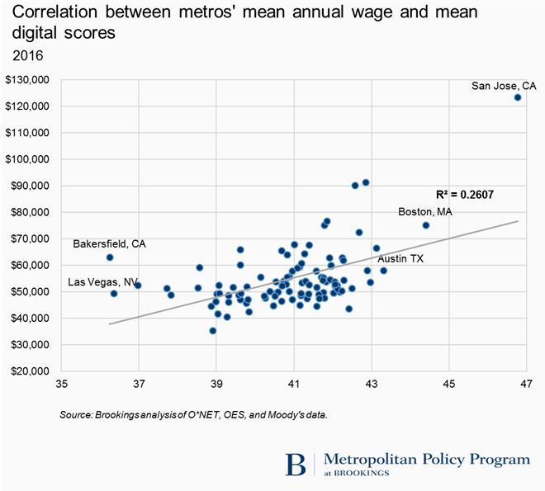

These trends underscore a key point about the influence of digitalization on regional prosperity: variations in the digital skills of the local workforce may be contributing to the polarization of cities’ economic fortunes. In this respect, to the extent that Elise Giannone attributes the divergence of city wages since 1980 to a mix of skill-biased technical change and local industry clustering, then digitalization is likely a contributing factor to the current divergence of cities’ prosperity levels.[53]

In short, digitalization appears to be associated with several important economic benefits for cities but also with the widening inter-metropolitan performance and wage gaps that economist Enrico Moretti calls “the Great Divergence.”[54] Digitalization, in that vein, appears at once to reflect and reinforce the polarization of workforce skills across places that is improving pay for many people and places while widening the divide between the leading cities and the laggards.

1. **Digitalization is changing the skills workers need to access economic opportunity while creating new race- and gender-based training challenges.**

Digitalization, finally, is changing the skills less advantaged workers need to secure good jobs. Given that, the spread of digital tools is underscoring the importance of digital competencies in helping less-educated workers secure basic opportunity even as it throws into relief sharp disparities among particular groups’ digital preparedness.

The digitalization of occupations, in this regard, represents an underrecognized feature of the environment within which communities must work as they seek to foster economic inclusion. Moreover, the spread of digital technology into most industries is altering the circumstances within which less-educated or otherwise marginalized workers strive to access solid livelihoods.

To see this, it is worth looking at changes in the nature of what have been called by turns “good jobs” or “middle-skill” jobs—jobs that have the potential to help workers without a four-year college degree earn enough to support themselves and begin to move toward the middle class.[55] Such jobs—here defined as full-time jobs that do not require a bachelor’s degree yet pay higher than the national average wage—represent a critical first link to opportunity for tens of millions of the nation’s working-age adults and struggling families. Because they are at once obtainable and stable, these positions in some 89 accessible full-time occupations provide a critical initial link to economic advancement for the two-thirds of Americans who lack a college degree.

However, an analysis of the changing skills profile of America’s 14 million or so “good jobs” makes clear that the nation’s most accessible decent positions are rapidly digitalizing and therefore demanding more digital competency than in the past. Specifically, where the mean digital score of America’s good jobs clocked in at 29 in 2002, it had more than doubled to 50 by 2016 (Table 7). Put another way, where 49 percent of these attainable full-time jobs required medium or high levels of digital competence 15 years ago, 87 percent of them do now. Thus, a sizable portion of the nation’s critical middle-skill employment now requires dexterity with basic IT tools, standard health monitoring technology, computer numerical control equipment, basic enterprise management software, customer relationship management software like Salesforce or SAP, or spreadsheet programs like Microsoft Excel.[56]

Table 7. Share of jobs by digital score, 2002 and 2016



Along these lines, digital scores in numerous occupations in maintenance, production, health care, and sales have surged from low to high-medium thanks to the spread of digital tools. First-line supervisors of construction workers, for example, now rate a high-middle 55 digital score (up from 8 in 2002), while the digital scores of real estate sellers, bus and track mechanics, and registered nurses have doubled since 2002 to reach solidly mid-digital status. Beyond that, another 2 million good jobs—frequently technicians whether in audio-video or civil engineering or electronics—now require high-digital skills. In sum, tens of millions of jobs that provide the best routes toward economic inclusion for workers without a college degree turn out to be less and less accessible to workers who lack basic digital skills. That the pace of digitalization remains rapid suggests that millions of workers could be shut out of decent middle-skill opportunities if they lack the requisite skills. By the same token, however, over 2 million high-digital, likely well-paying jobs do not require a college degree.

And here is the crux: the mean skills ratings of the jobs occupied by workers in various demographic groups differ in ways that almost certainly contribute to those groups’ uneven access to opportunity.

One way to see this is by way of the Program for the International Assessment of Adult Competencies (PIAAC) survey, which shows that the level of proficiency by the measure of “problem solving in [a] technology-rich environment” varies sharply by racial/ethnic group. The black and Hispanic populations have much larger shares rated “below level 1” on the PIACC technology proficiency measure compared to whites (Figure 15).

Figure 15. Share of U.S. adults by PIAAC proficiency

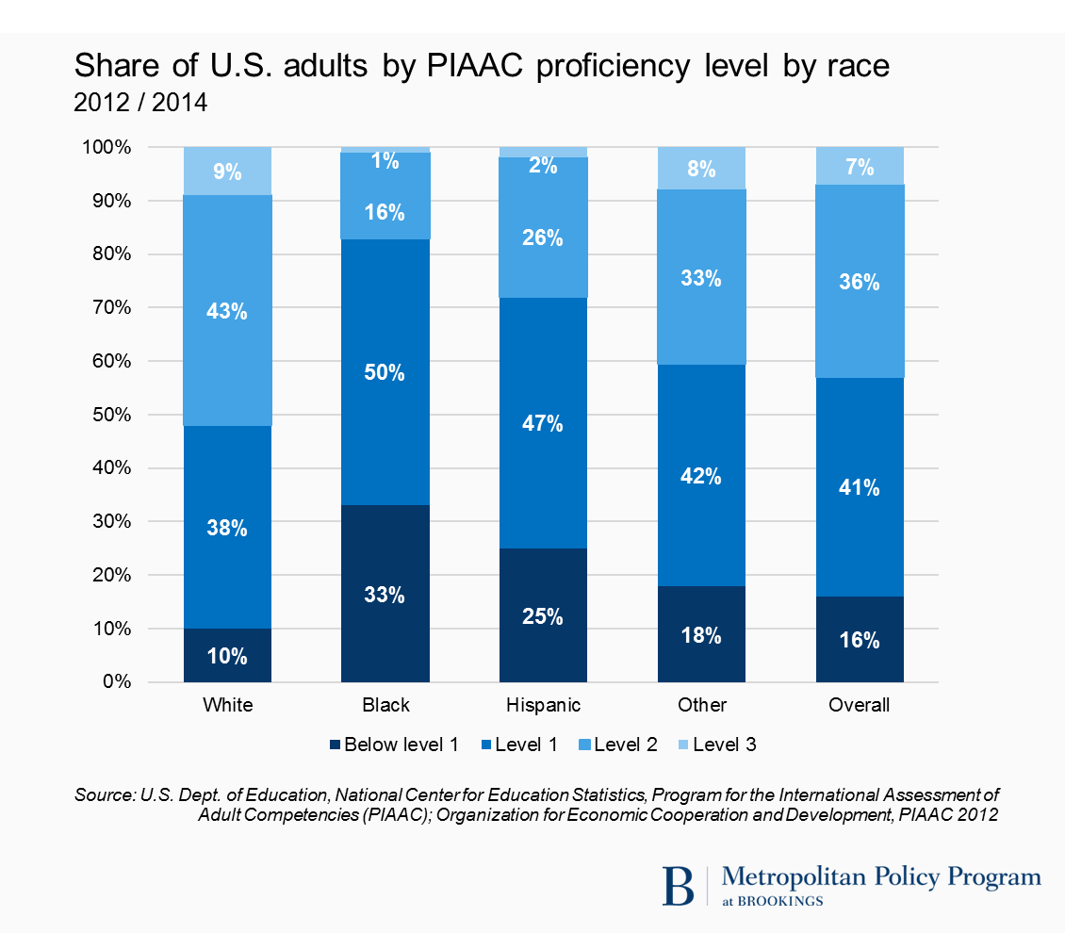

In parallel fashion, O*NET data also highlight this digital-skills access problem. Relatively modest aggregate variation across gender and racial lines obscures sharper variation across particular occupational groups, with clear implications for economic inclusion.

At the broadest level, the mean digital scores of the occupations filled by the members of particular demographic groups range notably (Figure 16). While occupations filled by white workers register a mean digital score of 48, those filled by Asians rate a much higher 51, while those held by black and Hispanic workers register at just 44 and 40, respectively. Women occupy jobs with a slightly higher mean digitalization score of 48 compared to 45 for men. That the relative rank order of these groups’ scores have not changed substantially even as the scores themselves rose by 60 to 80 percent between 2002 and 2016 underscores the difficulty in substantially improving groups’ relative human capital.

Figure 16. Average digital scores by demographic group, 2002 and 2016

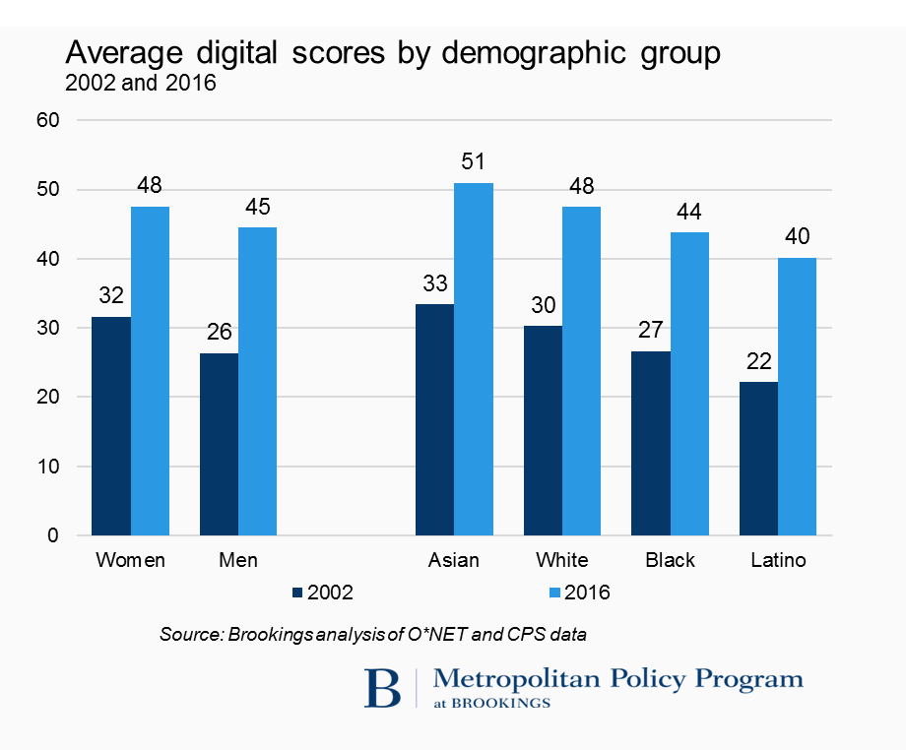

A closer look at the profile of particular groups’ employment further emphasizes the economic implications of differences of orientation and digital preparedness. Women, with slightly higher aggregate scores as a group than men, represent around three-quarters of the workforce in many of the largest medium-digital occupational groups, including the large (and growing) health care, office administration, education, and social service fields (Figure 17). By contrast, women remain significantly underrepresented in such highly digital positions as computer and mathematical occupations (25.5 percent) and engineering (14.2 percent). Conversely, men continue to dominate the highest-score computer, engineering, and management domains as well less-digital transportation, construction, natural resources, and building and grounds occupations.

Figure 17. Employment profile by demographic group, 2016



Equally sharp variation can be seen in the employment profiles of racial and ethnic groups. Whites, for their part, make up 65 percent of the workforce but remain overrepresented in such high-digital occupational groups as engineering and management and such medium-digital areas as business and finance, the arts, and legal and education professions (Table 8). Asians, by contrast, make up just 6 percent of the workforce but account for 21.3 percent of highly digital, high-pay computer and math occupations and 11.6 percent of engineering occupations. Blacks, meanwhile, make up 12 percent of the workforce but are overrepresented in such medium-digital occupations as office and administrative support, community and social service, and health care support as well as lower-digital jobs such as transportation, personal care, and building and grounds maintenance. And while Hispanics make up about 17 percent of the workforce, they are heavily overrepresented in such low-digital domains as farming, construction, and buildings and grounds maintenance. Conversely, blacks and Hispanics are significantly underrepresented in high-pay, high-digital technical, business, and finance occupational groups and somewhat underrepresented in medium-digital legal, sales, and education positions.

Table 8. Over- and underrepresentation of gender, racial groups by occupational group, 2016



In terms of change over time, these relative positions have not changed much over the last 15 years notwithstanding the pace of economic change. Despite slow growth in production and construction occupations, men do not seem to have heavily shifted into growing health care, personal care, or assistance jobs, for example. Nor have blacks or Hispanics made significant new inroads into medium- or high-digital occupational groups, although Hispanics have disproportionately expanded their presence in installation and maintenance, sales, construction, and farming.

In sum, while digitalization holds out significant opportunities for less-educated or historically marginalized workers or groups to move up the employment ladder, too few of them appear to be making that progress.

**V. Implications: strategies for adjusting**

Digitalization, in sum, is transforming the world of work. Workers, firms, industries, as well as entire regional labor markets are all being dramatically affected.

On the upside, the augmentation of workers’ abilities to perform existing jobs combined with the creation of entirely new jobs is delivering major benefits, including higher productivity and pay for wide ranges of workers, industries, and places.

Digitalization, in this regard, is increasing the potential of individuals and society.

On the downside, the nation’s uneven distribution of digital skills—combined with the distinctively uneven impacts on digital technologies on the labor market—appears to be associated with a series of more troublesome impacts.

Among these dynamics: Digitalization may be contributing to worker pay disparities, the hollowing out of job creation, and the divergence of metropolitan economic outcomes. That digitalization is a form of automation, moreover, further underscores why anxiety surrounds the digital revolution even as increased digital knowledge appears to be a stay against job loss.

In any event, though, one thing is certain: the acquisition of digital skills has now become a prerequisite for individual, industry, and regional success. As such, the spread of digitalization underscores the need for new, widespread, and more creative initiatives to improve workers’, firms’, and regions’ access to relevant digital and related “soft” skills.

In part, this need aligns with the familiar complaints of IT employers about the difficulty of filling high-skill technical openings, whether they are for software developers, data scientists, or cybersecurity professionals. This need relates in turn to the desire of states and cities to support high-value economic development.

At the same time, though, the need to reorient training and education reflects another fact: that digital skills have now become a prerequisite for basic economic inclusion, including for people without a bachelor’s degree. In this regard, the fact that nearly 90 percent of accessible “good” jobs now require high- or medium-level digital skills exemplifies the reality that “entire segments of the economy are [effectively] off-limits to people who lack basic digital skills,” as observed by the market analytics firm Burning Glass.[57]

In sum, major adjustments will be needed if society is going to make the best use of the new technologies without further expanding income disparities.[58]

To this end, then, two distinct priorities (and one cross-cutting vision) appear urgent. First, firms, industry associations, educational institutions, and governments must work urgently with workers and students to **expand the high-skill IT talent pipeline**. And second, governments, businesses, and others need to greatly **expand basic digital literacy, especially among underrepresented groups.**

Otherwise, on both fronts, an effort must be made to **cultivate durable human qualities**, not just rote skills better done by machines.

**Expand the high-skill IT talent pipeline**

The first order of business for many regions will be to expand the local pool of available IT talent in order to support growth and link workers to tech-sector employment.

Not only are specific “tech-creating” industries like software and IT itself a growing source of good-paying jobs in scores of metropolitan areas, but digital jobs are diffused widely throughout dozens of broader “tech-using” industries that are creating sharp demand for skilled digital workers across the entire economy.

This means that regions and local industries have every reason to focus on increasing the size and depth of skillsets of the local IT workforce, given the need to simultaneously supply tech firms with talent, drive productivity in the rest of the economy, and promote opportunity. All of these priorities will require efforts both to upskill incumbent IT workers and greatly expand the pipeline for new tech talent. Most of them will need to leverage alternatives to the standard higher-education pathway into the tech workforce.

Firms’ own improved management and training of current employees represents a critical starting point. With workers already in place, often with preexisting industry-specific IT knowledge, firms are the natural focal point for addressing regional skills needs. Likewise, middle-skill employees already in help-desk or network administration positions have baseline skills that make them good candidates to move up into software development and cybersecurity positions with additional training. Given that, companies, by their own initiative and through the use of government incentives, should **invest urgently in IT upskilling strategies for incumbent workers,** knowing that digital skills represent a key channel of productivity gains.To be sure, many employers fear that investments in training will be dissipated by worker mobility. Nevertheless, the digital imperative—and the difficulty of recruiting new people in tight labor markets—is prompting firms to do more. Tuition reimbursement programs are growing after a sharp contraction during the Great Recession. New online and accelerated learning models are at once lowering the cost of company-funded training and increasing its relevance by providing unbundled programs that target discrete in-demand skills. Along these lines, the Pennsylvania Economy League has highlighted industry-based associations among firms that are exploring digital training best practices and that could foreshadow collaboration on joint digital upskilling efforts.[59] In light of this ferment, governments should further incentivize company-based digital upskilling by preserving and expanding relevant federal and state tax benefits for education assistance programs—and clarifying that programs need not be either conventionally accredited or degree-granting. States may also want to explore repurposing existing job creation incentives to cover education programs, particularly those tied to in-demand skills.[60]

**Getting with the program: AT&T’s plan to prepare incumbent workers for an uncertain digital future**

In 2013, AT&T identified a challenge: 100,000 of its 240,000 employees were performing jobs that in 10 years’ time would become outdated. In response, the company dedicated itself to a comprehensive strategy—dubbed Workforce 2020 (WF2020)—for upskilling its incumbent workforce in preparation for the changing skill demands they anticipated. What has followed is an important illustration of both the disruptive impacts in store as digitalization spreads through the economy and the important role that thoughtful incumbent worker re-training will need to play in changing industries.

In the past four years, AT&T has spent $250 million dollars through WF2020 on professional development initiatives, as well as an additional $30 million annually on tuition assistance alone. Organizational structures were revised in order to root occupational roles more in current skill needs than operational function, and consequently, to promote employee mobility.

Central to WF2020 has been the notion that employee skill acquisition should be primarily self-guided and tailored to each participant’s own prospective career trajectory. The self-service platform AT&T developed allowed employees to assess their skill profile, identify gaps in their competencies, and parse occupational hiring trends both at AT&T and nationwide. Armed with this information, employees were then able to work with their supervisor to schedule a personalized retraining program of in-person coursework and online nanodegrees to be reimbursed by the company upon completion.

Though far from being fully implemented, WF2020 strongly suggests that internal investment in skill development among incumbent workers is not only vital for cultivating robustness to market change, but can even allow legacy outfits like AT&T to better leverage their employees’ firm-specific human capital for maximum competitive advantage in new markets.

For more information: <https://connect.att.jobs/workplace-2020>

Sources: Aaron Pressman, “Can AT&T Retrain 100,000 People?” *Fortune* (March 15, 2017); John Donovan and Cathy Benko, “AT&T’s Talent Overhaul,” *Harvard Business Review* (October, 2016)

However, firms’ internal upskilling efforts will never be able to provide sufficient IT talent development by themselves. Therefore, companies need to get much more involved in modernizing their local IT workforce development ecosystems, likely through the development of urgent, well-designed local sector strategies.

Firms have not always been energetic about signaling their specific talent needs or in shaping the regional talent pipeline. Thus, tech as well as IT-using firms should engage much more actively in the development of strong regional skills partnerships that bring together firms, community colleges, investment boards, accelerated learning companies, non-traditional intermediates, and others to deliver dynamic training solutions.

What might some of those solutions look like? One bundle of industry-aligned solutions clearly must involve a radical expansion of work-based training and recruitment. As with incumbent-worker upskilling, new-worker training in IT lends itself to non-degree, badge- or credential-based immersive or experiential learning around discrete tech platforms. Likewise, while apprenticeships, co-ops, and internships have been underutilized in IT, they in fact hold out special promise for the same reason. Given this, regional tech communities should work together to greatly **scale up the use of competency- and work-based training approaches** for IT roles. The two strategies are mutually supportive in their ability to widen the IT talent pipeline. The wider the spread of certifications like CompTIA A+, Microsoft Certified Solutions Developer, or VMware Certified Professional, the easier it becomes to confirm the possession of skills, however they were obtained.[61] Likewise, a greater embrace of apprenticeships and paid internships—linked to IT certifications—can widen the pipeline of future employees by reaching beyond the standard flow of university computer science or engineering graduates. And so local consortia of firms, economic development organizations, workforce intermediaries, community colleges, philanthropies, and others should work together to promote certification-based IT learning in regions and pair it with a systematic expansion of internship, co-op, and apprenticeship opportunities. To be sure, some of this promotion is happening organically. But to reach scale such efforts will likely require the organizational leadership of the key IT-sector industry intermediaries in each region—whether an industry association, accelerator, or cluster hub. Such a lead entity can serve as a central focal point for organization, promotion, outreach, intake, listings, referrals, and information exchange.

Related to expanding certifications and work-based training in regions is the need to **broaden the availability of accelerated learning solutions,** such as tech “bootcamps” and code schools. Such learning accelerators—ranging from the Flatiron School in New York to Galvanize’s gSchool in Denver to General Assembly in multiple cities—have won praise for their success at delivering immersive, in-person courses (often tied to job placement) that prepare or retrain workers for the jobs of the digital future. As such, the mostly private, for-profit accelerators have pioneered in working out a structured, industry-aligned route into the IT workforce. And yet, because their costs are high and their capacity limited, the bootcamps’ impact remains smaller than it might be. Moreover, several programs have closed recently because their leaders struggled to locate a sustainable business model.[62] For these reasons, regional IT communities should work to stabilize and expand the model. Employers should embrace the startups as key links in aligned training. States, municipalities, and foundations may want to invest funds to attract learning accelerators and subsidize the price of training slots. And colleges and universities might consider partnering with accelerators to offer programs for credit. What’s more, it could be that traditional universities and community colleges should duplicate the kinds of offerings provided by the accelerators (some now are), thereby making more practical digital training available with public funding.[63] In any event, the accelerated learning model is an IT-native training solution that merits further adoption. Along with incumbent-worker upskilling and competency- and work-based solutions, the bootcamps and code schools have already transformed discussions about “employer-centric” workforce development.

With that said, these approaches to expanding the tech workforce—incumbent training, competency- and work-based solutions, accelerated learning—won’t suffice by themselves. Also needed will be focused efforts to include women and people of color in IT training initiatives and to expand and improve computer science instruction in higher education and K-12.

Improved inclusion requires an urgent push to **provide career on-ramps, with an emphasis on underrepresented populations.** Data presented here confirm the gross underrepresentation of woman and people of color in most higher-digital industries and roles. Given that, outreach and inclusion need to become the hallmarks of IT workforce development. Part of this effort must involve more compelling communication. Regional business and civic leaders need to do a better job of painting an inspiring picture of the opportunities available in local tech roles for people of all backgrounds. But beyond that, more programs like Girls Who Code or Black Girls Code need to be undertaken to expose girls and minorities to the breadth and diversity of tech opportunities. And here the need to “make it real” with immersive, work-based engagement is even more urgent than for more traditional groups. In schools or neighborhoods, visits from tech professionals, after-school hackathons, and summer camps can help expose girls and minority kids to IT skills and careers as well as create interest for extracurricular tech education experiences. Likewise, job-shadowing opportunities at firms and other workplace exposure—if made available to underserved candidates—can do the same for potential applicants. If well-managed and supported by timely followup, such one-off experiences can be leveraged to engage students in deeper learning programs, whether in schools or elsewhere. In like fashion, once beginner skills have been conveyed, wrap-around support services and scholarships can help ensure participation and persistence in internships, co-op stints, and accelerated learning programs.

**Squaring Off Against Digital Disparities: LaunchCode offers St. Louis workers accessible on-ramps to tech-intensive careers**

Jim McKelvey, founder of the mobile payment platform, Square, began LaunchCode in 2013 in response to a troubling observation he had made when attempting to get Square off the ground in his hometown of St. Louis. While the city struggled with persistently high unemployment, the dearth of digital skills in the local labor market was consistently leading entrepreneurs in tech-oriented industries—McKelvey included—to invest outside of the region. Moreover, regional socio-economic disparities were being aggravated by historically underrepresented groups’ lack of access to traditional educational credentials, precluding their participation in the high-wage, highly digitized segment of the labor market.

In considering how to attack both problems, LaunchCode identified skill-specific technical certifications and paid apprenticeships as key gaps in the region’s IT talent pipeline. In conjunction with its national education partners and participating businesses, including recognizable names like MasterCard and Anheuser-Busch, LaunchCode has trained thousands in various programming languages, webpage design and development platforms, and connected over five hundred workers with new tech-intensive apprenticeships and permanent positions. LaunchCode has also explicitly targeted the gender and racial disparities that this report has shown across occupations. For example, its year-long, cost-free CoderGirl program is aimed squarely at the underrepresentation of women in highly digital occupations, and offers specialized learning tracks in database management, mobile app development, user experience design, and more. In line with the program’s founding objectives, nearly half of LaunchCode’s 2016 apprentices were formerly unemployed, and the 80 plus percent who were ultimately hired full-time experienced on average a doubling of their wages.

Over the last four years, LaunchCode has spread from its base of operations in St. Louis to other major metropolitan regions—South Florida, Providence, Kansas City, Seattle, Portland—suggesting as well the scalable potential of their skills development model. In June 2016, it received support through 2020 from the Department of Labor totaling $7.8 million for its Pacific Northwest expansion.

For more information: https://www.launchcode.org/

Sources: LaunchCode, “Annual Report 2016” (<https://www.launchcode.org/annualreport/2016>) and “Press Release – June 27, 2016” (https://www.launchcode.org/press#06-27-2016); Jean Martin, “Talent Matters: The case for reaching out to non-traditional IT talent,” *The Washington Post* (March 30, 2016); Sarah Kessler, “How Jim McKelvey’s LaunchCode is Helping Unconventional Tech Talent,” *Fast Company* (April 18, 2016)

Meaningfully expanding the IT talent pipeline will also require sustained work to **align and expand computer science (CS) education**. At the higher education level, CS education improvement represents a familiar variant of the ongoing efforts in many states and metropolitan areas to align education and training offerings with local sector needs.[64] To achieve such alignment, employers—ideally in concert with each other—need to define common skill requirements and actively communicate them to local educational institutions. Education leaders, for their part, need to respond accordingly, ideally by adopting some of the work-centric education models noted here. Such alignment, while challenging, is at least of a familiar type. Expanding K-12 CS education is different. Incorporating computer science into a state’s system of education means adding an entirely new subject into most states’ educational offerings, as observes the coding advocacy group Code.org.[65] To achieve that, states and cities should go both narrow and wide. On the narrow side, states and school districts should develop more non-traditional, digitally oriented schools that provide learning paths focused on, say, coding or cybersecurity.[66] Currently, lengthy waitlists attest to the popularity of many regions’ few digitally themed career and technical academies (CTAs). More CTAs and also high-quality charter schools focused on coding and tech (particularly in high-need areas) would contribute efficiently to IT development.[67] Thinking more widely, states and school districts need to put in place plans, programs, and accountabilities to provide high-quality K-12 CS education for all. To their credit, states like Arkansas, Massachusetts, and Washington and districts like those in New York, Chicago, San Francisco, and Broward County, Fla., have made strong moves to create CS education plans and achieve digital inclusion, whether through CS standards, added funding, and professional development for teachers or by special requirements and champions.[68] Though important initial steps have been enacted, efforts to integrate CS into K-12 education remain mostly inadequate to scale CS sufficiently to achieve the twin goals of universal student access and substantial greater educational inclusion. Accordingly, states and districts are going to need to innovate to locate substantial new resources to achieve faster progress. Effective public-private partnerships will likely be necessary to develop strategies to seek third-party funding from philanthropy or industry.

**Promote entry-level digital skills broadly, especially among the underrepresented**

Conventional—or unconventional—talent pipeline development for IT professions can’t be the only objective of the digital training and education agenda, however. Digitalization has now proceeded to the point that broad exposure to basic entry-level office applications is essential for everyone. And such exposure may matter more than IT pipeline initiatives if the United States is going to build an advanced economy that works for all.

To be sure, the national debate about technology skills continues to focus on sophisticated, high-tech skills such as writing code. And certainly initiatives such as scholarships for code academies and the like are highly relevant to improving the diversity of the high-skill IT pipeline. However, the data in this report suggest that when it comes to the nation’s broader economic health, the larger impact on U.S. prosperity may come elsewhere—in what Burning Glass calls the “humbler world of everyday software: spreadsheets and word processing, programs for medical billing and running computerized drill presses.”[69]

That the mean digital score of America’s 14 million accessible “good jobs” nearly doubled from 29 in 2002 to 50 by 2016 underscores why such “everyday” software matters so much. Serving as classic door-opener positions, mid-digital jobs in offices, retail, health care, factories, and management represent the crux sites of economic inclusion—the places where those without advanced education can hook onto the mainstream. And yet the rapid score increases tracked in this report for such positions—along with parallel evidence from Burning Glass’ analyses of online job postings—reflect that basic digital skills, specifically spreadsheet and word-processing proficiencies, have now become a baseline prerequisite for the vast majority of middle-skill decent jobs.[70] In this regard, where this report notes that 87 percent of such on-ramp jobs are now high- or medium-digital, Burning Glass reports basic productivity software skills are requested in 78 percent of the online postings for such positions. As to the overall labor market story, the present analysis shows that the more digital the on-ramp “good jobs” studied here are, the faster are their numbers and pay growing.[71]

All of which suggests the urgency of adding a new, less-glamorous focus on the basics such as Microsoft Excel or Salesforce customer relationship management (CRM) software to the digital skills agenda. In this vein, it is probably fair to say that the social good of having every high school student in America learn Salesforce might outstrip other trendier agendas in tech.

In any event, business, civic, and government should move urgently to expand the public’s understanding of the value of software basics. To accomplish this, new partnerships will need to leverage broad, often digital, outreach techniques so as to increase the speed of basic upskilling.

One place to start on this work is through the crafting of broad awareness campaigns. Such campaigns have been shown to help inspire engagement in other fields and surely could help broaden the number and diversity of people developing basic computer skills. Therefore, business, community, government, and philanthropic leaders may want to **develop powerful national, state, or regional marketing campaigns** focused on the value of basic digital skills and targeted at youth, underrepresented groups, and those who influence them. Such campaigns would not concern themselves with promoting sophisticated skills like coding. Instead, they would seek to reach various target audiences—girls, minorities, students at different grade levels, young workers—with tailored, vivid messages conveying the myriad ways basic computer skills and software competences can open up career opportunities of all sorts. For each of these groups, targeted social media appeals, engaging videos, and links from gaming sites would seek to bootstrap slices of the vast screen time of young audiences toward basic awareness of related career possibilities and the basic tech knowledge needed to support them. As to whether such strategies can make a difference, one only has to recall the genius activation of consumer behavior by tech platforms like Apple and Amazon to appreciate the power of vivid, sustained messaging on the benefits of basic productivity software to expand familiarity with basic workplace tools.

**Better Basics: STEM Utah’s multi-pronged approach to engaging K-12 youth in tech careers**

For the last three years, Utah’s STEM Action Center has been effectively coordinating a myriad of different programs and initiatives aimed at improving digital literacy and raising awareness of STEM careers among K-12 students. These have included the establishment of STEM designations for elementary and high schools, industry-recognized technical certifications, and hosting science and engineering fairs, competitions, and camps with partner organizations throughout the state.

Consistent with this report’s recommendations, STEM Utah has taken seriously the need to engage students in these subjects early with age-appropriate outreach and marketing efforts tailored to their interests. Funded by a $1.5 million dollar grant from refining and logistical services firm, Andeavor (formerly Tesoro), the Utah STEM Bus—or USB—has been visiting Utah schools offering intensive and highly interactive course modules on robotics, 3D printing, game design, and more, engaging students in regions where similar enrichment opportunities are often limited. The Center’s work with Code.org is also explicitly focused on prepping females and underrepresented demographic groups for careers in computer science.

Included in the state legislature’s original appropriation establishing the STEM Action Center was $13.5 million for the express purpose of expanding access to innovative instructional technologies for mathematics in public schools. It now offers grants for any of six different personalized digital learning programs, and in the 2015-2016 school year, those who received grants found students were on average 1.7 times more likely to perform at grade level proficiency than their peers at schools which did not.

STEM Utah has proven that for states and municipalities focused on meeting evolving skill demands in the labor market, it is crucial to introduce today’s youth early to the exciting and rewarding opportunities available to them in the emerging science and technology industries that form the core of the digital economy.

For more information: https://stem.utah.gov/

Source: STEM Action Center Utah (https://stem.utah.gov/)

A more structured brand of digital skills exposure can be achieved through the basic K-12 education system. Just as Hour of Code programming experiences have begun to increase computer science study in high school, a more concerted push to encourage mastery of basic productivity software has the potential to materially improve young workers’ fortunes in the labor market. In this light, student acquisition in high school of entry-level IT certifications—say for basic office productivity software applications—begins to look like a powerful way to prepare at-risk learners (and all others) for college success and meaningful employment. Accordingly, state boards of education and school districts should work with business to **introduce or scale up basic productivity software exposure and credentialing for all.** In this regard, the national push to roll out K-12 CS study in every state is essential but narrow by comparison with the broader exposure to more basic everyday software necessary to help middle-skill job-seekers maintain a place in a changing economy. Fortunately, though, numerous relevant IT-instruction programs exist online and in blended classroom programs and are making widely available high-quality IT curricula both inside and outside of school time. Many of these programs provide, moreover, for the acquisition of specific certifications for applications such as Microsoft Office and Oracle Database. Partnerships to make such instruction and certifications universal represent a low-cost, wide-reaching way to leverage IT training for social inclusion.

**A Foot in the Door: Microsoft’s Imagine Academy brings productivity software certification within reach for North Carolina high schoolers**

Executives, advocates, and educators insist on the need for more students to obtain sophisticated digital skills like software programming as a route to quality employment, and undoubtedly it would be beneficial for more young Americans to learn how to code. However, evidence in this report suggests that excessive focus on high-level digital skills like coding may be obscuring another gap in workforce preparation: the lack of broad exposure among students to the humbler realm of everyday software such as spreadsheets and enterprise management platforms that have become ubiquitous in the millions of workplaces.

This is where Microsoft’s Imagine Academy (originally IT Academy) comes into the equation. To bring digital workplace skills to North Carolina, Microsoft (also a partial funder of this report), partnered with the North Carolina Department of Public Instruction in 2010 to make available Imagine Academy subscriptions to at all 628 public high schools in the state and ensure students were able to earn certification as either a Microsoft Office Specialist (MOS) or Microsoft Technical Associate (MTA). Imagine Academy’s use of ebooks and online course modules and quizzes allows students to progress through the requisite coursework at their own pace wherever they can get online, both in the classroom and out.

These designations give high schoolers a strong upper hand in their first foray into the labor market by signaling to prospective employers their training in some of Microsoft’s most ubiquitous office productivity software, like its Office suite. For those students with the aptitude and interest, more advanced courses on network administration and database programming are now also being offered. In the past year, North Carolina surpassed 300,000 certifications to date, reflecting the tremendous annual growth the program has experienced since its creation. Over 1,300 students have to date gone on to obtain Master-level certifications through Imagine Academy, the highest level attainable.

The NC-Imagine Academy partnership illustrates precisely how multi-stakeholder collaboration on workforce development can yield programs that target teaching towards the most immediately applicable digital skills, and which numerous student testimonials make clear, prove to be highly rewarding.

For more information: https://www.microsoft.com/en-us/education/imagine-academy/default.aspx

Sources: North Carolina Department of Public Instruction, “Microsoft IT Academy” (<http://www.ncpublicschools.org/msita/>); Microsoft Imagine Academy (<https://www.microsoft.com/en-us/education/imagine-academy/default.aspx>); Authors’ own communication with Microsoft staff

In sum, the importance of digitalization in economic life requires a much more concerted effort than has yet occurred to not just expand the talent pipeline for high-skill tech roles but also to diffuse entry-level digital skills to basically everyone. In each case, discrete, certifiable digital skills must be conveyed far more widely than they have been.

**Cultivate durable human qualities**

But conventional skills development alone won’t be enough. Because of the nature, speed, and unpredictability of current technology trends, each of the two digital training and education priority agendas must include a special focus—perhaps paradoxical in the age of brilliant machines—on developing particular “soft” or “human” skills.[72]

Why does this matter? Human traits matter even more than before because the present unfolding era of astronomical computational speed means humans must focus on “what we are that computers aren’t,” as Andrew McAfee and Erik Brynjolfsson say.[73]

In this vein, the fact is that as IT continues to substitute for many tasks and complement other types of work, workers will need to develop skillsets that increasingly transcend rote clerical work and allow for resilience in the face of change. Along these lines, cultivating inherently human soft skills—such as adaptability, curiosity, and social intelligence—will be key to ensuring workers, industries, and places can prosper in the coming decades as IT advances accelerate and improvements in areas like artificial intelligence scale up. [74]

Drawing out such soft skills is becoming a critical special priority that must transform both IT talent development and efforts to broadly diffuse exposure to digital office tools. This priority parallels the recent advocacy for inserting an “A” for “arts” into so-called science, technology, engineering, and math (STEM) education, with the proviso that the “A” needs also to stand for virtues like adaptability. Specifically, training efforts will need to call forth and develop skillsets that increasingly emphasize flexibility, a passion for self-directed learning, and interpersonal skills over rote information processing or repetitive manual task completion, as the National Academy of Sciences panel on IT has stressed. [75]

Adaptability is now required because the rapid evolution of IT applications will continue to disrupt markets and reorient the types and numbers of jobs available, as well as the skills needed.[76]

A facility for constant learning is likewise now required because adaption to constant IT change requires constant reskilling, as software packages, technologies, and business models change.[77]

And for that matter, the need to focus on adding value beyond what computers can add makes it important for students and workers to cultivate the uniquely human interpersonal skills that machines don’t possess. In this regard, many commentators point out that the inherently social nature of human life means that some of the most durable human roles in the digitalized economy will be those that are the most inherently social.[78] For example, the ability to assess and work with people’s emotional states and social drives, whether as consumers or patients, will remain a deeply human skill for some time to come, as McAfee and Brynjolfsson suggest. Already, in fact, recent scholarship shows that the labor market increasingly rewards social skills while math-intensive, less social job categories have begun to contract.[79]

In keeping with all of this, then, training and education initiatives of all kind need to respond to digitalization not just with tech skills but with a stronger focus on strategies aimed at cultivating particular sorts of soft traits that will maximize the ability of humans to add value in a new machine age.

With much change ahead, both IT pipeline initiatives and broader software exposure efforts should **foster adaptability** by incorporating exercises and experiences that encourage critical thinking, build a readiness to deal with unpredictable or uncertain work challenges, and help people manage transitions.[80]

Likewise, every sort of training response to digitalization should **encourage a mindset of constant learning** and leverage the full panoply of modern training channels to do that, including classroom/in-person training, distance/e-learning, just-in-time on-the-job training, and web-based delivery and methods that blend web-based with in-person learning. In this regard, digital tools can be used to convey digital skills, but the crucial priority must be to change the culture of learning to establish learning as a lifelong passion appropriate to the need to consistently acquire new skills over time.[81]

And finally, the fact that no skills will be more durable or valuable than such uniquely human skills as social perceptiveness means that all kinds of training and education should do more to **focus on enhancing interpersonal skills and emotional intelligence**. New ways of working and of optimizing teamwork (such as design thinking and project learning) have begun to be widely disseminated, for example, and can improve education and training. Social skills such as persuasion, social intelligence, emotional responsiveness, and teaching others may well be in higher demand in the near future than narrow technical skills such as programming, and they can be sharpened through new forms of education.[82]

Granted, it won’t be easy to develop a curriculum or training modules for teaching or enhancing such noncognitive qualities, even though that is what needs to be done. Still, the outlines of what is needed are beginning to become clearer, in circumstances such as early childhood interventions to help parents nurture children’s development, new cooperative learning models in middle school, and so-called project-based learning approaches in high school, college, and the workplace.[83]

In sum, the greatest education and training needs placed on families, schools, and firms by the further digitalization of the workplace *may not* be just the mastery of more and different computer skills. Instead, the work ahead will likely be at least as much about getting better at doing the human things the machines cannot.

**VI. Conclusion**

This report quantifies, details, and maps the rapid progress of a massive economic trend that is changing the world of work radically. It attaches granular statistics to a sea change and tries to fill a gap in assessment.

Digitalization, after all, has been hard to get a grip on. Because of its ubiquity, it has not been easily measured. Because of its newness and power, it has been the subject both of excessive hype and growing fear.

Which is why this analysis has tried to provide new clarity about digitalization by providing new data and a balanced view.

Along those lines, this analysis has shown that digitalization is a hugely important trend and ultimately an ambiguous one. Digitalization is clearly spawning enormous benefit for the workers, industries, and places that immerse in it. Specifically, the advent of enhanced computing power and accelerating network speeds appear to be increasing the productivity and wages of the workers, industries, and places that adopt them. To the extent that computerization and artificial intelligence hold out the promise of a new productivity boom, digitalization must be pursued as a key goal for achieving regional and national prosperity.

And yet, the uneven distribution of digital skills across races, genders, and places—combined with the nature of these technologies’ power—is understandably contributing to widespread disquiet about the economy. Because digital technologies amplify the impact of some types of human labor while devaluing other work, they are inordinately benefiting some workers and places while marginalizing others. Likewise, the fact that digitalization is a form of automation means that its wide diffusion raises understandable concerns about near- and medium-term worker displacement. Even in the longer term, legitimate concerns surround the question of whether the advantages of digitally driven new work will offset the potential of large-scale job losses in the interim.

In view of this ambiguity, and in the face of significant uncertainty, a few practical recommendations may provide some direction forward.

First, states and regions must work urgently with industry to expand their local pools of high-quality IT talent, knowing that the digitalization of everything will for years continue to expand the need for well-prepared technical talent, not just in IT-producing industries but throughout the economy. For years this employment will be a source of good-paying jobs that will facilitate the digitalization of local firms and benefit regional prosperity. There is no option for workers, industries, and places except to immerse in digitalization.

Second, and perhaps more important, governments, the civic sector, and industry should develop strategies for radically broadening the exposure of those without a college degree to basic workplace productivity software. After 30 years of digitalization the facts are increasingly clear: a basic knowledge of Microsoft Office and other everyday software is now a prerequisite for joining the mainstream economy. Going forward, therefore, career on-ramp and opportunity jobs will be increasingly digital, so regions and intermediaries that want to craft an advanced economy that works for all will need to help underrepresented populations skill up in a specifically digital manner.

And finally, even while learning to work better with computers, all workers—whether in the higher-end IT pipeline or elsewhere—need to think much more seriously in the age of digitalization about what they can do that computers can’t. Computing will soon be virtually everywhere, which prompts jitters, yet that amounts to an incredible opportunity. People will be freed up to give the rote work to the machines and use their uniquely human qualities to solve pressing problems and lead unimagined advances. People of all walks of life should get started with that.

# Appendix Tables

**Table A. 2002 and 2016 digital scores for detailed occupations**

|  |  |  |
| --- | --- | --- |
| **Occupation** | **Digital score, 2002** | **Digital score, 2016** |
| Software Developers, Applications | 97 | 94 |
| Computer Programmers | 93 | 94 |
| Computer Network Support Specialists | 81 | 93 |
| Computer and Information Systems Managers | 79 | 92 |
| Computer Hardware Engineers | 97 | 91 |
| Information Security Analysts | 90 | 91 |
| Software Developers, Systems Software | 97 | 91 |
| Electronics Engineers, Except Computer | 67 | 90 |
| Astronomers | 51 | 85 |
| Computer Science Teachers, Postsecondary | 83 | 84 |
| Database Administrators | 90 | 84 |
| Mathematicians | 59 | 81 |
| Computer Operators | 77 | 79 |
| Sound Engineering Technicians | 42 | 79 |
| Audio-Visual and Multimedia Collections Specialists | 30 | 79 |
| Computer Systems Analysts | 96 | 79 |
| Instructional Coordinators | 32 | 78 |
| Operations Research Analysts | 61 | 78 |
| Actuaries | 40 | 78 |
| Art Directors | 74 | 78 |
| Physics Teachers, Postsecondary | 41 | 77 |
| Aerospace Engineers | 64 | 77 |
| Surveying and Mapping Technicians | 51 | 77 |
| Electrical Engineers | 78 | 77 |
| Nuclear Engineers | 55 | 76 |
| Surveyors | 34 | 76 |
| Audio and Video Equipment Technicians | 30 | 75 |
| Atmospheric and Space Scientists | 54 | 75 |
| Sales Engineers | 44 | 75 |
| Computer Numerically Controlled Machine Tool Programmers, Metal and Plastic | 61 | 74 |
| Technical Writers | 42 | 74 |
| Desktop Publishers | 73 | 74 |
| Statistical Assistants | 63 | 74 |
| Broadcast Technicians | 37 | 74 |
| Avionics Technicians | 49 | 74 |
| Radio and Television Announcers | 36 | 73 |
| Cartographers and Photogrammetrists | 31 | 73 |
| Electrical and Electronics Drafters | 49 | 73 |
| Film and Video Editors | 43 | 73 |
| Prepress Technicians and Workers | 22 | 73 |
| Statisticians | 66 | 73 |
| Mechanical Engineering Technicians | 33 | 73 |
| Financial Analysts | 59 | 73 |
| Electrical and Electronics Repairers, Commercial and Industrial Equipment | 58 | 73 |
| Computer, Automated Teller, and Office Machine Repairers | 59 | 72 |
| Computer Network Architects | 81 | 72 |
| Electrical and Electronics Engineering Technicians | 59 | 72 |
| Court Reporters | 56 | 72 |
| Producers and Directors | 24 | 72 |
| Agricultural Engineers | 38 | 71 |
| Economists | 44 | 71 |
| Engineering Teachers, Postsecondary | 53 | 70 |
| Photographers | 17 | 70 |
| Radio, Cellular, and Tower Equipment Installers and Repairers | 37 | 70 |
| Mechanical Engineers | 70 | 70 |
| Cost Estimators | 46 | 70 |
| Graphic Designers | 71 | 70 |
| Agricultural Sciences Teachers, Postsecondary | 36 | 69 |
| Forestry and Conservation Science Teachers, Postsecondary | 36 | 69 |
| Chemical Engineers | 47 | 69 |
| Materials Scientists | 33 | 69 |
| Medical and Health Services Managers | 67 | 69 |
| Petroleum Engineers | 39 | 69 |
| Epidemiologists | 44 | 68 |
| Reservation and Transportation Ticket Agents and Travel Clerks | 40 | 68 |
| Geographers | 25 | 68 |
| Materials Engineers | 38 | 68 |
| Biochemists and Biophysicists | 29 | 68 |
| Geoscientists, Except Hydrologists and Geographers | 44 | 68 |
| Legal Secretaries | 54 | 67 |
| Police, Fire, and Ambulance Dispatchers | 51 | 67 |
| Securities, Commodities, and Financial Services Sales Agents | 34 | 67 |
| Nuclear Medicine Technologists | 58 | 67 |
| Mechanical Drafters | 51 | 67 |
| Electronic Equipment Installers and Repairers, Motor Vehicles | 36 | 67 |
| Architectural and Engineering Managers | 45 | 67 |
| Lodging Managers | 37 | 67 |
| Radiation Therapists | 54 | 67 |
| Traffic Technicians | 42 | 67 |
| Sociology Teachers, Postsecondary | 36 | 66 |
| Hydrologists | 41 | 66 |
| Compliance Officers | 26 | 66 |
| Architectural and Civil Drafters | 57 | 66 |
| Market Research Analysts and Marketing Specialists | 45 | 66 |
| Chemists | 49 | 66 |
| Librarians | 52 | 66 |
| Medical Equipment Repairers | 40 | 66 |
| Gaming Managers | 14 | 66 |
| Landscape Architects | 55 | 65 |
| Archivists | 29 | 65 |
| Career/Technical Education Teachers, Middle School | 30 | 65 |
| Biological Science Teachers, Postsecondary | 36 | 65 |
| Education Administrators, Elementary and Secondary School | 39 | 65 |
| Library Assistants, Clerical | 39 | 65 |
| Postmasters and Mail Superintendents | 28 | 65 |
| Airline Pilots, Copilots, and Flight Engineers | 33 | 65 |
| Mathematical Science Teachers, Postsecondary | 47 | 65 |
| Animal Scientists | 32 | 65 |
| Zoologists and Wildlife Biologists | 23 | 64 |
| Mining and Geological Engineers, Including Mining Safety Engineers | 33 | 64 |
| Purchasing Agents, Except Wholesale, Retail, and Farm Products | 37 | 64 |
| Environmental Engineers | 56 | 64 |
| Advertising and Promotions Managers | 42 | 64 |
| Travel Agents | 57 | 64 |
| Administrative Services Managers | 53 | 64 |
| Audiologists | 27 | 64 |
| New Accounts Clerks | 52 | 64 |
| First-Line Supervisors of Office and Administrative Support Workers | 39 | 64 |
| Industrial Engineers | 46 | 64 |
| Radiologic Technologists | 55 | 64 |
| Medical Assistants | 35 | 64 |
| Civil Engineering Technicians | 39 | 64 |
| Order Clerks | 33 | 64 |
| Paralegals and Legal Assistants | 39 | 64 |
| Anthropologists and Archeologists | 29 | 64 |
| Architects, Except Landscape and Naval | 69 | 64 |
| Chemistry Teachers, Postsecondary | 47 | 64 |
| Accountants and Auditors | 48 | 63 |
| Political Science Teachers, Postsecondary | 36 | 63 |
| Camera Operators, Television, Video, and Motion Picture | 25 | 63 |
| Insurance Appraisers, Auto Damage | 21 | 63 |
| Economics Teachers, Postsecondary | 36 | 63 |
| Civil Engineers | 66 | 63 |
| Credit Counselors | 42 | 63 |
| Dispatchers, Except Police, Fire, and Ambulance | 25 | 63 |
| Medical Secretaries | 61 | 63 |
| Private Detectives and Investigators | 21 | 63 |
| Tax Preparers | 32 | 63 |
| Pharmacists | 52 | 63 |
| Medical and Clinical Laboratory Technicians | 36 | 62 |
| Editors | 41 | 62 |
| Meeting, Convention, and Event Planners | 21 | 62 |
| Police and Sheriff's Patrol Officers | 27 | 62 |
| Medical Scientists, Except Epidemiologists | 44 | 62 |
| Foresters | 52 | 62 |
| Library Technicians | 46 | 62 |
| Secretaries and Administrative Assistants, Except Legal, Medical, and Executive | 55 | 62 |
| Appraisers and Assessors of Real Estate | 27 | 62 |
| Tax Examiners and Collectors, and Revenue Agents | 30 | 62 |
| Industrial Engineering Technicians | 51 | 62 |
| Area, Ethnic, and Cultural Studies Teachers, Postsecondary | 36 | 62 |
| Personal Financial Advisors | 30 | 61 |
| Probation Officers and Correctional Treatment Specialists | 26 | 61 |
| First-Line Supervisors of Police and Detectives | 59 | 61 |
| Cardiovascular Technologists and Technicians | 48 | 61 |
| Sociologists | 42 | 61 |
| Commercial and Industrial Designers | 27 | 61 |
| Procurement Clerks | 30 | 61 |
| Set and Exhibit Designers | 21 | 61 |
| Human Resources Assistants, Except Payroll and Timekeeping | 47 | 61 |
| Financial Managers | 41 | 61 |
| Graduate Teaching Assistants | 40 | 61 |
| Marketing Managers | 33 | 61 |
| General and Operations Managers | 50 | 61 |
| Wholesale and Retail Buyers, Except Farm Products | 43 | 61 |
| Career/Technical Education Teachers, Secondary School | 30 | 61 |
| Public Relations Specialists | 33 | 61 |
| Customer Service Representatives | 25 | 61 |
| Special Education Teachers, Secondary School | 27 | 61 |
| Bill and Account Collectors | 35 | 60 |
| Respiratory Therapy Technicians | 50 | 60 |
| Special Education Teachers, Kindergarten and Elementary School | 27 | 60 |
| Industrial Production Managers | 47 | 60 |
| Property, Real Estate, and Community Association Managers | 25 | 60 |
| Middle School Teachers, Except Special and Career/Technical Education | 30 | 60 |
| Anthropology and Archeology Teachers, Postsecondary | 36 | 60 |
| First-Line Supervisors of Transportation and Material-Moving Machine and Vehicle Operators | 29 | 60 |
| Budget Analysts | 40 | 60 |
| Sales Managers | 70 | 60 |
| Loan Officers | 42 | 60 |
| Chiropractors | 16 | 60 |
| Real Estate Sales Agents | 31 | 60 |
| Electro-Mechanical Technicians | 34 | 60 |
| Secondary School Teachers, Except Special and Career/Technical Education | 30 | 60 |
| Construction Managers | 17 | 60 |
| Occupational Health and Safety Specialists | 28 | 60 |
| Transportation, Storage, and Distribution Managers | 23 | 60 |
| Environmental Scientists and Specialists, Including Health | 40 | 60 |
| Agricultural and Food Science Technicians | 18 | 60 |
| Detectives and Criminal Investigators | 23 | 60 |
| Human Resources Specialists | 37 | 60 |
| First-Line Supervisors of Mechanics, Installers, and Repairers | 16 | 60 |
| First-Line Supervisors of Non-Retail Sales Workers | 23 | 60 |
| Receptionists and Information Clerks | 55 | 60 |
| Billing and Posting Clerks | 43 | 59 |
| Tellers | 47 | 59 |
| Educational, Guidance, School, and Vocational Counselors | 32 | 59 |
| Farm and Home Management Advisors | 29 | 59 |
| Medical Records and Health Information Technicians | 59 | 59 |
| Buyers and Purchasing Agents, Farm Products | 24 | 59 |
| File Clerks | 33 | 59 |
| Claims Adjusters, Examiners, and Investigators | 29 | 59 |
| Social and Community Service Managers | 14 | 59 |
| Executive Secretaries and Executive Administrative Assistants | 45 | 59 |
| Training and Development Specialists | 63 | 59 |
| Real Estate Brokers | 54 | 59 |
| Industrial-Organizational Psychologists | 38 | 59 |
| Cargo and Freight Agents | 25 | 59 |
| Judicial Law Clerks | 37 | 59 |
| Respiratory Therapists | 55 | 59 |
| Brokerage Clerks | 45 | 59 |
| Health and Safety Engineers, Except Mining Safety Engineers and Inspectors | 35 | 59 |
| Power Distributors and Dispatchers | 31 | 59 |
| Education Administrators, Postsecondary | 39 | 59 |
| Parts Salespersons | 36 | 59 |
| Camera and Photographic Equipment Repairers | 25 | 58 |
| Substance Abuse and Behavioral Disorder Counselors | 28 | 58 |
| Environmental Science and Protection Technicians, Including Health | 40 | 58 |
| Elementary School Teachers, Except Special Education | 45 | 58 |
| Lawyers | 34 | 58 |
| Geological and Petroleum Technicians | 29 | 58 |
| Psychology Teachers, Postsecondary | 36 | 58 |
| Internists, General | 27 | 58 |
| Food Scientists and Technologists | 22 | 58 |
| Switchboard Operators, Including Answering Service | 36 | 58 |
| Nursing Instructors and Teachers, Postsecondary | 31 | 57 |
| Court, Municipal, and License Clerks | 26 | 57 |
| Production, Planning, and Expediting Clerks | 36 | 57 |
| Insurance Claims and Policy Processing Clerks | 35 | 57 |
| Purchasing Managers | 30 | 57 |
| Chemical Equipment Operators and Tenders | 15 | 57 |
| Bookkeeping, Accounting, and Auditing Clerks | 52 | 57 |
| Pharmacy Aides | 54 | 57 |
| Diagnostic Medical Sonographers | 51 | 57 |
| Special Education Teachers, Middle School | 27 | 57 |
| Podiatrists | 13 | 57 |
| Natural Sciences Managers | 45 | 57 |
| Correspondence Clerks | 36 | 57 |
| Fire Inspectors and Investigators | 23 | 57 |
| Museum Technicians and Conservators | 25 | 57 |
| Counter and Rental Clerks | 27 | 57 |
| Forensic Science Technicians | 41 | 57 |
| English Language and Literature Teachers, Postsecondary | 40 | 56 |
| Nuclear Technicians | 42 | 56 |
| Directors, Religious Activities and Education | 17 | 56 |
| Art, Drama, and Music Teachers, Postsecondary | 30 | 56 |
| Administrative Law Judges, Adjudicators, and Hearing Officers | 27 | 56 |
| Payroll and Timekeeping Clerks | 32 | 56 |
| Computer-Controlled Machine Tool Operators, Metal and Plastic | 40 | 56 |
| Historians | 29 | 56 |
| History Teachers, Postsecondary | 36 | 56 |
| Foreign Language and Literature Teachers, Postsecondary | 40 | 56 |
| Forest and Conservation Workers | 0 | 56 |
| Hotel, Motel, and Resort Desk Clerks | 41 | 56 |
| Physician Assistants | 27 | 56 |
| First-Line Supervisors of Fire Fighting and Prevention Workers | 21 | 56 |
| Surgeons | 22 | 56 |
| Telecommunications Line Installers and Repairers | 25 | 56 |
| Pharmacy Technicians | 41 | 56 |
| Urban and Regional Planners | 59 | 55 |
| Biological Technicians | 11 | 55 |
| Writers and Authors | 34 | 55 |
| Advertising Sales Agents | 33 | 55 |
| Financial Examiners | 37 | 55 |
| Automotive Service Technicians and Mechanics | 39 | 55 |
| First-Line Supervisors of Construction Trades and Extraction Workers | 8 | 55 |
| Emergency Medical Technicians and Paramedics | 40 | 55 |
| Registered Nurses | 38 | 55 |
| Mental Health and Substance Abuse Social Workers | 24 | 55 |
| Judges, Magistrate Judges, and Magistrates | 14 | 55 |
| Office Clerks, General | 53 | 55 |
| Chemical Technicians | 35 | 55 |
| Correctional Officers and Jailers | 13 | 55 |
| Parking Enforcement Workers | 10 | 55 |
| Farmers, Ranchers, and Other Agricultural Managers | 15 | 55 |
| Conservation Scientists | 19 | 55 |
| Public Address System and Other Announcers | 18 | 55 |
| Dietitians and Nutritionists | 57 | 54 |
| Pediatricians, General | 27 | 54 |
| Interior Designers | 25 | 54 |
| Oral and Maxillofacial Surgeons | 14 | 54 |
| Eligibility Interviewers, Government Programs | 25 | 54 |
| Interpreters and Translators | 23 | 54 |
| Social and Human Service Assistants | 16 | 54 |
| Curators | 31 | 54 |
| Agricultural Inspectors | 19 | 54 |
| Aircraft Mechanics and Service Technicians | 14 | 53 |
| Air Traffic Controllers | 39 | 53 |
| Fish and Game Wardens | 5 | 53 |
| Management Analysts | 39 | 53 |
| Insurance Underwriters | 28 | 53 |
| Nuclear Power Reactor Operators | 30 | 52 |
| Postal Service Clerks | 28 | 52 |
| Health Specialties Teachers, Postsecondary | 37 | 52 |
| Motorcycle Mechanics | 10 | 52 |
| Credit Analysts | 51 | 52 |
| Healthcare Social Workers | 42 | 52 |
| Dental Assistants | 40 | 52 |
| Locksmiths and Safe Repairers | 12 | 52 |
| Water and Wastewater Treatment Plant and System Operators | 35 | 52 |
| Speech-Language Pathologists | 27 | 52 |
| Shipping, Receiving, and Traffic Clerks | 22 | 52 |
| Commercial Pilots | 33 | 52 |
| Compensation, Benefits, and Job Analysis Specialists | 44 | 52 |
| Motorboat Mechanics and Service Technicians | 8 | 52 |
| Marine Engineers and Naval Architects | 40 | 52 |
| Orthotists and Prosthetists | 13 | 51 |
| Psychiatrists | 24 | 51 |
| Power Plant Operators | 23 | 51 |
| Stationary Engineers and Boiler Operators | 13 | 51 |
| Fabric and Apparel Patternmakers | 4 | 51 |
| Child, Family, and School Social Workers | 53 | 51 |
| Tool and Die Makers | 3 | 51 |
| Proofreaders and Copy Markers | 27 | 51 |
| Reporters and Correspondents | 44 | 51 |
| Extruding, Forming, Pressing, and Compacting Machine Setters, Operators, and Tenders | 5 | 51 |
| Insurance Sales Agents | 59 | 51 |
| Farm Equipment Mechanics and Service Technicians | 19 | 51 |
| Medical Equipment Preparers | 21 | 50 |
| Orthodontists | 14 | 50 |
| Heating, Air Conditioning, and Refrigeration Mechanics and Installers | 8 | 50 |
| Dentists, General | 17 | 50 |
| Drilling and Boring Machine Tool Setters, Operators, and Tenders, Metal and Plastic | 11 | 50 |
| Photographic Process Workers and Processing Machine Operators | 14 | 50 |
| Licensed Practical and Licensed Vocational Nurses | 30 | 50 |
| Recreational Therapists | 39 | 50 |
| Anesthesiologists | 24 | 50 |
| Chief Executives | 41 | 50 |
| Health Educators | 23 | 50 |
| Psychiatric Technicians | 15 | 50 |
| Medical and Clinical Laboratory Technologists | 43 | 50 |
| Occupational Therapists | 38 | 50 |
| Veterinarians | 13 | 49 |
| Clinical, Counseling, and School Psychologists | 34 | 49 |
| Mobile Heavy Equipment Mechanics, Except Engines | 6 | 49 |
| Adult Basic and Secondary Education and Literacy Teachers and Instructors | 30 | 49 |
| Dental Hygienists | 38 | 49 |
| Sales Representatives, Wholesale and Manufacturing, Technical and Scientific Products | 24 | 49 |
| Gaming Cage Workers | 46 | 49 |
| Ophthalmic Laboratory Technicians | 19 | 49 |
| Construction and Building Inspectors | 17 | 49 |
| Aircraft Structure, Surfaces, Rigging, and Systems Assemblers | 7 | 48 |
| Sales Representatives, Wholesale and Manufacturing, Except Technical and Scientific Products | 31 | 48 |
| Opticians, Dispensing | 17 | 48 |
| Prosthodontists | 14 | 48 |
| First-Line Supervisors of Helpers, Laborers, and Material Movers, Hand | 15 | 48 |
| Athletic Trainers | 3 | 48 |
| First-Line Supervisors of Production and Operating Workers | 28 | 48 |
| Meter Readers, Utilities | 16 | 48 |
| Clergy | 8 | 48 |
| Bus and Truck Mechanics and Diesel Engine Specialists | 17 | 48 |
| Occupational Therapy Assistants | 17 | 47 |
| Residential Advisors | 4 | 47 |
| Education Administrators, Preschool and Childcare Center/Program | 39 | 47 |
| Mental Health Counselors | 28 | 47 |
| Physical Therapist Aides | 20 | 47 |
| Optometrists | 50 | 46 |
| Obstetricians and Gynecologists | 27 | 46 |
| Family and General Practitioners | 27 | 46 |
| Interviewers, Except Eligibility and Loan | 42 | 46 |
| Veterinary Assistants and Laboratory Animal Caretakers | 4 | 46 |
| Retail Salespersons | 35 | 46 |
| Chefs and Head Cooks | 3 | 46 |
| Industrial Machinery Mechanics | 49 | 45 |
| Model Makers, Metal and Plastic | 29 | 45 |
| Railroad Conductors and Yardmasters | 20 | 44 |
| First-Line Supervisors of Landscaping, Lawn Service, and Groundskeeping Workers | 12 | 44 |
| First-Line Supervisors of Personal Service Workers | 11 | 44 |
| Captains, Mates, and Pilots of Water Vessels | 20 | 44 |
| Merchandise Displayers and Window Trimmers | 7 | 44 |
| Physical Therapists | 38 | 44 |
| Ship Engineers | 14 | 44 |
| Physical Therapist Assistants | 20 | 44 |
| Lathe and Turning Machine Tool Setters, Operators, and Tenders, Metal and Plastic | 9 | 44 |
| Chemical Plant and System Operators | 28 | 44 |
| Inspectors, Testers, Sorters, Samplers, and Weighers | 38 | 43 |
| Forging Machine Setters, Operators, and Tenders, Metal and Plastic | 6 | 43 |
| Coaches and Scouts | 5 | 43 |
| Separating, Filtering, Clarifying, Precipitating, and Still Machine Setters, Operators, and Tenders | 2 | 43 |
| Grinding, Lapping, Polishing, and Buffing Machine Tool Setters, Operators, and Tenders, Metal and Plastic | 3 | 42 |
| Gaming Supervisors | 14 | 42 |
| Amusement and Recreation Attendants | 15 | 42 |
| Surgical Technologists | 8 | 42 |
| Teacher Assistants | 16 | 42 |
| Furnace, Kiln, Oven, Drier, and Kettle Operators and Tenders | 6 | 41 |
| Automotive and Watercraft Service Attendants | 13 | 41 |
| Extruding and Drawing Machine Setters, Operators, and Tenders, Metal and Plastic | 8 | 41 |
| Machinists | 36 | 41 |
| Adhesive Bonding Machine Operators and Tenders | 5 | 41 |
| Heat Treating Equipment Setters, Operators, and Tenders, Metal and Plastic | 9 | 41 |
| Milling and Planing Machine Setters, Operators, and Tenders, Metal and Plastic | 6 | 40 |
| Recreation Workers | 21 | 40 |
| Firefighters | 19 | 40 |
| Bailiffs | 3 | 40 |
| Medical Appliance Technicians | 13 | 40 |
| Musical Instrument Repairers and Tuners | 4 | 40 |
| Embalmers | 5 | 40 |
| Athletes and Sports Competitors | 3 | 38 |
| Arbitrators, Mediators, and Conciliators | 27 | 38 |
| Bicycle Repairers | 0 | 38 |
| Mail Clerks and Mail Machine Operators, Except Postal Service | 13 | 38 |
| Automotive Body and Related Repairers | 14 | 38 |
| Multiple Machine Tool Setters, Operators, and Tenders, Metal and Plastic | 8 | 38 |
| Maintenance Workers, Machinery | 9 | 38 |
| Floral Designers | 3 | 38 |
| Molders, Shapers, and Casters, Except Metal and Plastic | 3 | 37 |
| Engine and Other Machine Assemblers | 21 | 37 |
| Electricians | 43 | 37 |
| First-Line Supervisors of Retail Sales Workers | 36 | 37 |
| Gaming and Sports Book Writers and Runners | 18 | 37 |
| Tool Grinders, Filers, and Sharpeners | 9 | 37 |
| Electrical Power-Line Installers and Repairers | 21 | 37 |
| Cutting and Slicing Machine Setters, Operators, and Tenders | 3 | 37 |
| Funeral Attendants | 0 | 37 |
| Tire Repairers and Changers | 8 | 37 |
| Self-Enrichment Education Teachers | 30 | 37 |
| Waiters and Waitresses | 22 | 37 |
| Stock Clerks and Order Fillers | 21 | 36 |
| Print Binding and Finishing Workers | 4 | 36 |
| Animal Trainers | 0 | 36 |
| Transportation Inspectors | 20 | 36 |
| Food Batchmakers | 0 | 36 |
| First-Line Supervisors of Food Preparation and Serving Workers | 14 | 36 |
| Hairdressers, Hairstylists, and Cosmetologists | 12 | 36 |
| Cashiers | 35 | 36 |
| Electrical and Electronic Equipment Assemblers | 60 | 35 |
| Helpers--Installation, Maintenance, and Repair Workers | 15 | 35 |
| First-Line Supervisors of Farming, Fishing, and Forestry Workers | 11 | 35 |
| First-Line Supervisors of Housekeeping and Janitorial Workers | 10 | 35 |
| Occupational Therapy Aides | 17 | 35 |
| Service Unit Operators, Oil, Gas, and Mining | 5 | 35 |
| Dental Laboratory Technicians | 10 | 35 |
| Flight Attendants | 9 | 35 |
| Recreational Vehicle Service Technicians | 9 | 35 |
| Crane and Tower Operators | 0 | 35 |
| Millwrights | 29 | 34 |
| Driver/Sales Workers | 9 | 34 |
| Ushers, Lobby Attendants, and Ticket Takers | 7 | 34 |
| Cutting, Punching, and Press Machine Setters, Operators, and Tenders, Metal and Plastic | 6 | 34 |
| Mechanical Door Repairers | 11 | 33 |
| Counter Attendants, Cafeteria, Food Concession, and Coffee Shop | 3 | 33 |
| Hazardous Materials Removal Workers | 5 | 33 |
| Food Cooking Machine Operators and Tenders | 8 | 33 |
| Crushing, Grinding, and Polishing Machine Setters, Operators, and Tenders | 5 | 33 |
| Industrial Truck and Tractor Operators | 2 | 33 |
| Fitness Trainers and Aerobics Instructors | 17 | 33 |
| Costume Attendants | 3 | 33 |
| Grinding and Polishing Workers, Hand | 10 | 33 |
| Packers and Packagers, Hand | 0 | 32 |
| Dining Room and Cafeteria Attendants and Bartender Helpers | 0 | 32 |
| Maintenance and Repair Workers, General | 23 | 32 |
| Highway Maintenance Workers | 4 | 32 |
| Mixing and Blending Machine Setters, Operators, and Tenders | 5 | 32 |
| Molding, Coremaking, and Casting Machine Setters, Operators, and Tenders, Metal and Plastic | 7 | 32 |
| Locomotive Engineers | 9 | 32 |
| Security Guards | 28 | 31 |
| Helpers--Production Workers | 1 | 31 |
| Machine Feeders and Offbearers | 2 | 31 |
| Demonstrators and Product Promoters | 22 | 31 |
| Cooks, Institution and Cafeteria | 4 | 31 |
| Umpires, Referees, and Other Sports Officials | 9 | 31 |
| Printing Press Operators | 11 | 31 |
| Tour Guides and Escorts | 19 | 31 |
| Pesticide Handlers, Sprayers, and Applicators, Vegetation | 0 | 31 |
| Vocational Education Teachers, Postsecondary | 39 | 30 |
| Bakers | 4 | 30 |
| Painters, Construction and Maintenance | 0 | 30 |
| Commercial Divers | 5 | 30 |
| Heavy and Tractor-Trailer Truck Drivers | 7 | 30 |
| Musicians and Singers | 3 | 30 |
| Painters, Transportation Equipment | 7 | 30 |
| Psychiatric Aides | 13 | 30 |
| Bartenders | 18 | 29 |
| Preschool Teachers, Except Special Education | 22 | 29 |
| Cooks, Fast Food | 3 | 29 |
| Butchers and Meat Cutters | 8 | 29 |
| Plating and Coating Machine Setters, Operators, and Tenders, Metal and Plastic | 8 | 29 |
| Baggage Porters and Bellhops | 6 | 29 |
| Locomotive Firers | 5 | 29 |
| Dietetic Technicians | 8 | 28 |
| Laundry and Dry-Cleaning Workers | 2 | 28 |
| Nursing Assistants | 20 | 28 |
| Kindergarten Teachers, Except Special Education | 24 | 28 |
| Automotive Glass Installers and Repairers | 2 | 27 |
| Boilermakers | 4 | 27 |
| Light Truck or Delivery Services Drivers | 5 | 27 |
| Combined Food Preparation and Serving Workers, Including Fast Food | 27 | 27 |
| Sheet Metal Workers | 44 | 27 |
| Sailors and Marine Oilers | 6 | 26 |
| Parking Lot Attendants | 3 | 26 |
| Operating Engineers and Other Construction Equipment Operators | 3 | 26 |
| Pest Control Workers | 2 | 26 |
| Orderlies | 20 | 26 |
| Welding, Soldering, and Brazing Machine Setters, Operators, and Tenders | 16 | 26 |
| Laborers and Freight, Stock, and Material Movers, Hand | 5 | 25 |
| Rail-Track Laying and Maintenance Equipment Operators | 5 | 25 |
| Carpenters | 0 | 24 |
| Bus Drivers, Transit and Intercity | 2 | 24 |
| Upholsterers | 4 | 23 |
| Structural Metal Fabricators and Fitters | 4 | 23 |
| Welders, Cutters, Solderers, and Brazers | 3 | 23 |
| Manicurists and Pedicurists | 0 | 23 |
| Home Health Aides | 3 | 23 |
| Couriers and Messengers | 10 | 23 |
| Packaging and Filling Machine Operators and Tenders | 16 | 22 |
| Roofers | 0 | 22 |
| Cabinetmakers and Bench Carpenters | 5 | 22 |
| Hosts and Hostesses, Restaurant, Lounge, and Coffee Shop | 14 | 22 |
| Helpers--Pipelayers, Plumbers, Pipefitters, and Steamfitters | 0 | 22 |
| Paving, Surfacing, and Tamping Equipment Operators | 2 | 22 |
| Postal Service Mail Carriers | 6 | 22 |
| Woodworking Machine Setters, Operators, and Tenders, Except Sawing | 7 | 22 |
| Continuous Mining Machine Operators | 4 | 21 |
| Dishwashers | 0 | 20 |
| Plasterers and Stucco Masons | 0 | 20 |
| Foundry Mold and Coremakers | 5 | 20 |
| Nonfarm Animal Caretakers | 11 | 20 |
| Refuse and Recyclable Material Collectors | 2 | 20 |
| Helpers--Carpenters | 2 | 20 |
| Excavating and Loading Machine and Dragline Operators | 1 | 19 |
| Pipelayers | 0 | 19 |
| Sawing Machine Setters, Operators, and Tenders, Wood | 5 | 19 |
| Cooks, Restaurant | 5 | 18 |
| Childcare Workers | 8 | 18 |
| Janitors and Cleaners, Except Maids and Housekeeping Cleaners | 3 | 18 |
| Reinforcing Iron and Rebar Workers | 0 | 17 |
| Cement Masons and Concrete Finishers | 5 | 17 |
| Construction Laborers | 2 | 17 |
| Cooks, Short Order | 3 | 17 |
| Glaziers | 0 | 17 |
| Gaming Dealers | 18 | 17 |
| Crossing Guards | 0 | 16 |
| Landscaping and Groundskeeping Workers | 0 | 16 |
| Taxi Drivers and Chauffeurs | 0 | 16 |
| Transportation Attendants, Except Flight Attendants | 9 | 16 |
| Farmworkers and Laborers, Crop, Nursery, and Greenhouse | 2 | 16 |
| Locker Room, Coatroom, and Dressing Room Attendants | 10 | 15 |
| Brickmasons and Blockmasons | 0 | 15 |
| Food Preparation Workers | 0 | 15 |
| Roustabouts, Oil and Gas | 0 | 15 |
| Cleaners of Vehicles and Equipment | 0 | 15 |
| Insulation Workers, Floor, Ceiling, and Wall | 0 | 14 |
| Personal Care Aides | 16 | 14 |
| Drywall and Ceiling Tile Installers | 1 | 14 |
| Bus Drivers, School or Special Client | 3 | 14 |
| Maids and Housekeeping Cleaners | 0 | 14 |
| Helpers--Electricians | 24 | 13 |
| Plumbers, Pipefitters, and Steamfitters | 0 | 13 |
| Carpet Installers | 0 | 12 |
| Food Servers, Nonrestaurant | 8 | 12 |
| Terrazzo Workers and Finishers | 5 | 10 |
| Tile and Marble Setters | 0 | 10 |
| Helpers--Brickmasons, Blockmasons, Stonemasons, and Tile and Marble Setters | 0 | 9 |
| Structural Iron and Steel Workers | 5 | 9 |
| Tapers | 0 | 2 |

**Table B. 2002 and 2016 mean digital scores for states**

|  |  |  |
| --- | --- | --- |
| **States** | **Mean digital score, 2002** | **Mean digital score, 2016** |
| District of Columbia | 32 | 51 |
| Massachusetts | 27 | 47 |
| Maryland | 27 | 47 |
| Connecticut | 26 | 47 |
| Virginia | 26 | 46 |
| Delaware | 26 | 46 |
| Utah | 24 | 46 |
| Arizona | 24 | 46 |
| Colorado | 27 | 46 |
| Washington | 25 | 46 |
| New Jersey | 26 | 46 |
| New York | 25 | 46 |
| California | 25 | 46 |
| Georgia | 25 | 46 |
| New Hampshire | 26 | 46 |
| Illinois | 25 | 45 |
| Texas | 25 | 45 |
| Minnesota | 25 | 45 |
| Rhode Island | 24 | 45 |
| Michigan | 24 | 45 |
| Nebraska | 24 | 45 |
| Ohio | 24 | 45 |
| Missouri | 24 | 45 |
| Oklahoma | 25 | 45 |
| North Carolina | 24 | 45 |
| Oregon | 24 | 45 |
| Pennsylvania | 25 | 45 |
| Kansas | 24 | 45 |
| Florida | 25 | 45 |
| Vermont | 24 | 45 |
| Alaska | 25 | 45 |
| Alabama | 24 | 45 |
| Tennessee | 23 | 44 |
| Idaho | 24 | 44 |
| Wisconsin | 23 | 44 |
| Maine | 23 | 44 |
| South Carolina | 23 | 44 |
| Iowa | 23 | 44 |
| New Mexico | 25 | 44 |
| Kentucky | 23 | 44 |
| South Dakota | 23 | 44 |
| Arkansas | 22 | 44 |
| West Virginia | 23 | 44 |
| Indiana | 23 | 44 |
| Montana | 23 | 43 |
| Mississippi | 22 | 43 |
| North Dakota | 23 | 43 |
| Hawaii | 23 | 43 |
| Louisiana | 24 | 43 |

**Table C. 2002 and 2016 mean digital scores for top 100 largest metropolitan areas**

|  |  |  |
| --- | --- | --- |
| **Metropolitan area** | **Mean digital score, 2002** | **Mean digital score, 2016** |
| San Jose-Sunnyvale-Santa Clara, CA | 32 | 47 |
| Boston-Cambridge-Newton, MA-NH | 28 | 44 |
| Austin-Round Rock, TX | 30 | 43 |
| Hartford-West Hartford-East Hartford, CT | 27 | 43 |
| Salt Lake City, UT | 25 | 43 |
| Raleigh, NC | 28 | 43 |
| Bridgeport-Stamford-Norwalk, CT | 28 | 43 |
| Seattle-Tacoma-Bellevue, WA | 27 | 43 |
| San Francisco-Oakland-Hayward, CA | 27 | 43 |
| Madison, WI | 27 | 42 |
| Provo-Orem, UT | 25 | 42 |
| Albany-Schenectady-Troy, NY | 26 | 42 |
| Philadelphia-Camden-Wilmington, PA-NJ-DE-MD | 26 | 42 |
| Baltimore-Columbia-Towson, MD | 27 | 42 |
| Rochester, NY | 24 | 42 |
| Charleston-North Charleston, SC | 25 | 42 |
| Palm Bay-Melbourne-Titusville, FL | 28 | 42 |
| Harrisburg-Carlisle, PA | 26 | 42 |
| Worcester, MA-CT | 25 | 42 |
| Birmingham-Hoover, AL | 25 | 42 |
| Phoenix-Mesa-Scottsdale, AZ | 25 | 42 |
| Oklahoma City, OK | 26 | 42 |
| Atlanta-Sandy Springs-Roswell, GA | 27 | 42 |
| Dallas-Fort Worth-Arlington, TX | 27 | 42 |
| Des Moines-West Des Moines, IA | 27 | 42 |
| Sacramento--Roseville--Arden-Arcade, CA | 27 | 42 |
| Washington-Arlington-Alexandria, DC-VA-MD-WV | 30 | 42 |
| Columbus, OH | 25 | 42 |
| Columbia, SC | 27 | 42 |
| New York-Newark-Jersey City, NY-NJ-PA | 26 | 42 |
| Akron, OH | 24 | 42 |
| Pittsburgh, PA | 25 | 42 |
| Richmond, VA | 25 | 42 |
| Kansas City, MO-KS | 26 | 42 |
| Tucson, AZ | 25 | 42 |
| Little Rock-North Little Rock-Conway, AR | 24 | 42 |
| Omaha-Council Bluffs, NE-IA | 25 | 42 |
| Jackson, MS | 24 | 42 |
| New Haven-Milford, CT | 25 | 42 |
| Houston-The Woodlands-Sugar Land, TX | 26 | 41 |
| Tampa-St. Petersburg-Clearwater, FL | 26 | 41 |
| Springfield, MA | 24 | 41 |
| Buffalo-Cheektowaga-Niagara Falls, NY | 24 | 41 |
| Cleveland-Elyria, OH | 25 | 41 |
| Denver-Aurora-Lakewood, CO | 28 | 41 |
| Cincinnati, OH-KY-IN | 25 | 41 |
| Minneapolis-St. Paul-Bloomington, MN-WI | 26 | 41 |
| Tulsa, OK | 26 | 41 |
| Syracuse, NY | 25 | 41 |
| Boise City, ID | 25 | 41 |
| Charlotte-Concord-Gastonia, NC-SC | 24 | 41 |
| Detroit-Warren-Dearborn, MI | 25 | 41 |
| San Diego-Carlsbad, CA | 26 | 41 |
| Chattanooga, TN-GA | 24 | 41 |
| Colorado Springs, CO | 28 | 41 |
| San Antonio-New Braunfels, TX | 25 | 41 |
| Miami-Fort Lauderdale-West Palm Beach, FL | 25 | 41 |
| St. Louis, MO-IL | 25 | 41 |
| Chicago-Naperville-Elgin, IL-IN-WI | 25 | 41 |
| Nashville-Davidson--Murfreesboro--Franklin, TN | 24 | 41 |
| Milwaukee-Waukesha-West Allis, WI | 25 | 41 |
| Providence-Warwick, RI-MA | 24 | 41 |
| Los Angeles-Long Beach-Anaheim, CA | 25 | 41 |
| Albuquerque, NM | 26 | 41 |
| Dayton, OH | 25 | 41 |
| Augusta-Richmond County, GA-SC | 23 | 41 |
| Jacksonville, FL | 26 | 41 |
| Wichita, KS | 24 | 40 |
| Lakeland-Winter Haven, FL | 23 | 40 |
| Allentown-Bethlehem-Easton, PA-NJ | 25 | 40 |
| Knoxville, TN | 24 | 40 |
| Spokane-Spokane Valley, WA | 24 | 40 |
| Virginia Beach-Norfolk-Newport News, VA-NC | 25 | 40 |
| Scranton--Wilkes-Barre--Hazleton, PA | 23 | 40 |
| Toledo, OH | 23 | 40 |
| Indianapolis-Carmel-Anderson, IN | 25 | 40 |
| Ogden-Clearfield, UT | 25 | 40 |
| Winston-Salem, NC | 24 | 40 |
| Greenville-Anderson-Mauldin, SC | 23 | 40 |
| Oxnard-Thousand Oaks-Ventura, CA | 26 | 40 |
| Portland-Vancouver-Hillsboro, OR-WA | 26 | 40 |
| Orlando-Kissimmee-Sanford, FL | 25 | 40 |
| Memphis, TN-MS-AR | 23 | 39 |
| Cape Coral-Fort Myers, FL | 24 | 39 |
| Grand Rapids-Wyoming, MI | 24 | 39 |
| Deltona-Daytona Beach-Ormond Beach, FL | 24 | 39 |
| Louisville/Jefferson County, KY-IN | 24 | 39 |
| New Orleans-Metairie, LA | 25 | 39 |
| Youngstown-Warren-Boardman, OH-PA | 22 | 39 |
| Greensboro-High Point, NC | 24 | 39 |
| North Port-Sarasota-Bradenton, FL | 25 | 39 |
| McAllen-Edinburg-Mission, TX | 24 | 39 |
| El Paso, TX | 24 | 39 |
| Urban Honolulu, HI | 24 | 39 |
| Baton Rouge, LA | 25 | 39 |
| Riverside-San Bernardino-Ontario, CA | 21 | 38 |
| Fresno, CA | 22 | 38 |
| Stockton-Lodi, CA | 22 | 37 |
| Las Vegas-Henderson-Paradise, NV | 21 | 36 |
| Bakersfield, CA | 22 | 36 |

**Table D. 2002 and 2016 mean digital scores for all metropolitan areas (to be completed)**

|  |  |  |
| --- | --- | --- |
| **Metropolitan area** | **Mean digital score, 2002** | **Mean digital score, 2016** |

# SELECTED REFERENCES

**General**

Atkinson, Robert, and Stephen Ezell. 2013. *Innovation Economics: The Race for Global Advantage* (New Haven, Conn.: Yale University Press).

Muro, Mark, and others. 2016. “America’s Advanced Industries: New Trends” (Washington: Brookings Institution).

Muro, Mark, and others. 2015. “America’s Advanced Industries: What They Are, Where They Are, and Why They Matter” (Washington: Brookings Institution).

Muro, Mark, and others. 2015. “Powering Advanced Industries, State by State” (Washington: Brookings Institution).

Muro, Mark, and Bruce Katz. 2010. “The New ‘Cluster Moment’: How Regional Innovation Clusters Can Foster the Next Economy” (Washington: Brookings Institution).

Organization for Economic Cooperation and Development (OECD). 2017. “Bridging the Gap: Inclusive Growth 2017 Update Report” (Paris: OECD).

**Digitalization**

Andes, Scott, and Mark Muro. February 25, 2014. “Software: America’s Hidden Manufacturing Advantage,” *The Avenue*.

Andreessen, Marc. August 20, 2011. “Why Software Is Eating the World,” *Wall Street Journal*.

Atkinson, Robert. 2007. “Addressing the STEM Challenge by Expanding Speciality Math and Science High Schools” (Washington: Information Technology and Innovation Foundation).

Atkinson, Robert, and Merrilea Mayor. 2010. “Refueling the U.S. Innovation Economy: Fresh Approaches to Science, Technology, Engineering, and Math (STEM) Education” (Washington: Information Technology and Innovation Foundation).

Atkinson, Robert, and Andrew McKay. 2007. “Digital Prosperity: Understanding the Economic Benefits of the Information Technology Revolution” (Washington: Information Technology and Innovation Foundation).

Autor, David. H. 2014. “Skills, Education, and the Rise of Earnings Inequality Among the `Other 99 Percent.’” *Science* 344: 843–51.

Autor, David, and David Dorn. 2013. “The Growth of Low-Skill Service Jobs and the Polarization of the U.S. Labor Market,” *American Economic Review* 10, no. 5: 1522–97.

Autor, David, and Brendon Price. June 21, 2013. “The Changing Task Composition of the U.S. Labor Market: An Update of Autor, Levy, and Murnane (2003),” MIT Working Paper.

Autor, David, Lawrence Katz, and Melissa Kearney. 2006. “The Polarization of the U.S. Labor Market,” Working Paper 11986 (Cambridge, Mass.: National Bureau of Economic Research).

Autor, David, Lawrence Katz, and Alan Krueger. 1997. “Computing Inequality: Have Computers Changed the Labor Market?” Working Paper 5956 (Cambridge, Mass.: National Bureau of Economic Research).

Autor, David, Frank Levy, and Richard J. Murnane. 2003. “The Skill Content of Recent Technological Change: An Empirical Exploration,” *Quarterly Journal of Economics* 118, no. 4: 1279-1333.

Bartel, Ann, Cesey Ichniowski, and Kathryn Shaw. 2005. “How Does Information Technology Really Affect Productivity? Plant-Level Comparisons of Product Innovation, Process Improvement, and Worker Skills,” Working Paper 11773 (Cambridge, Mass.: National Bureau of Economic Research).

Basu, Susanto, and John Fernald. 2006. “Information and Communications Technology as a General-Purpose Technology: Evidence From U.S. Industry Data,” Working Paper 2006-289 (Federal Reserve Bank of San Francisco).

Beaudry, Paul, Mark Doms, and Ethan Lewis. 2006. “The IT Revolution at the City Level: Testing a Model of Endogenous Biased Technology Adoption”.

Berger, Thor, and Carl Benedekt Frey. 2014. “Technology Shocks and Urban Evolutions: Did the Computer Revolution Shift the Fortunes of U.S. Cities?” Working Paper (Oxford, England: Oxford Martin School).

Berger, Thor, and Carl Benedikt Frey. 2016. “Structural Transformation in the OECD: Digitization, Deindustialization, and the Future of Work,” OECD Social, Employment, and Migration Working Papers No. 193 (Paris: OECD).

Bessen, James. 2016. “Information Technology and Learning On-the-Job,” Working Paper 16-47 (Boston University School of Law).

Bound, John, and George Johnson. 1992. “Changes in the Structure of Wages in the 1980s: An Evaluation of Alternative Explanations,” *American Economic Review* 82, no. 3: 371-92.

Branstetter, Lee G., Matej Drev, and Namho Kwon. 2015. “Get With the Program: Software-Driven Innovation in Traditional Manufacturing,” Working Paper 21752 (Cambridge, Mass.: National Bureau of Economic Research).

Bresmahan, Timothy F. 1999. “Computerization and Wage Dispersion: An Analytical Reinterpretation, *Economic Journal* 109, no. 456: 390–415.

Brynjolfsson, Erik and Lorin Hitt. 2000. “Beyond Computation: Information Technology, Organizational Transformation, and Business Performance,” *Journal of Economic Perspectives* 14, no. 4: 23–48.

Brynjolfsson, Erik, and Andrew McAfee. 2012. “Race Against the Machine: How the Digital Revolution Is Accelerating Innovation, Driving Productivity, and Irreversibly Transforming Employment and the Economy,” Research Brief Vol. XIII (Cambridge, Mass.: MIT Center for Digital Business).

Brynjolfsson, Erik, and Andrew McAfee. 2014. *The Second Machine Age: Work, Progress, and Prosperity in a Time of Brilliant Technologies* (New York: W.W. Norton).

Brynjolfsson, Erik, and Shinkyu Yang. 1996. “Information Technology and Productivity: A Review of the Literature,” in *Advances in Computers* (Cambridge, Mass.: Academic Press).

Burning Glass Technologies. 2013. “The Art of Employment: How Liberal Arts Graduates Can Improve Their Labor Market Prospects” (Boston: Burning Glass).

Burning Glass Technologies. 2015. “Crunched by the Numbers: The Digital Skills Gap in the Workplace” (Boston: Burning Glass).

Burning Glass Technologies. 2017. “The Digital Edge: Middle Skill Workers and Automation” (Boston: Burning Glass).

Byrne, David, John Fernald, and Marshall Reinsdorf. March 10-11, 2016. “Does the United States Have a Productivity Slowdown or a Measurement Problem?” *Brookings Papers on Economic Activity,* Conference Draft.

Card, David, and John DiNardo. 2002. “Technology and U.S. Wage Inequality,” *Economic Review* (Federal Reserve Bank of Atlanta)*.*

Code.org. Undated. “Nine Policy Ideas to Make Computer Science Fundamental to K-12 Education” (Seattle: Code.org).

Committee on Information Technology, Automation, and the U.S. Workforce of the Computer Science and Telecommunications Board. 2017. *Information Technology and the U.S. Workforce: Where Are We and Where Do We Go From Here?* (Washington: National Academies Press).

Deming, David. 2017. “The Growing Importance of Social Skills in the Labor Market,” Working Paper 21473 (Cambridge, Mass.: National Bureau of Economic Research).

Doms, Mark. December 23, 2005. “The Diffusion of Personal Computers Across the U.S.” *Economic Letter* (Federal Reserve Bank of San Francisco).

Donovan, John, and Cathy Benko. October 2016. “AT&T’s Talent Overhaul,” *Harvard Business Review*.

General Assembly and Burning Glass Technologies. 2015. “Blurring Lines: How Business and Technology Skills Are Merging to Create High Opportunity Hybrid Jobs,” (Boston: Burning Glass).

Giannone, Elisa. 2017. “Skill-Biased Technical Change and Regional Convergence” (University of Chicago).

Halpern, Diane. 1998. “Teaching Critical Thinking for Transfer Across Domains: Dispositions, Skills, Structure Training, and Metacognitive Monitoring,” *American Psychologist* 53, no. 4: 449-55.

Hamilton, Barton. 1997 “Returns to Computer Skills and Black-White Wage Differentials,” Working Paper (John M. Olin School of Business, Washington University in St. Louis).

Heckman, James, and Tim Kautz. 2012. “Hard Evidence on Soft Skills,” Working Paper 18121 (Cambridge, Mass.: National Bureau of Economic Research).

Hesketh, Beryl and A. Neal. 1999. “Technology and Performance,” in Elaine Pulakos, ed., *The Changing Nature of Performance: Implications for Staffing, Motivation, and Education* (San Francisco: Jossey-Bass Publishers).

Hess, Ed. June 2017. “In the AI Age, “Being Smart” Will Mean Something Completely Different,” *Harvard Business Review.*

Insaniti, Marco, and Karim Lakhani. November 2014. “Digital Ubiquity: How Connections, Sensors, and Data are Revolutionizing Business,” *Harvard Business Review.*

Jaimovich, Nir, and Henry Sui. 2012. “The Trend Is the Cycle: Job Polarization and Jobless Recoveries,” Working Paper 18334 (Cambridge, Mass.: National Bureau of Economic Research).

Kely, Andrew, and David DeSchryver. 2015. “Beyond Bootcamps: Policy Considerations for Accelerated Learning” (Boston: General Assembly).

Kochbar, Rakesh. 1994. “The Effect of Computer Use on the Earnings of Workers by Firm Size” (Washington: Small Business Administration, Office of Advocacy).

Lee, Neil, and Andrés Rodríguez-Pose. 2016. “Is There Trickle-Down From Tech? Poverty, Employment, and the High-Technology Multiplier in U.S. Cities,” *Annals of the American Association of Geographers* 105, no. 95: 1114-34.

Lee, One-Ki (Daniel), and others. 2012. “IT Impacts on Performance of Service Firms Through Operation-Level Dynamic Capability,” *Journal of Applied Business Research* 28, no. 6: 1283-1293.

Lerman, Robert, and others. 2004. “Can Expanding the Use of Computers Improve the Performance of Small Minority- and Women-Owned Enterprises?” (Washington: Urban Institute).

London, Manuel. 2015. “Lifelong Learning: Introduction,” in Manuel London, ed., *The Oxford Handbook of Lifelong Learning* (Oxford, England: Oxford University Press).

Ludwig, Helmuth, and Eric Spiegel. 2014. “America’s Real Manufacturing Advantage: A New Wave of Software Innovation Is About to Transform Industry—and Give the United States the Chance for a Lasting Edge,” *Strategy+Business* 74: 39-49.

Mandel, Michael, and Bret Swanson. 2017. “The Coming Productivity Boom: Transforming the Physical Economy with Information.” (Washington: The Technology CEO Council).

Manyika, James, and others. 2015. “Digital America: A Tale of the Haves and Have-Mores” (San Francisco: McKinsey Global Institute).

Manyika, James, and others. 2017. “A Future That Works: Automation, Employment, and Productivity” (San Francisco: McKinsey Global Institute).

Mincer, Jacob. 1989. “Human Capital Responses to Technological Change in the Labor Market,” Working Paper 3207 (Cambridge, Mass.: National Bureau of Economic Research).

Moretti, Enrico. 2012. *The New Geography of Jobs* (Boston: Houghton Mifflin Harcourt).

Moretti, Enrico. May 20, 2012. “America’s Great Divergence,” *Salon.*

Muro, Mark. August 14, 2017. “Where the Robots Are,” *The Avenue*.

Muro, Mark. November 17, 2016. “The Gig Economy: Complement or Cannibal?” *The Avenue*.

Muro, Mark. June 14, 2016. “Can the Internet of Things Help Renew Rust Belt Cities?” *The Avenue*.

Muro, Mark. May 19, 2015. “Manufacturing Startups Head for the Cloud—and Your City,” *The Avenue*.

Muro, Mark. June 4, 2014. “How Technology Is Transforming U.S. Manufacturing,” *Wall Street Journal*.

Muro, Mark, and Sifan Liu. March 8, 2017. “Tech in Metros: The Strong Are Getting Stronger,” *The Avenue*.

Muro, Mark, and Joseph Parilla. January 10, 2017. “Maladjusted: It’s Time to Reimagine Economic ‘Adjustment’ Programs,” *The Avenue*.

Palakos, Elaine, and others. 2000. “Adaptability in the Workplace: Development of a Taxonomy of Adaptive Performance,” *Journal of Applied Psychology* 85, no. 4: 612-24.

Pavlou, Paul, and Omar El Sawy. 2006. “From IT Leveraging Competence to Competitive Advantage in Turbulent Environments: The Case of New Product Development,” *Information Services Research* 17, no. 3: 198-227.

Peng, Gang, and Rangamohan Eunni. 2011. “Computer Skills, Non-Routine Tasks, and Wage Premium: A Longitudinal Study,” *Journal of Strategic Information Systems* 20, no. 4: 449–60.

Pennsylvania Economy League. 2017. “Driving Tech Talent Growth in PHL.” (Philadelphia).

Porter, Michael, and James Heppelmann. November 2014. “How Smart, Connected Products Are Transforming Competition,” *Harvard Business Review*.

Porter, Michael, and James Heppelmann. October 2015. “How Smart, Connected Products Are Transforming Companies,” *Harvard Business Review*.

Rothwell, Jonathan. 2013. “The Hidden STEM Economy” (Washington: Brookings Institution).

Salerno, Carlo, and Ben Wallerstein. 2015. “Bridging the Gap: Can Student Aid Help More Learners Acquire Skills for the New Economy?” (Boston: General Assembly).

Schanzanbach, Diane and others. 2016. “Seven Facts on Noncognitive Skills from Education to the Labor Market” (Washington: Hamilton Project).

Sessa, V. 2006. “Continuous Learning in Organizations: Individual, Group, and Organizational Perspectives”(Mahwah, N.J.: Lawrence Erlbaum Associates)*.*

Shearer, Richard, and others. 2015. “Opportunity Clusters: Identifying Pathways to Good Jobs in Metro New Orleans” (Washington: Brookings Institution).

Shook, Allyn, and Mark Knickrehm. 2017. “Harnessing Revolution: Creating the Future Workforce” (Dublin, IRL: Accenture).

Stanton, Jim, and others. 2017. “State of the States Landscape Report: State-Level Policies Supporting Equitable K-12 Computer Science Education” (New York: BNY Mellon).

Stiroh, Kevin. 2002. “Information Technology and the U.S. Productivity Revival: What Do the Industry Data Say?” *American Economic Review* 92, no. 5: 1559–76.

Tough, Paul. 2012. *How Children Succeed* (Boston: Mariner Books).

Tough, Paul. 2016. *Helping Children Succeed: What Works and Why* (Boston: Houghton Mifflin).

Valletta, Robert. 2006. “Computer Use and the U.S. Wage Distribution 1984–2003,” Working Paper (Federal Reserve Bank of San Francisco).

Varian, Hal. 2011. “The Economic Value of Google,” Presentation, San Francisco.

Walker, Jesse C. 2015. “Adaptability in the Workplace: An Exploratory Study on Adaptive Performance in the Workplace Using a Scenario-Based Tool,” Dissertation, University of Pennsylvania.

World Economic Forum. 2016. “The Future of Jobs: Employment, Skills, and Workforce Strategy for the Fourth Industrial Revolution” (Davos, Switzerland: World Economic Forum).

World Economic Forum. 2017. “Accelerating Workforce Reskilling for the Fourth Industrial Revolution: An Agenda for Leaders to Shape the Future of Education, Gender, and Work” (Davos, Switzerland: World Economic Forum).

**Acknowledgments**

The Brookings Institution is a nonprofit organization devoted to independent research and policy solutions. Its mission is to conduct high-quality, independent research and, based on that research, to provide innovative, practical recommendations for policymakers and the public. In this regard, the conclusions and recommendations of any Brookings publication are solely those of its author(s), and do not reflect the views of the Institution, its management, or its other scholars.

The Metropolitan Policy Program at Brookings would like to thank the following for their generous support of this analysis and our metropolitan advanced economy work more broadly: the Arconic Foundation, Bank of America, Central Indiana Corporate Partnership, HCA Healthcare, Microsoft, and Antoine van Agtmael. The Program is also grateful to the Metropolitan Council, a network of business, civic, and philanthropic leaders who act as financial and intellectual partners of the Metro Program.

Brookings is committed to quality, independence, and impact in all of its work. Activities supported by its donors reflect this commitment.

The authors are indebted to many colleagues who offered significant input with regard to the substantive development of the analysis. The authors would like to thank the following colleagues outside of Brookings for important insights or help: Cecille Alleyne, James Bessen, Randy Boyd, Michael Chui, Jon Cardinal, Stephen Ezell, Richard Florida, Nick Frontino, Joanne Harrell, Ian Hathaway, Sue Helper, Peter Hirshberg, David Johnson, Tom Kaplan, Jason Kloth, Bruce Katz, Jason Miller, Tom Ogletree, Stefan Pryor, Ralph Schulz, Josh Sevin, Matt Sigelman, Greg Spencer, Bledi Taska, John Taylor, and Donna Woodall.

Within Brookings, the following staff offered significant substantive input: Nathan Arnosti, Alan Berube, Liza Cole, Marek Gootman, Joseph Kane, Bruce Katz, Alec Friedhoff, Chris Howie, Julia Krieger, Amy Liu, Cecile Murray, Joe Parilla, Martha Ross, Richard Shearer, Emily Rabadi, Dustin Swonder, and Adie Tomer. Special thanks are due to Jacob Whiton. In addition, the authors wish to thank Patrick Watson for strong for editorial work and Anthony Fiano, David Lanham, and Luisa Zottis for their communications expertise.

# About the Metropolitan Policy Program at Brookings

The Metropolitan Policy Program at Brookings delivers research and solutions to help metropolitan leaders build an advanced economy that works for all.

To learn more, visit [www.brookings.edu/metro](http://www.brookings.edu/metro).

For more information on this report:

Mark Muro

Senior Fellow

Metropolitan Policy Program at Brookings

[**mmuro@brookings.edu**](mailto:mmuro@brookings.edu)

1. See, for important expressions of digital optimism, Marc Andreessen, “Why Software Is Eating the World,” *Wall Street Journal,* August 20, 2011 and Michael Mandel and Bret Swanson, “The Coming Productivity Boom: Transforming the Physical Economy with Information” (Washington: Technology CEO Council, 2017). Many other technologists are optimistic about the power and impact of digital technologies by worry about how their effects on the labor market. See in this vein Erik Brynjolfsson and Andrew McAfee, *The Second Machine Age: Work, Progress, and Prosperity in a Time of Brilliant Technologies* (New York: Norton & Co., 2014).
2. Perhaps the most ambitious analysis of digitalization in the economy measures the digital orientation of industries but does not provide data for regions. See James Manyika and others, “Digital America: A Tale of the Haves and Have-Mores” (San Francisco: McKinsey Global Institute, 2015).
3. Gartner IT Glossary, [www.gartner.com/it-glossary/digitzalization](http://www.gartner.com/it-glossary/digitzalization). See also I-Scoop, “Digitization, Digitalization, and Digital Transformation: The Differences,” [www.i-scoop.eu/digitization-digitalization-digital-transformation-disruption/](http://www.i-scoop.eu/digitization-digitalization-digital-transformation-disruption/).
4. For more on general purpose technologies, see Timothy Bresnahan and Manuel Trajtenberg, “General Purpose Technologies: `Engines of Growth?’” *Journal of Econometrics, Annuals of Econometrics* 65: 83-108, and Boyan Jovanovic and Peter Rousseau, “General Purpose Technologies,” National Bureau of Economic Research Working Paper 11093.
5. Brynjolfsson and McAfee, *The Second Machine Age*. See also Brynjolfsson and McAfee, *Race Against the Machine: How the Digital Revolution Is Accelerating Innovation, Driving Productivity, and Irreversibly Transforming Employment and the Economy* (Digital Frontier, 2011).
6. Tom Simonite, “Intel Puts the Brakes on Moore’s Law,” *MIT Technology Review,* March 23, 2016.
7. David Autor, Lawrence Katz, and Alan Krueger, “Computing Inequality: Have Computers Changed the Labor Market?” National Bureau of Economic Research Working Paper 5956, 1977.
8. Horace Dediu, “The Rise and Fall of Personal Computing,” 2012, and analysis of data from International Data Corporation and Gartner.
9. International Telecommunications Union, 2016.
10. Microsoft 2016 Annual Report.
11. See Jeff Barr, “Amazon S3: Two Trillion Objects, 1.1 Million Requests / Second,” Amazon Web Services blog, April 2013, and “Amazon S3 Storage 101: Object Storage for the Cloud,” *ComputerWeekly.com.*
12. ABI Research, as cited in Verifone, “The Proliferation of mPOS, available at [www.verifone.com/en/us/insight/proliferation-mpos](http://www.verifone.com/en/us/insight/proliferation-mpos)

   
13. Jeff Dunn, “Amazon’s Echo Isn’t Going to Give Up its Lead Anytime Soon.” *Business Insider.* May 9, 2017.
14. Marco Iansiti and Karim Lakhani, “Digital Ubiquity: How Connections, Sensors, and Data Are Revolutionizing Business,” *Harvard Business Review,* November 2014.
15. Mark Muro and Stephen Szell, “Advanced Industry, Digitalization, and Innovation Policy.” Unpublished PowerPoint. (Washington: Information Technology and Innovation Foundation and Metropolitan Policy Program at Brookings, 2017).
16. Deloitte, “The Digital Workplace: Think, Share, Do,” undated.
17. Manyika and others, “Digital America.”
18. Ibid. See also James Manyika and others, “The Internet of Things: Mapping the Value Beyond the Hype” (San Francisco: McKinsey Global Institute, 2015).
19. J. Stan Metcalfe, “Technology and Economic Theory,” *Cambridge Journal of Economics* 34(1): 153–71.
20. See, for example, Brynjolfsson and McAfee, *The Second Machine Age,* and Iansiti and Lajhani, “Digital Ubiquity.”
21. See Jacob Mincer, “Human Capital Responses to Technological Change in the Labor Market,” National Bureau of Economic Research Working Paper 3207, 1989; John Bound and George Johnson, “Changes in the Structure of Wages in the 1980s: An Evaluation of Alternative Explanations,” *American Economic Review* 82(3): 371-92; Robert Valletta, “Computer Use and the U.S. Wage Distribution 1984–2003,” Federal Reserve Bank of San Francisco Working Paper, 2006; and Gang Peng and Rangamohan Eunni, “Computer Skills, Non-Routine Tasks, and Wage Premium: A Longitudinal Study,” *Journal of Strategic Information Systems* 20(4): 449–60.
22. Committee on Information Technology, Automation, and the U.S. Workforce of the Computer Science and Telecommunications Board, *Information Technology and the U.S. Workforce: Where Are We and Where Do We Go from Here?* (Washington: National Academies Press, 2017). See also David Autor, “Skills, Education, and the Rise of Earnings Inequality Among the `Other 99 Percent,’” *Science* 344(6196): 843-51 and David Autor and others, “Trends in U.S. Wage Inequality: Revising the Revisionists,” *Review of Economics and Statistics* 90(2): 300-23.
23. For an early literature review see Erik Brynjolfsson and Shinkyu Yang, “Information Technology and Productivity: A Review of the Literature,” in Marvin Zelkowitz, ed., *Advances in Computers, Volume 43* (Cambridge, Mass.: Academic Press, 1996). See also Erik Brynjolfsson and Lorin Hitt, “Is Information Systems Spending Productive? New Evidence and New Results,” ICIS 1993 *Proceedings,* 43, and Erik Brynjolfsson and Lorin Hitt, “Computers and Economic Growth: Firm-Level Evidence,” MIT Clean School Working Paper, 1994.
24. See Brynjolfsson and Yang, “Information Technology and Productivity,” as well as Koson Sapprasert, “The Impact of ICT on the Growth of the Service Industries,” Center for Technology, Innovation, and Culture Working Paper, University of Oslo, 2010, which provides a newer literature review and provides new findings. See also One-Ki (Daniel) Lee and others, “IT Impacts on Performance of Service Firms Through Operation-Level Dynamic Capability,” *Journal of Applied Business Research* 28(6).
25. See Brynjolfsson and Yang, “Information Technology and Productivity,” as well as Ann Bartel and others, “How Does Information Technology Really Affect Productivity: Plant-Level Comparisons of Product Innovation, Process Improvement, and Worker Skills,” National Bureau of Economic Research Working Paper 11773, 2005.
26. Lee Branstetter and others, “Get With the Program: Software-Driven Innovation in Traditional Manufacturing,” National Bureau of Economic Research Working Paper 21752, 2015.
27. For a review of this line of research see Erik Brynjolfsson and Lorin Hitt, “Beyond Computation: Information Technology, Organizational Transformation, and Business Performance,” *Journal of Economic Perspectives* 14(4): 23–48.
28. Committee on Information Technology, Automation, and the U.S. Workforce, *Information Technology and the U.S. Workforce*.
29. Kevin Stiroh, “Information Technology and the U.S. Productivity Revival: What Do the Industry Data Say?” *American Economic Review* 92(5) 1559–76.
30. James Manyika and others, “Digital America.”
31. James Manyika and others, “A Labor Market That Works: Connecting Talent With Opportunity in the Digital Age” (San Francisco: McKinsey Global Institute, 2015).
32. See, for example, David Autor, Lawrence Katz, and Melissa Kearney, “The Polarization of the U.S. Labor Market,” National Bureau of Economic Research Working Paper 11986, 2006; David Autor, Frank Levy, and Richard Murnane, “The Skill Content of Recent Technological Change: An Empirical Exploration,” *Quarterly Journal of Economics* 118(4); David Autor and Brendon Price, “The Changing Task Composition of the U.S. Labor Market: An Update of Autor, Levy, and Murnane (2003),” National Bureau of Economic Research Working Paper, 2013; David Autor and David Dorn, “The Growth of Low-Skill Service Jobs and the Polarization of the U.S. Labor Market,” *Economic Review* 103(5): 1553-97; Autor, Katz, and Krueger, “Computing Inequality.”
33. See Autor, Katz, and Kearney, “The Polarization of the U.S. Labor Market,” and Autor and Dorn, “The Growth of Low-Skill Service Jobs and the Polarization of the U.S. Labor Market.”
34. Stiroh, “Information Technology and the U.S. Productivity Revival,” and Manyika and others, “Digital America.”
35. Brynjolfsson and McAfee, *The Second Machine Age.* Michael Mandel and Bret Swanson forecast major gains in their recent report, “The Coming Productivity Boom.”
36. Nir Jaimovich and Henry Siu, “The Trend Is the Cycle: Job Polarization and Jobless Recoveries,” National Bureau of Economic Research Working Paper 18334. 2012.
37. Paul Beaudry, Mark Doms, and Ethan Lewis, “The IT Revolution at the City Level: Testing a Model of Endogenous Biased Technology Adoption” (London: Center for Economic Performance, 2006).
38. Elisa Giannone, “Skill-Biased Technical Change and Regional Convergence” (University of Chicago, 2017).
39. Neil Lee and Andres Rodríguez-Pose, “Is There Trickle-Down From Tech? Poverty, Employment, and the High-Technology Multiplier in U.S. Cities,” *Annals of the American Association of Geographers* 105(95).
40. See www.onetcenter.org/overview.html
41. See www.bls.gov/oes/tables.htm and [www.bls.gov/cps/tables.htm](http://www.bls.gov/cps/tables.htm)
42. See [www.onetonline.org/help/online/scales](http://www.onetonline.org/help/online/scales) for background how O*NET converts original scores to standardized scores.
43. See [www.bls.gov/soc/classification.htm](http://www.bls.gov/soc/classification.htm) . The modern Standard Occupational Classification (SOC) system was first developed in 2000 and revised in 2010. We use the official crosswalk to connect 2000 SOC occupations to 2010 SOC occupations. For detailed 2000 occupations that have been divided into multiple new 2010 occupations, we estimated the statistics using the 2010 employment shares as weights.
44. Over 90 percent of national mean digital score change owes to within-occupation upskilling as opposed to shifts in the relative size of occupations. Roughly 96 percent of the 2002-2016 change in the nationwide mean digital score across all occupations is accounted for by the increasing digital content of occupations, with the remainder attributable to a shift in employment distribution toward more highly digital occupations. In this fashion, the national mean digital score increased by 14.9 points from 25.9 to 40.8, and 14.6 points of that increase was due to occupation score increases.
45. The industry definitions discussed in this paragraph reflect a modest set of modifications to the standard North American Industry Classification System (NAICS) two-digit sectors. These modifications include additional segmentations that identify standalone sectors for ICT and media, oil and gas extraction and mining, chemical and pharmaceutical manufacturing, and advanced and basic goods manufacturing.
46. For a definition and description of the advanced industry sector see Mark Muro and others, “America’s Advanced Industries: What They Are, Where They Are, and Why They Matter” (Washington: Brookings Institution, 2015).
47. See Michael Mandel and Bret Swanson, “The Coming Productivity Boom.” Mandel and Swanson believe “the diffusion of information into physical industries” is poised to end the nation’s “10-year productivity drought” and in so doing “revive the economy, create jobs, and boost incomes” Mandel and Swanson are particularly optimistic about the potential for sizable productivity gains in manufacturing, transportation, energy, education, retail, and health care.
48. Brookings is grateful to Michael Chui of the McKinsey Global Institute for sharing data here. For more on McKinsey’s automation analyses see James Manyika and others, “A Future That Works: Automation, Employment, and Productivity” (San Francisco: McKinsey Global Institute, 2017).
49. James Bessen, “Information Technology and Learning on the Job,” Boston University School of Law, Law and Economics Working Paper 16-47, 2016.
50. See, for example, David Autor and others, “The Polarization of the U.S. Labor Market,” as well as Autor and Dorn, “The Growth of Low-Skill Service Jobs and the Polarization of the U.S. Labor Market.”
51. Ibid. Note here that Autor and Dorn are careful to stress that the low education, low digital demand, job growth, and pay gains they identify take place mostly in “service occupations,” a group of low-skill occupations providing personal services, rather than across the entire service sector, a broad category that includes industries ranging from health care and communications to real estate.
52. After including the percent of the population with a bachelor’s degree or higher in an ordinary least squares regression of mean digital score on 2016 average wages, the digital score loses all significance (t score of -0.05). Digital scores are, in this respect, a leading expression of educational attainment in the 2000s.
53. Elisa Giannone, “Skill-Biased Technical Change and Regional Convergence.”
54. See Enrico Moretti, “America’s Great Divergence,” *Salon,* May 20, 2012.
55. Richard Shearer and his colleagues at the Brookings Institution define and analyze good jobs in one metropolitan area in Richard Shearer and others, “Opportunity Clusters: Identifying Pathways to Good Jobs in Metro New Orleans” (Washington: Brookings Institution, 2015). They employ three groups of criteria to identify good jobs that are attainable for workers without a four-year degree, provide full-time employment and benefits, and offer pathways to living wages and financial security. Burning Glass Technologies, the U.S. Competitiveness Project at Harvard Business School, and Accenture have developed definitions of “middle-skill jobs” that require more than a high school education but less than a bachelor’s degree while paying more than the national living wage. See, for example, U.S. Competitiveness Project, Burning Glass, and Accenture, “Bridge the Gap: Rebuilding America’s Middle Skills” (Boston: Harvard Business School, 2014) and Burning Glass, “Crunched by the Numbers: The Digital Skills Gap in the Workforce” (Cambridge, Mass., 2015).
56. See Burning Glass, “Crunched by the Numbers.”
57. Ibid.
58. This sentence paraphrases a sentence in Committee on Information Technology, Automation, and the U.S. Workforce, *Information Technology and the U.S. Workforce*.
59. Pennsylvania Economy League, “Driving Tech Talent Growth in PHL” (Philadelphia, 2017).
60. Erica Price Burns and Liz Simon, “Investing in Talent: A Policy Primer and Perspectives on Employer-Provided Educational Assistance” (New York: General Assembly, 2016).
61. Cushing Anderson, Matthew Marden, and Randy Perry, “IT Certifications: Shorter Road to Valuable Positions” (Framington: IDC, 2015).
62. Jeffrey Young, “Coding Boot Camps Won’t Save Us All,” *Slate,* August 3, 2017.
63. Sydney Johnson, “More Bootcamps Are Quietly Coming to a University Near You,” *EdSurge,* August 2, 2017.
64. See National Skills Coalition, “Sector Partnership Policy Toolkit: Summary,” www.nationalskillscoalition.org/state-policy/sector-partnerships.
65. Code.org, “Nine Policy Ideas to Make Computer Science Fundamental to K-12 Education,” Seattle.
66. See, among others, Rob Atkinson, “Addressing the STEM Challenge by Expanding Specialty Math and Science High Schools” (Washington: Information Technology and Innovation Foundation, 2007).
67. Jessica Lee and others, “Cracking the Code on STEM: A People Strategy for Nevada’s Economy” (Las Vegas: Brookings Mountain West, 2014).
68. Jim Stanton and others, “State of the States Landscape Report: State-Level Policies Supporting Equitable K-12 Computer Science Education” (New York: BNY Mellon, 2017).
69. Burning Glass, “Crunched by the Numbers.”
70. Ibid.
71. These findings comport with similar findings from Burning Glass (“Crunched by the Numbers”). See also Burning Glass, “The Digital Edge: Middle Skill Workers and Automation” (Boston, 2017).

   
72. For a concise introduction to the robust body of evidence that “soft” or “noncognitive” skills like social awareness or leadership skills—as opposed to cognitive skills like math and reading skills that are measured by standardized tests—strongly improve labor market outcomes, see Diane Whitmore Schanzanbach and others, “Seven Facts on Noncognitive Skills From Education to the Labor Market” (Washington: Hamilton Project, 2016). See also James Heckman and Tim Kautz, “Hard Evidence on Soft Skills,” National Bureau of Economic Research Working Paper 18121, 2012.
73. Andrew McAfee and Erik Brynjolfsson, *Machine Platform Crowd: Harnessing Our Digital Future”* (New York: W.W. Norton, 2017).
74. Committee on Information Technology, Automation, and the U.S. Workforce, *Information Technology and the U.S. Workforce*.
75. Ibid.
76. James Walker, “Adaptability in the Workplace: An Exploratory Study on Adaptive Performance in the Workplace Using a Scenario-Based Tool,” Dissertation, University of Pennsylvania, 2015.

    See also Roberta Blakiston, “Building Knowledge, Skills, and Abilities: Continual Learning in the New Information Landscape,” *Journal of Library Administration* 51: 7-8.
77. Manuel London, “Lifelong Learning: Introduction,” in Manuel London, ed., *The Oxford Handbook of Lifelong Learning.* (Oxford: Oxford University Press, 2011). See also World Economic Forum, “The Future of Jobs: Employment, Skills, and Workplace Strategy for the Fourth Industrial Revolution” (Davos, Switzerland, 2016).
78. See, for example, Committee on Information Technology, Automation, and the U.S. Workforce, *Information Technology and the U.S. Workforce,* as well as Ed Hess, “In the AI Age, ‘Being Smart’ Will Mean Something Completely Different,” *Harvard Business Review*, June 19, 2017, and McAfee and Brynjolfsson, *Machine Platform Crowd*. McAfee and Brynjolfsson write: “Our MIT colleague and prodigiously talented researcher Deb Roy has pointed out that this social nature gives us a powerful way to predict what jobs and tasks will remain least affected by technological progress: very simply, they’re the ones that tap into our social drives.”
79. See, for example, David J. Deming, “The Growing Importance of Social Skills in the Labor Market,” National Bureau of Economic Research, 2017.
80. See, for instance, Walker, “Adaptability in the Workplace.”
81. Manuel London, “Lifelong Learning: Introduction” and the Committee on Information Technology, Automation, and the U.S. Workforce, *Information Technology and the U.S. Workforce.*
82. World Economic Forum, “The Future of Jobs.”
83. For clear discussions of how new theories about the importance of noncognitive traits are informing the development of new programmatic and education-system responses, see Paul Tough, *How Children Succeed* (Boston: Mariner, 2012) and Paul Tough, *Helping Children Succeed: What Works and Why* (Boston: Houghton Mifflin, 2016).