Generated Math Assessment Questions

**Assessment Description:** This assessment contains two multiple-choice questions designed to test students' problem-solving abilities in counting arrangements and geometric spatial reasoning.

# Question 1

**Question:** A pizza restaurant offers a pizza consisting of 1 size, 1 crust and 1 topping. The table shows the options available for each item. How many different pizzas are possible?  
  
| Size | Crust | Topping |  
| :---: | :---: | :---: |  
| Small | Thin | Pepperoni |   
| Medium | Thick | Mushroom |   
| Large | Stuffed | Sausage |   
| | | |   
| | | |

**Options:**

**(A) 27**

(B) 28

(C) 54

(D) 26

(E) Nine

**Explanation:** To find the total number of different pizzas, multiply the number of options for each component: 3 × 3 × 3 = 27

**Curriculum Mapping:**

Subject: Quantitative Math

Unit: Data Analysis & Probability

Topic: Counting & Arrangement Problems

# Question 2

**Question:** The top view of a cylindrical container holding 8 tightly packed spherical balls is shown. The objects are arranged in a 4×2 rectangular pattern. If each object has a radius of 1.4 centimeters, which of the following are closest to the dimensions, in centimeters, of the rectangular cylindrical base?

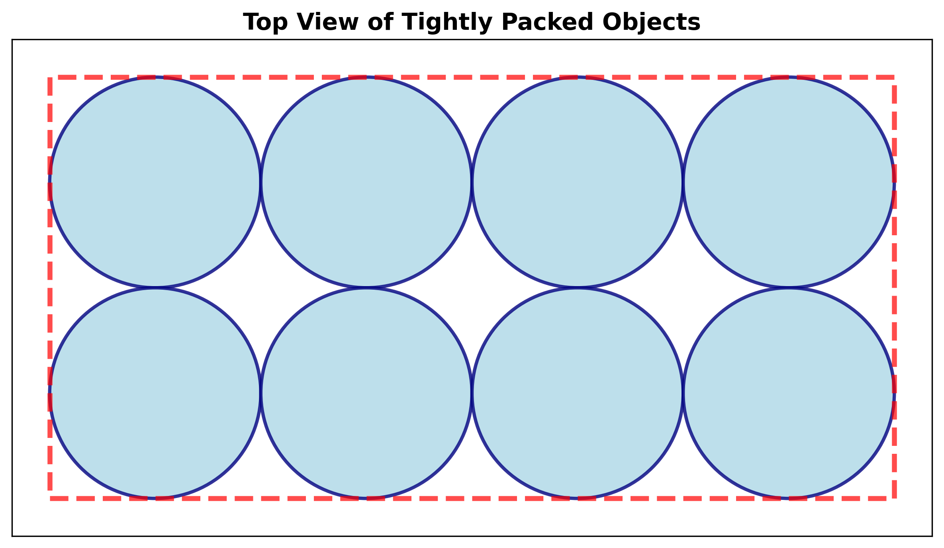

**Options:**

(A) 4 × 2

(B) 5 × 2

**(C) 11 × 5**

(D) 2 × 11

(E) 2 × 5

**Explanation:** Since the spherical balls are tightly packed with radius 1.4 cm, each has a diameter of 2.8 cm. The dimensions are: 4 objects × 2.8 cm = 11.2 cm by 2 objects × 2.8 cm = 5.6 cm.

**Curriculum Mapping:**

Subject: Quantitative Math

Unit: Geometry and Measurement

Topic: Area & Volume