Generated Math Assessment Questions

**Assessment Description:** This assessment contains multiple-choice questions designed to test students' problem-solving abilities in counting arrangements and geometric spatial reasoning.

# Question 1

**Question:** A pizza restaurant offers size, crust, topping. How many combos?  
  
| size | crust | topping |  
| :---: | :---: | :---: |  
| Small | Thin | Pepperoni |  
| Medium | Thick | Mushroom |  
| Large | Stuffed | Sausage |

**Options:**

(A) 26

(B) 9

**(C) 27**

(D) 54

(E) 28

**Explanation:** Multiply: 3 × 3 × 3 = 27

**Curriculum Mapping:**

Subject: Quantitative Math

Unit: Data Analysis & Probability

Topic: Counting & Arrangement Problems

# Question 2

**Question:** The top view of a cylindrical container holding 8 tightly packed spherical balls is shown. Radius = 1.4 cm. Find base dimensions.

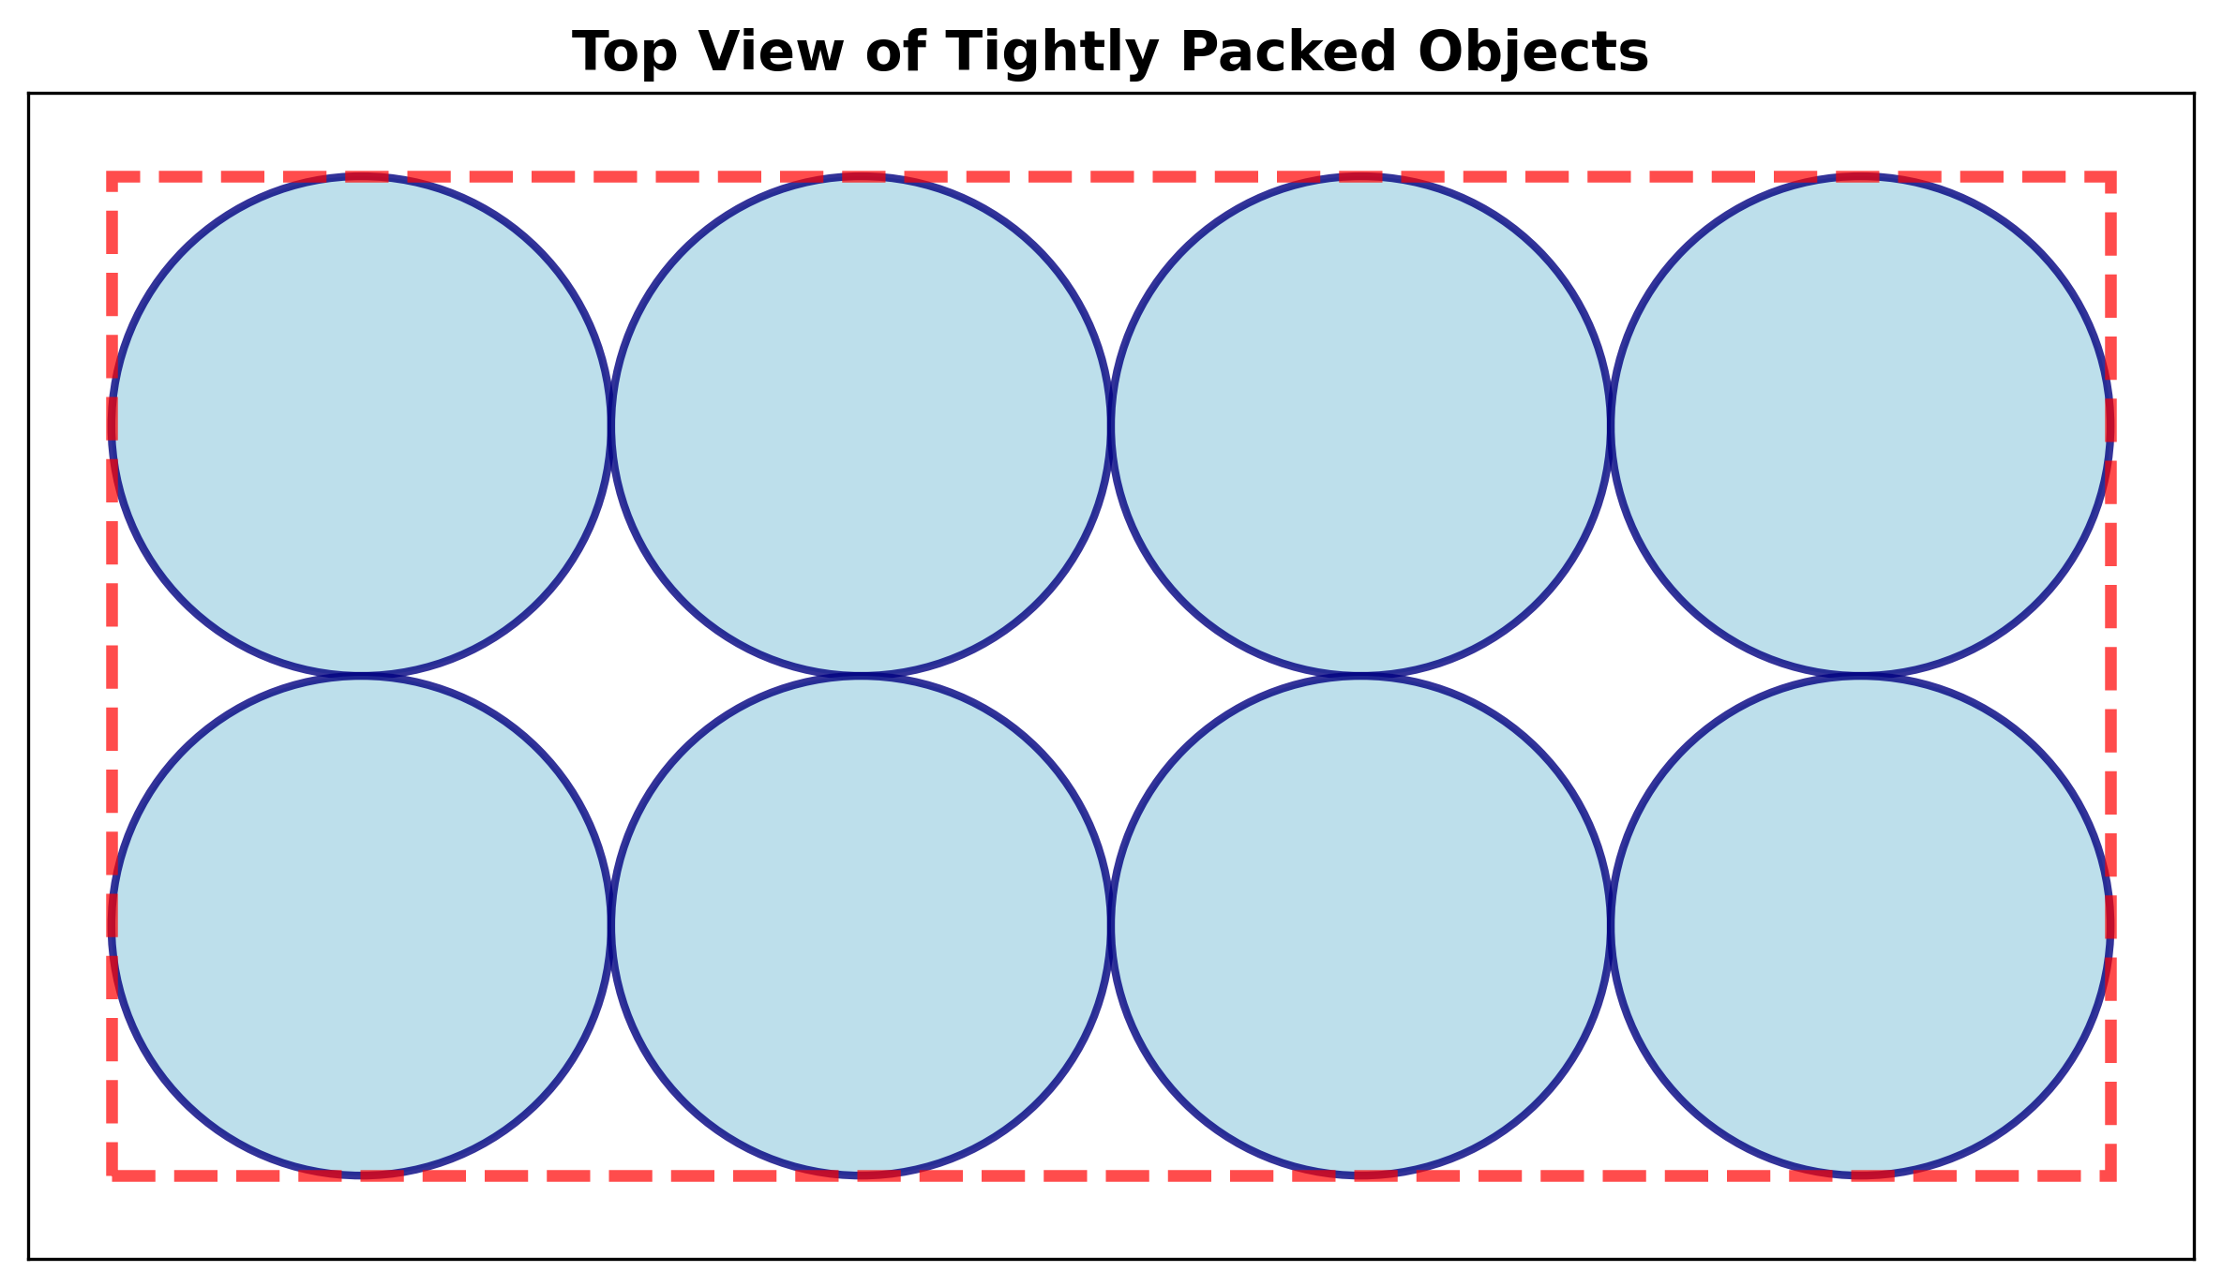

**Options:**

(A) 5 × 11

(B) 6 × 2

**(C) 11 × 5**

(D) 12 × 12

(E) 5 × 2

**Explanation:** 4 × 2.8 cm = 11.2 cm and 2 × 2.8 cm = 5.6 cm

**Curriculum Mapping:**

Subject: Quantitative Math

Unit: Geometry and Measurement

Topic: Area & Volume