WEEK 2 REPORT

Data Sourcing, Import & Transformation
for Construction Metrics
Power BI | Dataset: paimana_construction_bi_dataset_v2.csv

1. Objective and Dataset Overview
This report documents a repeatable Power BI workflow for sourcing, importing, cleansing, and transforming construction project data. The selected CSV contains 500 project records and 14 fields covering project identity, sector, implementing agency, state, original and revised costs, target dates, time extensions, progress, and reported bottlenecks.
Dataset check | Result | Use in analysis
Rows / columns | 500 / 14 | Project-level analysis
Unique Project_ID | 500; no duplicates | Suitable as a project key
Missing values | 213 in Primary_Bottleneck; other fields complete | Handle as “None”
Cost fields | Values in crore (Cr) | Cost and overrun analysis
Progress fields | Physical: 10–99%; financial: 5–100% | Progress comparison

2. Data Sourcing
The working file for this exercise is the supplied paimana_construction_bi_dataset_v2.csv. Its filename and structure do not, by themselves, establish that it is an official public dataset. For a production report, record the original publisher, download page, download date, licence, geographic coverage, and update frequency before treating it as verified public data.
Public sources that can support or validate construction-related measures include:
- Open Government Data Platform India (data.gov.in) — https://www.data.gov.in/ Search for public infrastructure, project, transport, and state-level datasets.
- Ministry of Statistics and Programme Implementation (MoSPI) — https://www.mospi.gov.in/ Infrastructure project monitoring and related statistical publications.
- Central Public Works Department (CPWD) — https://cpwd.gov.in/ Works manuals, schedules of rates, and cost-estimation references.
- Ministry of Road Transport and Highways (MoRTH) — https://morth.nic.in/ Road and highway sector reports and programme information.
Potential metrics: original versus revised project cost, cost overrun, time extension, physical progress, financial progress, sector/state distribution, and recorded bottleneck. Labour productivity is not directly measurable from this file because workforce hours, headcount, and completed work quantities are not included.

3. Importing the CSV into Power BI
Power BI Desktop supports CSV and other common formats. The following steps use Power Query so that the preparation process can be refreshed and repeated.
- Open Power BI Desktop and select Home → Get data → Text/CSV.
- Browse to paimana_construction_bi_dataset_v2.csv and inspect the preview. Confirm that the delimiter is comma and the first row contains column headers.
- Choose Transform Data rather than loading immediately. This opens Power Query Editor.
- Rename the query to Construction_Projects and verify that all 14 columns are present and correctly separated.
- Set data types: Project_ID, Project_Name, Sector, Implementing_Agency, State, and Primary_Bottleneck = Text; cost fields = Decimal Number; Time_Extension_Days and progress fields = Whole Number; target-date fields = Date.
- Review the Applied Steps pane. Rename unclear steps and keep transformations in a logical order.
- Select Close & Apply to load the prepared table into the Power BI data model.

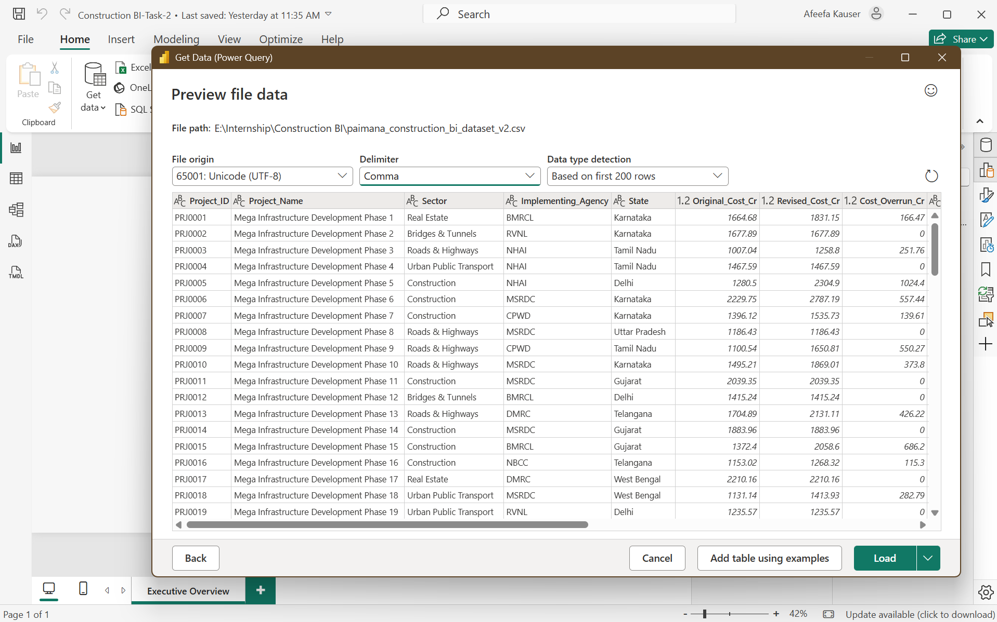

[Fig: Dataset Load]

Recommended field types
Field group | Power BI type | Reason
Project identifiers and categories | Text | Prevents IDs and labels being treated as numeric measures.
Original_Cost_Cr, Revised_Cost_Cr, Cost_Overrun_Cr | Decimal Number | Supports totals, averages, and variance calculations.
Original_Target_Date, Revised_Target_Date | Date | Enables date comparisons and time-based visuals.
Time_Extension_Days, progress percentages | Whole Number | Supports numeric summaries and validation.

Data ingestion control
Keep an untouched copy of the source CSV. Record the filename, source location, retrieval date, and any known limitations. When the source file is updated, use the same folder path and refresh the query; recheck row counts and data-quality checks after each refresh.

4. Cleansing and Transformation in Power Query
Apply the following sequence to make the dataset consistent and suitable for analysis.
Check structure and headers: Confirm 500 rows, 14 columns, correct header names, and no shifted columns. Remove only genuinely empty rows or columns.
Set data types: Convert the two target-date columns to Date and the cost fields to Decimal Number. Resolve any conversion errors rather than silently replacing them.
Trim and clean text: For Project_Name, Sector, Implementing_Agency, State, and Primary_Bottleneck, use Transform → Format → Trim and Clean. Standardise spelling and capitalisation where inconsistent.
Check duplicates: Select Project_ID and use Remove Duplicates only if duplicate IDs are confirmed. The supplied file has 500 unique IDs, so no project rows need to be removed for this check.
Handle missing bottlenecks: Primary_Bottleneck has 213 blank values. Replace nulls with “None” for clear reporting, or preserve nulls and create a separate flag if blanks have a distinct business meaning. Do not infer a bottleneck without evidence.
Validate numerical ranges: Confirm costs are non-negative; progress percentages are between 0 and 100; and Time_Extension_Days is non-negative. The supplied progress fields fall within 0–100 and time extensions are non-negative.
Validate cost calculation: Check whether Cost_Overrun_Cr equals Revised_Cost_Cr minus Original_Cost_Cr. The supplied values are consistent with this calculation, subject to rounding precision.
Validate dates and duration: Confirm Revised_Target_Date is not earlier than Original_Target_Date. If deriving date duration, document whether the calculation is calendar days and compare it with Time_Extension_Days rather than overwriting the supplied value.
Create analysis-ready fields: Optionally add Cost_Overrun_Pct = DIVIDE([Cost_Overrun_Cr], [Original_Cost_Cr]) and Progress_Gap_Pct = [Financial_Progress_Pct] - [Physical_Progress_Pct]. Define these as measures or calculated columns according to reporting needs.

Useful Power Query operations
Use Change Type, Trim, Clean, Replace Values, Remove Duplicates, Filter Rows, and Add Column → Custom Column where appropriate. Power Query transformations should be non-destructive and repeatable; avoid manual edits to individual cells in the loaded report.
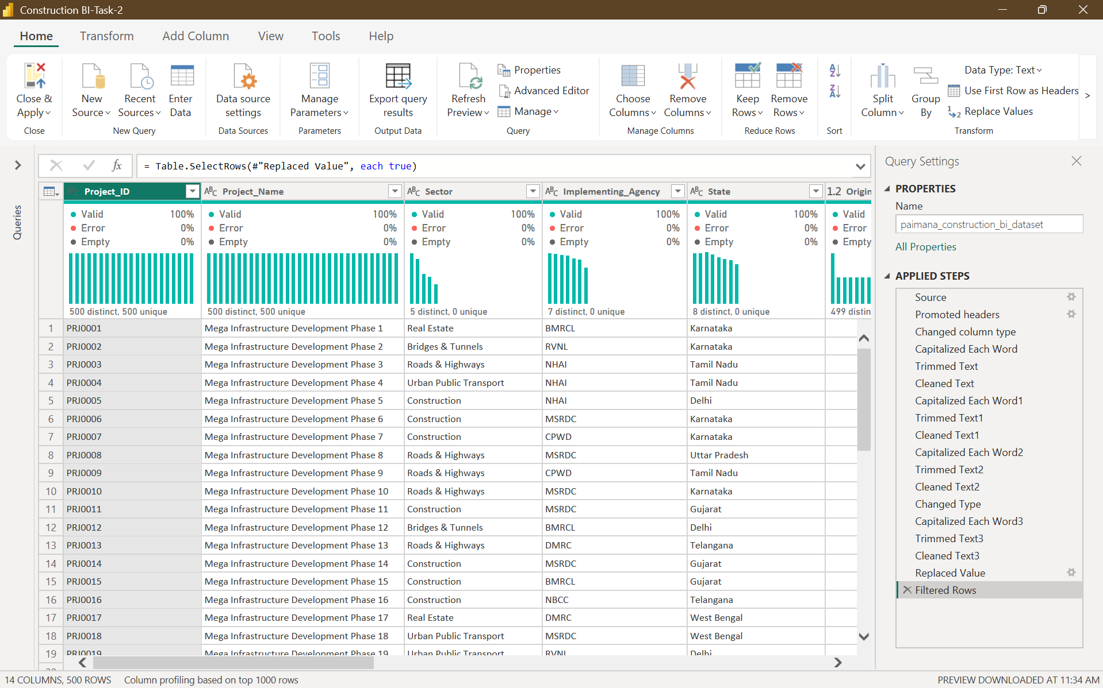

5. Combining Data, Quality Checks and Challenges

Combining data from multiple sources
If additional public datasets are added, first identify a reliable common key (for example, a project ID, agency, state, or reporting period). Use Merge Queries when matching records by a shared key; use Append Queries when adding rows from files with the same column structure. Standardise state names, agency names, units, and date formats before combining. Avoid joining only on project name unless uniqueness has been verified.

Quality checks before publishing
- Compare row count and distinct Project_ID count with the source file.
- Confirm no unexpected nulls in key fields and review all conversion errors.
- Check that cost overrun is not negative unless the business definition permits cost savings.
- Validate percentage fields and target-date logic.
- Compare totals before and after transformations to ensure records were not unintentionally lost.
- Document every replacement, filter, calculated field, and assumption.

Challenges and mitigation
Challenge | Handling strategy
213 missing bottleneck values | Use “None” or a missing-value flag; disclose the limitation.
Source provenance is not confirmed by the file alone | Record and verify the original public publisher, licence, date, and metadata.
No labour or quantity measures | Do not report labour productivity from this dataset; source workforce hours and output quantities separately.
Potential differences between time extension and date gap | Validate definitions and retain both fields until reconciled.
Inconsistent categories across future sources | Trim text, standardise category labels, and map values using a documented reference table.

6. Outcome
The CSV is suitable for a first-stage project monitoring report after the documented Power Query checks. It supports cost, schedule, progress, and bottleneck analysis across project, sector, agency, and state. The main known limitation is the 213 missing bottleneck entries; public-source provenance should also be verified before describing the file as an official open dataset. After Close & Apply, build visuals such as original versus revised cost, cost overrun by sector/state, time extensions, physical versus financial progress, and bottleneck counts.

