1. **Consider the MOVIE DATABASE**

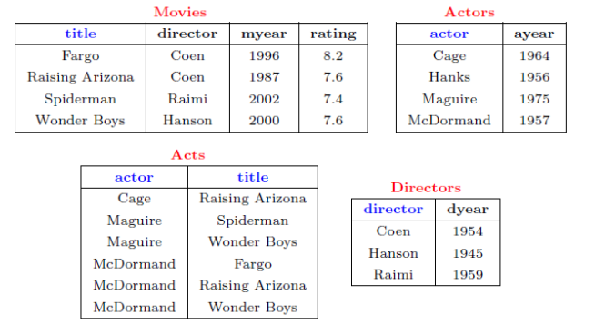

Write following relational algebra queries for a given set of relations.

1. Find movies made after 1997

2. Find movies made by Hanson after 1997

3. Find all movies and their ratings

4. Find all actors and directors

5. Find Coen’s movies with McDormand

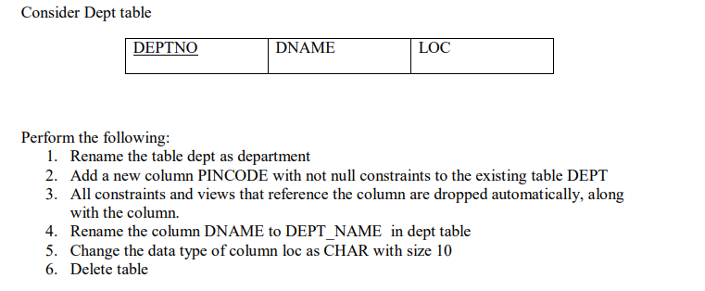

1. **Consider Employee table**

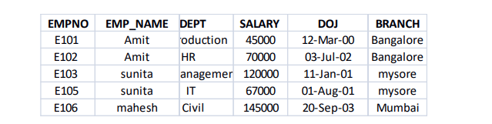

Perform the following

1. Display all the fields of employee table

2. Retrieve employee number and their salary

3. Retrieve average salary of all employee

4. Retrieve number of employee

5. Retrieve distinct number of employee

6. Retrieve total salary of employee group by employee name and count similar names

7. Retrieve total salary of employee which is greater than >120000

8. Display name of employee in descending order

9. Display details of employee whose name is AMIT and salary greater than 50000