LIGHT MAGIC STUDIOS

Light Magic Studios is a full service photography studio. Celebrating over 15 years of service, our studio specializes in high quality family and individual portraits, weddings, special occasion photography, as well as school, sport, and group photo packages. The following video provides additional information:

[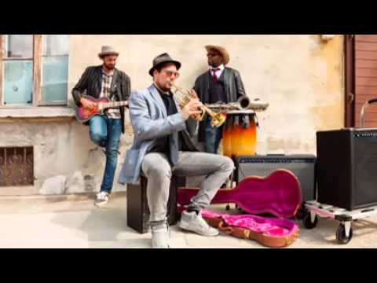](https://www.youtube.com/watch?v=b8F15Q0Ap4M)

Light Magic Studios can provide a valuable service for parents, while earning profits for your school or organization. Some of the benefits and features of fundraising with our studio include:

1. Earn 5% off every order
2. Free preview photos
3. Photo packages and add-ons

We can provide a number of add-ons to your photo package to add value and exponentially increase the amount of money you can earn for your school, sport, club, or organization. The following is a list of some of our extra options for your photos:

* Small Size Add-ons Key chains, luggage tags, buttons
* Apparel Photo t-shirts, sweatshirts, hoodies
* Papers Stationary, invitations, thank you cards

For a list of all of our products and services visit our website at www.lightmagicstudios.com or call us at (212) 555-0433.