NOVA Advising and Counseling

# Campus Counseling

Counselors and advisors help students define goals through student development instruction, academic advising, personal counseling, and programming. Mental health counseling and therapy are not provided by the College staff; however, referrals can be made within the local community. Counseling hours are noted below.

Academic advising is important at NOVA. Academic advising helps you to meet your educational objectives.

If you cannot come to campus to meet with your advisor, Online Virtual Advising is available to you.

Virtual advisors are available by chat or email. Please have your NOVA Student ID number ready.

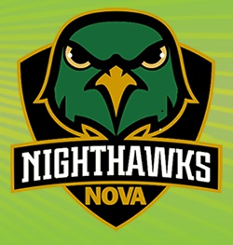

# Speak with a Virtual Advisor

Virtual Advisors Are Available by Chat or Email

**Hours:**

* Monday – Friday: 11:30 a.m. – 2:30 p.m.
* Monday – Thursday: 6:00 p.m. – 8:00 p.m.

**Via Email:**

[AcademicAdvising@nvcc.edu](mailto:AcademicAdvising@nvcc.edu)

Emails are answered within 24 hours.

**Online Chat:** Click on the LiveChat link at <http://www.nvcc.edu/virtualadvising/index.html> to talk to a virtual advisor.

Who Is My Academic Advisor?

Once you have chosen a degree program and you have been advised by a counselor for your first semester, you can begin seeing an Academic Advisor. Your advisor will be a faculty member in your chosen field of study. Academic advisors help students to register for classes, give advice about how to improve academic performance, give advice about transferring to colleges and universities after you complete your program at NOVA, and give advice about entering the workforce in your field of study. Each NOVA campus handles assigning of Academic Advisors a little different, so visit <http://www.nvcc.edu/advising/my-advisor.html> to find contact information for your academic advisor.