Afeefah Manzoor

ITN213

Assignment5

MySQLWorkbench:  
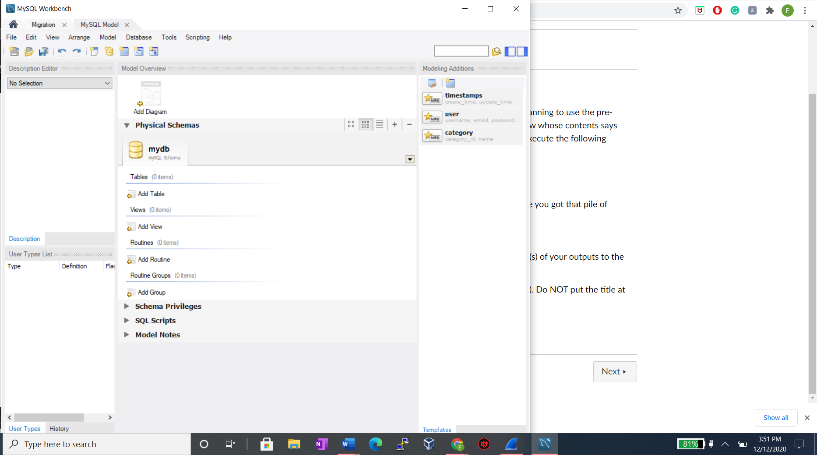

Node -v &npm -v

