Afeefah Manzoor

ITN213

Assignment 7

Screenshot 7:

Screenshot 1: Creating RDS

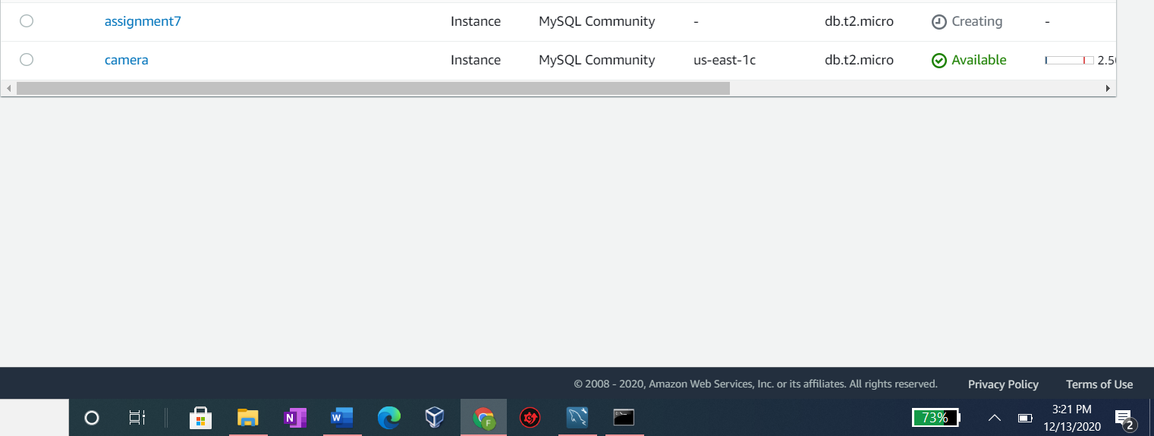



Screenshot 2:Managing Security

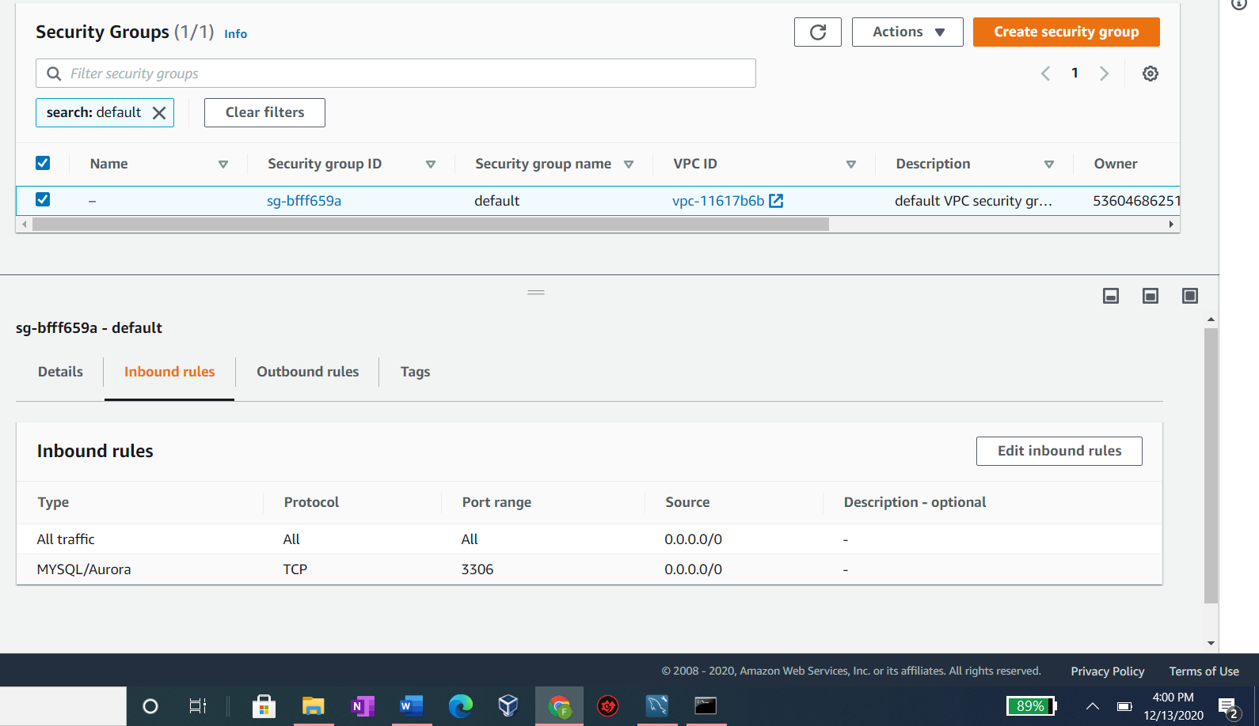



Screenshot 3: Connect to DB instance

