Afeefah Manzoor

ITN262 Lab 3: Configuring Windows File System Permissions

Screenshot 1:

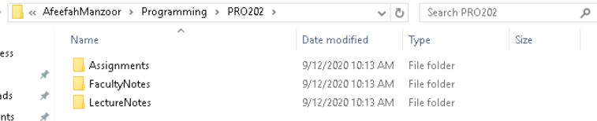

Screenshot 2:

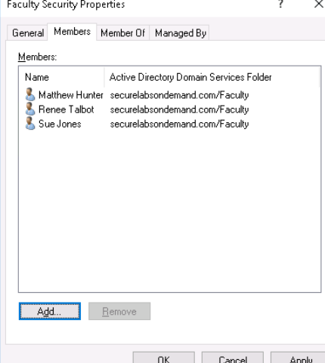

Screenshot 3:

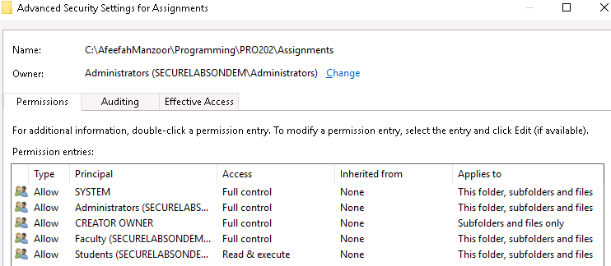

Screenshot 4:

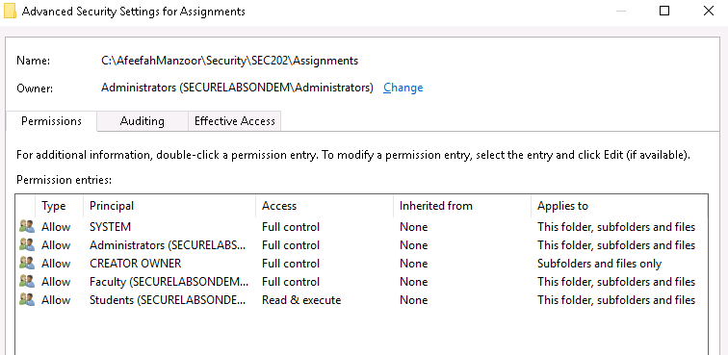

Screenshot 5:

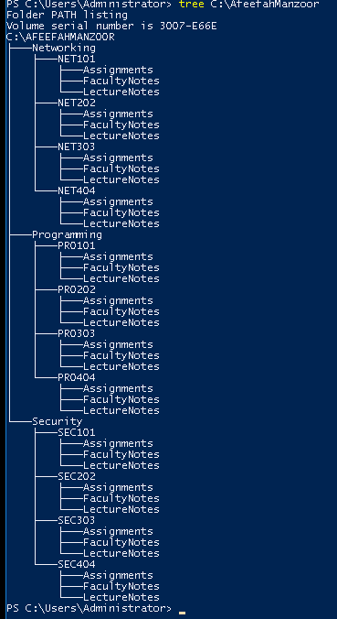

Screenshot 6:

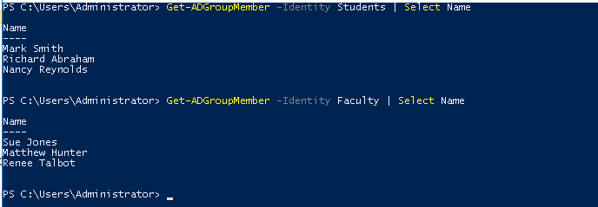

Screenshot 7:

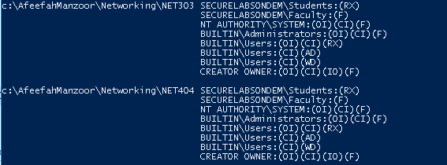

Screenshot 8:

