Table of Contents

Lab Topology 1

Section 1………………………………………………………………………………………………………………………………………………….2

Section 2……………………………………………………………………………………………………………………………………………………..3

# Topology

This lab contains the following virtual devices. Please refer to the network topology diagram below.

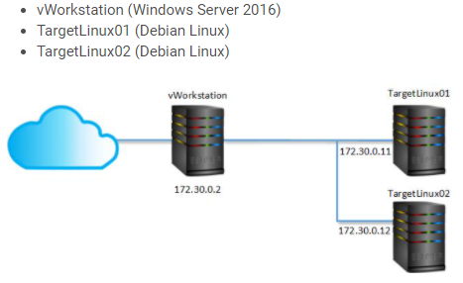

Section 1:

Screenshot1:

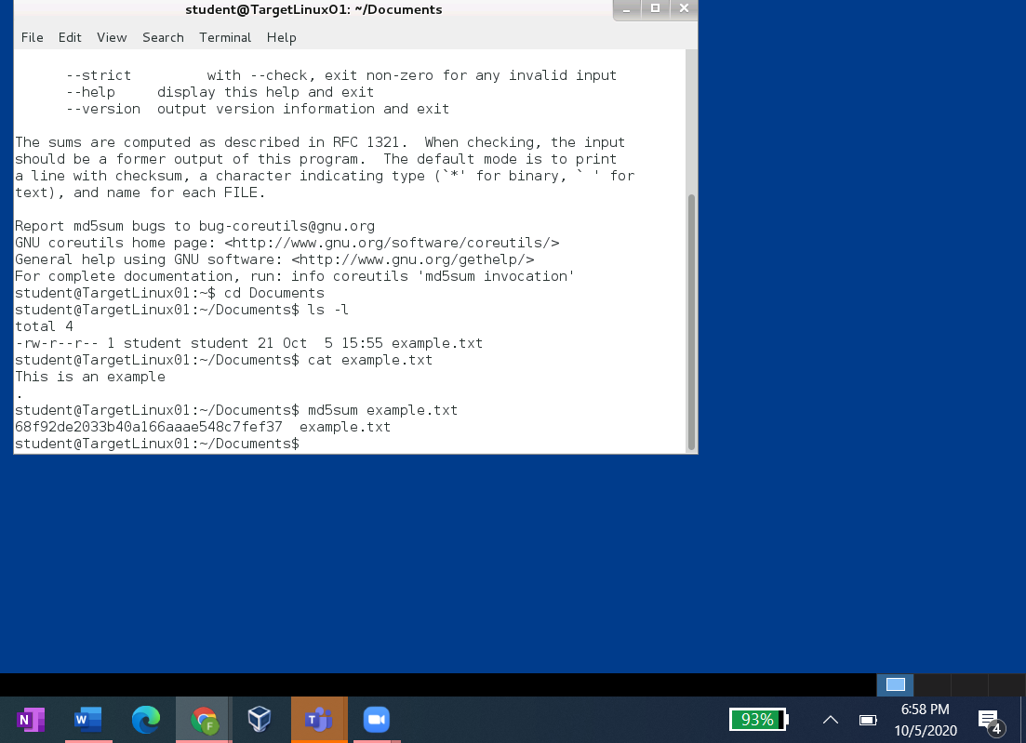

Screenshot 2:

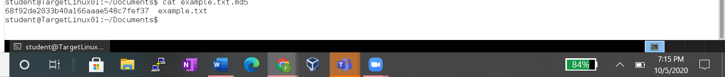

Screenshot 3:

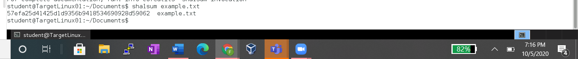

Screenshot 4:



Screenshot 5:

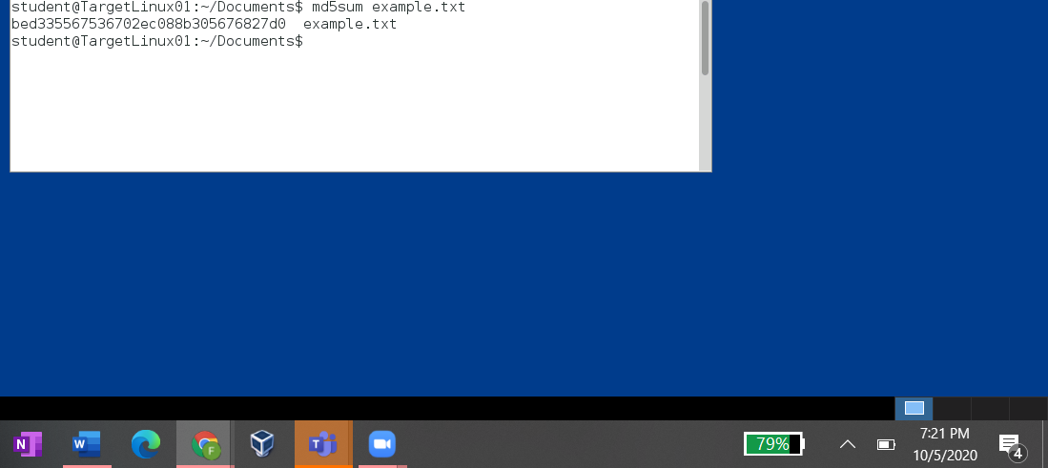

Screenshot 6



Screenshot 7

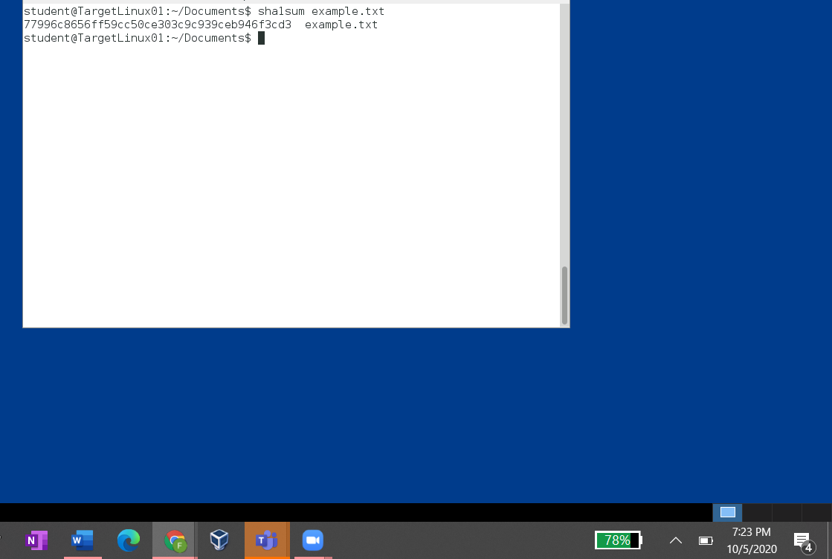

Screenshot 8

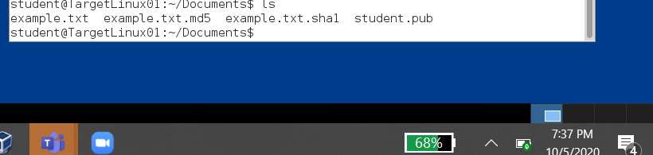

Screenshot 9

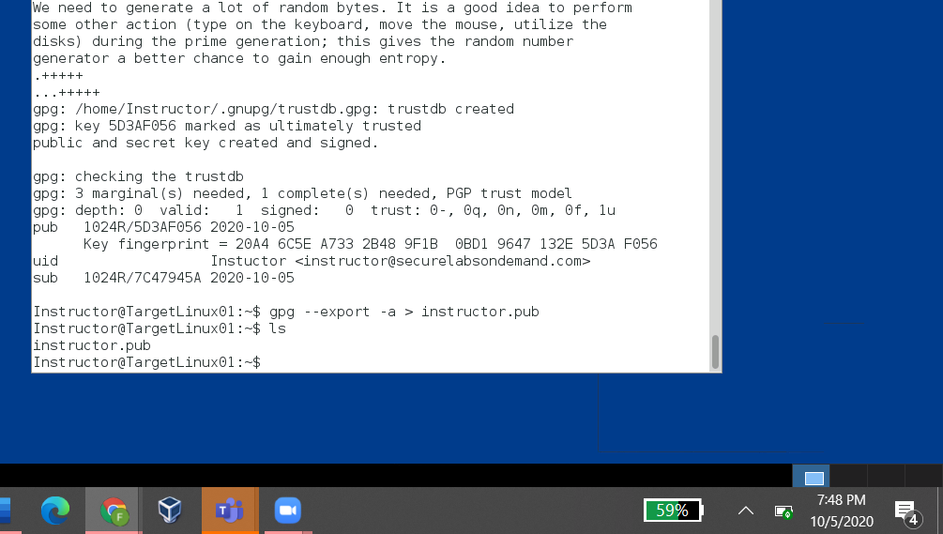

Screenshot 10

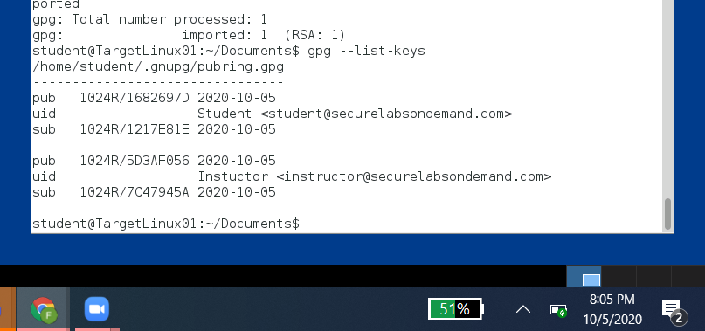

Screenshot 11



Screenshot 12

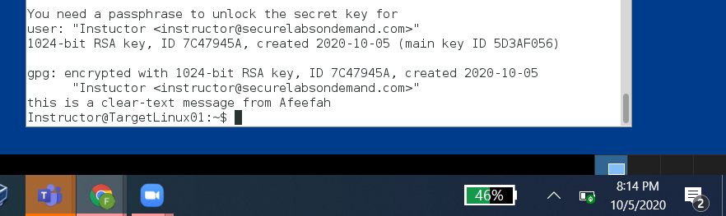

Section 2:

Screenshot 13

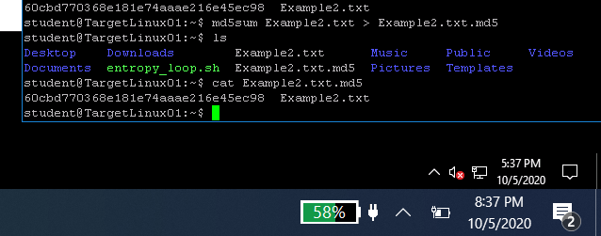

Screenshot 14

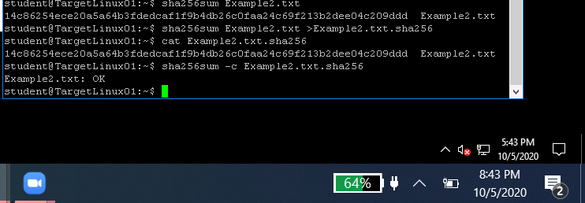

Screenshot 15

Screenshot 16

Screenshot 17

Screenshot 18

Screenshot 19

Screenshot 20