Table of Contents

Topology 1

SECTION 1 2

Part 1: 2

Part 2: 3

Part 3 3

Section 2 5

Part 1: 5

Section 3: 7

Part 1: 7

Part2: 7

Part 3: 8

# Topology

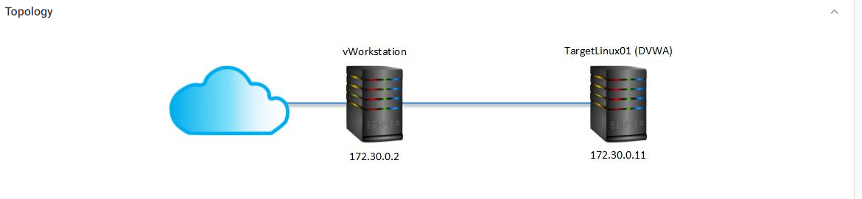

# SECTION 1

## Part 1:

Step 5:

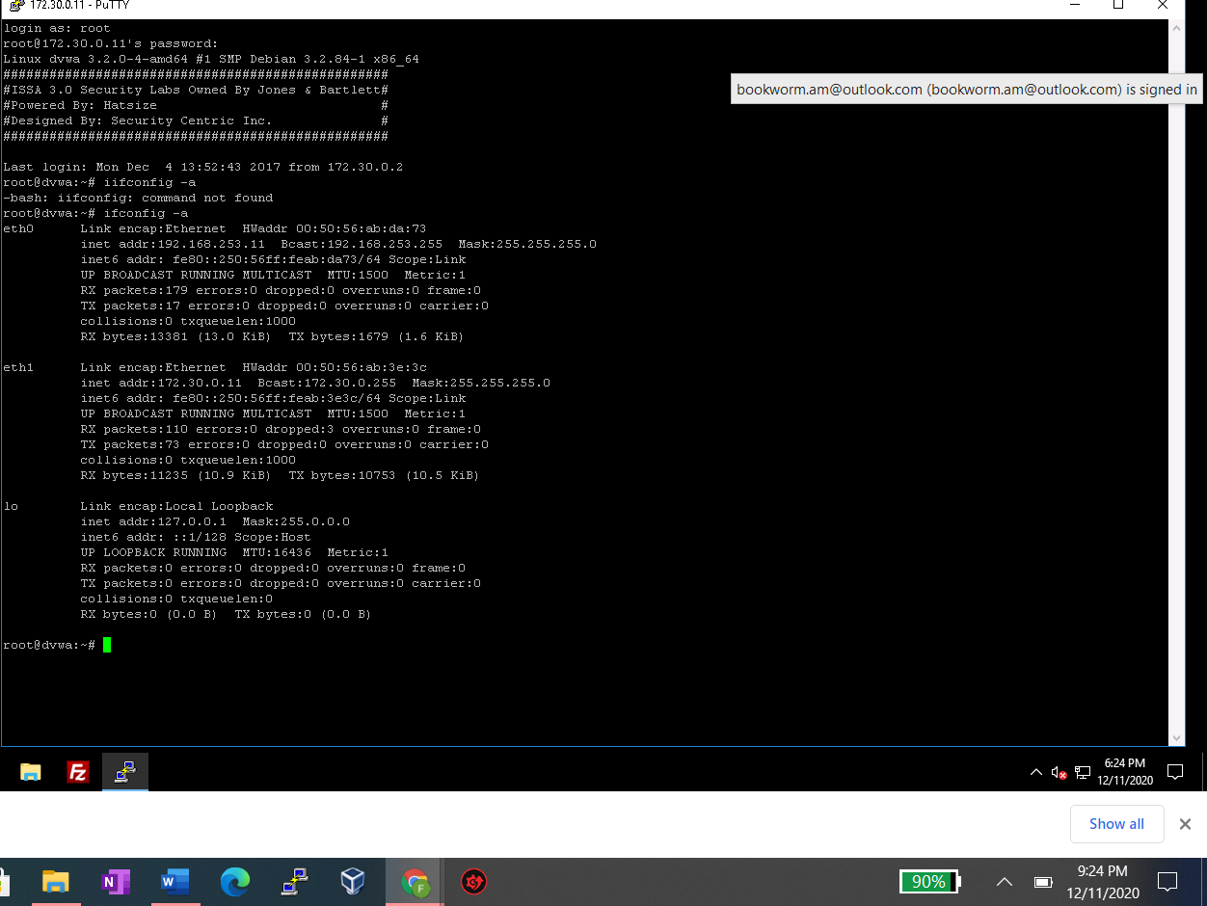

Step 8:

It works by displaying and capturing packet headers & matching them against the criteria.

Step: 14:

It makes an interactive map for targeted sites by using a recursive crawl & dictionary based probes. The make is now annotated with output from a # of non-disruptive security checks.

## Part 2:

Step 9:

The HTTP Headers add-on has a summery of all the details of the webpage, such as the images on the page, the details of the cookies, language, etc….

Step 13:

By sniffing the information in the packets’ headers.

## Part 3

Step 1:

*A publicly traded retailer with retail outlets and online shopping and shipping options*

* Loss of integrity of inventory
* Loss of confidentiality of customer’s PII data
* Delayed order fulfilment
* Loss of customers and credibility
* Possible theft and redirection of organization funds

*A small, private law firm whose small website features forms for potential clients to complete that require name, address, contact number, and reason for scheduling an appointment*

Loss of confidentiality – potential clients’ details are leaked

Competitors may gain from this information – leading to loss of leads

Clients lose faith in the firm and will chose a competitor

Loss of scheduling information can lead to cancelled and forgotten appointments further showing that the firm in unprofessional and cannot be trusted

A small firm will face the backlash and find it difficult to build credibility again

*A real estate appraisal company that provides residential-loan applicants of a publicly traded financial institution with online appraisals – all applicant information is sent to the appraisal company electronically*

Loss of confidential data

Severe penalties under the SOX (Sarbanes Oxley) Act

Possible litigations by individuals and the Federal Trade Commission (FTC)

Identity theft of clients – leading to more losses and litigation

*A Web hosting company that provides leased servers for the websites of clients, ranging from small firms to large online retailers*

Disruption in services – leading to loss of network and cloud availability to clients

Labelled unreliable, insecure – and no clients will want such services to host their organizations data and websites

Breach of service contract – can lead to financial losses and litigation

Possible loss of integrity and confidentiality with the clients’ hosted data – leading to catastrophic and cascading repercussions.

Loss of reputation and clientele

# Section 2

## Part 1:

Step 6:

-TCPdump works by displaying and capturing packet headers & matching them against the criteria.

- Skipfish makes an interactive map for targeted sites by using a recursive crawl & dictionary based probes. The make is now annotated with output from a # of non-disruptive security checks.

Part 3:

Step 1:

*A city government that allows people with parking tickets to pay the fines online using a credit card or online check*

* + Loss of credit card information
  + Financial fraud with stolen details
  + PCI-DSS compliance violations

*A local residential-cleaning business with a website that acts as a company brochure; no forms of any type are located on the website*

* + Possible defacing of the website – by malicious hackers
  + Change in contact information – leading to possible clients contacting a competitor

*A software development company that develops and licenses online shopping software to large corporations*

* + Loss of highly confidential data involving license keys and digital signatures
  + Leads to frauds involving clients’ software
  + Huge financial losses for the clients
  + Clients will sue for losses
  + Possible loss of clients’ payment details – leading too financial losses – and compliance violations and litigations
  + Loss in intellectual property involving algorithms used for generation license keys
  + Can lead to the company going bankrupt and shutting down

*A private, locally owned bank with a website that accepts loan applications online*

* + Loss of customer’s PII data – leading to possible identity theft and compliance violations
  + Lost data can be very useful for competitors
  + Loss of customers
  + Loss of reputation

*A local doctor’s office that maintains all patient information within the office; it doesn’t share electronically with any entities and doesn’t have a website or use any custom-developed software*

* + Business threats are offline – loss of paperwork, patient’s details, stolen information, loss of information through dumpster diving, social engineering etc.
  + HIPAA violations – leading to steep penalties
  + Can lead to the health care providers losing their licenses
  + Complete loss of credibility, severe losses, and irreparable damages

*An online-only retailer which sells athletic equipment using shopping-cart software that has been developed in-house and uses PayPal whenever a customer makes a purchase*

* + Loss of orders
  + Loss of inventory details
  + Forged orders leading to loss of goods
  + Loss of genuine customers
  + Financial losses

# Section 3:

## Part 1:

Why is it important for organizations to review HTTP headers in web applications before their release?

So information doesn’t get unknowingly leaked.

## Part2:

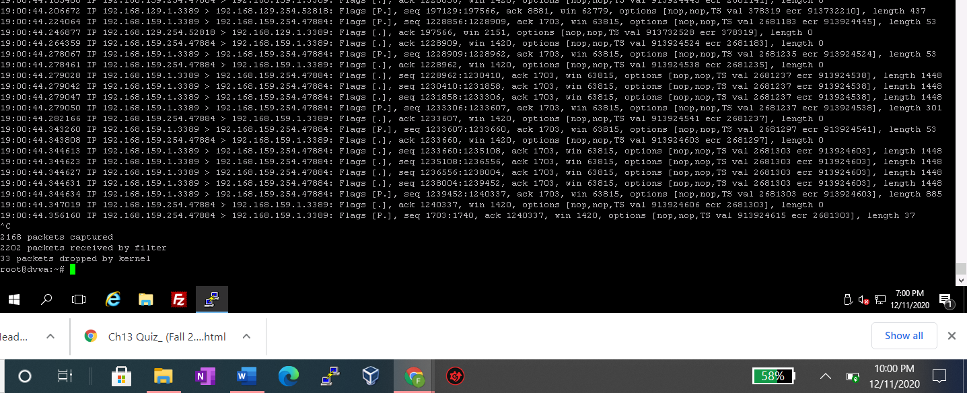

## Part 3:

Corporationtechs.com

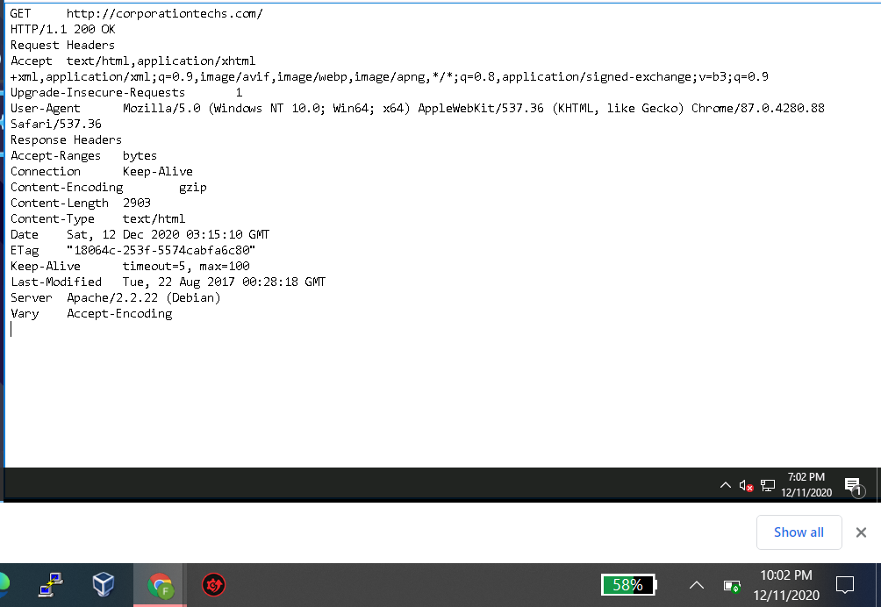Chrome

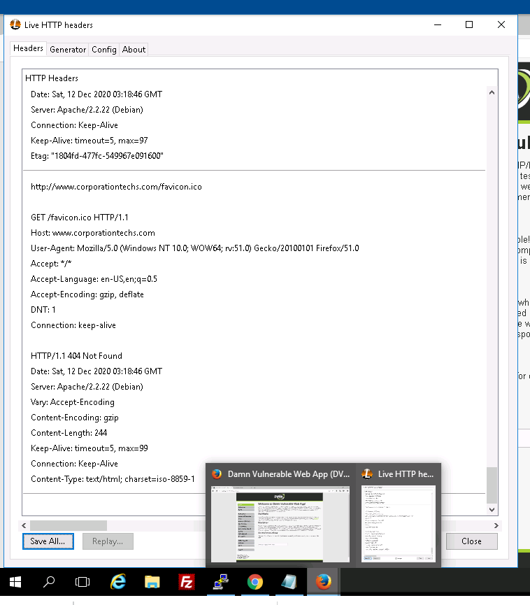

Cloafparadox.com

