Table of Contents

Topology 1

SECTION 1 2

Part 1: 2

Part 2: 2

Part 3 3

Section 2 4

Part 1: 4

Section 3: 4

Part 1: 4

Part2: 4

Part 3: 4

# Topology

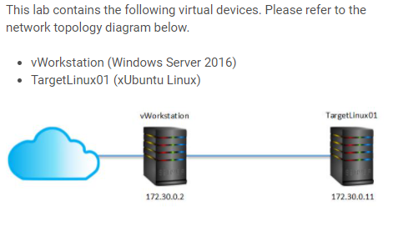

# SECTION 1

## Part 1:

Step 12:

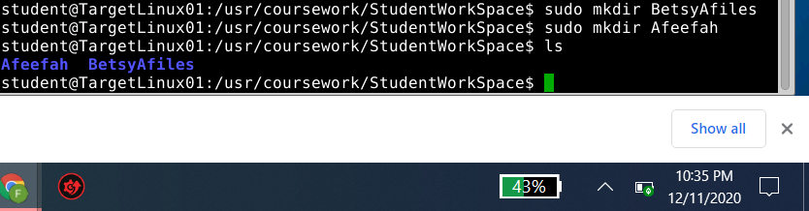

## Part 2:

Step 6:

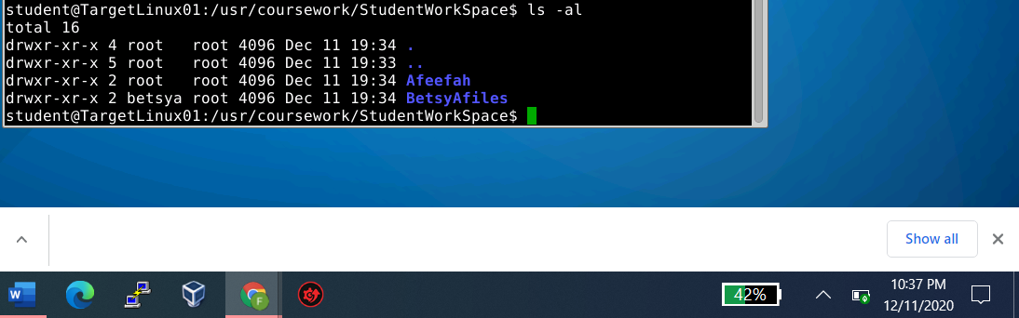

Step 9:

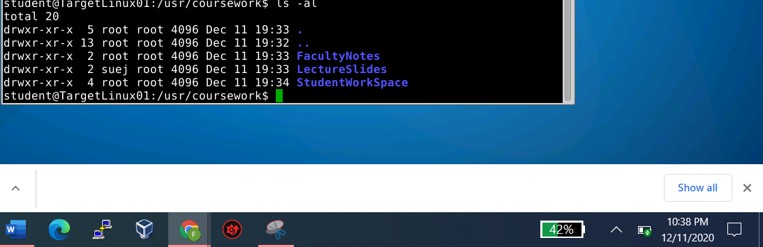

## Part 3

Step 8:

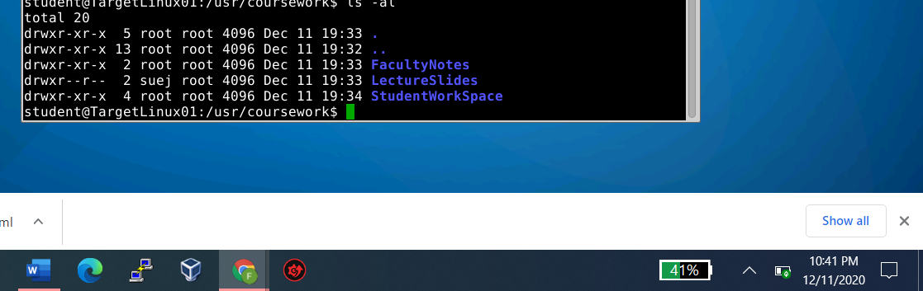

Step 14

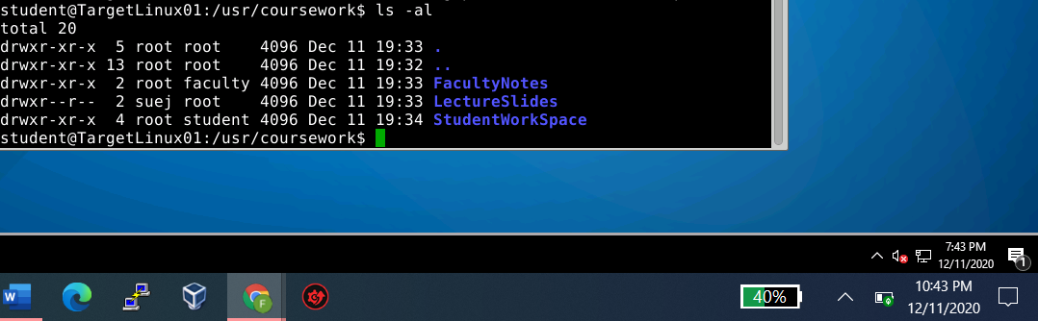

Step 19

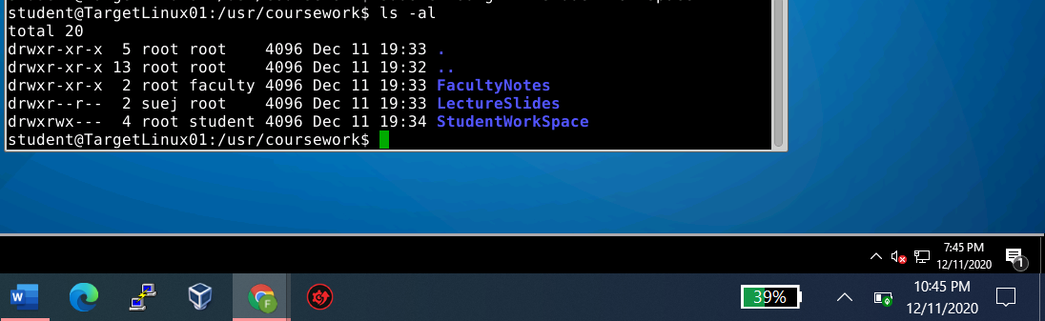

Step 23



# Section 2

## Part 1:

Step 28

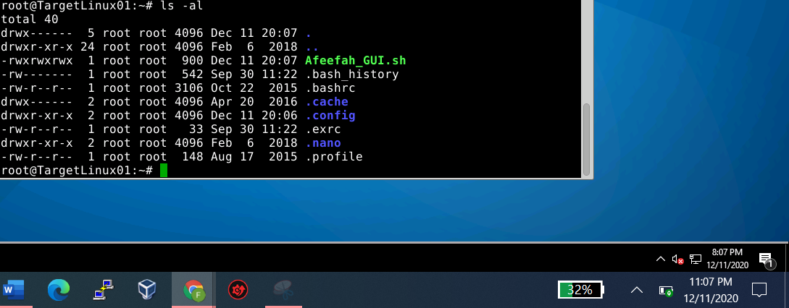

# Section 3:

## Part 1:

Bash- command processor that runs in a terminal window

Awk- data drive scripting language that takes acting w/ data streaming textal data.

Yad- lightweight GUI interaction shell where the user can input information to gain from a user/other user.

## Part2:

## Part 3: