Afeefah Manzoor

ITN 263 Lab 10 Report

1. all the processes associated with Remote Desktop Services;



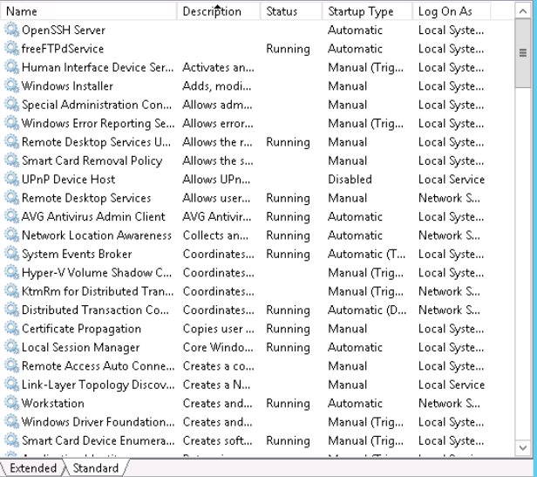

1. current system performance;

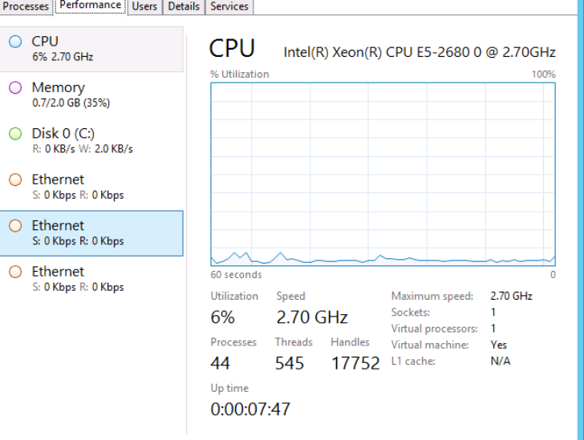

1. Windows Application Log;

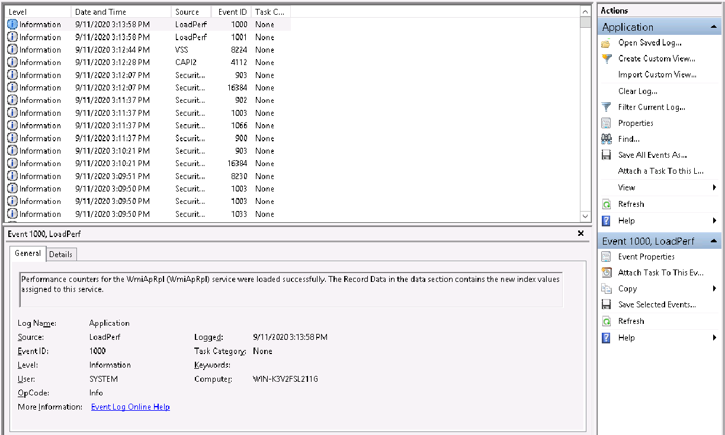

1. the entire event entry for the error;

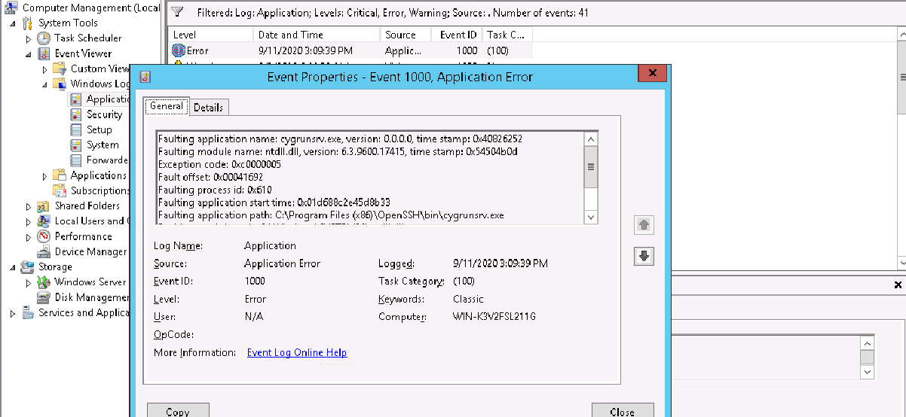

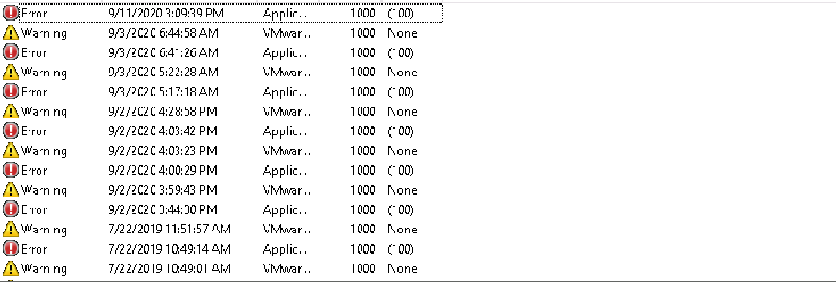

1. the Status and Startup Type columns for the Windows services that manage Remote Desktop Services;

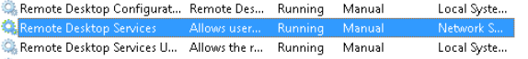

1. first page of the report, including the header;

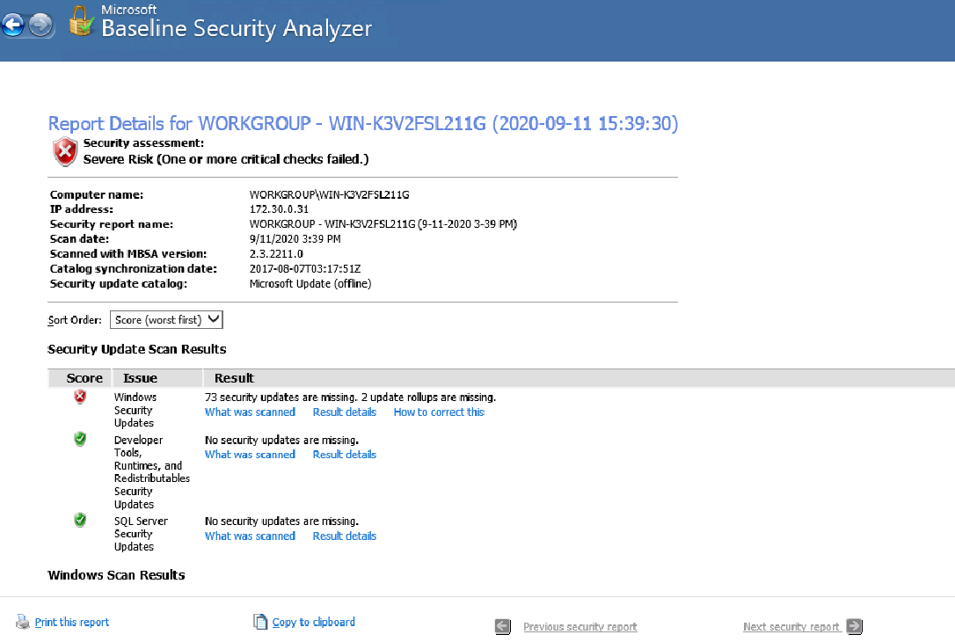

1. Result Details for the Shares issue;

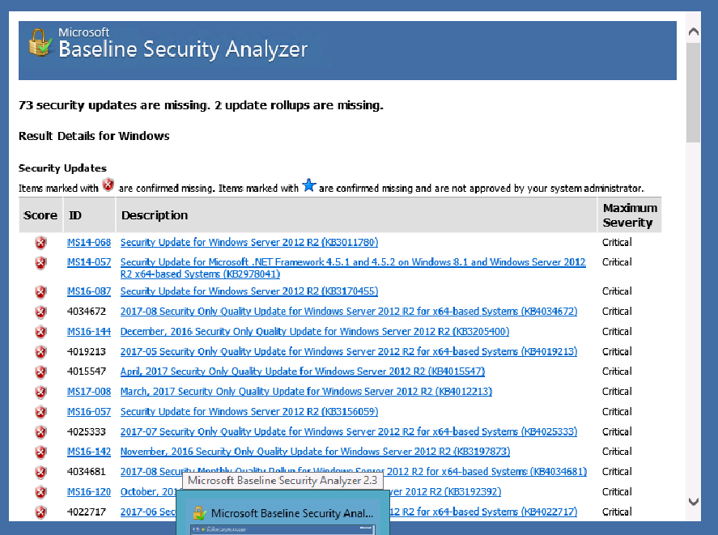

1. all the processes associated with Remote Desktop Services;





1. current system performance;

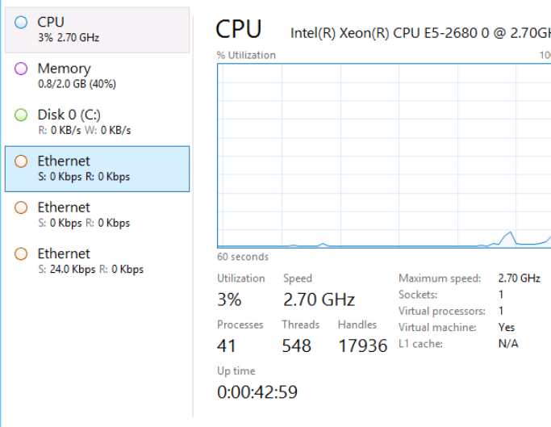

1. the AVG processes on the Memory tab;

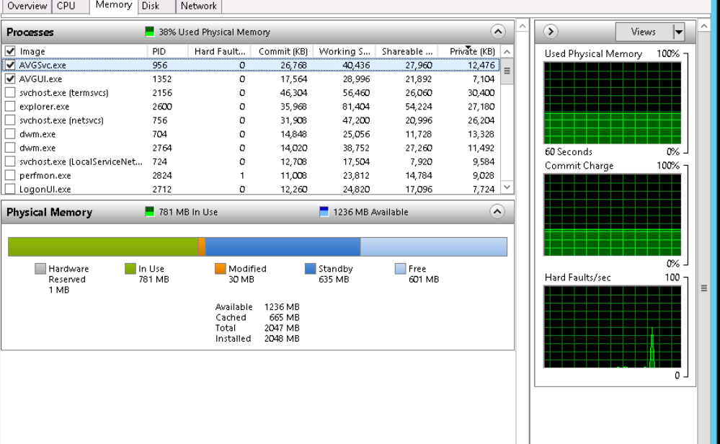

1. AVG update URL in the Resource Monitor;

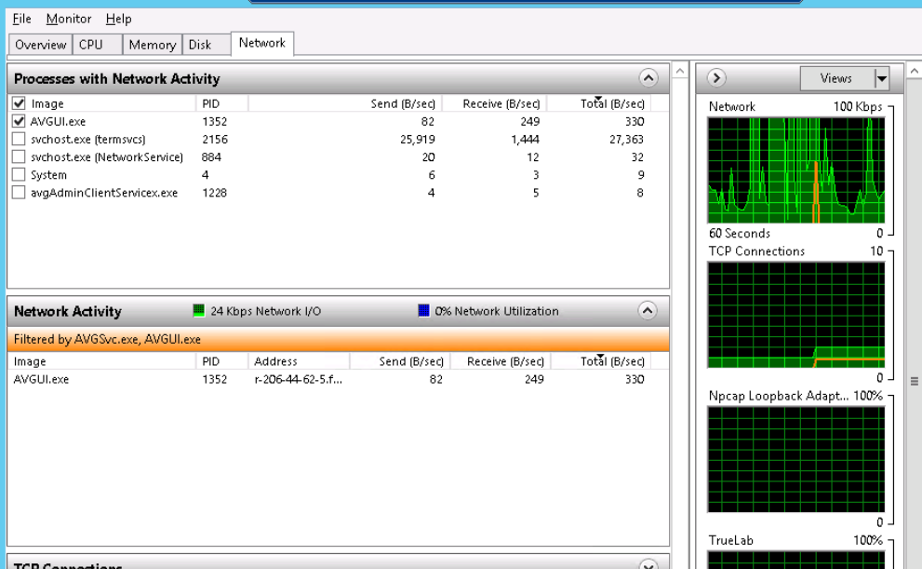

1. the entire event entry for the first error in the Application Log;

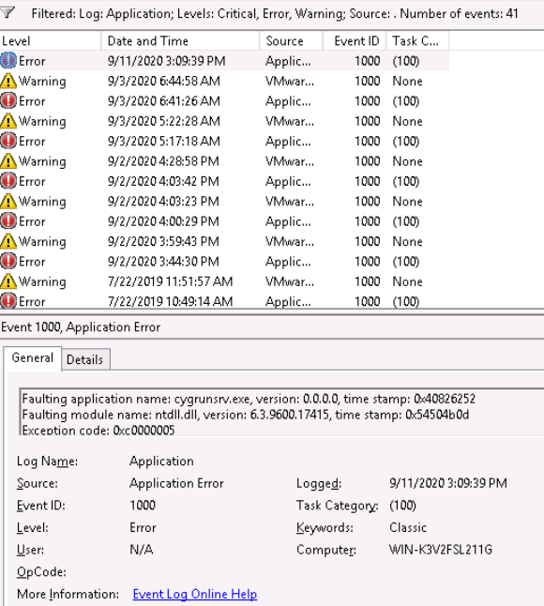

1. the entire event entry for the first error in the System Log;

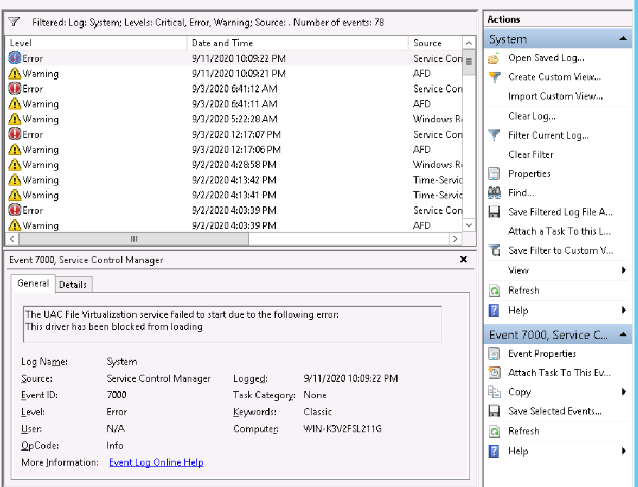

1. the entire entry for the first issue in the Security Log;

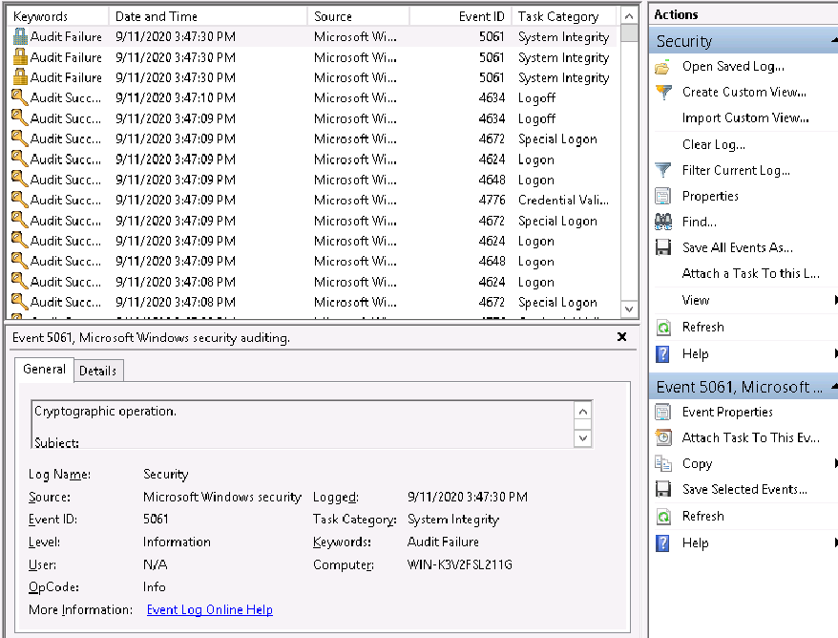

1. the Status and Startup Type columns for the Windows services that manage Remote Desktop Services;



1. the Dependencies tab;

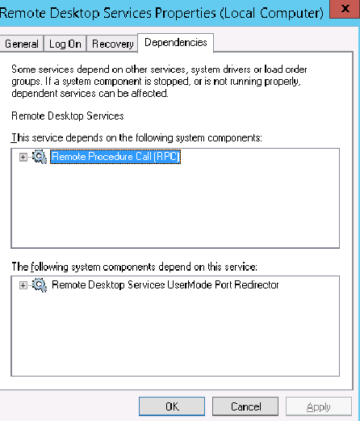

1. the report header and the Security Update Scan Results;

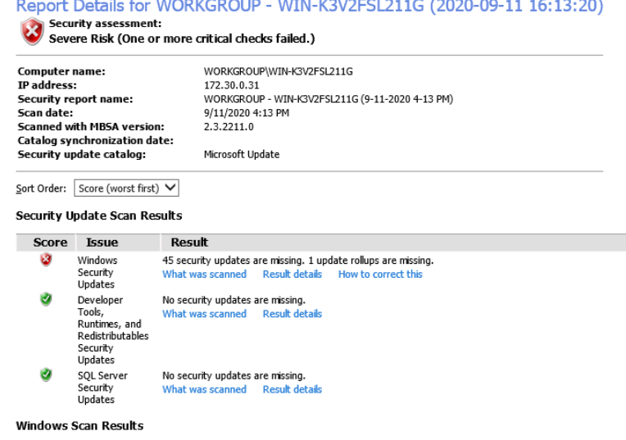

1. the ID numbers and KB (Knowledge Base) numbers for the first page of critical updates;

I installed KB2978041 