Screenshot 1:

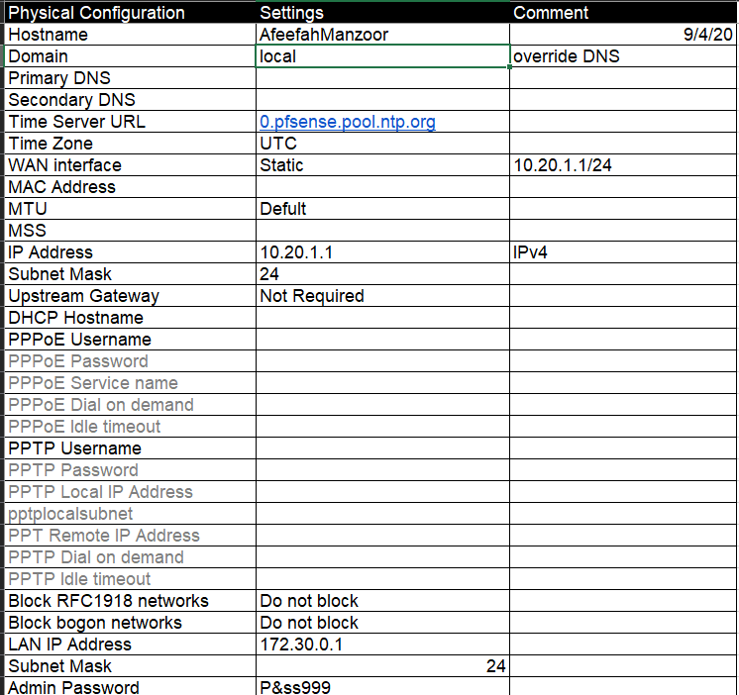

Screenshot 2:

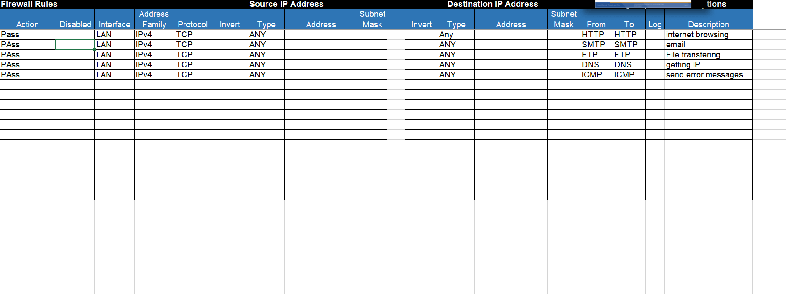

Screenshot 3:

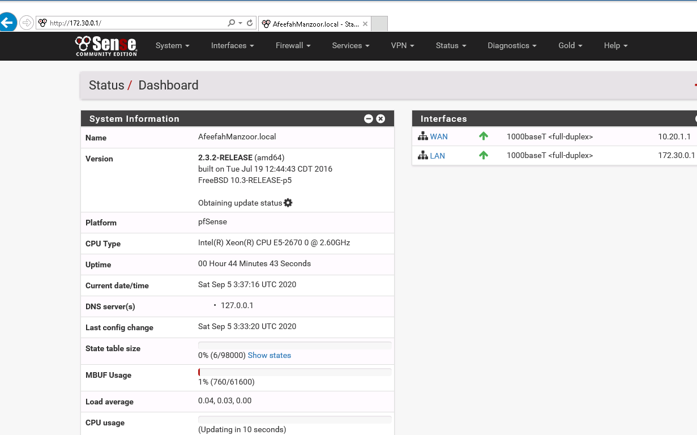

Screenshot 4:

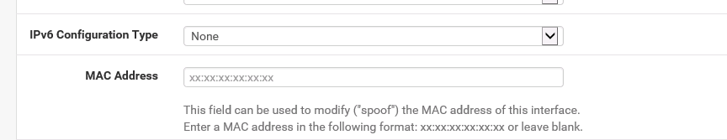

Screenshot 5:

