Afeefah Manzoor

ITN263 Lab 4 Report

1. Virtual IP address table;
2. NAT Mappings table;
3. 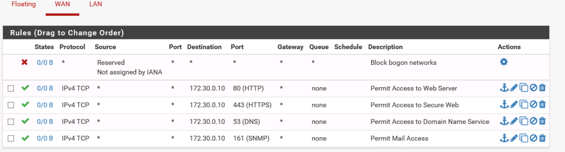Completed WAN Rules table;
4. *yourname*_PFSENSE-FW-PLANNER-NAT.xls; --Screen shot only
5. Virtual IP address table;



1. NAT Mappings table;
2. Completed WAN Rules table;

