Afeefah Manzoor

ITN263

Lab 5

Screenshot 1:

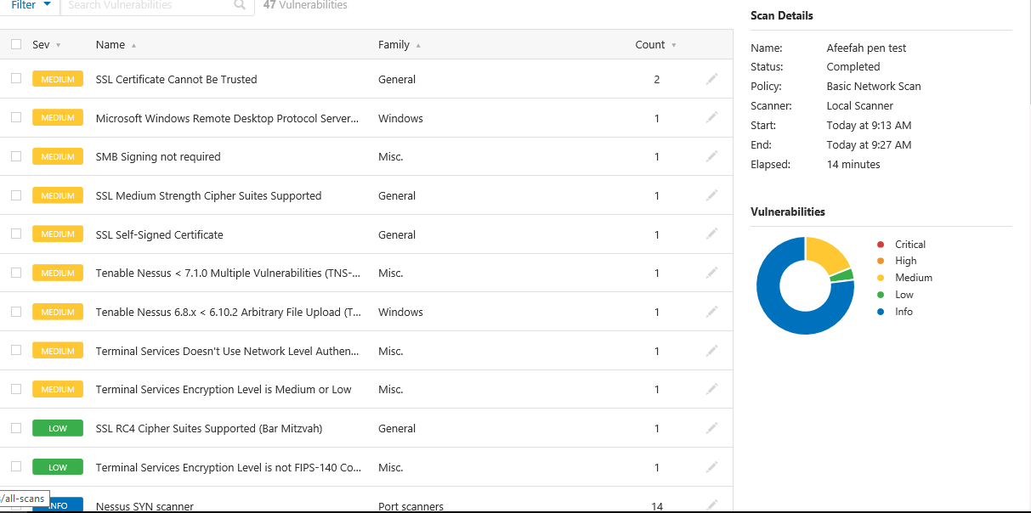

Screenshot 2:

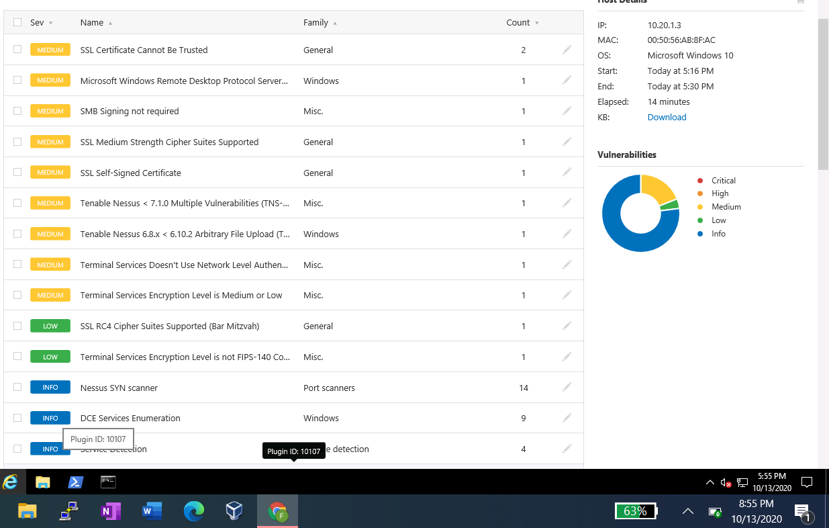

Screenshot 3:

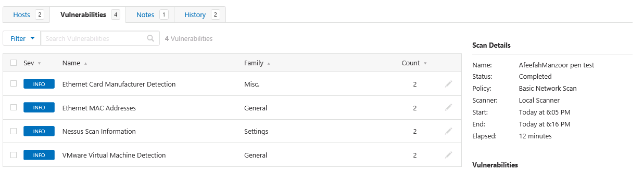

Screenshot 4:

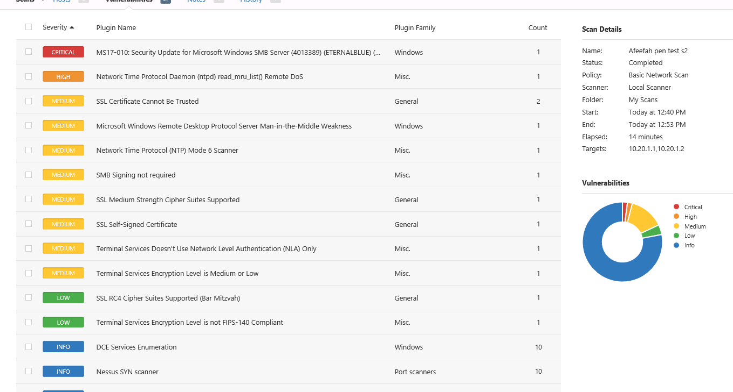

screenshot 5:

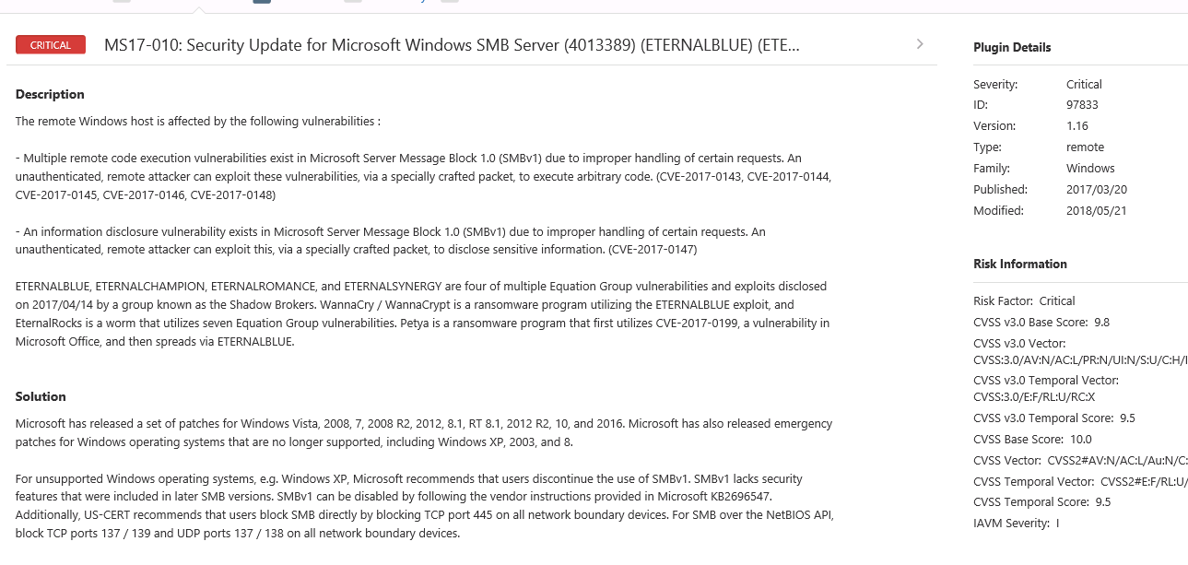

Screenshot 6:

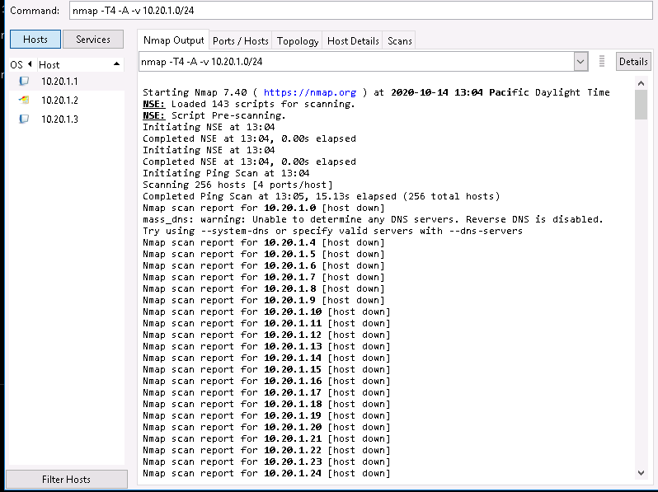

Screenshot 7:

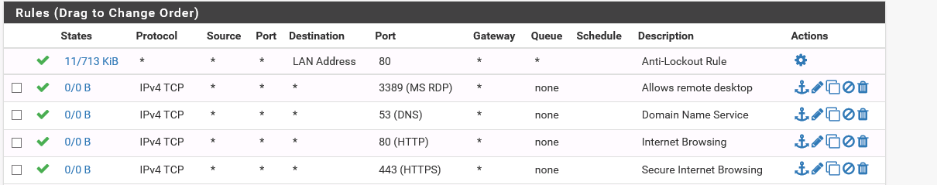

Screenshot 8:

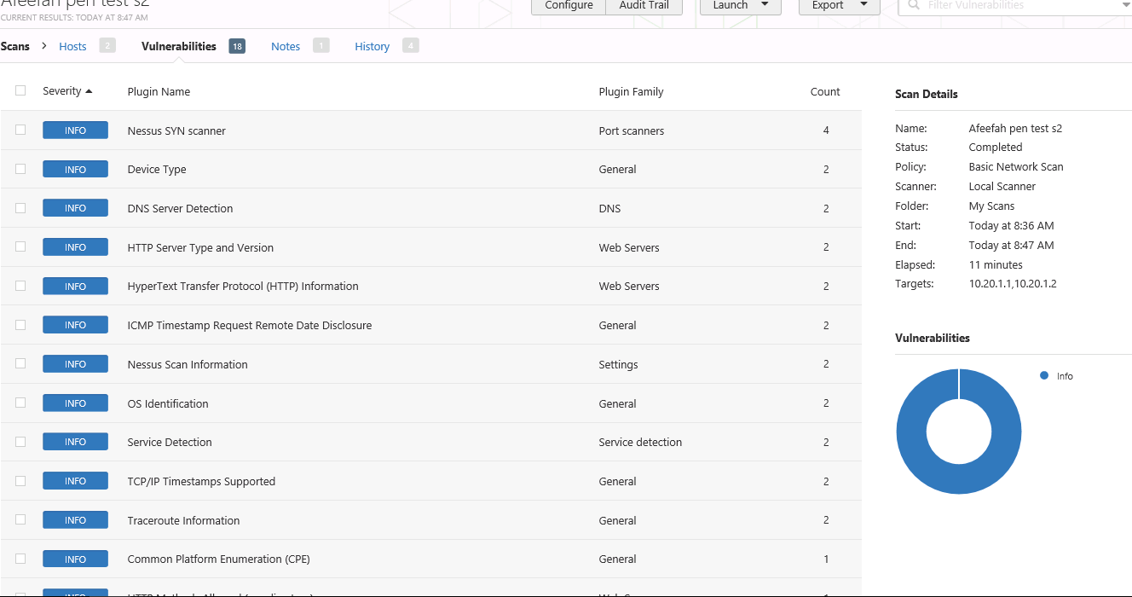

1. It’s important to run a pen test since the user would not know how they can be affected by an attack and how to defend the user’s system. Also port 53 and 80 were affected and have a rule on closing them.
2. 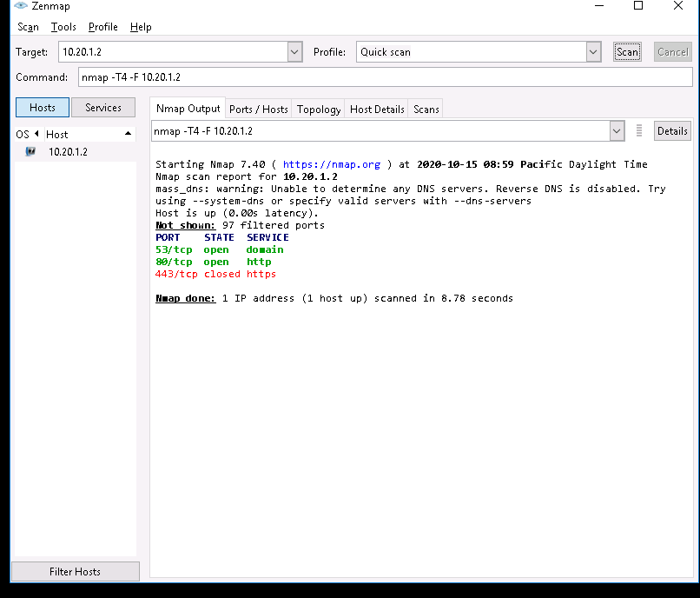
3. 