Afeefah Manzoor

ITN263

Lab Report 7

Screenshot 1:

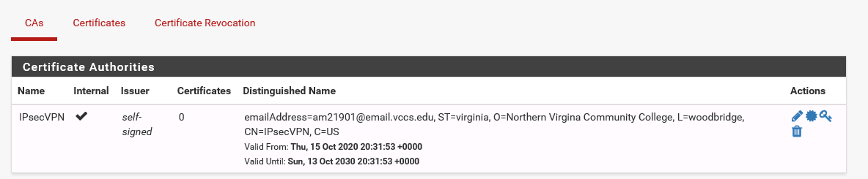

Screenshot 2:

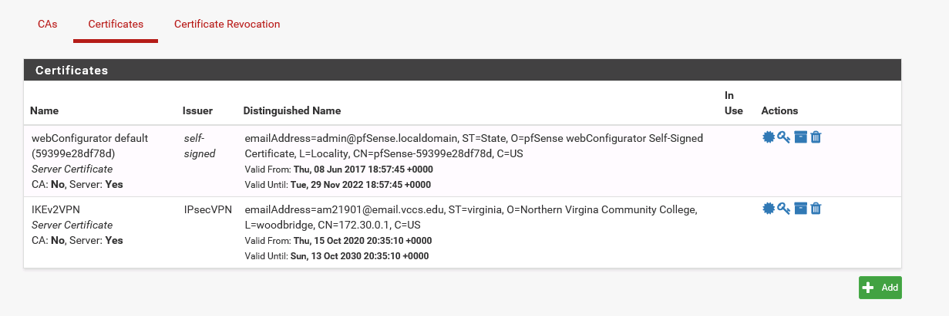

Screenshot 3:

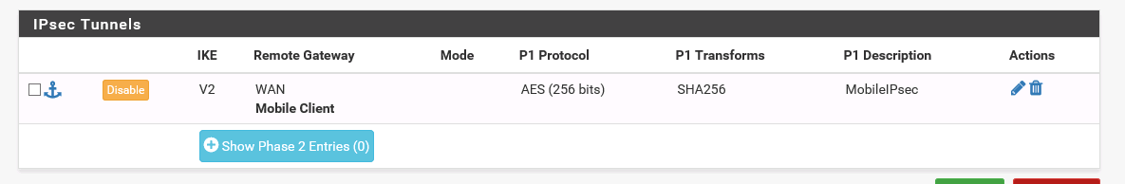

Screenshot 4:

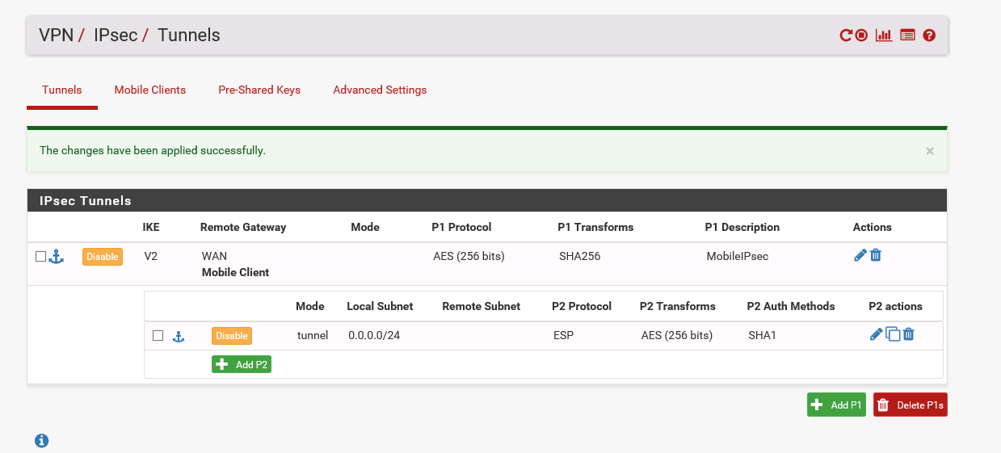

Screenshot 5:



Screenshot 6:



Screenshot 7:



Screenshot 8:

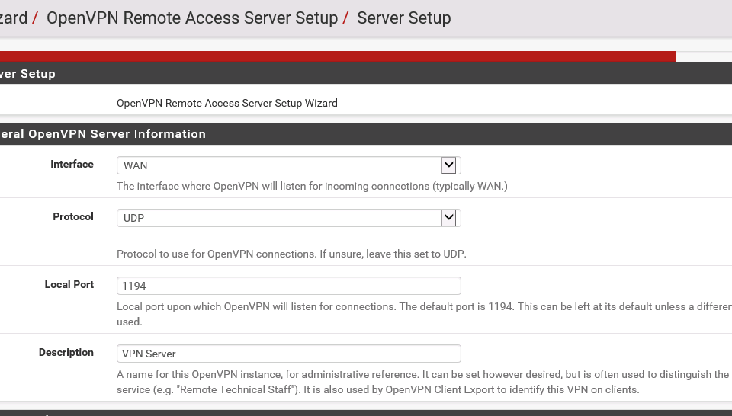

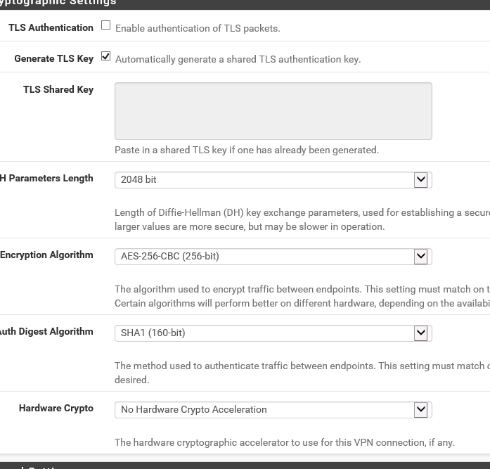

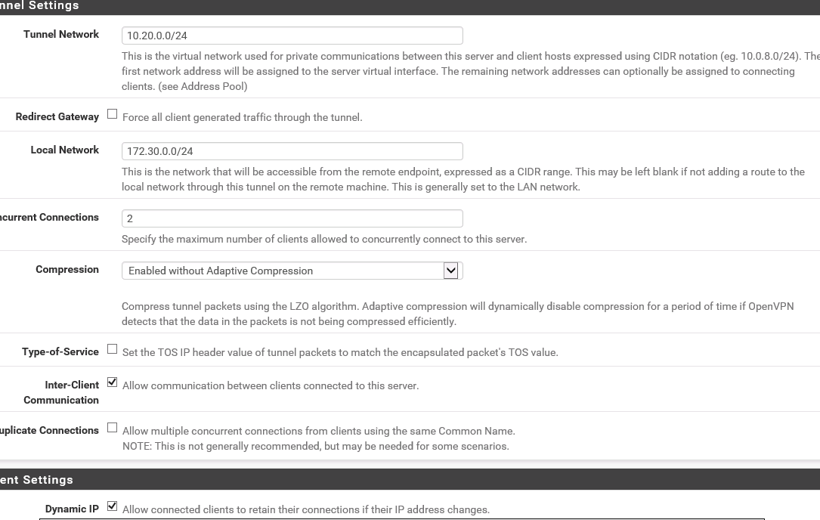

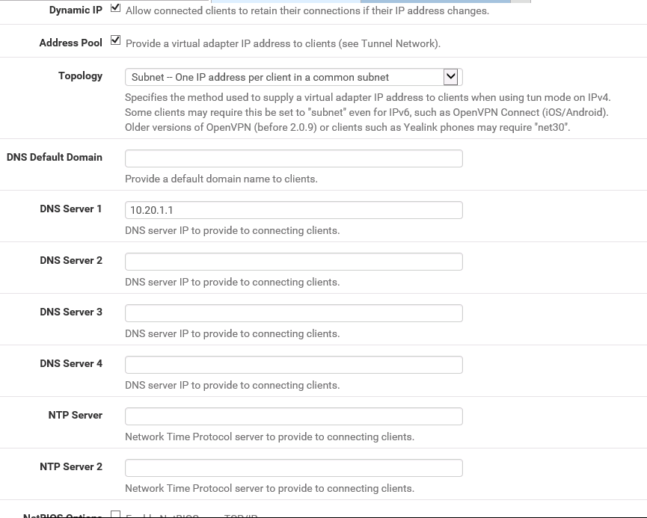

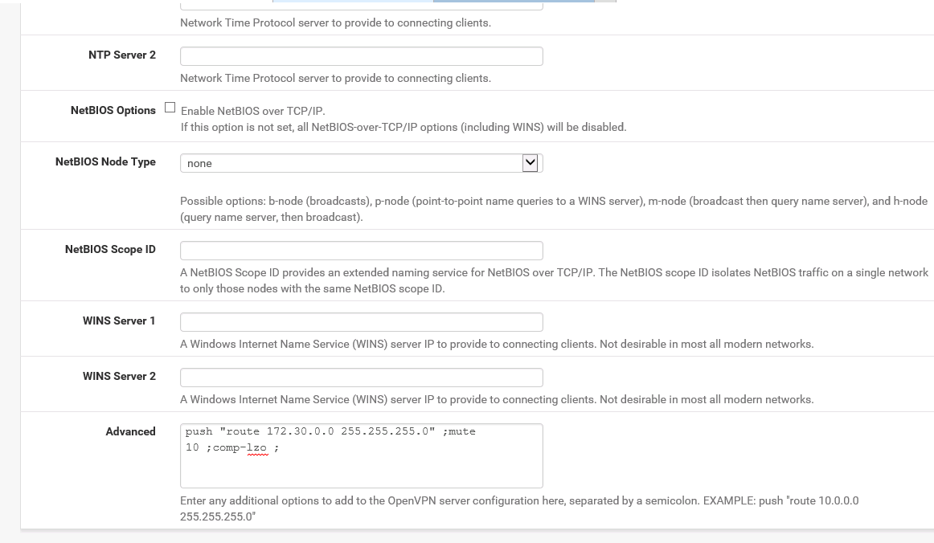

Screenshot 9:

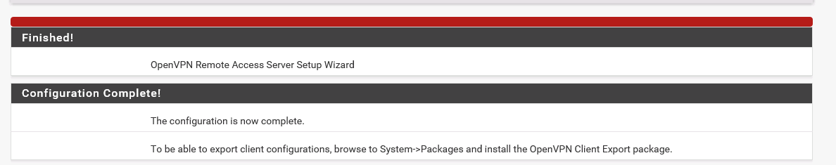

Screenshot 10

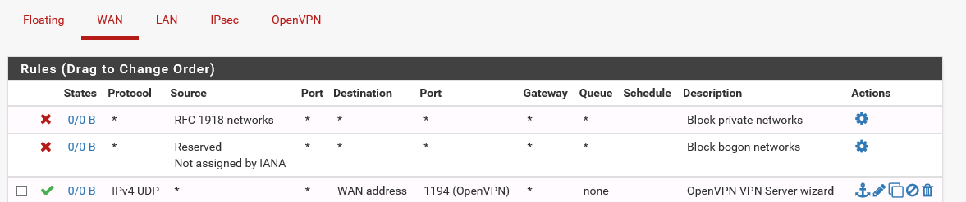

Screenshot 11:

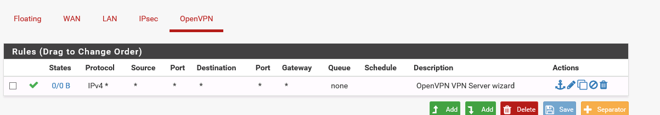

1. It is not 100% safe because sometimes the VPN service may have been crashing and forcefully shut down before establishing whatever the connection the user was trying. This defeats the purpose of keeping amenity from using a VPN if it is forcefully shut down before it makes the connection.
2. 