Afeefah Manzoor

ITN263

Lab report 9

Screenshot 1:

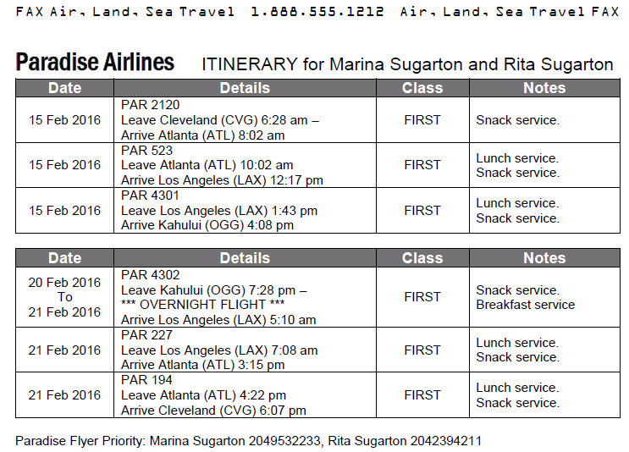

Screenshot 2:

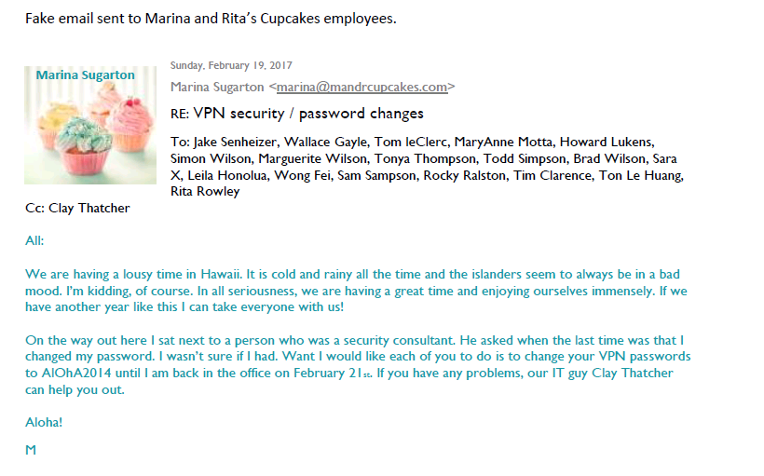

Screenshot 3:



Sprear phising email sample

|  |  |
| --- | --- |
| To: | Charlie Roberts <croberts@beingattacked.com> |
| From: | Susan Dougherty <susand@innocentbystander.com> |
| Date: | 10/15/2020 |
| Subject: | A favor? |

Dear Charlie,

I am the chairperson for this year’s fundraising efforts for the Cure Strange Childhood Disease Society. Our goal is to raise $500,000 and with your help we can reach our goal. Please [click here](https://172.30.0.99) and make a donation today.

Thanks!

Susan Dougherty

Chairperson

Screenshot 4:

