Afeefah Manzoor

ITN266

Blab09

Project 1

Screenshot 1:

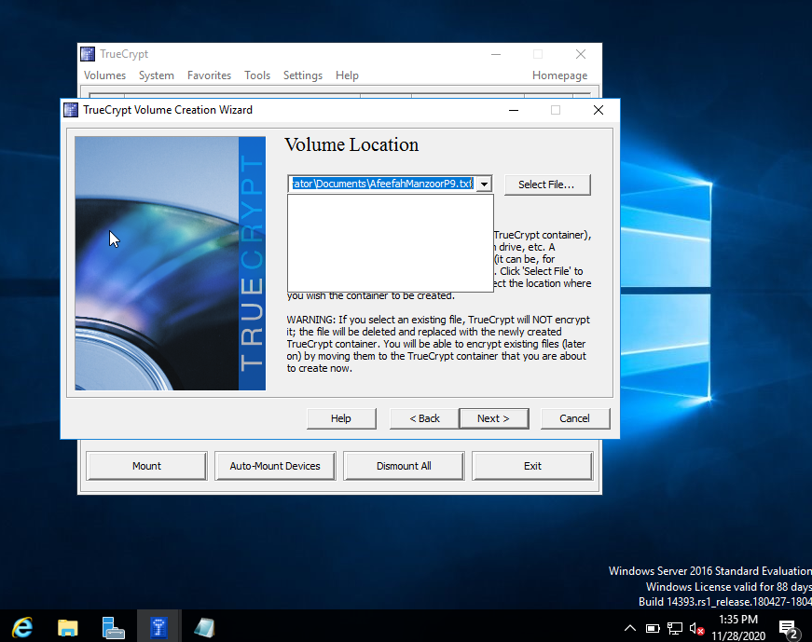

Screenshot 2: