Afeefah Manzoor

ITN266

BLAB00

Project 1:

Screen Capture 1:

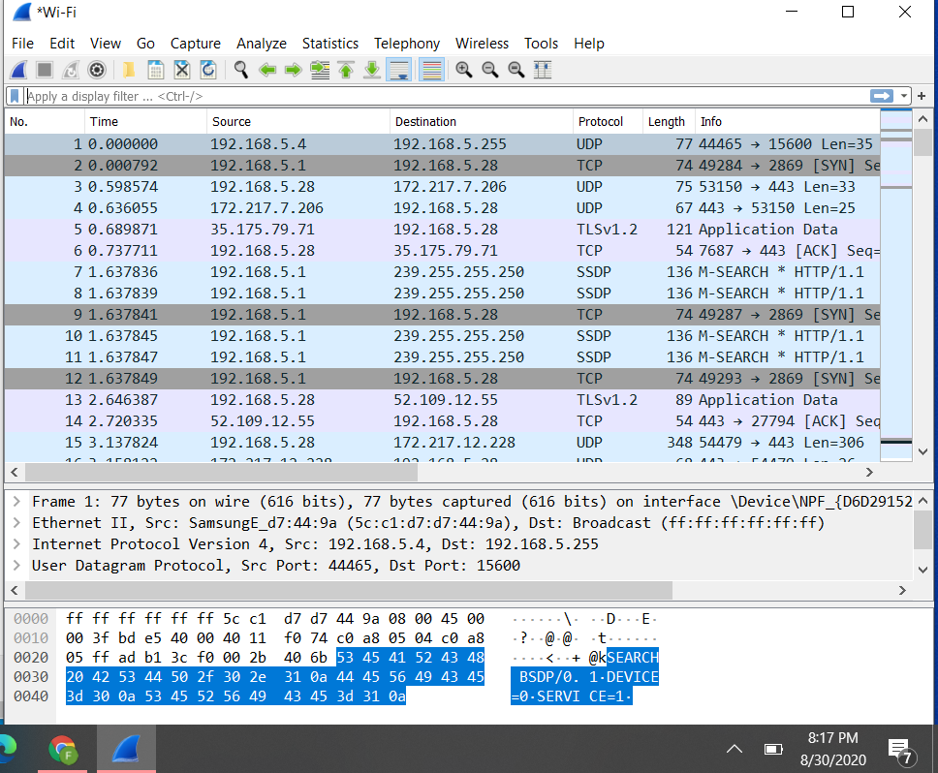

Screen Capture 2:

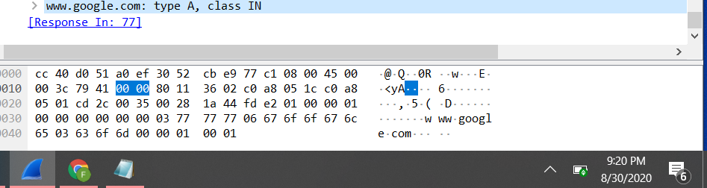

Project 2:

Screen Capture 1:

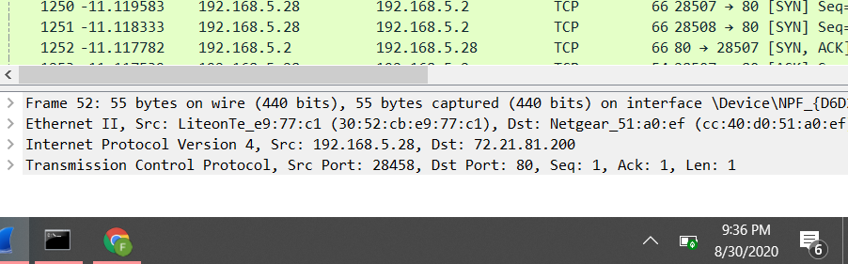

Screen Capture 2:

