Afeefah Manzoor

ITN266

Screen Capture 1: Installing Virtual Box >> Step 14

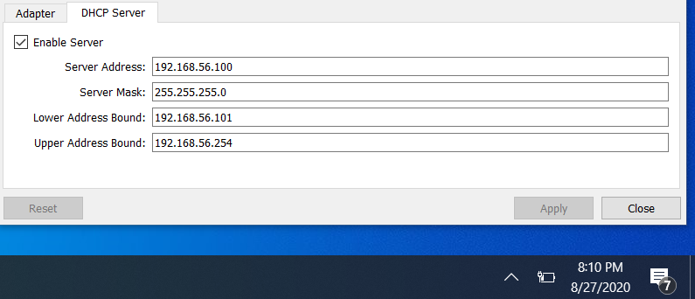

Screen Capture 2: Installing Kali >> Kali Desktop

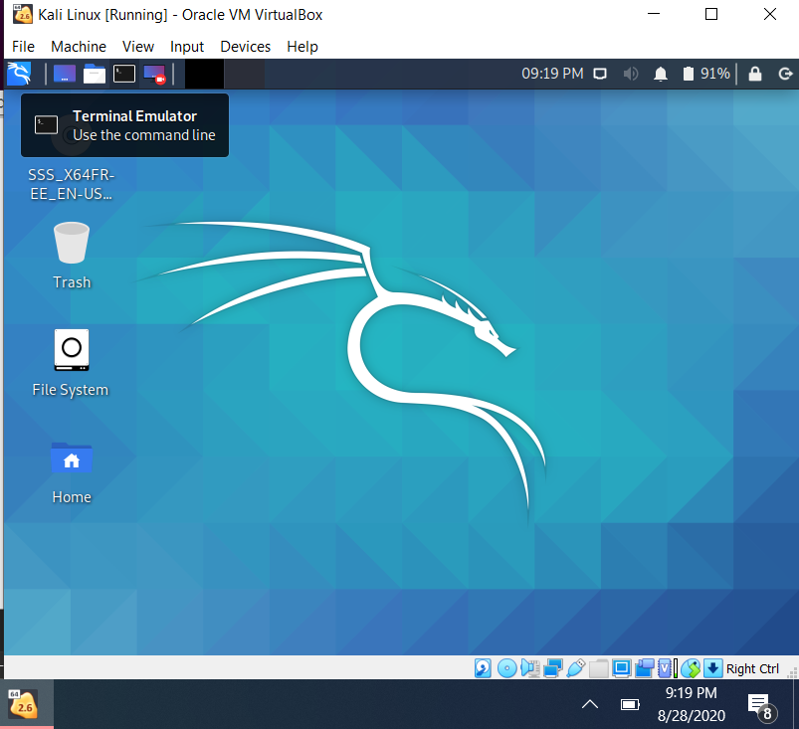

Screen Capture 3: Installing Metasploitable >> step 14

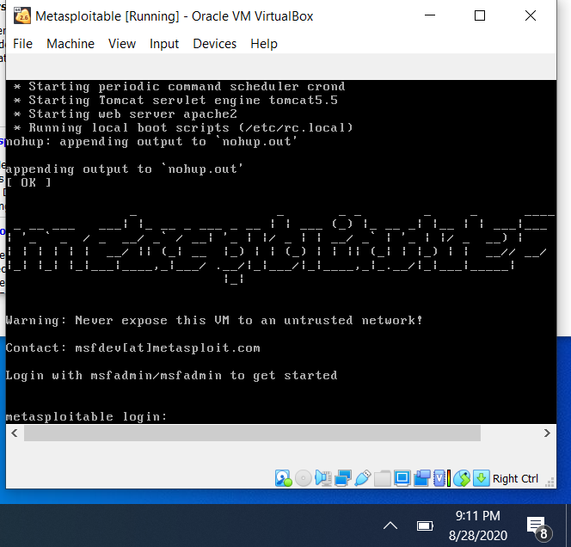

Screen Capture 4: Install Windows Server 2016 >> Windows Desktop

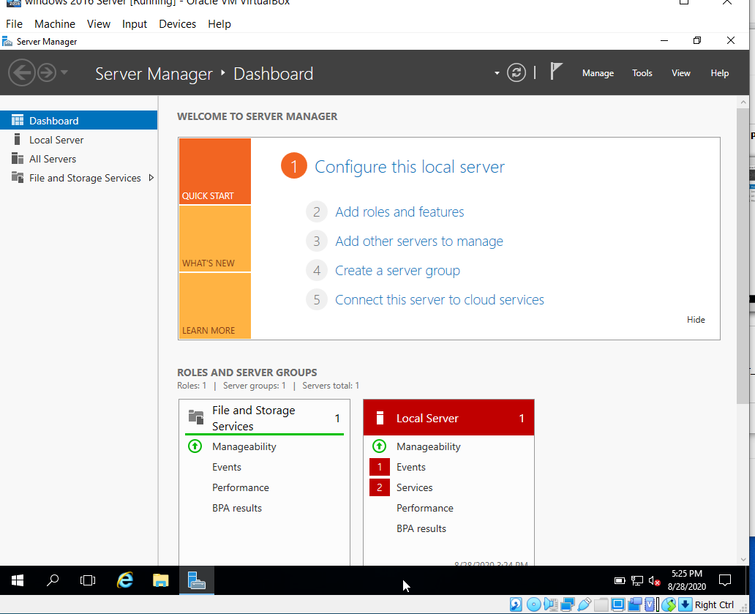

Screen Capture 5: Install Ubuntu >> Ubuntu Desktop

