Afeefah Manzoor

ITN 266

PLAB01a

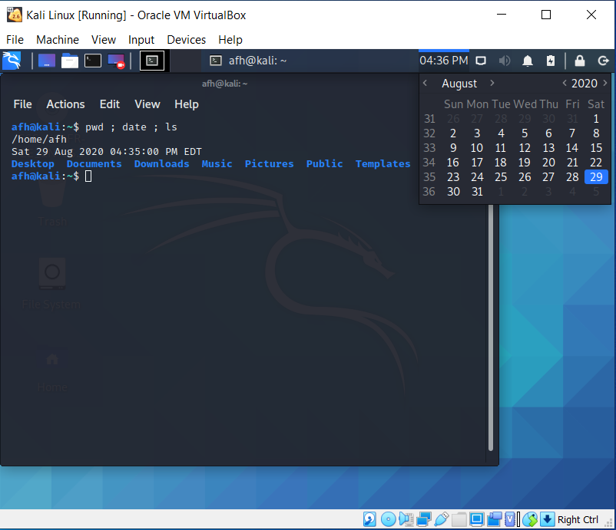Screen Capture 1: Output of the pwd ; date ; ls command

Screen Capture 2: Output of the pwd command

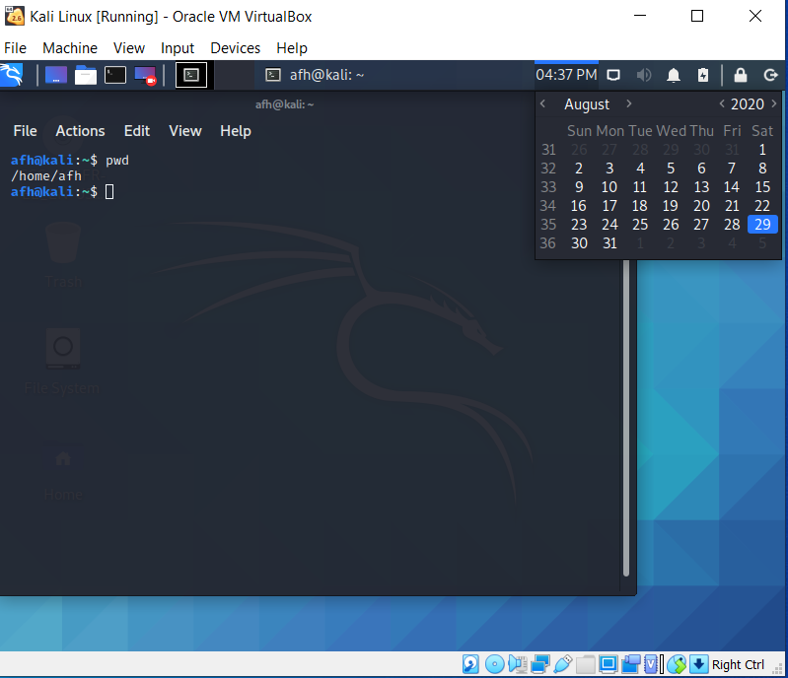

Screen Capture 3: Output of the cd /etc command

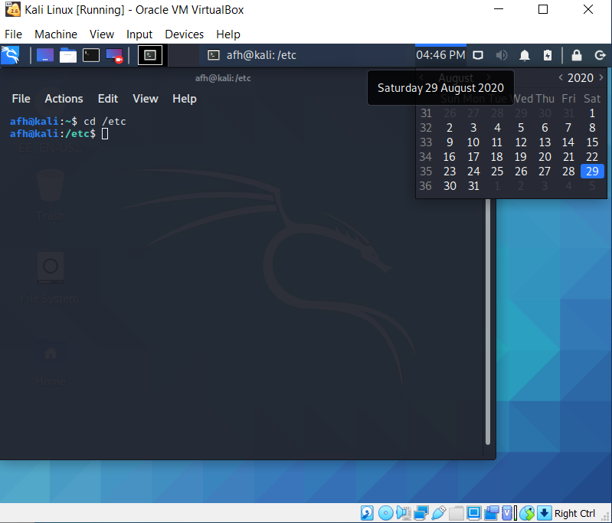

Screen Capture 4: Output of the cd /etc/skel command

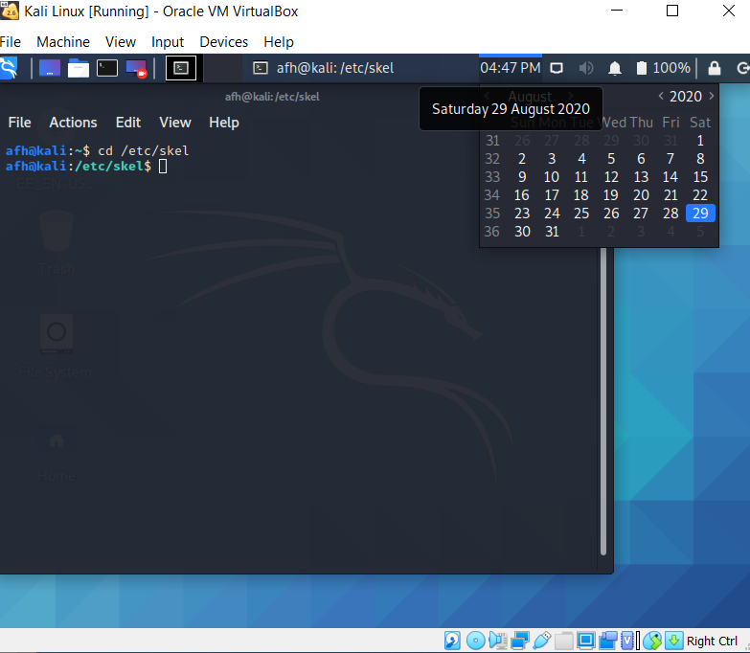

Screen Capture 5: Output of the ls command

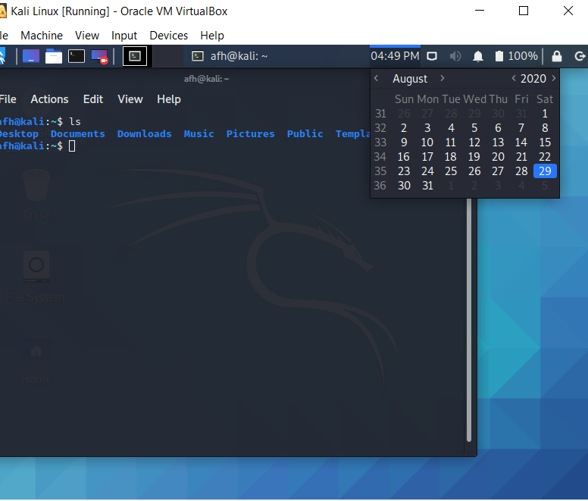

Screen Capture 6: Output of the ls -d D\* commandcd

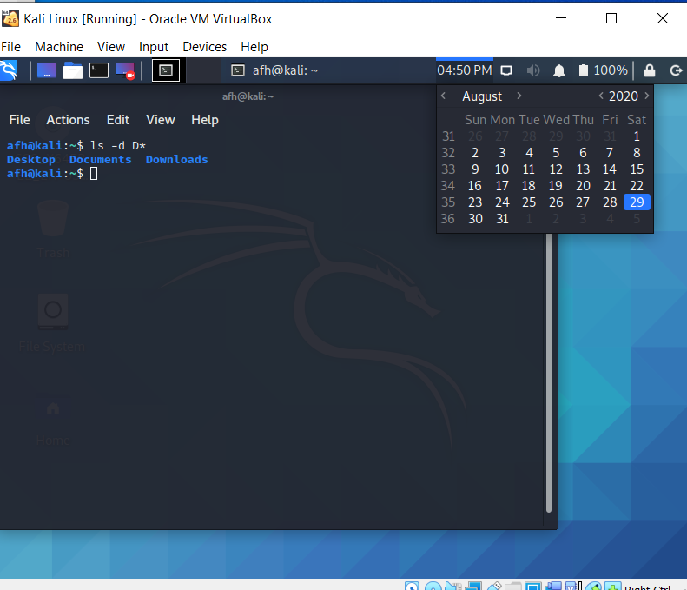

Screen Capture 7: Output of the ls -d ????? command

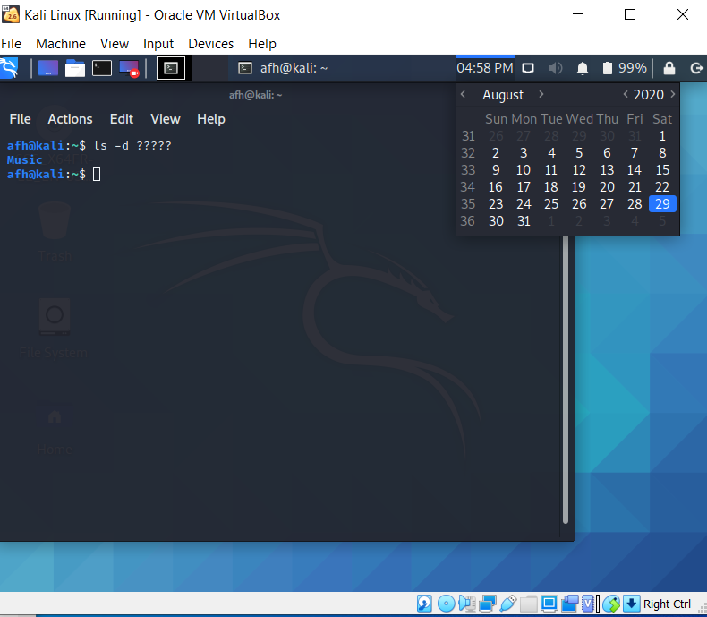

Screen Capture 8: Output of the file /etc/hosts command

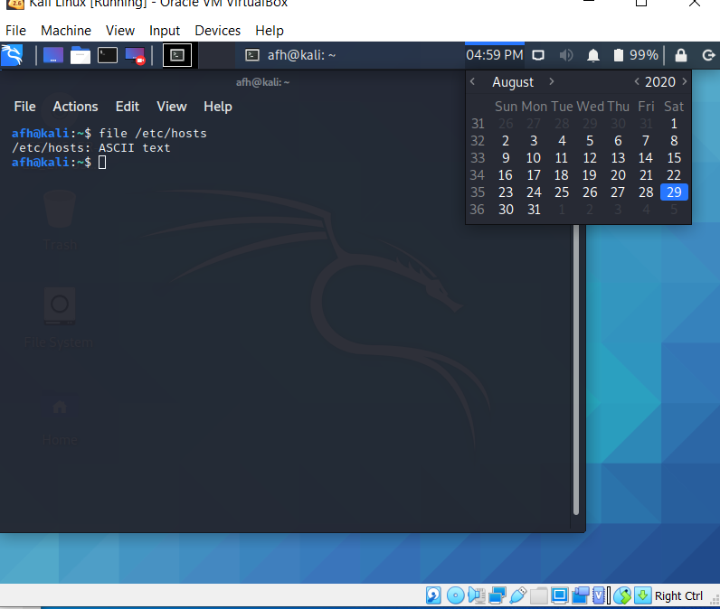

Screen Capture 9: Output of the less --help command

