Afeefah Manzoor

ITN266

PLAB01b

Screen Capture 1: head -n 3 /etc/group command

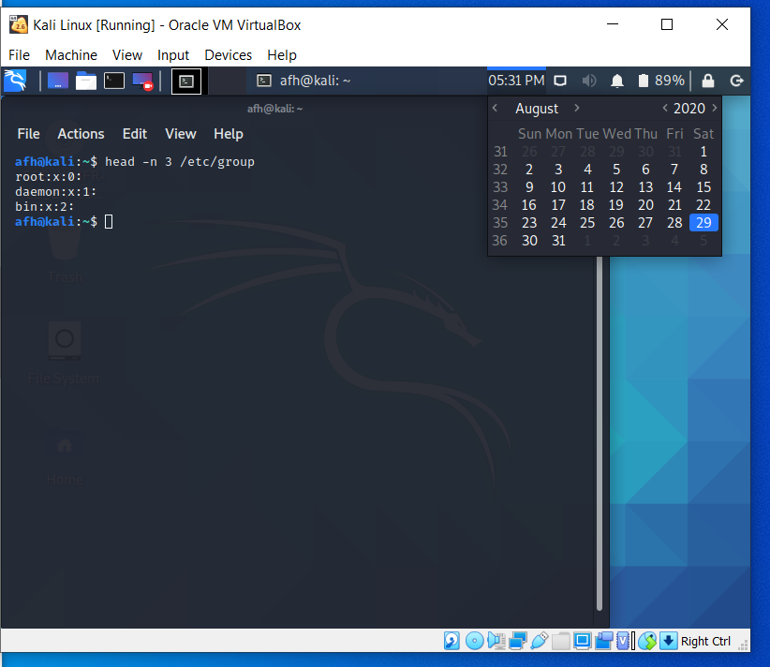

Screen Capture 2: Output of the tail -n 3 /etc/group command

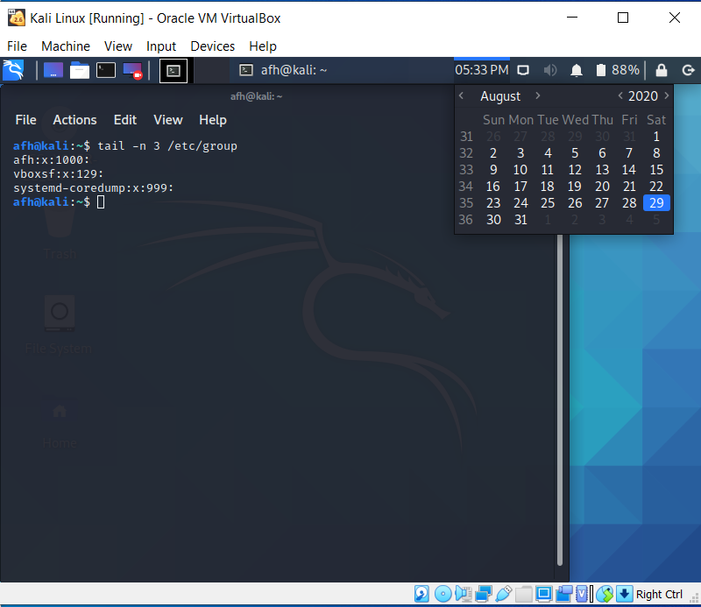

Screen Capture 3: Output of the mkdir -v test command

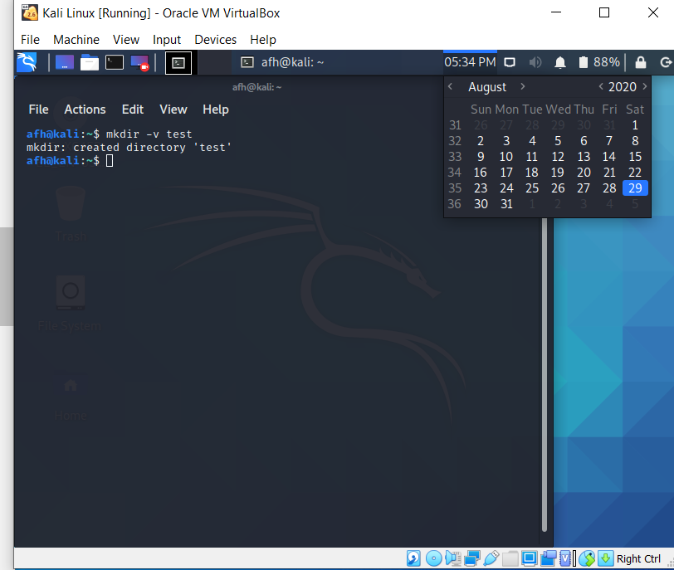

Screen Capture 4: Output of the cp -v /etc/hosts . command

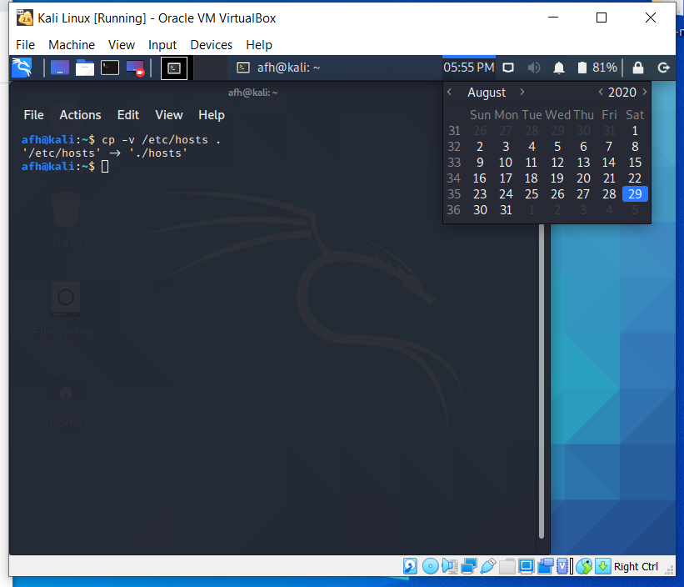

Screen Capture 5: Output of the mv -v /tmp/myfile ~ command (you should get an error message....why?)

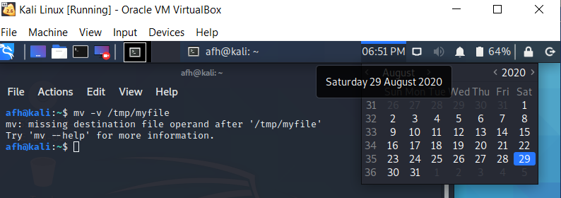

Because the destination is missing.

Screen Capture 6: Output of the rm -v file.txt command (you should get an error message....why?)

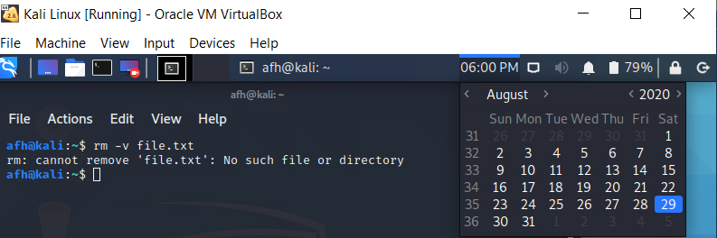

Because that file does not exist

Screen Capture 7: Output of the rmdir -v data command (you should get an error message....why?)

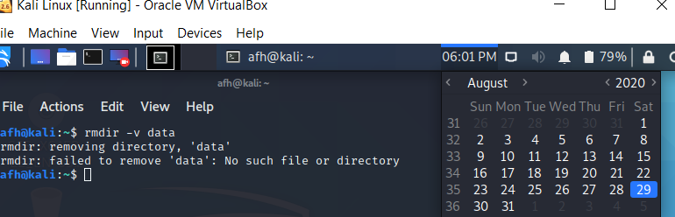

Because the directory does not exist or is not empty

Screen Capture 8: Output of the rm -v file.txt command (you should get an error message....why?)

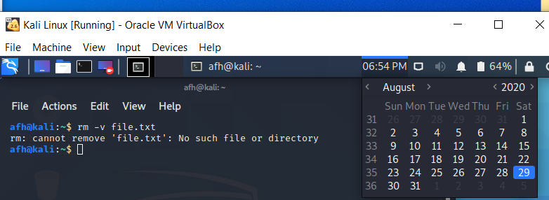

Because the file does not exist.

Screen Capture 9: Output of the touch filename command (use the ls command to show the file was created)

