Afeefah Manzoor

ITN266

PLAB01c

Screen Capture 1: Output of the echo $HISTSIZE command

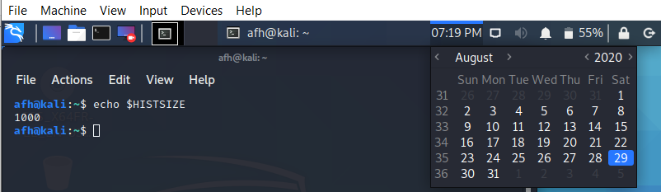

Screen Capture 2: Output of the set | head -n 5 command

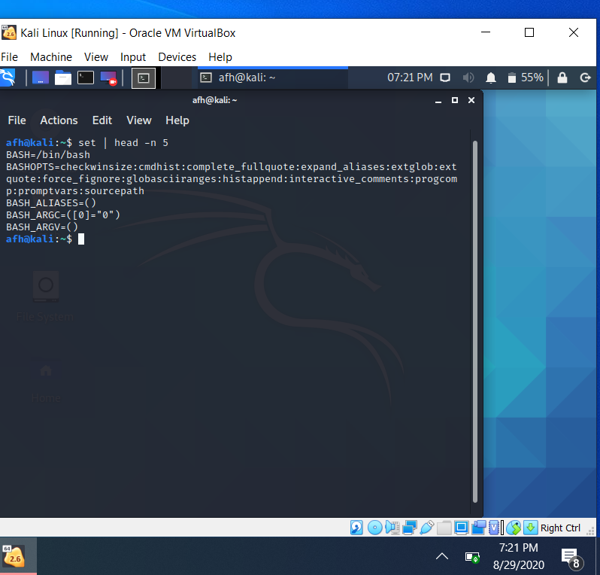

Screen Capture 3: Output of the echo $NOPE  AND  set -u  AND  echo $NOPE commands

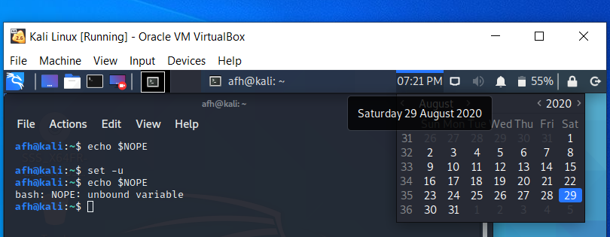

Screen Capture 4: Output of the echo $PS1 command

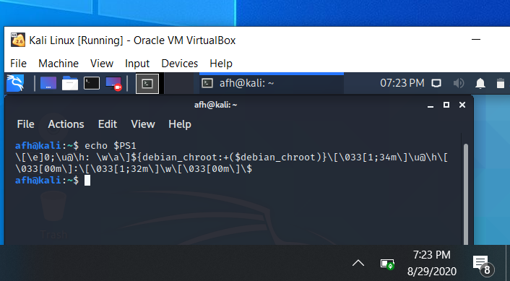

Screen Capture 5: Output of the echo $PATH command

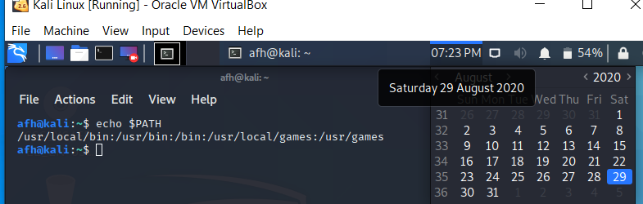

Screen Capture 6: Output of the /usr/xbin/xeyes command (You should get an error message ---why?)

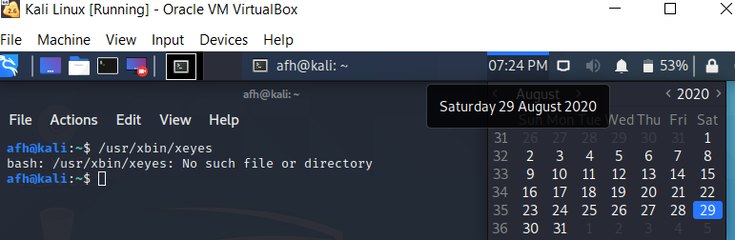

The command to get the eyes is */usr/bin/xeyes* not */usr/xbin/xeyes*

Screen Capture 7: Output of the export -p command

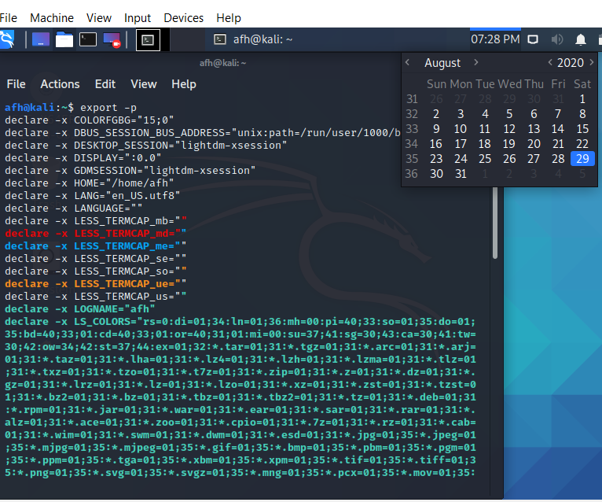

Screen Capture 8: Output of the env command

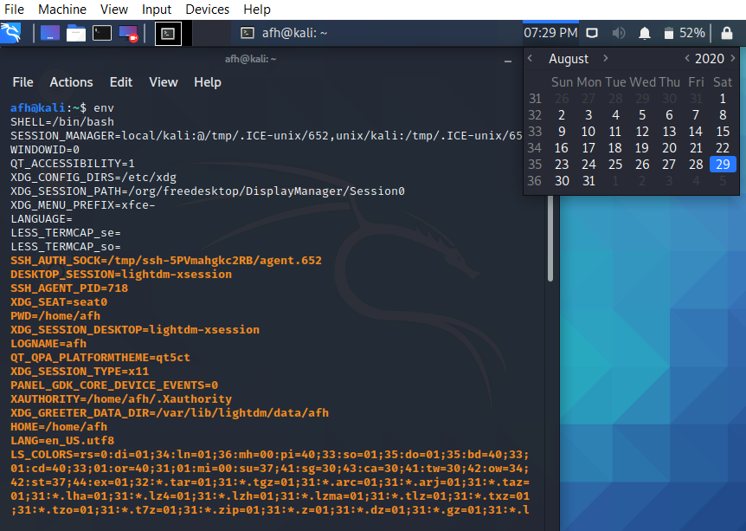

Screen Capture 9: Output of the alias command

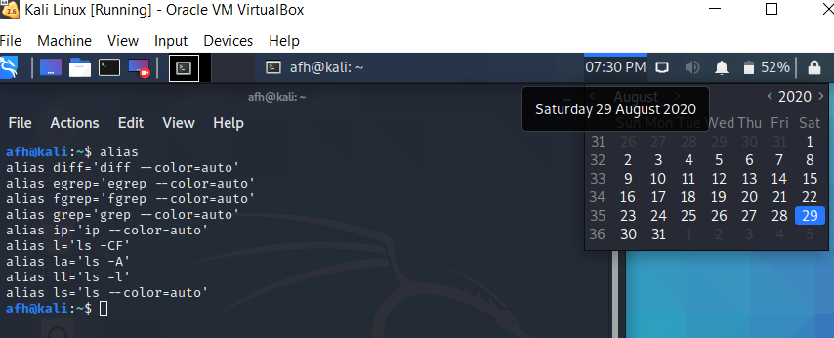

Screen Capture 10: Output of the history 5 command

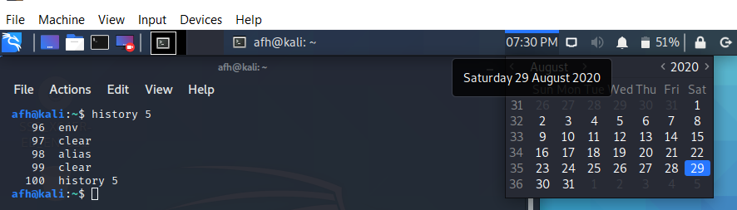

Screen Capture 11: Output of the !84 command

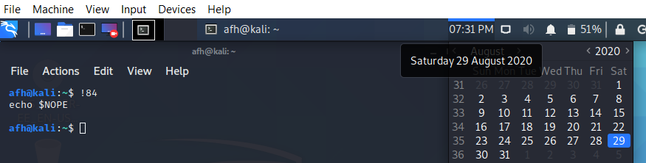

Screen Capture 12: Output of the ls/usr/share/dict AND ^ra^re commands

