Screen Capture 1:Output of the cal > month command (use the ls command to show that the file was created)

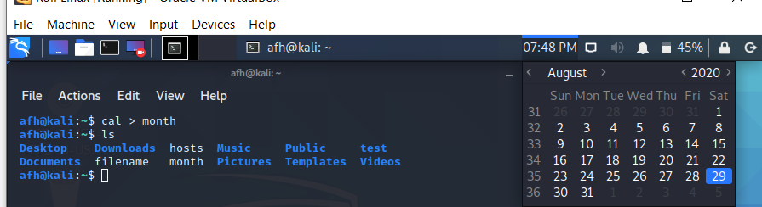

Screen Capture 2:  Output of the ls -l /etc | grep "Apr 16" command (make sure you are lsin a directory that contains some file and change the date to the date of some files)

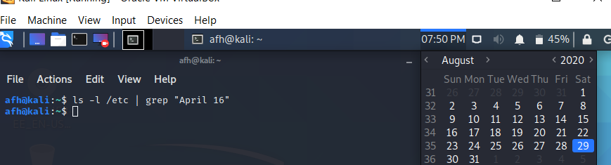

Screen Capture 3: Output of the head -50 copyright | tail command (change the file copyright to the name of a file in your current directory)

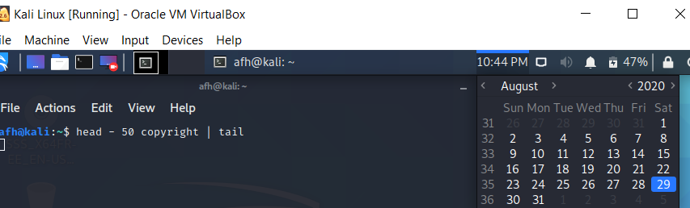

Screen Capture 4: Output of the head -50 copyright | tail | nl command (change the file copyright to the name of a file in your current directory)

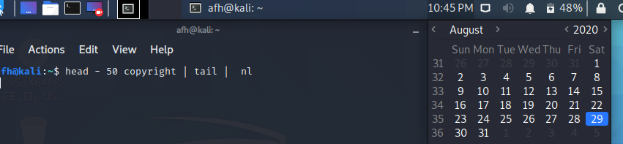

Screen Capture 5:  Output of the echo "Today is $(date) and you are in the $(pwd) directory" command

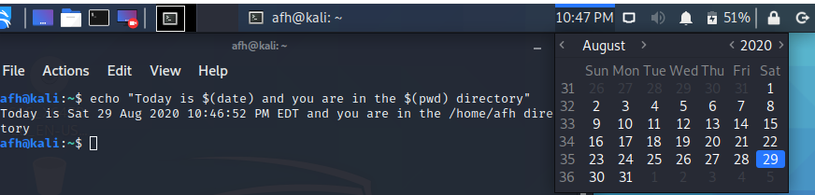

Screen Capture 6:  Output of the find /etc -name "\*.cfg" -exec file {} \; command

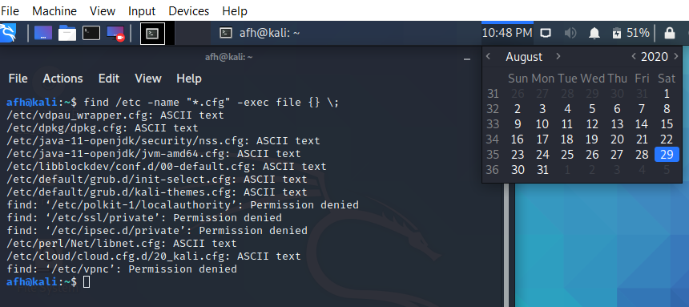

Screen Capture 7: Output of the find / -regex ".\*chpasswd.\*8.\*" 2> /dev/null command (this command might take one or two minutes)

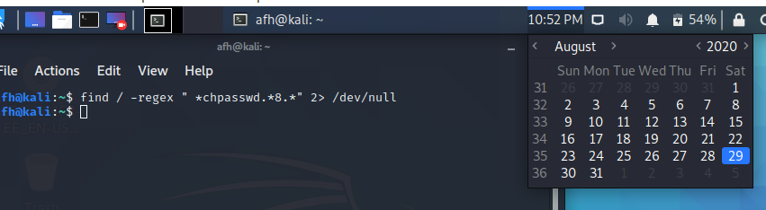

Screen Capture 8: Output of the grep "the" /etc/rsyslog.conf command

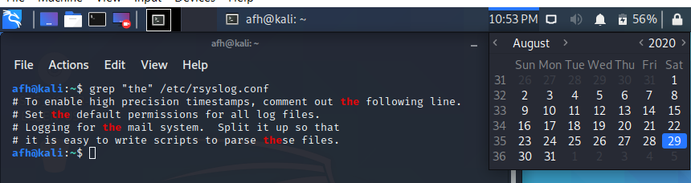

Screen Capture 9:  Output of the grep -r ":[0-9][0-9]:games:" /etc 2> /dev/null command

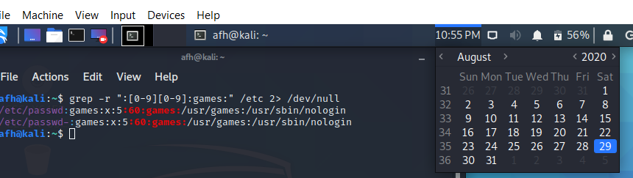

Screen Capture 10: Output of the cat /etc/hosts AND sed 's/localhost/myhost/' /etc/hosts commands

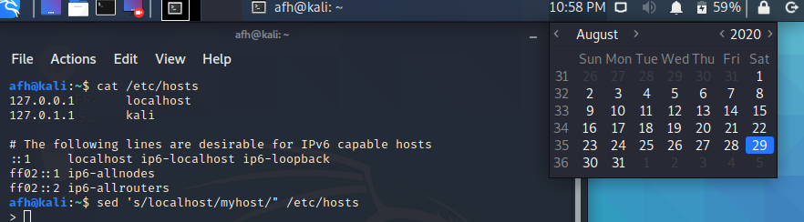

Screen Capture 11: Output of the ls -lh juju.gz command (create a file named juju with the touch command first)

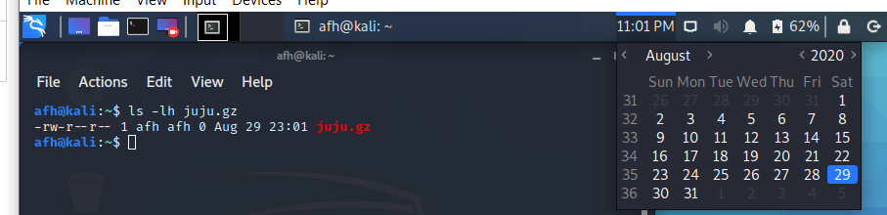

Screen Capture 12: Output of the ls -lh juju command (create a file named juju with the touch command first)

