Afeefah Manzoor

ITH266 plab01g

Screen capture 1:

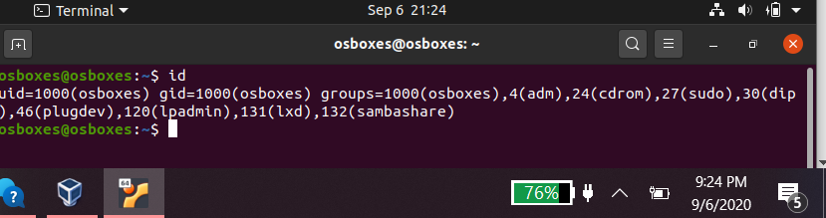

Screen capture 2:

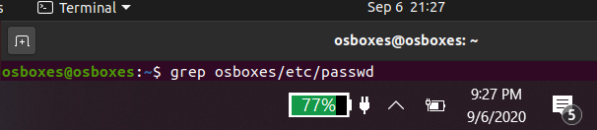

Screen capture 3:

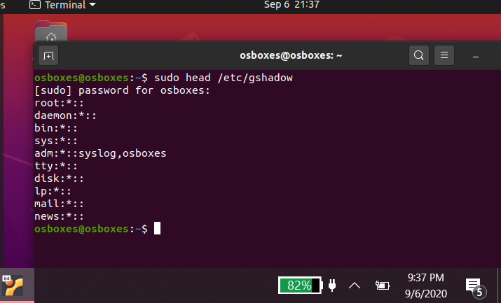

Screen capture 4:

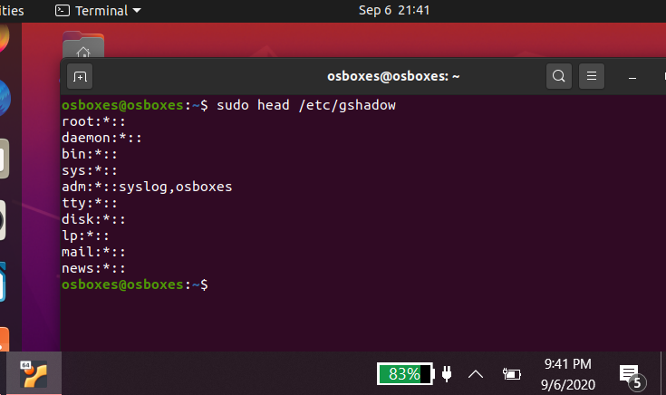

Screen capture 5:

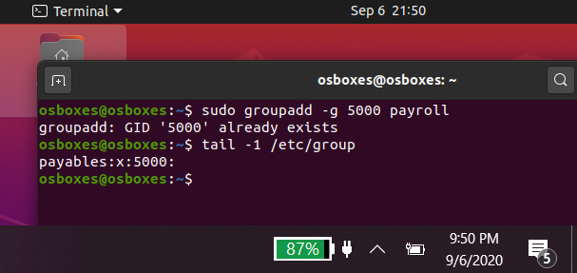

Screen capture 6:

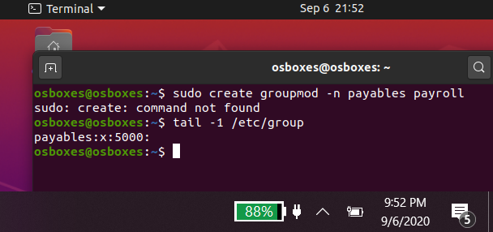

Screen capture 7:

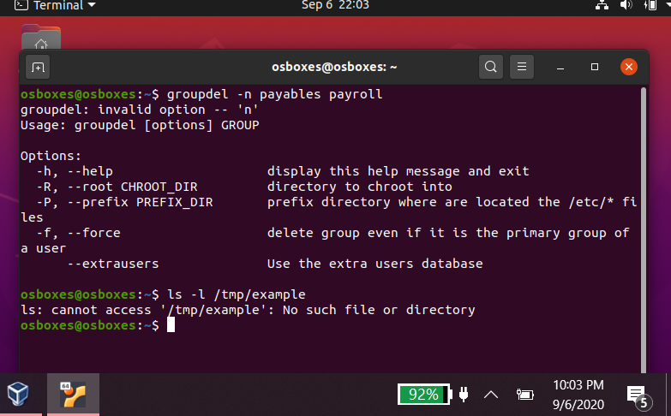

Screen capture 8:

