Afeefah Manzoor

ITN 261

Wifi and Wireless

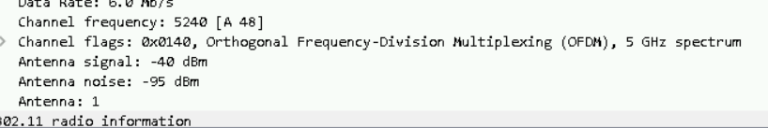

Channel frequency: 5240

