Afeefah Manzoor

ITN 277: Forensics 2

In Class Hands On Network Forensics

1. What is the IP address of the Windows host that gets infected?

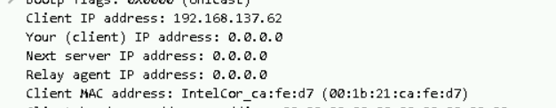

IP: 192.168.137.62

1. What is the MAC address of the infected Windows host?

MAC: 00:1b:21:ca:fe:d7

1. What is the domain name of the compromised web site?

Qwe.mvdunalterableairreport.net

Adstairs.ro





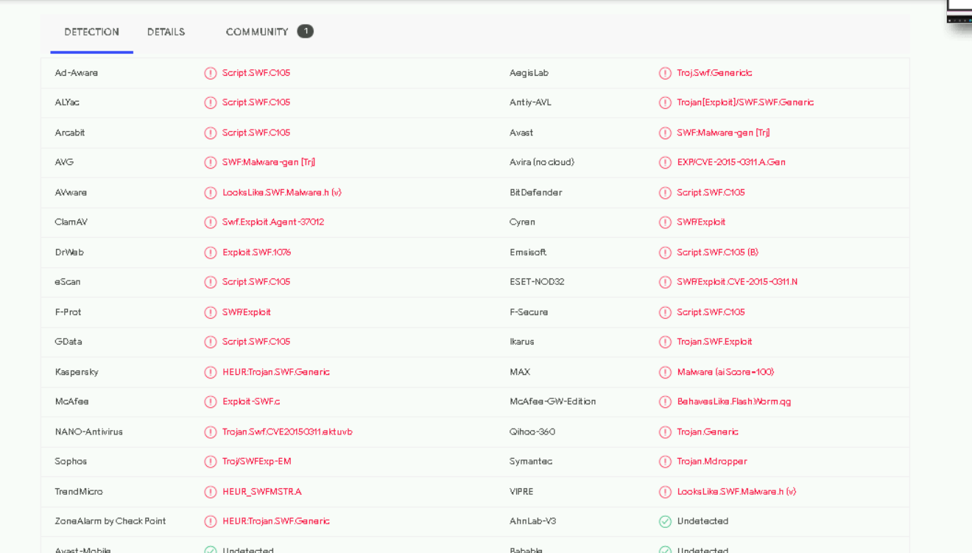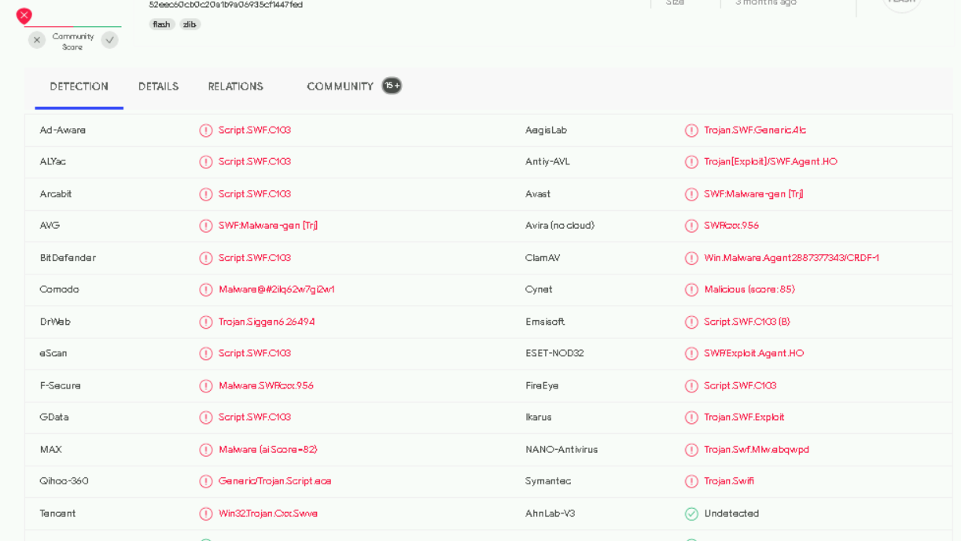

1. What is the IP address of the compromised web site?

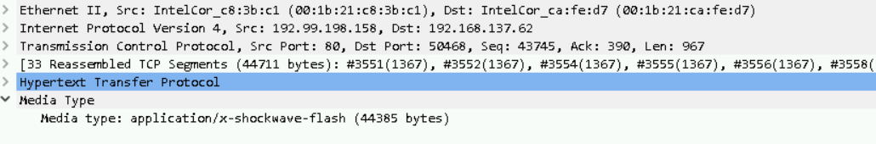

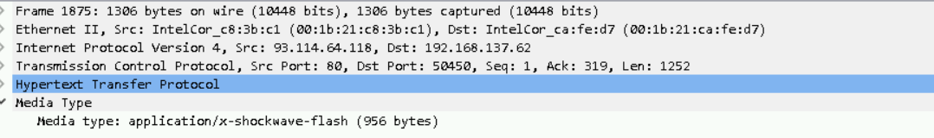

93.114.64.118

192.99.198.158

1. What is the domain name that delivered the exploit kit and malware payload?

Qwe.mvdunalterableairreport.net

Adstairs.ro

1. What is the IP address that delivered the exploit kit and malware payload?

93.114.64.118

192.99.198.158