Afeefah Manzoor

ITH 261

Extra Credit

* MAC address of the infected computer.

00:50:8b:01:db



* IP address of the infected computer.

10.54.112.205



* Host name of the infected computer.

Pendjiek-PC



* The person's name (or account name) using the infected host.



citibank

* A general description of how the computer became infected

The computer was infected with a zberp/zeus trojan through an image that was downloaded from classicalbitu.com

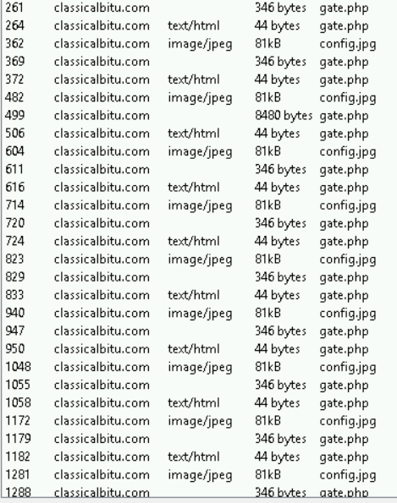

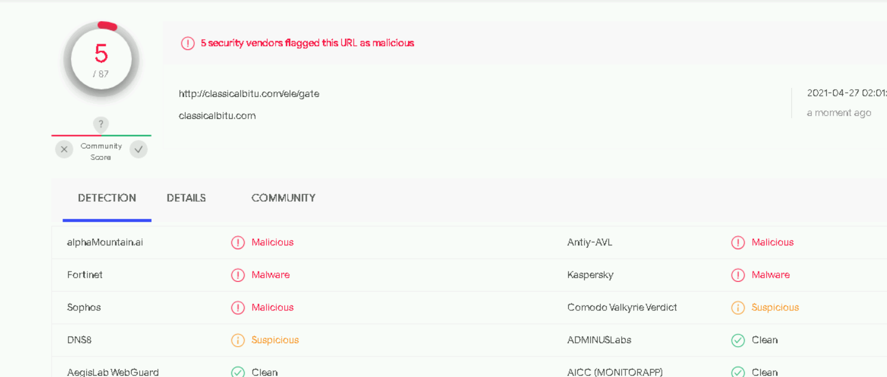

* The country or general location of the infected computer.

 the location is somewhere in the utc timezone

