Afeefah Manzoor

ITN261 Granny’s Machine

What is the host name, MAC address, and IP address computer?

What items of malware were found on Granny's computer? Name of Malware, source of malware

How did the malware get there? (I need an explanation that shows the method of infection, source, and how you know)

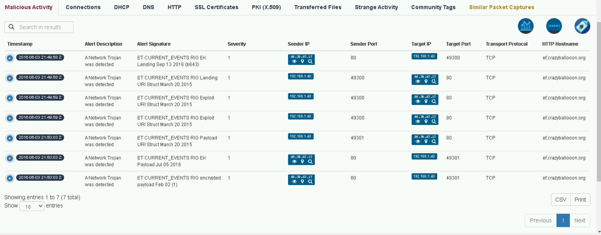

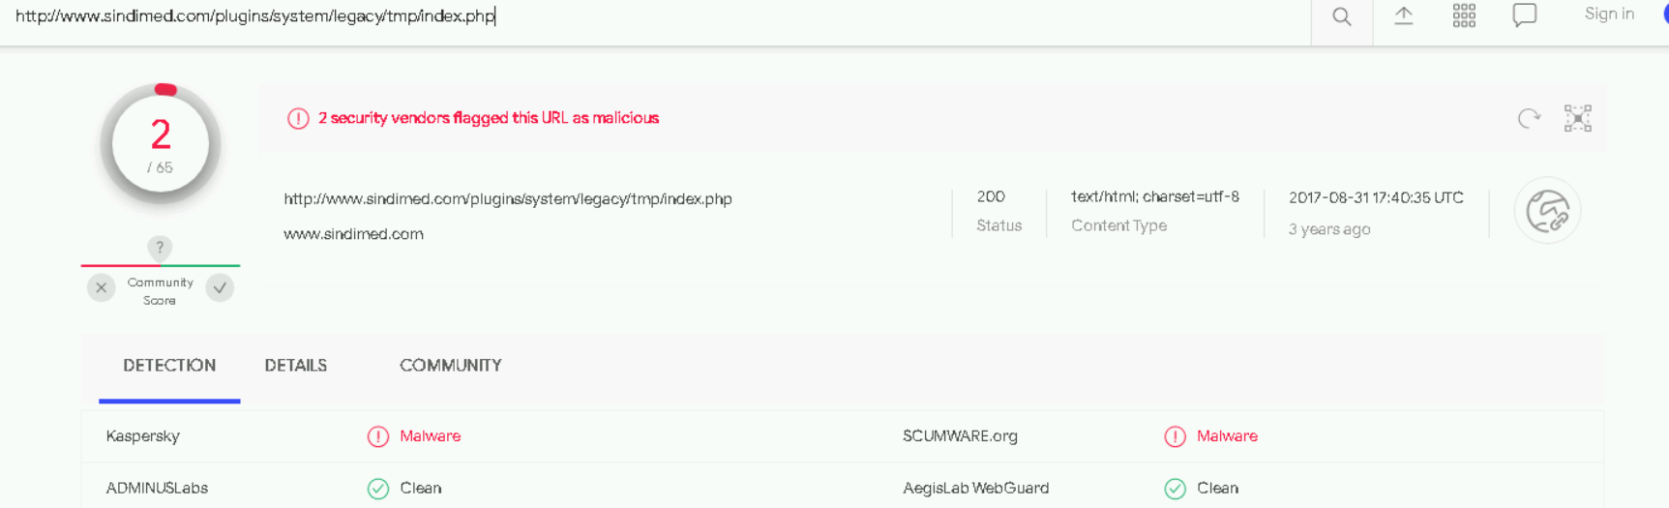email e

