Afeefah Manzoor

ITN 261

Hacking Case

**What operating system was used on the computer?**

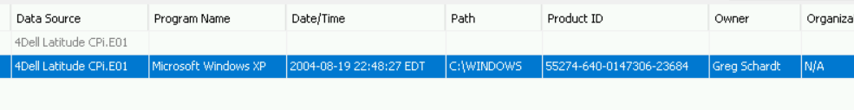

Windows XP

**What is the computer account name?**

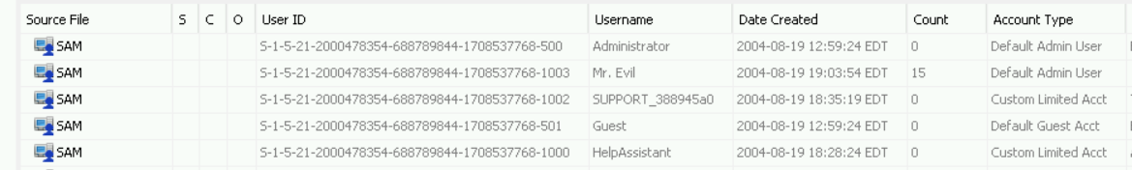

sam

**How many accounts are recorded (total number)?**



5

**Find 6 installed programs that may be used for hacking.**









123 wasp, Cain and Abel, LookAtLAN, LookAtHost, Ethereal, faberToys, winpcap

**Search for the main users web based email address. What is it?**



mrevilrulez@yahoo.com

**Yahoo mail, a popular web based email service, saves copies of the email under what file name?**

 0