Afeefah Manzoor

ITN261

In Class: What Happened?

* Date and time of the activity.



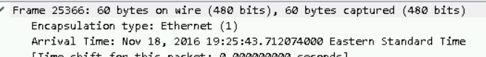

Nov 18 2016 from 7:16:02pm – 7:25:43pm EST

* A brief description of what Jon did to infect his Windows laptop.

On November 18, 2016, Jon connected his laptop onto the company WiFi. With the IP of 172.16.104.115 and a MAC address of 00:21:70:5b:f4:2c. On his laptop(TUCKER-4A9F-WIN) was infected with a RIG Exploit kit and a LuminosityLink Trojan. The REG Exploit Kit was inserted by an advertisement and the LumonisityLink Trojan allows a backdoor to be opened and I believe it was installed a shockwave application with these malware through the free.bayonok.com website.

