Afeefah Manzoor

ITN 261

More Payloads Exploration

https://www.offensive-security.com/metasploit-unleashed/using-exploits/

1. Try the Bind Payload

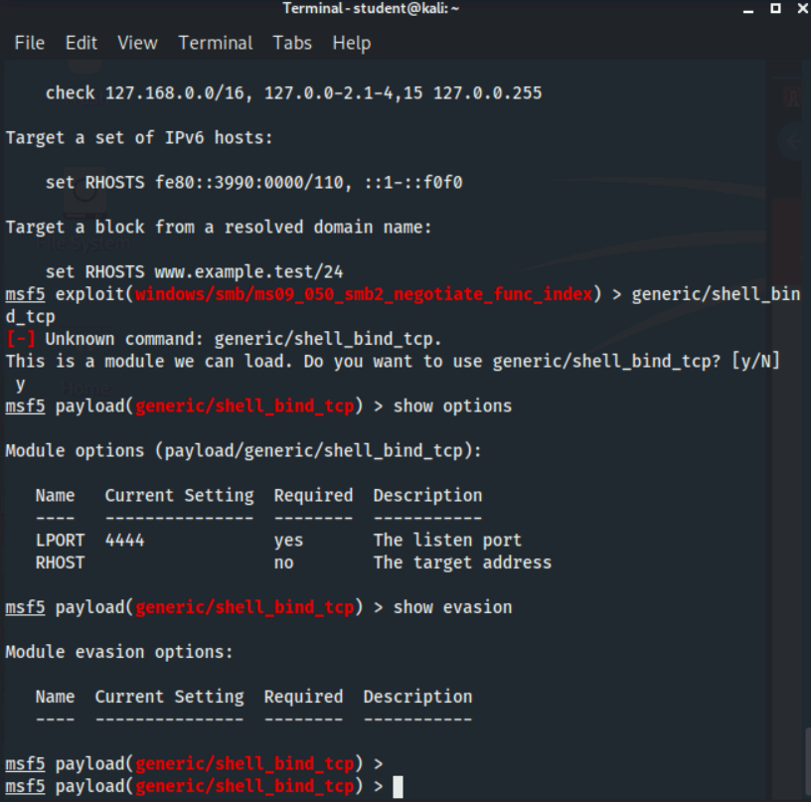

https://www.hackingarticles.in/msfvenom-tutorials-beginners/

Can you get a screenshot showing "Starting interaction with 1...."

2. How about the Reverse TCP Payload or HTTPS Payload?

