Afeefah Manzoor

Practice for Part 2 Midterm

ITN261

1. What is the name of Ann’s IM buddy?



Addyn

1. What is Ann's computer IP address and MAC address?

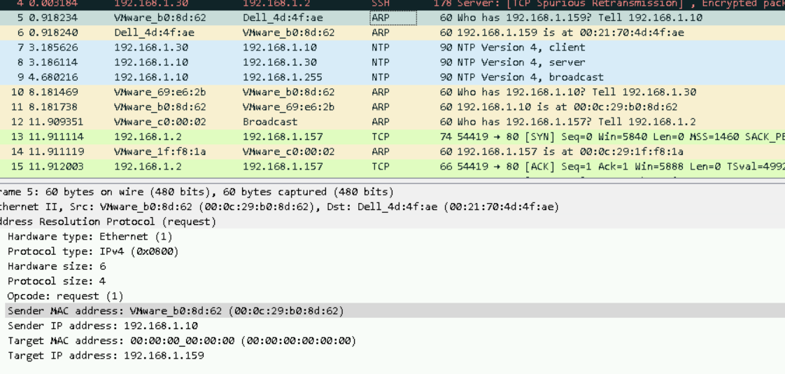

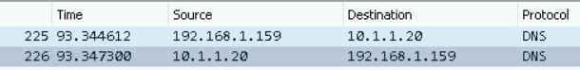

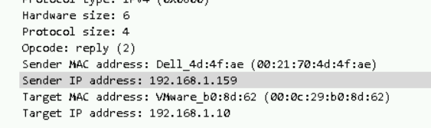

IP: 192.168.1.159

MAC: 00:21:70:4d:4f:ae

1. What was the first comment in the captured IM conversation?

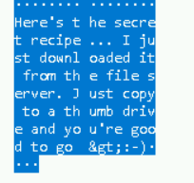Here’s the secret recipe. I just downloaded it from the file server. Just copy to a thumb drive and you’re good to go.

1. What is the name of the file Ann transferred?



Recipe.docx

1. What is the secret recipe?